| WORKSPACE SETUP |
| --- |

## WINDOW 1

* 1. TCOLE
  2. Quiz

## WINDOW 2

* 1. [Symbolab](https://www.symbolab.com/)
  2. [Desmos](https://www.desmos.com/calculator)
  3. [Matrix Multiplier](https://matrix.reshish.com/multiplication.php)
  4. Google

| 12 INDEFINITE INTEGRALS AND FURTHER APPLICATIONS |
| --- |

## Fundamental Theorem of Calculus

|  |
| --- |

## Antidifferentiation Rules and Formulae

$\int{}kf(x)dx=k\int{}f(x)dx$

$\int{}[f(x)+g(x)]dx=\int{}f(x)dx+\int{}g(x)dx$

$\int{}[f(x)-g(x)]dx=\int{}f(x)dx-\int{}g(x)dx$

$\int{}0dx=c$

$\int{}1dx=x+c$

$\int{}(ax+b)^{r}dx=\frac{1}{a(r+1)}(ax+b)^{r+1}+c$

$\int{}\frac{d}{ax+b}dx=\frac{d}{a}ln|ax+b|+c$

$\int{}sin(kx)dx=-\frac{1}{k}cos(kx)+c$

$\int{}cos(kx)dx=\frac{1}{k}sin(kx)+c$

$\int{}\sec^{2}(kx)dx=\frac{1}{k}tan(kx)+c$

$\int{}e^{kx}dx=\frac{1}{k}e^{kx}+c$

$\int{}\frac{b}{\sqrt{a^{2}-x^{2}}}dx=b\sin^{-1}(\frac{x}{a})+c$

$\int{}\frac{-b}{\sqrt{a^{2}-x^{2}}}dx=b\cos^{-1}(\frac{x}{a})+c$

$\int{}\frac{a}{a^{2}+x^{2}}dx=\tan^{-1}(\frac{x}{a})+c$

$\int{}\frac{1}{a^{2}+x^{}}dx=\frac{1}{a}\tan^{-1}(\frac{x}{a})+c$

## Average Value of Function over interval [a,b]

|  |
| --- |

## Time Integrals

|  |
| --- |

| 13 LIMITS AND INTEGRATION TO INFINITY |
| --- |

## Limits to Infinity

* 1. If then $\lim_{x→∞}\frac{1}{x^{r}}=0$
  2. If $r>0$ then $\lim_{x→∞}x^{r}=∞$
  3. 

## Limits to Negative Infinity

* 1. 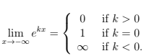
  2. 

## Limit Laws

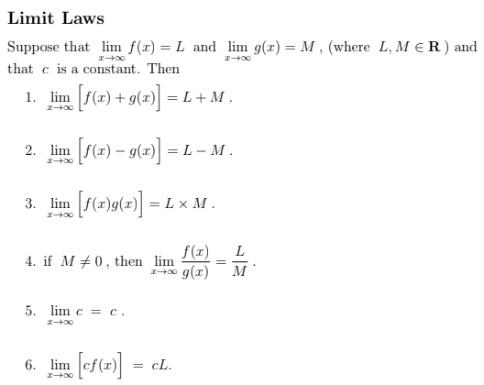

## Integration to Infinity

* 1. 
  2. 
  3. 
  4. 
  5. 
  6. 

### Example

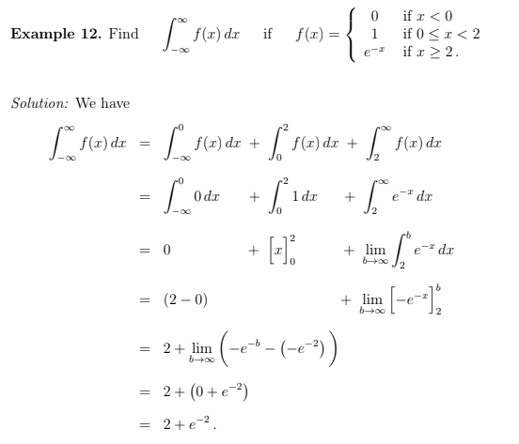

| 14 FURTHER APPLICATIONS OF DIFFERENTIATION |
| --- |

## Linear Approximation

|  |
| --- |

## Approx. Max Error

| Approx. Max Error |
| --- |

## Approx. Max Percentage Error

| Approx. Max Percentage Error |
| --- |

## Angle of Inclination

|  |
| --- |

## Angle between two curves

* 1. Find the angle of inclination of each of the lines, and then
  2. Subtract the smaller angle from the larger angle

| 15 MATRICES AND SYSTEMS OF LINEAR EQUATIONS |
| --- |

## Scalar Multiplication

|  |
| --- |

## Order

|  |
| --- |

| Square Matrix $m=n$ |
| --- |

## General Form of a Matrix

<diagram>

## Equality

$A$ and $B$ are only equal if and only if:

1. They are of the same order
2. Corresponding elements are equal $a_{ij}=b_{ij}$ for all $\{i,j\}$

## Matrix Addition

$A+B$ only exists if $A$ and $B$ have the same order

## Matrix Multiplication

* 1. only exists if $A(m×n)$ and $B(n×p)$
  2. <diagram>
  3. $AB≠BA$ (non-commutative)

## Identity Matrix

<diagram>

## Inverse Matrix

|  |
| --- |

* 1. Singular: $|A|=0$
  2. Non-Singular/Regular:

|  |
| --- |

To find $X$:

$A^{-1}AX=A^{-1}C$

$X=A^{-1}C$

* When $det(A)≠0$ then $AX=C$ has a unique solution $(X=A^{-1}C)$
* When $det(A)=0$ then $AX=C$ has either
  + Infinitely many solutions, or
  + No solutions

1. Solving a System of 2 Linear Equations with 2 Unknowns

| 16 STATISTICS |
| --- |

## Fundamental Theorem of Calculus

|  |
| --- |

## 

| 17 PERMUTATIONS AND COMBINATIONS |
| --- |

## Fundamental Theorem of Calculus

|  |
| --- |

## 

| 18 AN INTRODUCTION TO PROBABILITY |
| --- |

## Fundamental Theorem of Calculus

|  |
| --- |

## 

| 19 CONDITIONAL PROBABILITY |
| --- |

## Multiplication Rule

|  |
| --- |

## Independent Events

$A$ and $B$ are independent if and only if $Pr(A∩B)=Pr(A)×Pr(B)$

| 20 DISCRETE RANDOM VARIABLES |
| --- |

## Expected Value of Random Variable

|  |
| --- |

## Variance of a Random Variable

|  |
| --- |

## 

| 21 BERNOULLI TRIALS |
| --- |

## 

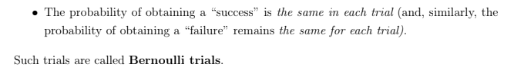

| 22 REVISION OF BINOMIAL, HYPERGEOMETRIC AND GEOMETRIC PROBABILITY DISTRIBUTIONS |
| --- |

## Binomial Distribution

* 1. =number of successes in sequence $n$
  2. No conditions for order
  3. $p$ =probability of success (constant); given as percentage of large population

|  |
| --- |

* 1. Mean

|  |
| --- |

* 1. Variance

|  |
| --- |

## 

## Hypergeometric Distribution

* 1. =number of items with a particular property in sample size $n$
  2. Choosing **without replacement**
  3. No
  4. 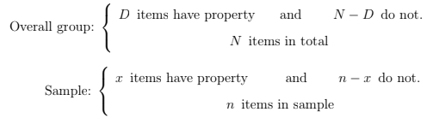

|  |
| --- |

* 1. Mean

|  |
| --- |

* 1. Variance

|  |
| --- |

## 

## Geometric Distribution

* 1. =number of failures **before/until** success
  2. No max $X$
  3. $p$ =probability of success (constant); given as percentage of large population

|  |
| --- |

|  |
| --- |

* 1. Mean

|  |
| --- |

* 1. Variance

|  |
| --- |

## 

## 

| 23 CONTINUOUS RANDOM VARIABLES |
| --- |

$Pr(X≤b)=Pr(X<b)$

$Pr(X≥a)=Pr(x>a)$

$Pr(a≤X≤b)=Pr(a<X<b)$

## 

## Probability Density Functions

* 1. 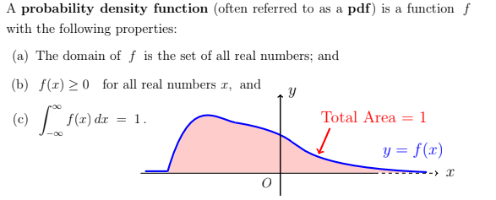

|  |
| --- |

* 1. 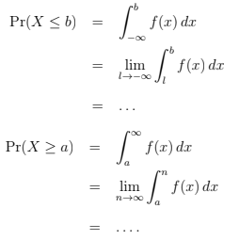

## Median



## Expected Value

|  |
| --- |

## Properties of Expected Value

* 1. 
     1. ^ Same for discrete random variables
  2. 
  3. 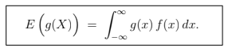

## Variance





## Properties of Variance and Standard Deviation

1. 
   1. ^ same for discrete random variables

| 24 THE NORMAL DISTRIBUTION |
| --- |

## Fundamental Theorem of Calculus

|  |
| --- |

## 

| 25 STATISTICAL INFERENCE |
| --- |

## Population proportion

|  |
| --- |

## Sample proportion

|  |
| --- |

## 

## Random Variable for sample proportion

|  |
| --- |

## Approximating X

