| 1 MOTION AND FORCES |
| --- |

## Displacement vs Distance

* 1. Displacement

|  |
| --- |

* Change in position of an object
* Can be positive or negative
* $Δx$: Displacement [$±$ m]
* $x_{f}$: Final Position [m]
* $x_{i}$: Initial Position [m]
  1. Distance

| Distance $≥$ Displacement |
| --- |

* The *magnitude* or size of displacement between two positions
* Distance travelled: the *total length* of the path traveled between two positions

1. Scalar VS Vector
2. Time, Velocity, Speed and Acceleration
3. Graphs: Distance-Time, Speed-Time and Acceleration-Time
4. Kinematic Equations (Constant Acceleration)
5. Falling Objects
6. Vectors
7. Projectile Motion
   1. Equations of Projectile Motion
   2. Horizontal Motion ($x$ direction)

|  |
| --- |
|  |
|  |

* 1. Vertical Motion ($y$ direction)

|  |
| --- |
|  |
|  |

* Change in position of an object
* Can be positive or negative
* $Δx$: Displacement [m]
* $x_{f}$: Final Position [m]
* $x_{i}$: Initial Position [m]

| 2 CIRCULAR MOTIONS, ENERGY AND OSCILLATIONS |
| --- |

## Reflection

* 1. Law of Reflection

|  |
| --- |

* : Angle of reflection
* $θ_{r}$: Angle of incidence

| 3 WAVES AND OPTICS |
| --- |

## Reflection

* 1. Law of Reflection

|  |
| --- |

* : Angle of reflection
* : Angle of incidence

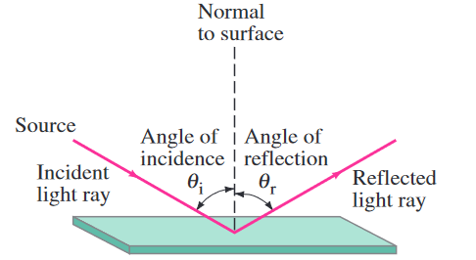

## Mirrors

* 1. Objects appear *behind* the mirror

## Refraction

* 1. Velocity of light depends on material, just like sound

|  |
| --- |

* : Observed Speed of Light [$m/s$]
* $c$: Speed of Light in Vacuum [$m/s$]
$c=3.00×10^{8}m/s$

* $n$: Index of Refraction
  + $n>1$ so $v<c$
  1. Frequency depends on source - does not change; wavelength must

|  |
| --- |
| Proof: $v=\frac{c}{n}, v=fλ$ $λ=\frac{v}{f}=\frac{c}{nf}=\frac{λ_{0}}{n}$ |

* $λ$: Frequency [$Hz$]
* $λ_{0}$:
* $n$: Index of Refraction

|  |
| --- |

* : Frequency
* $λ_{0}$:
* $n$: Index of Refraction
  1. Reduced velocity of wavefront passing across boundary

## Snell’s Law/Law of Refraction

|  |
| --- |

* : Index of Refraction for Medium 1
* $n_{2}$: Index of Refraction for Medium 2
* $n_{1}$: Angle between Ray and Surface Normal of Medium 1
* $n_{2}$: Angle between Ray and Surface Normal of Medium 2
  1. Ray changes direction (refracts) because leading wavefront slows
  2. Wavelength decreases because frequency unchanged and speed reduced
  3. Beam in the glass is wider, hence intensity is less inside

## Total Internal Reflection

* 1. Critical Angle

|  |
| --- |

* : Critical Angle [$°/rad.$]
* $P_{0}$: Present Value // Principal Value

## Image Formation

* 1. A lens converts the direction of rays to a common position (focal point)

|  |
| --- |

* : Critical Angle [$°/rad.$]
* $f$: Present Value // Principal Value
* $θ$:
  1. Thin lenses
     1. Convex - converging - positive: thicker at the middle

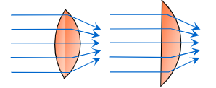

* + 1. Concave - diverging - negative: thinner at the middle

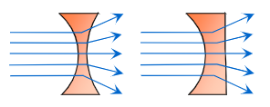

* 1. Thin Lens Formula

|  |
| --- |

* : Critical Angle [$°/rad.$]
* $d_{i}$: Critical Angle [$°/rad.$]
* $f$: Present Value // Principal Value

| Variable | Positive ($+$) when... | Negative ($-$) when... |
| --- | --- | --- |
| $d_{o}$ | Left of lens | Right of lens |
| $d_{i}$ | Right of lens | Left of lens |
| $y, y'$ | Above optical axis | Below optical axis |
| $f$ | Converging | Diverging |

## Human Eye

* 1. Lens Power

|  |
| --- |

* : Lens Power [diopters, $dpt/D$]
* $f$: [$m$]
  1. Colour Vision: Rods and Cones
     1. Rods: detect light and dark
     2. Cones: colour sensitive (red, green, blue) but less sensitive than Rods
  2. Accommodation
     1. Ciliary Muscle: changes radius of curvature
     2. Relaxed: focus to infinity
     3. Contract: focus nearer
  3. Vision Defects
     1. Myopia: Near-sighted; lens too strong - needs diverging lens
     2. Hyperopia: Far-sighted; lens too weak - needs converging lens

| 4 ELECTRICITY AND MAGNETISM |
| --- |

## Photons and Photoelectric Effect

| 5 ATOMIC PHYSICS, RADIATION AND POWER |
| --- |

## Photons and Photoelectric Effect

* Light(photons) knocks electrons out of metal plates if it meets the minimum threshold energy/frequency required (this minimum energy is given by the Work Function, $W_{0}$)
  + After reach minimum threshold, if $↑$ intensity, $↑$ number of electrons knocked out
* Current is proportional to intensity
* Current appears immediately
* Current only if frequency is above some minimum threshold
* Threshold frequency depends on cathode metal
* Current stopped by applying some minimum stopping potential (Vstrop)
* Stopping potential depends on frequency
* 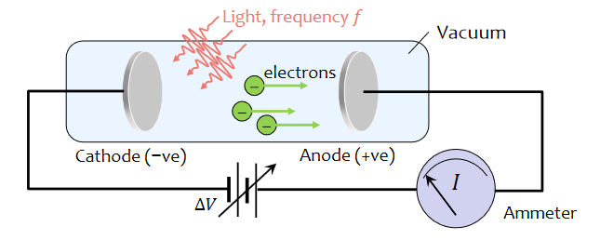
  1. Photon Energy

|  |
| --- |

* 1. Kinetic Energy of Ejected Electron

|  |
| --- |
|  |

* 1. Least tightly held Electron Energy
* Least tightly held electrons will be ejected with the most kinetic energy ()

|  |
| --- |

* 1. Stopping potential/stopping voltage

| $eV_{stop}=hf-W_{0}$ [eV] $V_{stop}=\frac{hf}{e}-V_{0}$ [V] |
| --- |
| Conservation of Energy (Gain in PE=Loss of KE) $eV_{stop}=KE_{max}$ $eV_{stop}=E-W_{0}$ $∴eV_{stop }=hf-W_{0}$ |

* $E$: Photon energy [J]
* $h$: Planck’s constant
  + $h=6.63×10^{-34}$ [Js]
  + $h=4.14×10^{-15}$ [eVs]
* $f$: Frequency [Hz]
$f=\frac{c}{λ}$

* $KE$: Kinetic Energy of Ejected Electron [J]
* $h$: Planck’s constant = $6.63×10^{-34}$ [Js]
* $f$: Frequency [Hz]
* $V_{stop}$: stopping potential/stopping Voltage [V]
  + Voltage when the current in the circuit is 0
* $h$: Planck’s constant = $6.63×10^{-34}$ [Js]
* $f$: Frequency [Hz]
$f=\frac{c}{λ}$

* $W_{0}$: Work function/Binding Energy [eV]
$W_{0}=hf_{0}$

* $V_{0}$: Work function/Binding Energy as Voltage [V]
* $f_{0}$: Threshold frequency
  + Minimum energy required to free an electron
* eV : Electron Volts
  + $1eV=1.6×10^{-19}$ [J]

## Magnetic Resonance Imaging

* 1. Magnetic Dipole Moment

|  |
| --- |

* 1. Potential Energy of Magnetic Dipole

|  |
| --- |

* 1. Energy Difference

|  |
| --- |

* : Magnetic Dipole Moment [J/T]
* $\vec{A}$: Area in the ‘current(I) circle’[m^2]
  + Vector because current moves in specific direction
* $I$: current in the loop
* $B$: [T]
* $U$: Potential Energy [J]

## Matter Waves

* 1. De Broglie wavelength of a particle

|  |
| --- |

|  |
| --- |

* : Magnetic Dipole Moment [J/T]
* $\vec{A}$: Area in the ‘current(I) circle’[m^2]
  + Vector because current moves in specific direction
* $I$: current in the loop
* $B$: [T]
  1. Standing Waves

## Quantized Energy

|  |
| --- |

* 1. Energy levels
* When particle confined to specific regions of space
  + They bounce back and forth between the walls/boundaries of the confined space
  + This creates a standing wave
  + The wavelength of the standing wave is $λ_{n}$
* Quantum systems (like the one described) can only exist at specific energy levels ($n$)
  + Can make transitions between energy levels by *absorbing* or *emitting* photons
  + Ground state: $n=1$
  + ALWAYS INTEGERS

## Photons, Huygens Principle, Diffraction

* 1. Huygens’ Principle
* The new position of the wavefront is a surface tangent to the wavelets
  1. Single-slit diffraction

|  |
| --- |

* 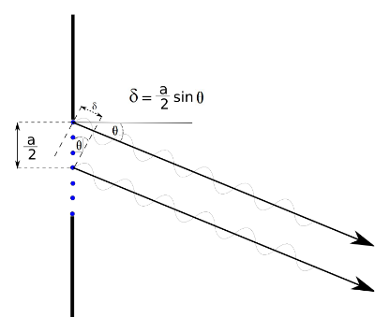

## Heisenberg Uncertainty

* 1. Huygens’ Principle

|  |
| --- |

|  |
| --- |

* : Angle of reflection
* $θ_{r}$: Angle of incidence

|  |
| --- |

* : Angle of reflection

|  |
| --- |

* : Angle of reflection

|  |
| --- |

* : Angle of reflection

|  |
| --- |

* : Angle of reflection

|  |
| --- |

* : Angle of reflection

|  |
| --- |

* : Angle of reflection

|  |
| --- |

* : Angle of reflection

|  |
| --- |

* : Angle of reflection

|  |
| --- |

* : Angle of reflection

|  |
| --- |

* : Angle of reflection

|  |
| --- |

* : Angle of reflection

## Photons and Photoelectric Effect

* Light(photons) knocks electrons out of metal plates if it meets the minimum threshold energy/fre

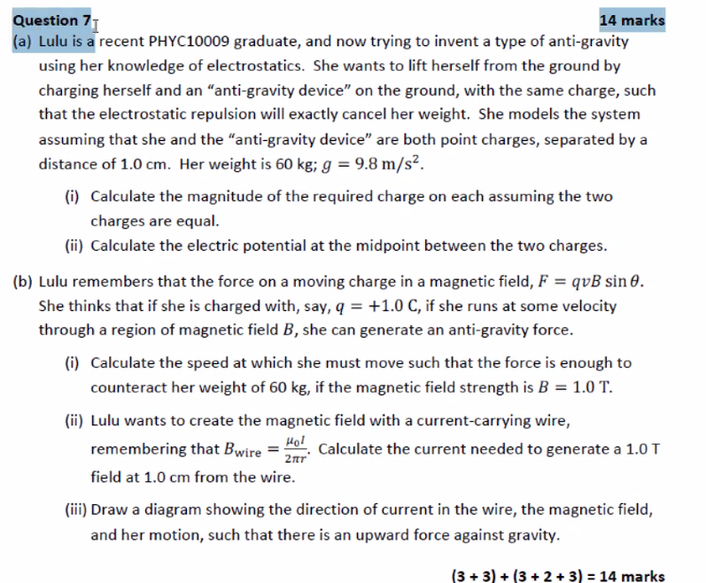

i) $±2.57×10^{6}C$