Installation guide for Selenium (Chrome Browser)

For more information, please go to <https://selenium-python.readthedocs.io/installation.html>

**Step 1: Install selenium**

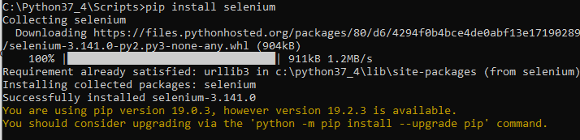

**Step 2: Download the driver for the browser (e.g. Chrome)**

1. Check the version of your chrome

Open a Google Chrome browser and type **chrome://settings/help**

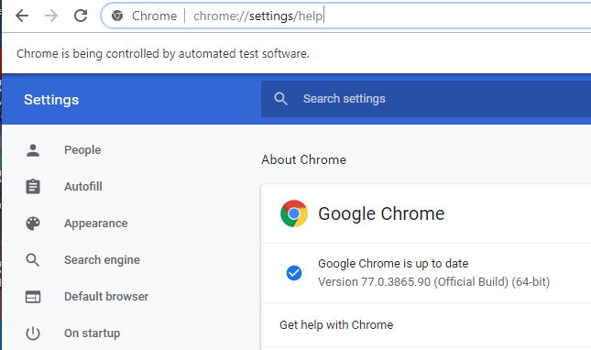

1. Depending on your installed version (e.g. the version of the above Google Chrome is version 77), go to the link <https://sites.google.com/a/chromium.org/chromedriver/downloads> and download the same version.

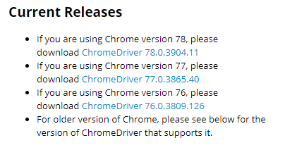

1. From Wing Personal IDE, find out what is the system path.

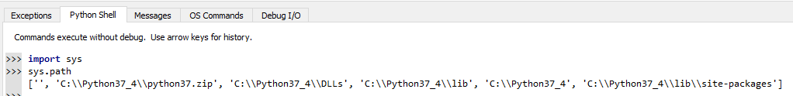

1. Uncompressed and placed the downloaded Chrome driver (e.g. chromedriver.exe) in one of the system path (e.g. C:\\Python37_4).