**Authentication Protocol**

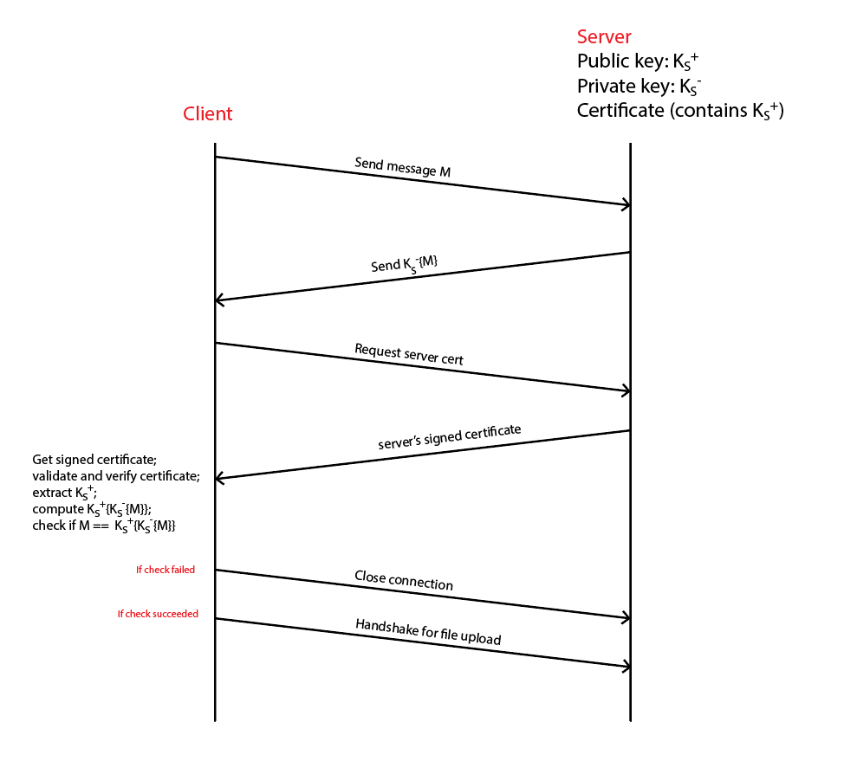

**Confidentiality Protocol 1**

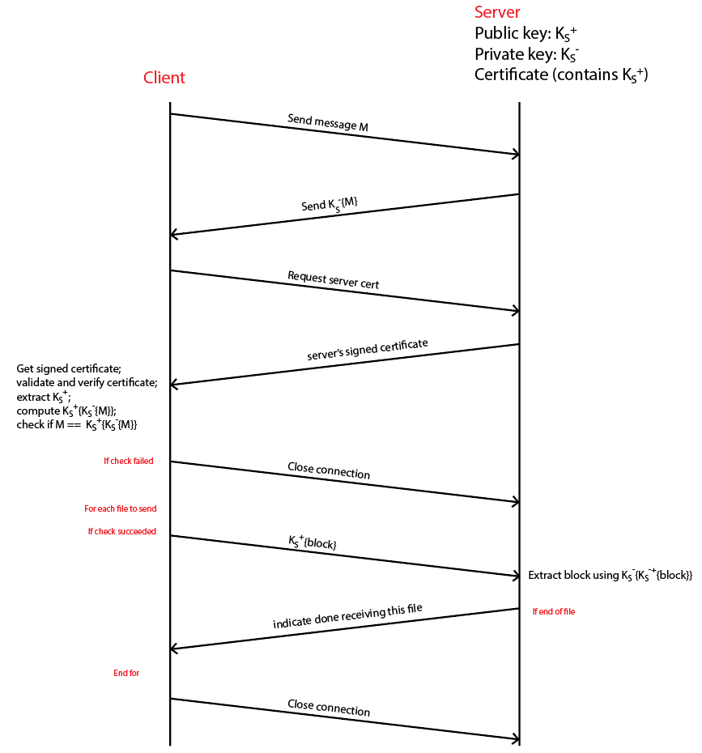

**Confidentiality Protocol 2**