C语言综合研究与高强度程序训练报告8

研究过程
- 定义一个描述学生成绩的数据类型
struct stu {
unsigned char c;
unsigned char os;
unsigned char masm;
unsigned char java;

struct stu far* next;
};

struct stu型数据的前四个数据项存储学生的几门课程的成绩；数据项next存储下一个学生成绩的地址。
2) 定义一个数组；struct stu a[375];
3) 将内存0:0处的3000个数据当作375个struct stu型的数据，将它们的c、os、masm、java数据项的内容拷贝到数组a的对应数据项中。
4) 查看数组a中课程成绩总分小于400大于200的数据，用next数据项将它们连接起来。
5) 将连接起来的数据打印出来。
struct stu {
unsigned char c;
unsigned char os;
unsigned char masm;
unsigned char java;

struct stu far* next;
};

struct stu a[375];
int scoreSum[375];
int index[375];

main(){

int i;
int count = 0;
int step = 0;
int id = 0; /* for index array*/

/*copy for init*/
for(i = 0; i < 375; i++){
a[i].c = *(unsigned char far*)(0x0 + step + 0);
a[i].os = *(unsigned char far*)(0x0 + step + 1);
a[i].masm = *(unsigned char far*)(0x0 + step + 2);
a[i].java = *(unsigned char far*)(0x0 + step + 3);

step += 8;
}

/* select the corresponding data by the condition */
for(i = 0; i < 375; i++){
scoreSum[i] = a[i].c + a[i].os + a[i].masm + a[i].java;
if(200 < scoreSum[i] && scoreSum[i] < 400) {
index[count] = i;
count++;
}
}

/* connect*/
for(i = 0; i < count; i++){
a[index[i]].next = (struct stu far*)(&a[index[i + 1]]);
}

/*print the data*/
printf("The contend of index array : \n");
id = index[0];
for(i = 0; i < count; i++){
printf("%d ", id);
if(i != (count - 1)) {
printf("--> ");
}
id = index[i + 1];
}
}
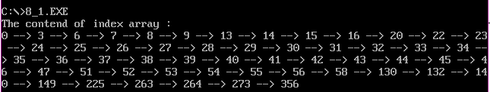

修改后:
struct stu {
unsigned char c;
unsigned char os;
unsigned char masm;
unsigned char java;

struct stu far* next;
};

struct stu a[375];
int scoreSum[375];
int index[375];

main(){

int i;
int count = 0;
int step = 0;
int id = 0; /* for index array*/

/*copy for init*/
for(i = 0; i < 375; i++){
a[i].c = *(unsigned char far*)(0x0 + step + 0);
a[i].os = *(unsigned char far*)(0x0 + step + 1);
a[i].masm = *(unsigned char far*)(0x0 + step + 2);
a[i].java = *(unsigned char far*)(0x0 + step + 3);

step += 8;
}

/* select the corresponding data by the condition */
for(i = 0; i < 375; i++){
scoreSum[i] = a[i].c + a[i].os + a[i].masm + a[i].java;
if(200 < scoreSum[i] && scoreSum[i] < 400) {
index[count] = i;
count++;
}
}

/* connect*/
for(i = 0; i < count; i++){
a[index[i]].next = (struct stu far*)(&a[index[i + 1]]);
}

/*print the data*/
printf("The contend of index array : \n");
id = index[0];

for(i = 0; i < count; i++){
printf("id = %d \n", id);
printf("current --> %lx\n", (char far *)(a[index[i]].next));
printf("id.c = %u id.os = %u id.masm = %u id.java = %u \n", a[id].c, a[id].os, a[id].masm, a[id].java);
printf("next --> %lx\n", (char far *)(a[index[i + 1]].next));
printf("----------------------\n");
id = index[i + 1];
}

}

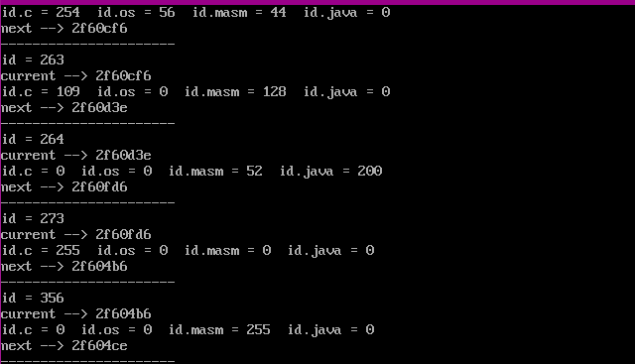

思考并解决的问题

三、思考未解决的问题

四、研究体会

