f
THE ASSOCIATION OF CLIMATE, SOCIOECONOMIC FACTORS AND RECENT INCIDENCE ON THE CYCLICAL DENGUE EPIDEMIC IN THAILAND, 2013

by
Pantila Taweewigyakarn
MD, Chulalongkorn University, Thailand, 2011

Submitted to the Graduate Faculty of
Graduate School of Public Health in partial fulfillment
of the requirements for the degree of
Master of Public Health

University of Pittsburgh
2017

UNIVERSITY OF PITTSBURGH
GRADUATE SCHOOL OF PUBLIC HEALTH

This essay is submitted
by
Pantila Taweewigyakarn
on

June 21, 2017
and approved by

Essay Advisor:
Evelyn O. Talbott, DrPH, MPH _________________________________
Professor
Epidemiology
Graduate School of Public Health
University of Pittsburgh

Essay Reader:
Martha Ann Terry, PhD _________________________________
Associate Professor
Behavioral and Community Health Sciences
Graduate School of Public Health
University of Pittsburgh

Copyright © by Pantila Taweewigyakarn
2017
ABSTRACT
Evelyn O. Talbott, DrPH, MPH
THE ASSOCIATION OF CLIMATE, SOCIOECONOMIC FACTORS AND RECENT INCIDENCE ON THE CYCLICAL DENGUE EPIDEMIC IN THAILAND, 2013

Pantila Taweewigyakarn, MPH
University of Pittsburgh, 2017

In 2013, Thailand experienced a cyclical dengue epidemic which caused the highest incidence compared to the previous six years. Since targeting the areas at risk of the next dengue epidemic is of public health relevance, we demonstrate potential factors that affected the provincial dengue incidence during that period. We collected data on dengue incidence in 77 provinces and determined the association between dengue incidence and independent variables including temperature, relative humidity, rainfall, rain days, average household income, average years of school education, urban area rates, and percentage of access to tap water. We also adjusted for the previous dengue incidence between 2009 and 2012. Spatial regression analysis revealed that the number of total rain days during the rainy season was positively associated with dengue incidence. The incidence rates in 2010 and 2012 were also of borderline significance. None of the socioeconomic factors was significant. The subgroup analysis among children under age 15 showed similar results. Additional analyses on the non-dengue seasons showed the incidence during January to April was associated with the incidence in 2012, while the incidence during October to December was associated with the urban area rates. Moreover, we found the serotype switching from DENV1 and DENV2 to DENV3 in 2013. Based on our findings, the provinces with more rain days tend to have higher dengue incidence, especially if they had high dengue incidence in the last cyclical epidemic. We recommend that those provinces should prepare for the next dengue cyclical epidemic by strengthening dengue control measures prior to and during the rainy season.

TABLE OF CONTENTS
preface xii
1.0 Introduction 1
2.0 Background 2
2.1 Dengue disease overview 2
2.1.1 Signs, Symptoms and Diagnostic tests 2
2.1.2 Dengue Treatment 5
2.1.3 Dengue prevention and control 6
2.1.3.1 Mosquito control 6
2.1.3.2 Prevention of Human Exposure 7
2.1.3.3 Dengue Vaccine 8
2.2 Dengue Epidemiology 8
2.2.1 The infectious agent and modes of transmission 8
2.2.2 Global Dengue distribution 9
2.2.3 Dengue situation in Thailand 11
2.3 Factors influencing Dengue Incidence 12
2.3.1 Host factors 12
2.3.2 Agent (viral) factors 13
2.3.3 Environmental factors 13
2.3.3.1 Vector 13
2.3.3.2 Climate factors 15
2.3.3.3 Socioeconomic factors 16
2.3.3.4 Ecological factors 17
2.4 Previous studies on climate and socioeconomic factors on dengue incidence in Thailand 18
2.5 Summary 20
3.0 Objectives 22
4.0 Methods 23
4.1 Data collection 23
4.1.1 The dependent variable 23
4.1.2 Independent variables 24
4.1.2.1 Climate factors 24
4.1.2.2 Socioeconomic factors 24
4.1.3 Previous dengue incidence rates 25
4.2 Descriptive study and Data prediction 25
4.3 Analytic study 25
4.3.1 Univariate analysis 25
4.3.2 Multivariate analysis 26
4.3.3 Spatial Analysis 26
4.4 Summary 26
5.0 Results 28
5.1 Descriptive study Results 28
5.1.1 Dengue incidence in Thailand, May to September 2013 28
5.1.2 Climate factors during May to September 2013 31
5.1.3 Socioeconomic and ecologic factors distribution, 2013 33
5.1.4 Previous incidence rates during 2009 -2012 34
5.2 Analytic study results 38
5.2.1 Univariate analysis 38
5.2.2 Multivariate analysis 38
5.2.3 Spatial Analysis 39
5.3 Subgroup analysis results: children under 15 43
5.4 Additional analysis results: the non-rainy seasons 47
5.4.1 January to April 2013 47
5.4.2 October to December 2013 47
5.5 Summary 48
6.0 Discussion 49
7.0 Conclusion and Recommendations 55
Appendix A: DENGUE CRUDE AND AGE-SPECIFIC INCIDENCE rates, THAILAND, 2013 by province 56
Appendix B: SUMMARY OF CLIMATE DATA FROM MAY TO SEPTEMBER 2013 BY REGION 60
Appendix C: summary of socioeconomic data, 2013 by region 63
bibliography 66
List of tables
Table 1. Age-specific dengue incidence rate, Thailand, May-September 2013 29
Table 2. Dengue incidence rates by region, Thailand, May-September 2013 29
Table 3. Climate factors across 65 provinces with available weather stations, May-September 2013 by month 31
Table 4. Summary of climate factors across 65 provinces in Thailand during May- September 2013 33
Table 5. Summary of socioeconomic factors, Thailand during May- September 2013 34
Table 6. Univariate analysis between ln(dengue incidence) and independent factors 40
Table 7. Multivariate analysis between ln(dengue incidence) and the independent factors 41
Table 8. Spatial regression analysis between ln(dengue incidence) and the independent factors. 43
Table 9. Univariate analysis between ln(dengue incidence) among children under 15 and the independent factors 45
Table 10. Multivariate analysis between ln(dengue incidence) among children under 15 and the independent factors. 46
Table 11. Spatial analysis between ln(dengue incidence) among children under 15 and the independent factors. 46
Table 12. Average temperature (°C) from May to September 2013 by region 60
Table 13. Average relative humidity (%) from May to September 2013 by region 61
Table 14. Total rainfall (mm) from May to September 2013 by region 61
Table 15. Total rain days (days) from May to September 2013 by region 62
Table 16. Average monthly household income, Thailand 2013 by region 63
Table 17. Average years of school education, Thailand 2013 by region 64
Table 18. Average urban area rates, Thailand 2013 by region 64
Table 19. Median proportion of access to tap water, Thailand 2013 by region 65
List of figures
Figure 1. The number of dengue cases by month, Thailand 2013 29
Figure 2. Geographical distribution of dengue crude incidence by province, Thailand, May-September 2013 30
Figure 3. Geographical distribution of average temperature, average relative humidity, total rainfall, and total rain days by province, Thailand, May to September 2013 32
Figure 4. Geographical distribution of average household income, average years of school education, urban area rates and access to tap water rates by province, Thailand, 2013 36
Figure 5. Geographical distribution of dengue crude incidence rates by province, Thailand, 2009-2012 37
Figure 6. Univariate Moran’s I demonstrating spatial autocorrelation of ln(dengue incidence), Thailand, 2013 41
Figure 7. The LISA (Local Indicators of spatial Spatial Association) cluster map and significance map demonstrating the spatial effect on ln(dengue incidence) in Thailand, 2013 42

preface
Foremost, I would like to express my deepest gratitude to my essay advisor, Dr. Evelyn O. Talbott, DrPH, MPH, Department of Epidemiology, Graduate School of Public Health, University of Pittsburgh, who is also my academic advisor, for her continuous support during my MPH study. She demonstrates the way an epidemiologist thinks, and her advice helps guide my research into the right direction. In addition, I would like to acknowledge Dr. Martha A. Terry, PhD, Department of Behavioral and Community Health Science, Graduate School of Public Health, University of Pittsburgh as the second reader of this essay for her valuable comments on this essay.
Also, I would like to thank Bureau of Epidemiology, Department of Disease Control, Thailand and Dr. Bhophkrit Bhopdhornangkul,MD, MPH, Phramongkutklao College of Medicine, Thailand for providing the data used in this research.
I would like to express my great appreciation to all of my proofreaders: Melissa Yang, the writing center, University of Pittsburgh, John Cenedella, and Matthew Madruga for their supports throughout the process of writing this essay.
Finally, I must express my heartfelt thanks to my family and friends for their endless encouragements.

Introduction
The World Health Organization (WHO) has listed dengue as one of the 17 neglected tropical diseases (NTDs) with worldwide distribution of over three million cases and three thousand deaths (World Health Organization [WHO], 2017). The NTDs are a group of diseases that are widely spread in tropical and subtropical areas e.g. Chagas disease, Leishmaniasis, Leprosy, and Rabies. The majority of affected populations are impoverished. Endemic areas also share common characteristics including a lack of adequate sanitation and hygiene practices, frequent exposure to infectious vectors and animals that can be potential disease carriers (WHO, 2017). Impacts on health and economy have been observed in those endemic regions (Shepard, Undurraga, & Halasa, 2013).
Dengue disease has been an important communicable disease in Thailand for more than 60 years (Hammon, 1973). Starting from a localized outbreak in the capital of the country, dengue did spread throughout the country within 30 years. Therefore, dengue has become a priority disease in every province due to its high morbidity rate, especially among children. Although dengue is endemic in the country, big epidemics of dengue occur every two to five years. In this study, we demonstrate potential factors including climate and socioeconomic factors that affected the provincial dengue incidence in the year 2013, which was the latest cyclical epidemic of dengue in Thailand.

Background

Dengue disease overview

Signs, Symptoms and Diagnostic tests
Dengue is a mosquito-borne, acute febrile hemorrhagic disease caused by dengue virus. Asymptomatic dengue infection was estimated to be 50 to 90% (Kyle & Haris, 2008). In 1997, dengue disease was divided into three forms: dengue fever, dengue hemorrhagic fever, and dengue shock syndrome.
Dengue fever (DF) is characterized by an acute onset of fever, which may last for two to seven days. It can be accompanied by headache, myalgia, arthralgia, nausea and vomiting, rash, and bleeding. Dengue fever is usually mild and self-limited. However, some patients may have major bleeding, which is differentiated from dengue hemorrhagic fever. Physical examination may reveal lymphadenopathy. Leucopenia with relative lymphocytosis and mild thrombocytopenia can be found from a laboratory investigation. Elevated transaminase, reflecting liver involvement, is not frequent. There are two ways to confirm the presence of dengue infection: detection of dengue virus in blood or serum during early symptomatic phase (within five days after onset) or detection of specific antibody activation during convalescent phase (six days or more after onset). Viral detection can be performed by viral culture and isolation, molecular techniques (e.g. RT-PCR) to detect specific dengue viral genomes, and immunofluorescence methods to detect dengue viral antigens. Testing specific antibodies to dengue can confirm dengue infection from two types of results. One is dengue IgM seroconversion from negative to positive. The other is the four-fold increase in dengue IgG in serum specimens collected at the convalescence phase compared to the acute phase (Heymann, 2009). The overall case fatality dengue fever is less than 1% (Shepherd, Hinfey, Shoff, & Bronze, 2015).
Dengue Hemorrhagic fever (DHF) is more severe than dengue fever. In 1997, WHO proposed a clinical case definition of DHF as follows:
The following symptoms must all be present
- Fever, or history of acute fever, lasting 2–7 days, occasionally biphasic.
- Haemorrhagic tendencies, evidenced by at least one of the following:
  - petechiae, ecchymoses or purpura
  - bleeding from the mucosa
  - haematemesis or melaena.
- Thrombocytopenia (100,000 cell per mm³ or less)
- Evidence of plasma leakage due to increased vascular permeability, manifested by at least one of the following:
  - a rise in the haematocrit equal to or greater than 20% above average for age, sex and population;
  - a drop in the haematocrit following volume-replacement treatment equal to or greater than 20% of baseline;
  - Signs of plasma leakage such as pleural effusion, ascites and hypo- proteinaemia (WHO, 1997, p.19).
Hence, the key symptom of DHF that helps distinguish DHF from DF is plasma leakage. Under proper treatment, the case fatality of DHF was 2 to 5%. On the other hand, the case fatality could reach 50% if left untreated. Approximately 20 to 30% of DHF patients develop dengue shock syndrome (DSS) (Shepherd et al., 2015).
Dengue shock syndrome (DSS) is the most severe form of dengue infection. It involves symptoms and signs of circulatory failure. The definition of DSS (WHO, 1997) is
All of the above four criteria for DHF must be present, plus evidence of circulatory failure manifested by:
- Rapid and weak pulse, and
- Narrow pulse pressure (< 20 mmHg (2.7 kPa) )
or manifested by:
- Hypotension for age, and
- Cold, clammy skin and restlessness (WHO, 1997, p.20).
The case fatality rate of DHF varied from 12% to 44% across different countries (Shepherd et al., 2015).
The WHO 1997 criteria were quite strict and there were rising numbers of severe dengue which did not meet the strict criteria. Thus, in 2012, the WHO proposed a new classification of dengue. In this new classification, dengue is categorized into three forms: dengue without warning signs, dengue with warning signs, and severe dengue.
Dengue cases in the new criteria include laboratory-confirmed dengue and probable dengue. The probable dengue case is characterized by a patient having a fever with two of following symptoms: nausea and vomiting, rash, aches and pain, positive tourniquet test, and leucopenia. The warning signs include abdominal pain or tenderness, persistent vomiting, clinical fluid accumulation, mucosal bleed, lethargy and restlessness, liver enlargement > 2 cm, and an increase in hematocrit concurrent with a rapid decrease of platelet count. If patients have these warning signs and symptoms, they should be under close observation and may require medical intervention.
Severe dengue is characterized by the patient having severe plasma leakage leading to shock and fluid accumulation with respiratory distress, severe bleeding, and severe organ involvement, e.g. liver (transaminase enzyme ≥ 1000 unit), impaired consciousness, and other organ involvement (WHO, 2012).

Antibody-Dependence Enhancement: an explanation of severe dengue
The exact pathogenesis of developing severe dengue is not clearly understood. Recent studies show the disease severity is associated with the serotype of dengue virus and secondary infection through an antibody-dependent enhancement process (ADE) (Guzman, Alvarez & Halstead, 2013). Normally, after primary infection, the body produces a specific IgG antibody against the infected serotype of dengue, and this can protect against the same type of dengue infection for a long period. Neutralization will occur if the level of antibody to bind the virus is higher than a certain threshold. However, if the level of antibody is less than the threshold, the residual antibody will form an antibody-virus complex and facilitate infection and viral replication. The study also shows that the antibody produced after primary infection has cross-reactions to other dengue types; however, the affinity to bind to the virus is not enough to result in neutralization. Thus, the secondary infection by other types of dengue virus is likely to have an ADE and results in severe dengue.
Even though secondary infection is associated with severe dengue, there is little knowledge about the tertiary and quaternary infection. However, the severe form of dengue was not expected. One study conducted in Thailand estimated a very low percentage (0.08-0.8%) of dengue hospitalizations due to the tertiary and quaternary infections (Gibbons et al., 2007). This could be because the antibody from the first two infections might provide adequate immunity to neutralize the virus in the subsequent infections (Bhoomiboonchoo et al., 2015).

Dengue Treatment
There is no specific treatment for dengue. Symptomatic and supportive treatments include Non-NSAID (NSAIDs: Non-Steriodal Anti-Inflammatory Drug) antipyretics, adequate fluids and electrolytes. Transfusions of blood components e.g. packed red cells, fresh frozen plasma, and platelets are used if needed, especially for patients who have massive bleeding and shock.

Dengue prevention and control

Mosquito control
Mosquito control has been the main method of preventing dengue from the past to the present. The targets of mosquito control include both adults and larvae. The main method for adult mosquito control is insecticide spraying. Many types of insecticides are used to control dengue. Initially, in the 1940s an organochlorine compound (dichrolo-diphentyl-trichrolo ethane: DDT) was used. Due to DDT’s environmental toxicity and bioaccumulation property, it was banned in the 1960s and replaced by organophosphate (temephos, malathion, chlorpyrifos, etc.) and carbamate compounds (propoxur, bendiocarb). Although organophosphates and carbamates are less toxic to the environment compared to organochlorine compounds like DDT, they are still harmful to humans. Some of the organophosphate compounds, e.g. temephos, have been used up to the present time.
In the 1980s, pyrethroids compounds such as deltamethrin, permethrin, and cypermethrin were introduced. They are highly toxic to mosquitoes, but have low toxicity for mammals. Due to the selective property of pyrethroids, they have become more popular and replace organophosphate compounds in some countries. Nonetheless, many recent studies show an increasing trend of insecticide resistance to organophosphate, carbamate, and pyrethroids from different parts of the world (Manjarres-Suarez & Verbel, 2013). In fact, the effectiveness of insecticide spraying is difficult to determine. Many studies on the effectiveness did not take into account potential confounding factors and the results were inconclusive (Bouzid, Brainard, Hooper & Hunter, 2016).
In addition to adult mosquitoes, mosquito larvae are also another target for vector control. There are many methods to destroy larvae and prevent them from becoming adult mosquitoes, which are the disease carriers. The first one is physical intervention, such as removal of water from discarded containers and regular cleaning of storage water containers. For some types of storage containers from which water cannot be removed, a chemical substance called temephos sand granules (ABATE) can be put in the water containers to destroy mosquito larvae. The recommended dose of temephos in drinking water is 1 mg/L. The observed lethal dose (LD50) in animals including rats, mice, dogs, and cats were high (Temephos, 1993).
A study in humans showed no acute toxicity in humans ingesting temephos 256 mg/day for five days and no chronic toxicity in human ingesting temephos 64 mg/day for four weeks (Gosserin, Smith, & Hodge., 1984). If humans drink two to three liters of water a day, they should orally receive two to three mg/day of temephos. Thus, acute toxicity does not occur with normal use. Additionally, the No Observed Adverse Effect Level (NOAEL) of temephos for human chronic exposure is 2.3 mg/kg per day (WHO, 2009) and there is no evidence of chronic toxicity of temephos involving reproductive or carcinogenic effects (United States Environmental Protection Agency [US EPA], 2016). Therefore, temephos is considered safe. The last method to eliminate mosquito larva is the biological approach. Effective species known for larvicidal purposes are lavivorous fish e.g. Gambusia affinis and copepods (Macrocyclops albidus), a type of freshwater crustacean. This method is appropriate for outdoor standing water containers like fish ponds and flower ponds.

Prevention of Human Exposure
Wearing garments covering the entire legs and long-sleeved clothes is generally recommended to prevent mosquito bites. Some travel clothes are coated with insecticides e.g. permethrin. Wearing insecticide-coated clothes can reduce the rate of mosquito bites by 50% if partially covered and up to 90% if fully covered (Orsborne et al., 2016). However, these clothes may not be suitable for the climate, which is typically hot and wet in the tropics. In addition to clothes, skin repellant is another option. The recommended skin repellant is 20 to 30% DEET (N,N-diethyl-m-toluamide). Although dengue mosquitoes bite during daytime, bed nets with or without insecticide coating are also helpful especially for children who usually sleep during the day.

Dengue Vaccine
The latest available methods for dengue control include a dengue vaccine. After over 20 years of study, Dengvaxia, the first tetravalent dengue vaccine was approved by the WHO in April 2016. The vaccine is live-attenuated and requires three injections with the interval of six months apart. It comprises four serotypes of dengue virus. Based on a study in Latin America, the overall vaccine efficacy is 58.7-69.8%. The vaccine could reduce hospitalization by 80% and reduced severe hospitalizations by 90% (Villar et al., 2015). However, the protection against each serotype is different, i.e. 58.4%, 47.1%, 73.6%, and 83.2% for DENV1, DENV2, DENV3, and DENV4, respectively (Hadinegoro et al., 2015). A reduction in hospitalizations was observed only among children nine years old and older, while the hospitalization rate was higher among children under nine years old (Relative risk = 1.58). Thus, the vaccine is currently recommended only for people aged nine to 45-years-old who live in endemic areas (seroprevalence ≥50% at 9 years) (WHO, 2016).

Dengue Epidemiology

The infectious agent and modes of transmission
There are four types of dengue viruses: type 1, 2, 3, and 4. All types can cause DHF and DSS. To cause DHF and DSS, type 2 and 4 need to be secondary infections while type 1 and 3 can cause the severe disease with the initial infection. Humans and monkeys are known as reservoirs. The incubation period of dengue is five to 10 days. The infectious period is during the febrile phase.
The virus is carried by the Aedes mosquito, mainly Aedes Aegypti. When an infective mosquito bites a human, it releases the virus from its salivary glands into the human blood system. This is the most common way of dengue transmission. However, dengue can also be transmitted through blood-borne mechanisms, such as blood transfusions (Sabino et al., 2016), needle stick injuries (Langgartner, Audebert, Scholmerich, & Gluck 2002; Lee et al., 2016), or even mucosal contact with infected blood (Wilder-Smith, 2012).

Global Dengue distribution

Populations
In 1990, fewer than 500,000 cases were reported to the WHO. Only 25 years later, in 2015, more than 3,000,000 cases were reported globally. This increase might be due to the disease transmission itself or other factors including an increase in population, improvement of surveillance systems, and changes in the case definitions. Since the symptoms of dengue have a very wide range, asymptomatic infections and clinically mild symptoms are probably underreported. The WHO estimates that 50-100 million people are infected annually worldwide. Of this number, over 20,000 died (WHO, 2017). Dengue is most prevalent among children under 15. While there is no gender preference in dengue infection, female children are at higher risk of severe manifestation compared to males at the same age. In addition, a recent study also shows the shifting trend of contracting dengue toward early adults (Limkittikul, Brett, & L’Azou, 2014).

Places
Dengue is endemic in tropic zones including South East Asia, South Asia, Africa, Central America, the northern part of South America, and the southern part of North America. The countries around the equator line tend to have higher dengue incidence rates compared to the subtropic region because the tropical climate is suitable for Aedes mosquitoes’s breeding and survival. There are an estimated 3.9 billion people living in dengue endemic areas throughout the world (WHO, n.d.).
Since 1999, there has been an increasing number of studies reporting imported dengue cases in subtropical regions including Europe, some parts of the USA, and Australia, especially from returning travelers. In some circumstances, the disease also spreads locally and results in locally-acquired cases or become autochthonous if the vectors are present in the area. This global spreading was a result of global transportation, the presence of capable vectors in the regions, and the absence of dengue protective immunity in some populations (Wilder-Smith, 2012).

Time
Dengue has a seasonal pattern. The number of patients usually rises during the rainy season especially in Asia, the Caribbean, and South America. The relationship between the rainy season and dengue incidence in Central America and Africa is not clear (Wilder-Smith, 2012). Apart from the seasonal pattern, the cycle of very large dengue epidemics can be observed every two to five years among Asian countries like Thailand, Laos, Cambodia, Myanmar, and Malaysia (Heymann, 2009).

Dengue situation in Thailand
Thailand is one of the countries with endemic dengue. Dengue cases can be found throughout the year all over the country; however, the typical dengue season is during the rainy season, from May to September of every year. Cyclical dengue epidemics in Thailand tend to occur every two to three years. The cycle is fast when compared to other Asian countries. Each year, approximately 100,000 dengue cases are reported to the national communicable disease surveillance system (The R506 surveillance system). For instance, in the year 2010, 116,947 cases were reported to the system, and the dengue mortality rate was 0.22 per 100,000 (Bureau of Epidemiology Thailand, 2010).
The highest incidence rate occurs among children under age 15 and the case fatality rate was the highest among children. A recent study also revealed shifting in age group toward adults (Limkittikul et al., 2014). In 1980, the study showed 96% of 11-year-old children had antibodies against at least one serotype of dengue virus, and almost 80% out of this population had antibodies against at least two serotypes of virus. In 2010, the serology survey taken at the same place revealed only 65% of 11-year-old children had antibodies against at least one serotype of dengue virus. Moreover, the 2010 survey demonstrated that only 82% of 18-year-old population had antibodies against at least one type of dengue virus (Rodríguez-Barraquer et al., 2014). The findings suggest an increase in the proportion of adults who do not have immunity against dengue, and this explains the shifting trend of dengue infecting adult populations.

Factors influencing Dengue Incidence

Host factors
A number of host factors are related to dengue infection and developing severe dengue, including age, gender, race, immunity, genetic factors, and underlying disease presence.
Age – Children are the most affected population. This is mainly due to a lack of immunity, risky behaviors, and less use of protective equipment.
Gender – Although males and females have equal risk of infection, severe manifestation occurs among female children more frequently than males. This might be due to higher immunity response and higher vascular permeability among girls. There is no difference of infection rates and severity between the two genders among adult populations (WHO, 2007).
Race – Black populations have less severe dengue infection than white populations (Rodenhuis-zybert, Wilschut, & Smit, 2010). The cellular response to the dengue virus, which stimulates cytokines and inflammation response, is stronger among the white populations than the black populations. Dengue outbreaks in the African continent usually present mild clinical symptoms (Sierra, Kouri & Guzman, 2007).
Immunity – Immunity plays a major role in dengue; however, the role is quite complex. Post-infection immunity against one serotype can protect humans from that particular serotype for a long period. However, in case of secondary infection by another dengue serotype, immunity could help facilitate the dengue virus to attack cells. As a consequence, the patient is likely to have severe manifestations. Nonetheless, the tertiary and quaternary infections are less likely to be severe when compared to the secondary infection because the immunity from the first two infections might be able to neutralize the virus in the subsequent infections (Gibbons et al., 2007).
Genetic factors – Specific human leukocyte antigen (HLA) genes and non-HLA genes play a role in dengue susceptibility. For example, some HLA types including HLA class I and class II are associated with severe disease, while HLA B-13, B-14 and B-29 are protective (Rodenhuis-Zybert et al., 2010).
Underlying diseases – Some diseases may increase severity of dengue; for example, patients with G6PD deficiency are more likely to develop DHF since the viral replication is higher than those without the disease (Rodenhuis-zybert et al., 2010).

Agent (viral) factors
The severity of dengue infection is related to the type of dengue virus. DENV1 is likely to produce mild symptoms. DENV3 may produce the greatest number of severe infection during the primary infection. DENV2 and DENV4 are associated with severe symptoms like hepatitis, major organ bleeding, and dengue shock syndrome (Heymann, 2009). However, the place of origin of the dengue virus may be also related to the virulence. The WHO suggested that the “Asian” genotypes of DENV2 and DENV3 are associated with severe manifestations in the secondary infection (WHO, 2017). In addition, an introduction or a re-introduction of a new serotype into a place where people do not have prior protective immunity can result in a dengue epidemic.

Environmental factors

Vector
Aedes mosquitoes are the main vector for dengue transmission. Two types of Aedes mosquitoes carry the dengue virus, Aedes Aegypti and Aedes Albopictus. A. Aegypti is thought to be responsible for dengue epidemics in urban settings around the world (Kyle & Haris, 2008). Although A. Albopictus can also carry the virus, the species is less anthropophilic. Thus, A. Albopictus is less likely to cause an outbreak.
A. Aegypti is usually found in urban communities because its habitat is usually people’s houses that are moist and dark, and it prefers to live indoors. It bites during daytime. Only the female A. Aegypti bites humans since it needs blood for laying eggs. It often bites more than one person during the blood feeding period. The life span of a female A. Aegypti is around four to six weeks. With these habits, one mosquito can spread the disease to several people and cause an outbreak. The female mosquito lays eggs in clear, standing water. However, it does not need to be clean. Therefore, water containers around residences, e.g. jars, unused or discarded bowls or glasses, and discarded tires, are good breeding sites for the mosquitoes. After being laid, the eggs will hatch in one to two days, or longer in unfavorable environments. After that, the larva stage will last seven to 10 days before turning into the pupa stage. The pupa stage lasts for one to two days, and then, a pupae becomes an adult mosquito. Overall, it usually takes nine to 14 days for an egg to develop into an adult. Once a mosquito bites an infected host who has viremia, the dengue virus from the host will pass through the mosquito’s gut and finally lodge in its salivary glands. At this time, the mosquito becomes infective to another host. We call the period from getting the virus until the virus is present in the salivary glands the external incubation period (EIP).
Entomological data were used to predict dengue incidence in several studies, but the results were inconsistent. Abundance of larvae should not be used as a predictor for dengue incidence because it was not significantly correlated. Adult mosquito survey is more correlated to the incidence; however, the information rarely exists since this type of study is not feasible and expensive (Loius et al., 2014).

Climate factors

Temperature
Temperature has a complex effect on dengue transmission. First, a high ambient temperature increases viral replication inside the vector. It also shortens the EIP and accelerates disease spreading. Secondly, temperature has an effect on vector development and behavior. High temperature shortens the process of egg hatching, pupation, becoming an adult, and blood feeding (biting humans). However, both effects on the virus and the vector require the optimal temperature ranges. Too high or too low temperatures will decrease vector and viral activities. For example, at the temperatures below 15°C and above 36°C, mosquitoes will stop blood feeding.
A previous study showed different optimal ranges of temperature for the various activities of vectors. Survival rates of vectors and development to an adult are highest at 26°C compared to at 25°C and 30°C. Blood feeding rate is the highest at 26°C, and decreases when the temperature increases. The EIP is getting shorter when temperatures get beyond 27°C (Morin, Comrie, & Ernst, 2013). Apart from the effects on the vector and the virus, higher temperature usually facilitates evaporation, which results in a declined number of breeding sites. Thus, the effect of temperature on dengue transmission is very complicated because almost every process of the vector reproduction and the viral replication is maximized by different temperatures. Even though it is hard to determine the best temperature for the vectors to transmit the disease because of the complex roles of the temperature on the vectors’ activities, a recent review suggested that the maximum dengue transmission occurs at 26-29°C (Mordecai et al., 2017).

Humidity
An impact of relative humidity occurs when eggs emerge, right before the aquatic stage. Although the relative humidity was found to be negatively associated with the size of adult Aedes mosquitoes, the relationship between the mosquito size and dengue transmission is still inconclusive (Vargas, Ya-umphan, Phumala-morales, Komalamisra, & Dujardin, 2014).

Rainfall
Rainfall has an effect on vector distribution since higher rainfall increases numbers of breeding sites. A previous study showed that in the times of frequent rainfall e.g. La Niňa, the areas in which mosquitoes were found were wider than during the drier period (Morin et al., 2013).
Lack of rainfall may not always result in the absence of dengue cases. One study shows that during the dry season, people are more likely to store water in their houses. Thus, mosquitoes still have indoor breeding sites for their reproduction (Wai et al., 2012).

Socioeconomic factors

Poverty
There have been several studies on an international scale indicating that dengue incidence is prevalent in developing countries, leading to the establishment of the NTDs program to eliminate the priority neglected tropical diseases in the regions at risk (Mulligan, Dixon, Sinn & Elliott, 2015). Previous studies on a smaller scale show weak positive associations between poverty and dengue incidence; however, some suggested insignificant associations (Mulligan et al., 2015).

Education
Education level has an inconclusive effect on dengue incidence. Some studies showed that higher education level was positively associated with an increasing number of dengue cases (Mulligan et al., 2015). However, Siqueira et al. (2004) demonstrated low education level as a risk factor.

Housing conditions
Since A. Aegyptii lives in humans’ houses, housing conditions can affect the vector’s reproduction and survival. Moreover, they facilitate a human-vector exposure. The presence of tap water or regular water supply may reduce the need for water storage containers. Installing window screens can help prevent mosquitoes from other places coming into a house. Spiegel et al. (2007) showed that poor housing was positively related to the dengue incidence. According to Mulligan et al.’s systematic review of 12 studies, five studies from Brazil and Vietnam did not demonstrate a significant effect of having a household regular water supply. On the other hand, household overcrowding and the absence of an air-conditioner could be potential risk factors (Mulligan et al., 2015). In addition, housing conditions can be related to the poverty level.

Ecological factors

Urban areas
It is generally accepted that dengue is more predominant in urban areas. However, the term “urban areas” has several definitions, so it is difficult to conclude which definition or measurement of “urban areas” should be related to dengue incidence. Previous studies revealed the different definitions used. For instance, the study in Taiwan created an “urban area” variable based on multiple aspects e.g. population density, residents’ occupation, the number of clinics, and median income. In another study in China, Qi et al. (2015) used streets, road density, and population density to indicate an urban area.
A study from Thailand showed a significant association between built-up areas and dengue incidence whereas no association between forest areas and dengue was observed (Nakhapakorn&Tripathi, 2005). Wu et al. (2008) suggested that a high level of urbanization was associated with dengue incidence in Taiwan taking into account climate factors and spatial correlation. Qi et al. (2015) also demonstrated the higher incidence of dengue in urban areas.
Although the comparison between studies in terms of urban areas is difficult due to the heterogeneity of the definitions, the previous studies usually suggested that the higher level of urban areas had higher dengue incidence when compared to lower ones. What makes dengue more prevalent in urban areas could be that the urban residential areas had higher population density.

Previous studies on climate and socioeconomic factors on dengue incidence in Thailand
Thailand is a country in South East Asia, located in the tropical region, at 15.87 ºN and 100 ºE. The country covers approximately 200,000 square miles. The first dengue case in Thailand was reported in 1949; after that, there were sporadic cases until the late 1970s. Since then, the disease has been widely spreading all over the country (Limkittikul et al., 2014). Even though the total population of Thailand ranks the fourth in South East Asia, the burden on economy and health due to dengue is the second in the region (Shepard et al., 2013).
Like other parts of the world, certain factors such as climate, socioeconomic, and ecological factors have been found to be associated with the dengue incidence in Thailand. Campbell et al. (2013) looked at 19-year data and revealed that the highest transmission occurred at the mean temperature around 28-30°C and the mean relative humidity was at 80%. They also reported that the disease transmission was sensitive to slight temperature changes. Nonetheless, this study did not support a strong association between rainfall and dengue incidence (Campbell, Lin, Iamsirithaworn, & Scott, 2013). Sensitivity to small changes in temperature was also observed in the study of climate factors and dengue outbreaks in Thailand by Parker and Holman (2012). They demonstrated a significant but extremely small effect of rainfall on the occurrence of dengue outbreaks. However, a study at the provincial level proposed a positive association between temperature, rainfall, and humidity and dengue incidence (Ninphanomchai, Chansang, Hii, & Rocklov, 2014). For an association between climate and dengue vectors, Scott et al. (2000) found that temperature was correlated with female mosquito abundance, while rainfall was not. In addition, female mosquito infection rates in the summer were important predictors of dengue incidence in the following rainy season (Siriyasatien, Phumee, Ongruk, Jampachaisri, & Kesorn, 2016).
In addition to climate, geography is also a significant factor. Altitude determines the vector distribution. A study in a province in Thailand demonstrated that Aedes mosquitoes were not found higher than 1,800 meters above sea level (Sarfraz et al., 2014). Moreover, geographical barriers seem to play a role on the viral serotype. Dengue virus serotypes circulating in Thailand are different from other strains circulating in South East Asia; this could be explained by natural country borders between Thailand and neighboring countries (Salje et al., 2017).
In Thailand, urban areas are positively associated with dengue transmission. Salje et al. (2017) revealed a great diversity of dengue virus serotypes in the high population density area, and people in the dense areas were at 10 times risk of dengue reinfection. High larva densities were also found to be associated with high population density areas (Sarfraz et al., 2014). A cross-sectional study in a province located in central Thailand demonstrated that the combined residential, commercial, and densely populated urban areas had the highest dengue transmission when compared to each of residential, commercial or densely populated urban areas alone. In addition, areas where there was high incidence of dengue in the past five years tended to have high dengue incidence in the following year (Koyadun et al., 2012). A multi-site study in two provinces showed household size and distance from a village to the nearest urban area were negatively associated with dengue incidence, suggesting the impact of urban areas on dengue transmission (Tipayamongkholgul & Lisakulruk, 2011).
Socioeconomic factors have been studied as well. People with higher levels of education and larger household size were positively associated with history of dengue infection while household income did not show statistical significance (Koyadun et al., 2012). Vannavong et al. (2017) studied the socio-demographic status of people and larva density in rural and suburban villages in Thailand. They found the level of income was positively associated with the proportion of larva density. They explained that the wealthy households were likely to have more water containers than the poor households (Vannavong et al, 2017).

Summary
Dengue is a mosquito-borne disease that have a wide range of clinical manifestations. Although the majority of the patients have mild clinical symptoms, severe forms of dengue can result in death if left untreated. Children are the most affected population. Dengue is endemic among tropical countries; however, there have been a number of imported dengue cases in subtropic areas.
Multiple factors affect dengue incidence. For host factors, immunity plays an important role in dengue infection. While the primary infection is usually mild or asymptomatic, the secondary infection is likely to be more severe due to an ADE process. Gender, underlying diseases and genetic factors are also related to host susceptibility to the disease. Moreover, different strains of the virus might have difference virulence.
Because dengue is mostly vector-borne, environmental factors are crucial for disease transmission. Climate factors, especially temperature, have a strong association with the disease incidence. Increases in temperature are associated with increasing vector reproductive and feeding activities as well as viral replication. Rainfall also increases the number of breeding sites. However, evidence for the effect of socioeconomic factors on dengue transmission is not as strong as the climate factors. Poverty and urban areas appear to be positively associated with the disease incidence, while educational level and housing conditions are still inconclusive.

Objectives
In the year 2013, the number of dengue cases in Thailand was the highest over the 10 year-period. Since the provincial dengue incidence in Thailand during the cyclical dengue epidemic in 2013 varied across the country, we hypothesize that the dengue incidence could be associated with the different environmental and socioeconomic factors as well as prior incidence of each province. Understanding these factors will guide decision and policy for disease prevention and control of the right target (Oxman, Lavis, Lewin, & Fretheim, 2009). Thus, we describe the distribution of dengue disease during this cyclical dengue epidemic as well as potential factors across Thailand and find an association between those factors and dengue incidence during that period.

Methods

Data collection

The dependent variable
We collected provincial level data on dengue incidence. We obtained the number of dengue cases during the calendar year 2013 from the National Communicable Disease Surveillance Database (R506) available on the website of Bureau of Epidemiology, Department of Disease Control, Thailand (http://www.boe.moph.go.th/boedb/surdata/index.php). The R506 is a hospital-based passive surveillance system established in 1968. It is available in every district hospital, provincial hospital, and tertiary hospital under the Ministry of Public Health.
The surveillance case definition for dengue fever is a patient who meets the clinical criteria i.e. having an acute onset of fever and two of the following symptoms: severe headache, retro-orbital pain, myalgia, arthralgia, rash, bleeding, and positive tourniquet test. If a dengue patient has plasma leakage symptoms, the patient will be reported as DHF. If the patient has a compromised circulatory system, this will be reported as DSS. The data were obtained as a line list of de-identified individual records in a comma separated value (CSV) format, consisting of the variables gender, age, address at provincial level, diagnosis type, and date of onset. The data management was done using STATA/SE v.14.2.
In this study, we combined the number of cases of all dengue classifications. The incidence rate is defined as the number of cases during the five-month rainy season divided by mid-year population in 2013, and then multiplied by 100,000 to get the incidence rate per 100,000 population. We also considered the non-rainy period in additional analyses.

Independent variables

Climate factors
Data on climate factors by month were requested from Thai Meteorology Department. We averaged the mean temperature (degree Celsius, °C) and relative humidity (%) in each province over the five-month period. We collected the cumulative rainfall (mm) and cumulative rain days (days). The climate information from each province came from its provincial weather station.

Socioeconomic factors
We collected all socioeconomic data at the provincial level from various sources. The average household income in 2013 was retrieved from the website of National Statistics Office, Ministry of Information and Communication Technology, Thailand, available at http://popcensus.nso.go.th. We obtained data on the average years of school education among people aged 15 and over from the Office of the Education Council, Ministry of Education. Urban area data were obtained from the Department of Local Administration, Ministry of Interior, through the Public Policy Program for the Future Urban Development, Rangsit University, Thailand. The urban area rate in a province is defined as the proportion of people living in municipal area of a province divided by total population in that province. The data on access to tap water were collected from Thai population census in 2011, the latest census available.

Previous dengue incidence rates
We collected the crude dengue incidence rates in each province during 2009-2012 from the national communicable disease surveillance database available on the website of Bureau of Epidemiology, Department of Disease Control, Thailand.

Descriptive study and Data prediction
We described the distribution of dengue incidence over the five-month period and the information of the independent variables using maps. Since 12 provinces out of 77 provinces did not have their own weather stations, we used ordinary Kriging methods to interpolate data on temperature, relative humidity, rainfall, and rain days in those missing records. We set the number of sectors equal to 4, lag size equal to 4, and the number of lags equal to 17 in order to determine the number of neighbors influencing the predicted values. The maps and data prediction were performed in ARCMAP v.10.4.1.

Analytic study

Univariate analysis
We measured an association between the factors of interest and dengue incidence using Poisson regression. The outcome is natural logarithm of dengue incidence rate over five-month period ( ln(dengue incidence) ). Significance is determined by p-value less than 0.05. The predictability is determined by R².

Multivariate analysis
The independent variables which have p-value less than 0.1 from the univariate analysis will be included in the model. The model will be checked for multicollinearity using visual inflation factors (VIF).

Spatial Analysis
Univariate Moran’s I was used in order to determine spatial autocorrelation of the dengue incidence. If spatial autocorrelation is present, we will determine the need for ordinary least square (OLS) model, spatial lag model or spatial error model based on the significance of the Lagrange Multiplier Test for lag and error. We will compare goodness of fit between the spatial model and the OLS model using R². The ordinary least square regression and the spatial analysis were performed in GEODA.
All significance levels in this study are determined by p-value equal to 0.05.

Summary
We conducted a cross-sectional study during May to September 2013 using data from 77 provinces in Thailand. The dengue incidence rates during the study period were an outcome of interest. Our independent factors are climate factors, socioeconomic factors, urban area rates, and the incidence rates in 2009-2012. We determined the association using univariate analysis, multivariate analysis and spatial analysis.
Using the same procedures, we also performed a subgroup analysis for children under 15, which is the most affected population. In addition, we also performed additional analyses for the non-rainy seasons, which the incidence rates were lower than the rainy season.

Results

Descriptive study Results

Dengue incidence in Thailand, May to September 2013
In 2013, 154,444 dengue cases were reported to the R506 surveillance system throughout the year (Figure 1). One hundred and thirty-six people died (Case Fatality Rate; CFR = 0.09%). During May to September 2013, which was the typical dengue season, there were 109,262 cases (169.08 cases/100,000 population). The age-adjusted dengue incidence rate was 162.80 per 100,000 population. The age-adjusted incidence rates of each province were shown in Appendix A. Male to female ratio was 1:1.03. Children under 15 had the highest incidence rate (Table 1). The incidence rate decreased in older age groups. Almost 1/3 of all cases were living in urban areas.
The two provinces with the highest incidence were Chiang Mai and Chiang Rai. The region with the highest incidence rate was the northern region followed by the southern west coast and the lower northeastern, respectively (Figure 2). Table 2 shows the incidence rates by region.

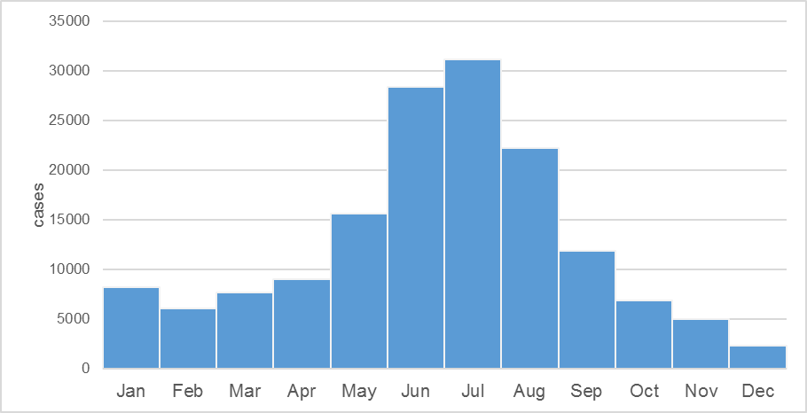
Figure 1. The number of dengue cases by month, Thailand 2013

Table 1. Age-specific dengue incidence rate, Thailand, May-September 2013
Age group | Incidence proportion (/100,000 population)
< 15 year | 360.08
15-29 year | 278.51
30-64 year | 74.41
>65 year | 27.66

Table 2. Dengue incidence rates by region, Thailand, May-September 2013
Region | Incidence rates (/100,000 population)
Northern | 355.07
Southern West Coast | 209.70
Lower Northeastern | 180.57
Upper Northeastern | 158.32
Southern East Coast | 133.58
Eastern | 119.82
Central | 82.19

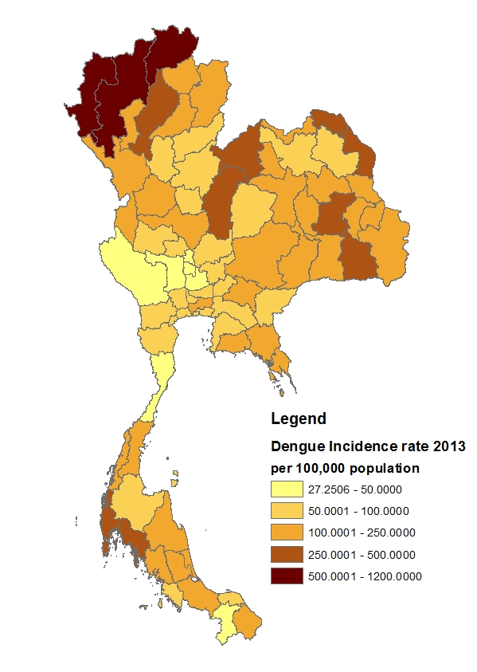
Figure 2. Geographical distribution of dengue crude incidence by province, Thailand, May-September 2013
(Data source: Bureau of Epidemiology, Department of Disease Control, Thailand, 2013)

Climate factors during May to September 2013
May to September was the rainy season. In 2013, the mean temperature did not vary much among the provinces. The mean of relative humidity generally increased from May to September, similar to the pattern of the median of total rainfall. However, the median of rain days were not different between months. We found high variability among the provinces in the variables total rainfall and total rain days, while temperature and relative humidity had narrow variability (Table 3). The summary of the climate factors during the five-month period is shown in Table 4, and the details of climate factors in each region is in Appendix B.

Table 3. Climate factors across 65 provinces with available weather stations, May-September 2013 by month
 | May | June | July | August | September
Temperature (°F)
Mean | 85.5 | 83.41 | 82.09 | 82.08 | 81.46
Range* | 82.0-88.9 | 81.0-85.5 | 79.2-84.6 | 79.9-84.9 | 79.3-83.8
Relative humidity (%)
Mean | 74.31 | 78.83 | 80.69 | 80.85 | 83.28
Range* | 61-86 | 71-88 | 72-90 | 72-89 | 73-89
Total Rainfall (mm)
Median | 130.2 | 173 | 202.8 | 199.5 | 281.1
Range* | 15.1-558.6 | 39.7-949.9 | 37.5-1622.5 | 57.9-684.3 | 5.3-661.6
Total Rain days (days)
Median | 15 | 17 | 19 | 17 | 19
Range* | 7-22 | 7-28 | 7-29 | 10-25 | 1-26
*Range among 65 provinces

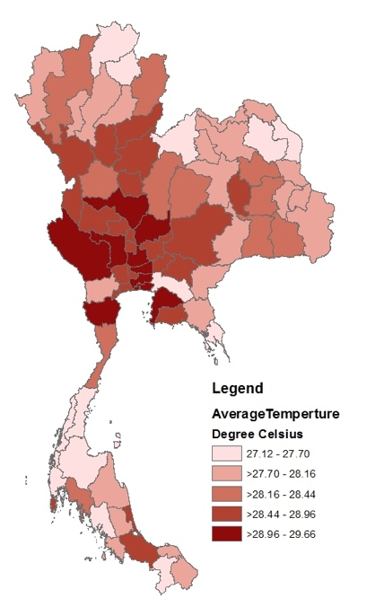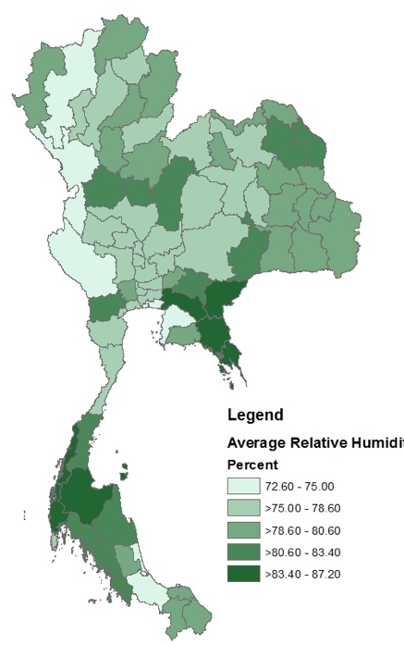

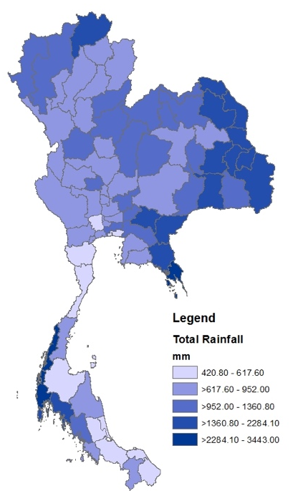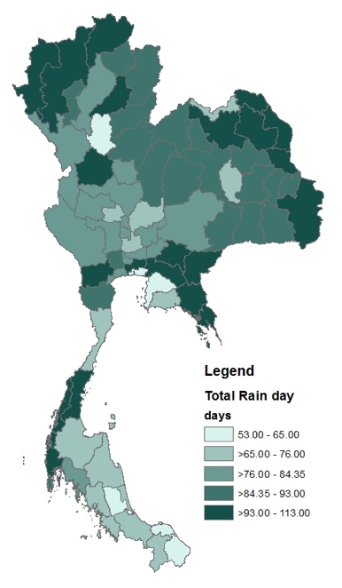
Figure 3. Geographical distribution of average temperature, average relative humidity, total rainfall, and total rain days by province, Thailand, May to September 2013

(Source: Thai Meteorology Department, 2013)
Table 4. Summary of climate factors across 65 provinces in Thailand during May- September 2013
Factors | Mean (SD) | Median | Min | Max
Mean Temperature over 5 months (C) | 83.0(0.6) | - | 87.82 | 85.39
Mean Relative Humidity over 5 months (%) | 79.46(2.8) | - | 72.6 | 87.2
Total Rainfall over 5 months (mm) | - | 952 | 420.8 | 3443
Total Rain days over 5 months (day) | - | 86 | 53 | 113

Socioeconomic and ecologic factors distribution, 2013
The national average monthly household income in 2013 was 663.05 USD. The minimum was 252.03 USD and the maximum was 1405.36 USD. The central region had the highest average household income, while the upper northeastern region had the lowest.
Despite the fact that the Thai government provides 12 years of education starting from primary school to high school level (Ninpraphan, n.d.), our data showed the average years of school education in 2013 was only 7.89 years. The minimum was 6.2 years, and the maximum was 11 years. The highest average years of school education was observed in Bangkok, the capital of Thailand, and the nearby provinces. The provinces at the borders, especially in the northern region, had the fewest number of year attending schools. The pattern of education level distribution was similar to the income distribution.
The urban area rate is the highest in Bangkok, where the whole area was considered an urban area. There was high variability of urban area rates across the country. We observed clusters of high urban area rates in each region e.g. Bangkok and surrounding provinces in the central, Chonburi, Rayong, and Chantaburi in the eastern, Khon Kaen and its neighbors in the northeastern, Lamphun, Chiang Mai, Chiang Rai, and Lampang in the northern, and Songkhla and Patthalung in the southern region. These are large cities of Thailand where we find important industries and commerce, tourist attractions, and universities.
Access to tap water varied across the country. The median proportion of people with access to tap water was 79.3%. Bangkok had 99.3% access to tap water. Mae Hong Son, a province in the north of Thailand connected to Myanmar border, had the lowest access to tap water at 40.2%. The central region had the highest access to tap water. We observed less access to tap water in other regions, especially in the east and the south.
Table 5 shows the national average monthly household income, average number of year attending school, median of urban area rates and median of access to tap water rates. Figure 4 shows the geographical distribution of all four socioeconomic factors. The data at the regional level are demonstrated in Appendix C.

Table 5. Summary of socioeconomic factors, Thailand during May- September 2013
Factors | Mean (SD) | Median | Min | Max
Average monthly household income (USD) | 663.05(191.3) | - | 252.03 | 1405.46
Average number of year attending school (years) | 7.89(0.89) | - | 6.2 | 11
Urban area rate (%) | - | 33.81 | 13.5 | 100
Access to tap water rate (%) | - | 79.3 | 40.2 | 99.3

Previous incidence rates during 2009 -2012
The dengue incidence rates between 2009 and 2012 varied from year to year. In 2009, the overall incidence rate was the lowest compared to the others. The most affected part was along the western border from the northern region to the southern west coast. Next, in 2010, there was a cyclical epidemic. The predominant areas were in the northern, the lower north eastern, the eastern, and the southern parts. The central region was spared. In 2011, the most affected part was in the central region, while other regions were less affected. Finally, in 2012, the dengue incidence was distributed almost all over the country (Figure 5).

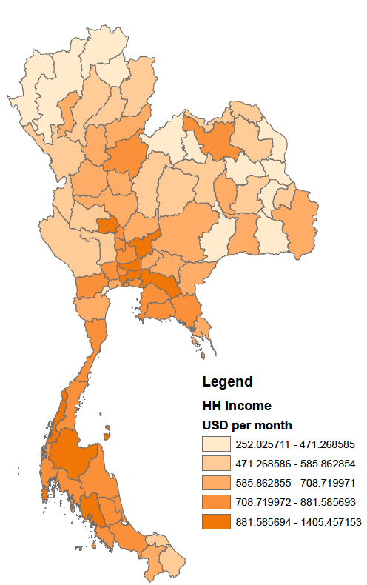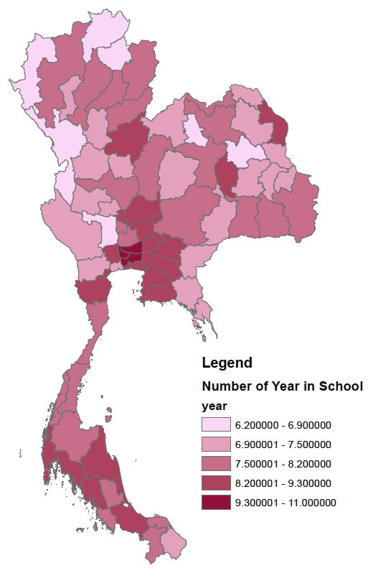

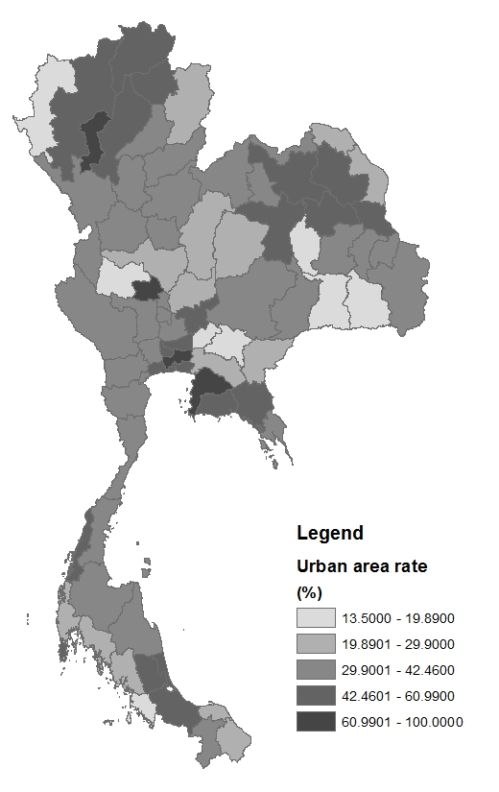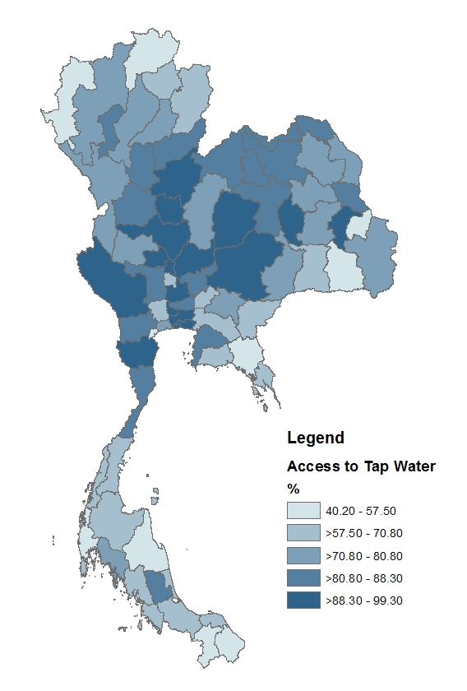
Figure 4. Geographical distribution of average household income, average years of school education, urban area rates and access to tap water rates by province, Thailand, 2013

(Data sources: the National Statistics Office, the Office of the Education Council, the Department of Local Administration, and Thai population census)

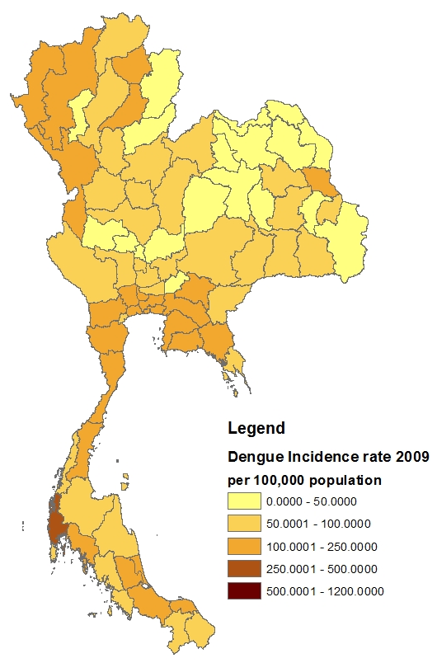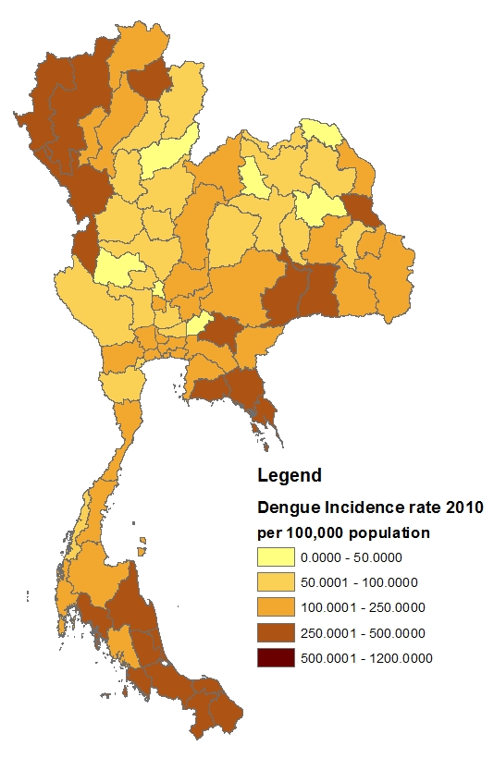

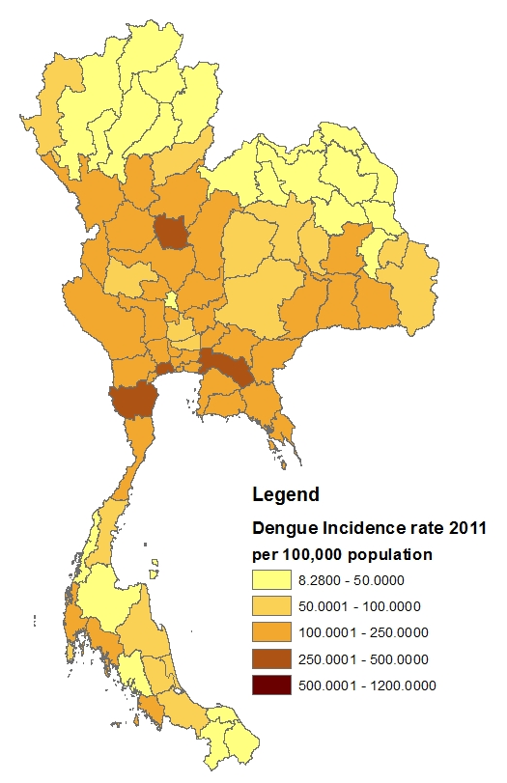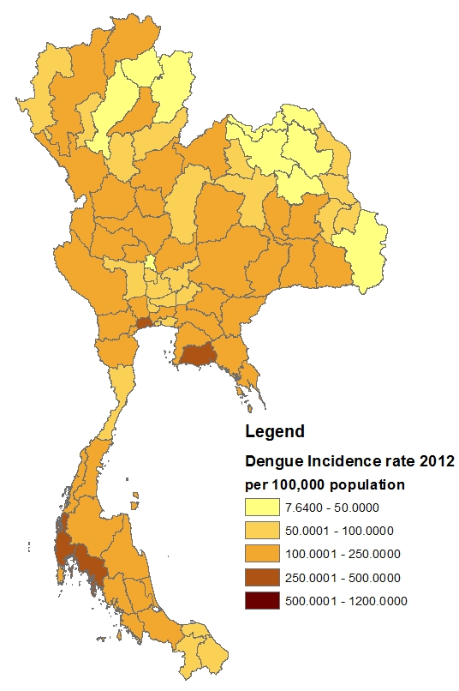
Figure 5. Geographical distribution of dengue crude incidence rates by province, Thailand, 2009-2012
(Data source: Bureau of Epidemiology, Department of Disease Control, Thailand, 2009-2012)

Analytic study results

Univariate analysis
We performed univariate analysis using the independent factors against the natural logarithm of dengue crude incidence in each province as the outcome. We used the crude incidence rate because the crude and the age-adjusted incidence rates were similar in most provinces (Appendix A).
According to the univariate analysis results, we found that mean temperature, average monthly household income, and tap water access rates were negatively associated with the outcome, whereas total rainfall and total rain days are positively associated. The relative humidity, average years of school education, and urban area rates were not statistically significant. The incidence rate in 2010 and 2013 were significant while the rate in 2009 was marginal. The results are shown in Table 6.

Multivariate analysis
We selected mean temperature, total rainfall, total rain days, average monthly household income, and proportion of household access to tap water into our multivariate regression model. We also adjusted for the dengue incidence rate in the previous four years. Since relative humidity showed no statistical significance and was highly correlated with total rainfall (regression coefficient = 62.2%), we excluded the variable from the model. We also excluded the urban area rate and the average years of school education from the model because they had p-value greater than 0.1 and provided low predictability for the outcome.
The model including nine variables had the R² equal to 48.13%. Total rain days and average monthly household income were statistically significant as well as the incidence in 2010 and 2011.

Spatial Analysis
We also tested the spatial correlation of the dengue incidence using univariate Moran’s I technique. The results showed that the dengue incidence had spatial correlation (spatial correlation coefficient = 0.47) (Figure 5). There was a spatial effect in the northern and the western part of the country (Figure 6). The Lagrange Multiplier test for error also showed significant spatial correlation among residuals (p=0.02). The robust Lagrange Multiplier was also significant (p=0.01).
Since the spatial correlation was significant, we performed a multivariate analysis adjusting for spatial autocorrelation. The model adjusting for spatial correlation yielded R² at 60.48%, which better fit the data than the non-spatial model. In this model, total rain days became the only significant predictor while other independent variables were no longer significant (Table 8).

Table 6. Univariate analysis between ln(dengue incidence) and independent factors
Factors | Regression coefficient | p-value | R²(%)
Mean Temperature | -0.562 | <0.001 | 19.59
Relative humidity | 0.036 | 0.24 | 1.86
Total rainfall | 0.0004 | 0.003 | 11.10
Total rain days | 0.0212 | <0.001 | 13.76
Average monthly household income | -0.001 | 0.002 | 12.09
Average years of school education | -0.15 | 0.109 | 3.39
Urbanization proportion | 0.0016 | 0.761 | 0.12
Access to tap water | -0.015 | 0.01 | 8.33
Dengue incidence rate in 2009 | 0.003 | 0.06 | 4.55
Dengue incidence rate in 2010 | 0.002 | 0.002 | 12.45
Dengue incidence rate in 2011 | -0.002 | 0.3 | 5.82
Dengue incidence rate in 2012 | 0.001 | 0.35 | 1.16

Table 7. Multivariate analysis between ln(dengue incidence) and the independent factors
Factors | Regression coefficient | p-value
Mean Temperature | -0.106 | 0.52
Total rainfall | 0.00003 | 0.85
Total rain days | 0.0212 | 0.005
Average monthly household income | -0.001 | 0.006
Access to tap water | 0.004 | 0.52
Dengue incidence rate in 2009 | 0.0007 | 0.65
Dengue incidence rate in 2010 | 0.002 | 0.008
Dengue incidence rate in 2011 | -0.002 | 0.04
Dengue incidence rate in 2012 | 0.002 | 0.14

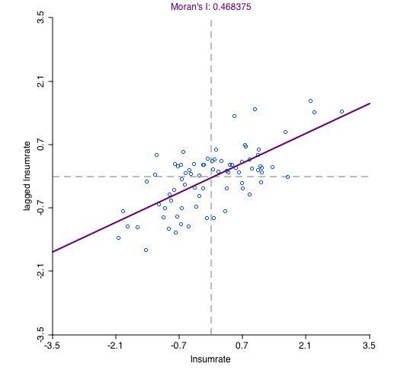

Figure 6. Univariate Moran’s I demonstrating spatial autocorrelation of ln(dengue incidence), Thailand, 2013
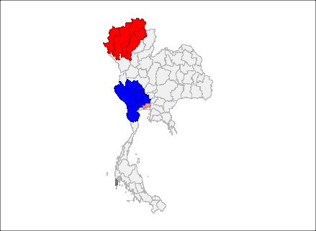
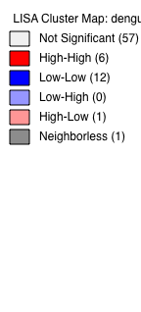

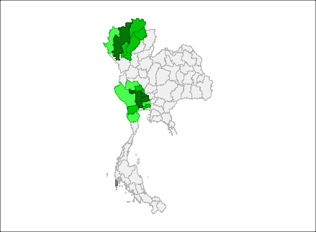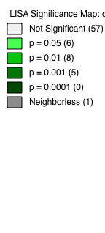

Figure 7. The LISA (Local Indicators of spatial Spatial Association) cluster map and significance map demonstrating the spatial effect on ln(dengue incidence) in Thailand, 2013

(Data source: Bureau of Epidemiology, Department of Disease Control, Thailand 2013)

Table 8. Spatial regression analysis between ln(dengue incidence) and the independent factors.
Factors | Regression coefficient | p-value
Mean Temperature | 0.11 | 0.89
Total rainfall | 0.00007 | 0.46
Total rain days | 0.014 | 0.03
Average monthly household income | -0.0003 | 0.40
Access to tap water | -0.0028 | 0.55
Dengue incidence rate in 2009 | 0.0016 | 0.27
Dengue incidence rate in 2010 | 0.0012 | 0.06
Dengue incidence rate in 2011 | -0.0018 | 0.11
Dengue incidence rate in 2012 | 0.0021 | 0.06

Subgroup analysis results: children under 15
We tested the association between the natural logarithm of dengue incidence rate among children under 15 and the independent factors. According to the univariate analysis, we found mean temperature, total rainfall, total rain days, and average monthly household income were significant factors with average years of school education of borderline significance (Table 9).
In the multivariate analysis, we included the mean temperature, total rainfall, total rain days, average monthly household income, and average years of school education in the model because they had p-values less than 0.1. We also adjusted for the previous incidence rates. We found total rain days, average household income, and the incidence rate in the previous years were associated with the incidence in this population (Table 10). The R² of the model was 41.44%.
The Lagrange Multiplier test for error showed statistical significance (p=0.007) and the robust Lagrange Multiplier test also reported p-value equal to 0.02. Thus, we performed the spatial analysis using spatial error model. The spatial error model provided the R² equal to 60.34%. The model reported a significant association between the incidence in 2013 and the incidence in 2012. Total rain days and the incidence rate in 2010 were marginally significant with p-value equal to 0.06 and 0.07, respectively (Table 11).

Table 9. Univariate analysis between ln(dengue incidence) among children under 15 and the independent factors
Factors | Regression coefficient | p-value | R²(%)
Mean Temperature | -0.48 | <0.001 | 13.76
Relative humidity | 0.038 | 0.22 | 2.01
Total rainfall | 0.00045 | 0.002 | 12.04
Total rain days | 0.025 | 0.006 | 18.00
Average monthly household income | -0.0014 | 0.001 | 13.00
Average years of school education | -0.17 | 0.08 | 4.12
Urbanization proportion | -0.005 | 0.93 | 0.01
Access to tap water | -0.004 | 0.48 | 0.66
Dengue incidence rate in 2009 | 0.001 | 0.50 | 0.60
Dengue incidence rate in 2010 | 0.001 | 0.13 | 3.04
Dengue incidence rate in 2011 | -0.002 | 0.15 | 2.80
Dengue incidence rate in 2012 | 0.001 | 0.31 | 1.39

Table 10. Multivariate analysis between ln(dengue incidence) among children under 15 and the independent factors.
Factors | Regression coefficient | p-value
Mean Temperature | -0.15 | 0.43
Total rainfall | 0.00002 | 0.91
Total rain days | 0.022 | 0.008
Average monthly household income | -0.002 | 0.003
Average years of school education | 0.16 | 0.20
Dengue incidence rate in 2009 | -0.001 | 0.43
Dengue incidence rate in 2010 | 0.0001 | 0.26
Dengue incidence rate in 2011 | -0.002 | 0.15
Dengue incidence rate in 2012 | 0.003 | 0.024

Table 11. Spatial analysis between ln(dengue incidence) among children under 15 and the independent factors.
Factors | Regression coefficient | p-value
Mean Temperature | -0.10 | 0.60
Total rainfall | 0.00002 | 0.90
Total rain days | 0.013 | 0.06
Average monthly household income | -0.0003 | 0.40
Average years of school education | 0.03 | 0.77
Dengue incidence rate in 2009 | -0.001 | 0.40
Dengue incidence rate in 2010 | 0.0001 | 0.07
Dengue incidence rate in 2011 | -0.0007 | 0.58
Dengue incidence rate in 2012 | 0.0024 | 0.04

Additional analysis results: the non-rainy seasons

January to April 2013
The incidence rate during this period was 47.94 per 100,000 population. The highest incidence was among children under 15, which was 115.44 per 100,000 population. The incidence rate among people aged 15-29, 30-64, and 65 and over were 78.07, 16.96 and, 5.35 per 100,000 population, respectively.
The univariate analysis showed relative humidity, total rainfall, total rain days, monthly household income, and average years of school education had p-value less than 0.1. When we included all of these variables in the model together with the previous incidence rates during 2009-2012, the only significant factor was the incidence rate in 2012, with the regression coefficient equal to 0.004 (p=0.001). Other climate and socioeconomic variables were no longer significant. No spatial autocorrelation was observed in the dengue incidence rate during this period.

October to December 2013
The incidence rate during this period was 21.97 per 100,000 population. The highest incidence was among children aged less than 15, which was 42.08 cases per 100,000 population. The incidence rate among people aged 15-29 years old was 36.69, which was close to that among children. The incidence among people ages 30-64 and 65 and over were 11.10 and 4.24 cases per 100,000 population, respectively.
Based on the univariate analysis, mean temperature, relative humidity, total rainfall, total rain days, average monthly household income, access to tap water rate, and urban area rate had p-value less than 0.1. When we performed the multivariate analysis with all of these variables in the model and adjusted for the previous incidence rates during 2009-2012, we found a significant association between the incidence rate of this period and the urban area rate (regression coefficient=0.019, p-value=0.03) as well as the incidence rate in the year 2011 (regression coefficient=0.004, p-value=0.04). No spatial autocorrelation was observed as well.

Summary
There were 109,262 dengue cases reported to the surveillance system during May to September 2013 (70.75% of the total number of dengue cases in 2013). The incidence was highest among children under 15.
For the main analysis, during May to September 2013, Total rain days are significantly associated with the dengue incidence in the provinces. The incidence rate in 2010 and 2012 are marginally significant.
For the subgroup analysis, the incidence rate among children under 15 in the provinces is associated with the incidence rate in 2012, while total rain days and the incidence rate in 2010 are marginally significant.
For the non-rainy seasons, the incidence during January to April 2013 is associated with the incidence in 2012. The incidence rate during October to December is associated with urban area rates and the incidence in 2011.

Discussion
In Thailand, dengue incidence has its peak in the rainy season (late May to early October). The situation of dengue incidence in 2013 should be considered as a cyclical dengue epidemic since the number of cases was higher than in the previous six years. We observed an unusual rising number of cases in the early part of the year during January through April. This has continued from the rising dengue incidence during the winter season of the year 2012. During the dengue season 2013, the incidence among children aged less than 15 years was the highest. Although the incidence among population aged 15-29 was lower than those of children’s age group, it was distinctively high when compared to the two older age groups, i.e. four times than the population aged 30-64 and almost 10 times than the population aged 65 and over. This might be due to the age-shifting trend of dengue-contracting young adults, which could be explained by the declining proportion of early adults having protective immunity against dengue (Rodriquez-Barraquer et al., 2014). During the period, the most affected area was in the northern region, especially the northern border provinces connected to Myanmar and Laos PDR. The geographical distribution was similar to the pattern observed in 2010.
We selected the period of study only in the rainy season because the incidence in this season was the highest. In addition, we could diminish the effect of seasonality. However, we still found variability in climate factors across the country. Cumulative rainfall and rain days had high variability, whereas average temperature did not show much difference among the 77 provinces throughout the period. Because a previous study suggested that a small change in temperature could affect dengue transmission, we also included temperature in our analysis. Taking into account other independent variables and spatial autocorrelation, we found a significant association between the number of rain days during dengue season and dengue incidence, while other climate variables including temperature, relative humidity, and rainfall were not statistically significant. The effect of temperature and relative humidity might be attenuated by using the average value representing the climate of the five-month period. However, our results were consistent with some previous studies showing less effect of rainfall level and dengue incidence (Campbell et al., 2003; Parker & Holman, 2012). Rainfall can have various effects on the vector’s reproduction. It might increase numbers of breeding sites, but heavy rainfall can wash away mosquito larvae as well. The positive association between numbers of rain days during the period and the disease incidence is reasonable because more frequent rain should create new breeding sites as well as protect the breeding sites from evaporation.
We did not find any significance of socioeconomic factors on dengue incidence from our analysis. Average monthly household income was no longer significant after adjusting for the spatial autocorrelation. The finding was consistent with a previous cross-sectional study (Koyadun et al., 2012). In addition, Mulligan et al. (2015) reviewed multiple studies on poverty and dengue incidence and found heterogeneous effects of poverty. Thus, the effect of income is still inconclusive. For education level, our study showed that average education level was not associated with dengue incidence in the province. A study in Malaysia revealed that higher education was associated with higher knowledge about the disease, while it was not associated with dengue prevention practices (Wong, Shakir, Atefi, & AbuBakar, 2015). Moreover, the average years of school education in a province may reflect its urbanization. Koyadun et al. (2012) found a significantly positive association between education level and the disease incidence in a study at the household level. They concluded that this might be due to a higher proportion of educated people in those urban areas. Although our results did not show a significance of population-average level of education on the dengue incidence, we would like to emphasize that our results should not be applied to the individual level.
The urban area rate, defined as the proportion of people living in municipal area over total population in the province, also shows no significant effect on the dengue incidence. It is possible that the percentage might be underestimated and not represent the true proportion of people living in the municipality areas, e.g. people who had addresses outside the area might stay there to study or work during the week and stay at home in the weekend. These people would be categorized as living outside municipality areas, whereas in fact, they spent more time, especially daytime, in that area. This could affect the association between the urban area rate and dengue incidence in a province, especially among teenagers and adults. Other aspects of urban areas should be included in further studies.
There has been a recommendation regarding utilization of tap water to control dengue. It is believed that installation of tap water might reduce the need for household water storage containers and eventually reduce numbers of mosquito breeding sites. From our findings, central Thailand has the highest rates of access to tap water. This might be related to the geographical difference. The central part of Thailand is characterized by a large lowland plain while parts of other regions are covered by mountain ranges which makes it challenging for tap water services. However, a study in the northern Thailand during 2004-2006 discovered that water tanks were found in every household (Elstner, Bollen, & Sangkapitux, 2006) despite the availability of community tap water services. Thus, household water storage is probably a common practice regardless of tap water access. This could explain why we did not observe a significant association between the tap water access and dengue distribution.
The last factor was the four-year prior dengue incidence rates in each province. Since population immunity might be associated with the dengue epidemic in an area and some studies reported the relationship between previous incidence and current dengue incidence (Endy et al., 2002; Ng et al., 2015). We selected the previous four years because we wanted to include the previous cyclical dengue epidemic and assumed that every province had a chance to be recently attacked by dengue. None of the prior incidence rates was significantly related to the incidence in the epidemic period in 2013. Nevertheless, the incidence in 2012 and 2010 were marginally significant (p-value = 0.06).
Dengue incidence in 2012 was unusual. The peak during the rainy season was lower than its previous years but the declining phase did not touch the baseline. However, it remained high throughout the winter and summer period (November 2012 to April 2013) and rocketed again in May 2013. Our marginally significant findings suggested that the provinces with high incidence in 2012 tended to have high incidence again in 2013. Moreover, the year 2010 was the latest cyclical dengue epidemic year prior to the year 2013.
From 2010 to 2012, the predominant circulating dengue serotypes in Thailand were DENV1 and DENV2 (Department of Medical Science Thailand [DMSc], 2010; DMSc, 2012). In May 2013, we found that DENV3 had become the predominant serotype until the end of the year (DMSc, 2013). This change in predominant dengue serotype, called serotype switching, was found to be related to dengue epidemic in Singapore and Malaysia in 2013 as well (Ng et al., 2015). Another study regarding this issue was done by Endy et al. (2002) from 1998-2000. The study was conducted in several schools in a district in Thailand. The study demonstrated that the schools which had dengue outbreaks of one serotype were less likely to be attacked by the same serotype again in the next year. Although immunity plays an important part in dengue epidemics, they suggested that environmental factors were also important. Despite the low level of dengue antibodies among students in some schools, the outbreak did not occur during the three-year study period (Endy et al., 2002). Thus, for this epidemic in 2013, we speculated that the provinces with historical high incidence might have some characteristics that made them prone to dengue spreading, e.g. abundance of vectors, crowding population, and poor housing. Continuous raining, i.e. more numbers of rain days, would facilitate mosquito reproduction and result in an increasing number of vectors. Finally, when the new serotype appeared in the region where the majority of people might not have the immunity against the emerging serotype, the dengue epidemic occurred.
The subgroup analysis focusing on children under 15 showed similar results. Dengue incidence in this population during the rainy season had a significant, positive association with the incidence in 2012 after adjusted for other independent variables and spatial autocorrelation. However, total rain days and the incidence in 2010 were marginally significant. This might be because the epidemic in 2013 was started in 2012. No socioeconomic factor was significantly associated with the incidence in this subgroup.
We also performed additional analyses for the dengue incidence in the non-rainy seasons. During the period before the epidemic, January to April 2013, the incidence was significantly associated with the incidence in 2012. On the other hand, the incidence during October to December 2013 was associated with the incidence in 2011 and the urban area rate. It is possible that disease control in urban areas might be more difficult. As a consequence, the incidence was still high even after the rainy season. However, the explanation of the association with the incidence in 2011 was not entirely clear.
There are some limitations to our study. First, even though we included possible factors related to dengue incidence, we were not able to obtain information on other factors known to affect dengue transmission e.g. the data on population movement and hidden populations, vector indicators, and local prevention and control measures. Secondly, using average temperature and relative humidity over a long period might attenuate the effect of these variables. Thirdly, as an ecological study, the results may not be applied to an individual level. Finally, being a cross-sectional study did not allow us to draw a causal relationship between the incidence and the independent variables.

Conclusion and Recommendations
Dengue is a serious public health problem affecting tropical regions, mainly South East Asia. This paper reviewed clinical characteristics of dengue, dengue distribution, and factors associated with dengue transmission such as host factors, viral factors, and environmental factors. We conducted a cross-sectional study on dengue incidence in Thailand, 2013. Using univariate, multivariate and spatial analyses, we determined an association between the provincial dengue incidence and multiple factors including average temperature, relative humidity, total rainfall, total rain days, average monthly household income, average years of school education, urban area rates, rate of access to tap water, and the previous dengue incidence in 2009 to 2012. During May to September 2013, 109,262 dengue cases were reported. The northern region had the highest incidence (355.07 per 100,000 population). Children under 15 was most affected by dengue.
Based on our findings, the number of rain days is significantly associated with dengue incidence during the rainy season. Moreover, the incidence rates seen in previous years are highly correlated with future epidemics; therefore, we recommend that the local public health agency strengthen dengue control measures in areas with frequent rain during dengue season, e.g. advise people to remove water from discarded containers, turn containers upside down if possible. This was one of the first investigations to use GIS spatial analysis to investigate both socioeconomic, and weather covariates in one model to consider the conjoint relationships of risk factors for dengue in Thailand. Targeting of particularly high risk areas in the future should help to reduce morbidity and mortality in Thai population.

Appendix A: DENGUE CRUDE AND AGE-SPECIFIC INCIDENCE rates, THAILAND, 2013 by province
Province Code | Province Name | Crude incidence Rate | Age-adjusted incidence rate
10 | Bangkok | 127.48 | 132.98
11 | SamutPrakan | 61.83 | 62.84
12 | Nonthaburi | 56.40 | 60.74
13 | PathumThani | 57.40 | 58.02
14 | Ayuttaya | 36.95 | 38.68
15 | AngThong | 42.63 | 45.74
16 | Lopburi | 63.46 | 66.82
17 | SingBuri | 31.46 | 34.53
18 | ChaiNat | 68.17 | 75.25
19 | Saraburi | 95.47 | 95.49
20 | ChonBuri | 87.28 | 85.08
21 | Rayong | 160.55 | 156.81
22 | Chanthaburi | 200.56 | 203.22
23 | Trat | 212.59 | 213.00
24 | Chachoengsao | 66.72 | 66.88
Province Code | Province Name | Crude incidence Rate | Age-adjusted incidence rate
25 | PrachinBuri | 156.43 | 155.11
26 | NakornNayok | 93.10 | 96.04
27 | SaKaew | 85.51 | 80.41
30 | NakhonRatchasima | 203.13 | 204.96
31 | BuriRum | 115.28 | 109.51
32 | Surin | 210.35 | 200.71
33 | SiSaKet | 259.83 | 252.42
34 | UbonRatchathani | 128.62 | 121.24
35 | Yasothorn | 132.14 | 136.87
36 | Chaiyaphum | 92.56 | 94.99
37 | AmnatCharoen | 124.30 | 122.66
38 | BuengKan | 259.64 | 238.63
39 | NongBuaLumPoo | 165.38 | 160.58
40 | KhonKaen | 144.64 | 148.10
41 | UdonThani | 70.87 | 68.97
42 | Loei | 329.80 | 333.65
43 | Nongkhai | 191.17 | 189.35
44 | MahaSarakham | 227.06 | 236.32
45 | RoiEt | 264.91 | 275.05
46 | Kalasin | 126.05 | 127.98
Province Code | Province Name | Crude incidence Rate | Age-adjusted incidence rate
48 | NakhonPhanom | 269.02 | 256.57
49 | Mukdahan | 234.59 | 225.85
50 | ChiangMai | 606.04 | 617.26
51 | Lamphun | 247.92 | 260.87
52 | Lampang | 408.02 | 454.84
53 | Uttaradit | 75.90 | 83.31
54 | Phrae | 181.03 | 207.61
55 | Nan | 156.34 | 157.99
56 | Phayao | 178.08 | 190.21
57 | ChiangRai | 1012.44 | 1020.91
58 | MaeHongSon | 649.41 | 628.04
60 | NakhonSawan | 100.54 | 106.27
61 | Uthaithani | 70.46 | 73.31
62 | KamphaengPhet | 106.58 | 107.22
63 | Tak | 199.92 | 180.89
64 | Sukhothai | 67.87 | 74.25
65 | Phitsanulok | 99.96 | 113.47
66 | Pichit | 80.13 | 84.55
67 | Phetchabun | 273.02 | 279.70
70 | Ratchaburi | 74.49 | 76.50
71 | Kanchanaburi | 29.38 | 28.35
Province Code | Province Name | Crude incidence Rate | Age-adjusted incidence rate
73 | NakhonPathom | 61.36 | 61.99
74 | SamutSakorn | 75.47 | 75.02
75 | SamutSongkram | 52.04 | 56.77
76 | Phetchaburi | 84.68 | 87.85
77 | PrachuapKhiriKhan | 43.00 | 42.20
80 | NakhonSiThammarat | 171.74 | 167.40
81 | Krabi | 276.38 | 244.92
82 | Pangnga | 278.19 | 273.66
83 | Phuket | 418.66 | 400.15
84 | Suratthani | 77.17 | 73.73
85 | Ranong | 106.32 | 100.02
86 | Chumphon | 152.17 | 151.29
90 | Songkhla | 227.49 | 214.97
91 | Satun | 75.04 | 63.88
92 | Trang | 108.84 | 103.80
93 | Phatthalung | 136.37 | 136.24
94 | Pattani | 79.38 | 66.01
95 | Yala | 49.26 | 46.20
96 | Narathiwat | 113.42 | 115.37

Appendix B: SUMMARY OF CLIMATE DATA FROM MAY TO SEPTEMBER 2013 BY REGION
Table 12. Average temperature (°C) from May to September 2013 by region
Region | Mean | SD | Min | Max
Central | 28.96 | 0.30 | 28.08 | 29.56
Eastern | 28.42 | 0.77 | 27.52 | 29.66
Northern | 28.22 | 0.47 | 27.12 | 28.78
Upper Northeastern | 28.04 | 0.36 | 27.56 | 28.66
Southern East Coast | 27.97 | 0.36 | 27.46 | 28.64
Southern West Coast | 27.79 | 0.63 | 27.12 | 28.62
Lower Northeastern | 27.18 | 0.24 | 27.82 | 28.66

Table 13. Average relative humidity (%) from May to September 2013 by region
Region | Mean | SD | Min | Max
Eastern | 82.17 | 4.18 | 75 | 87.2
Southern West Coast | 82.67 | 2.89 | 78.4 | 87
Northern | 78.83 | 2.24 | 74.6 | 81.8
Upper Northeastern | 79.53 | 1.67 | 77.8 | 82.8
Lower Northeastern | 79.22 | 1.51 | 76.4 | 81
Southern East Coast | 79.64 | 2.95 | 74.2 | 84.8
Central | 77.49 | 1.92 | 72.6 | 81.6

Table 14. Total rainfall (mm) from May to September 2013 by region
Region | Median | Min | Max
Southern West Coast | 1660.2 | 944.7 | 3379.9
Eastern | 1315.9 | 784.4 | 3443
Lower Northeastern | 1402.8 | 897.3 | 1512.2
Upper Northeastern | 1140.5 | 800.6 | 1849.2
Northern | 952 | 719.3 | 1654.7
Central | 807.9 | 452.4 | 1122.6
Southern East Coast | 555.3 | 420.8 | 919.3

Table 15. Total rain days (days) from May to September 2013 by region
Region | Median | Min | Max
Eastern | 96.5 | 59 | 105
Upper Northeastern | 92.5 | 75 | 113
Lower Northeastern | 90 | 84 | 97
Northern | 88 | 65 | 108
Southern West Coast | 86 | 69 | 108
Central | 81.5 | 59 | 105
Southern East Coast | 71 | 53 | 96

Appendix C: summary of socioeconomic data, 2013 by region
Table 16. Average monthly household income, Thailand 2013 by region
Region | Mean | Min | Max
South West Coast | 839.34 | 725.70 | 950.57
Central | 775.38 | 464.49 | 1405.46
East | 755.30 | 601.11 | 987.09
South East Coast | 739.02 | 479.22 | 1053.27
North | 542.16 | 252.03 | 785.41
Lower Northeast | 529.53 | 411.95 | 642.26
Upper Northeast | 516.52 | 397.74 | 663.05

Table 17. Average years of school education, Thailand 2013 by region
Region | Mean | Min | Max
South West Coast | 8.48 | 7.6 | 9.1
Central | 8.33 | 6.9 | 11
East | 8.28 | 7.2 | 9.3
South East Coast | 7.99 | 7.3 | 9.1
Lower Northeast | 7.54 | 7.1 | 8.2
Upper Northeast | 7.53 | 6.8 | 8.7
North | 7.33 | 6.2 | 8.6

Table 18. Average urban area rates, Thailand 2013 by region
Region | Mean | Min | Max
Central | 43.23 | 19.89 | 100
North | 39.75 | 14.3 | 67.74
Upper Northeast | 37.79 | 15 | 56.6
South East Coast | 36.84 | 22.08 | 59.06
East | 36.84 | 13.5 | 74.8
South West Coast | 33.25 | 17.83 | 60.67
Lower Northeast | 32.29 | 16.05 | 45.58

Table 19. Median proportion of access to tap water, Thailand 2013 by region
Region | Median | Min | Max
Central | 90.5 | 40.4 | 99.3
Upper Northeast | 82.5 | 73 | 90.7
Lower Northeast | 80.4 | 53.6 | 91.3
North | 76.2 | 40.2 | 92.1
East | 70.4 | 55.4 | 87.2
South West Coast | 67.05 | 54.1 | 74
South East Coast | 63 | 46.7 | 83.1

bibliography
Back, A. T., & Lundkvist, A. (2013). Dengue viruses - an overview. Infection Ecology & Epidemiology, 3. doi:10.3402/iee.v3i0.19839

Bhoomiboonchoo, P., Nisalak, A., Chansatiporn, N., Yoon, I. K., Kalayanarooj, S., Thipayamongkolgul, M., . . . Gibbons, R. V. (2015). Sequential dengue virus infections detected in active and passive surveillance programs in Thailand, 1994-2010. BMC Public Health, 15, 250. doi:10.1186/s12889-015-1590-z

Bouzid, M., Brainard, J., Hooper, L., & Hunter, P. R. (2016). Public Health Interventions for Aedes Control in the Time of Zikavirus- A Meta-Review on Effectiveness of Vector Control Strategies. PLoS Negl Trop Dis, 10(12), e0005176. doi:10.1371/journal.pntd.0005176

Campbell, K. M., Lin, C. D., Iamsirithaworn, S., & Scott, T. W. (2013). The complex relationship between weather and dengue virus transmission in Thailand. Am J Trop Med Hyg, 89(6), 1066-1080. doi:10.4269/ajtmh.13-0321

Centers for Disease Control and Prevention. (1995). Preventing Dengue Fever in Travelers. Retrieved from https://wonder.cdc.gov/wonder/prevguid/p0000443/p0000443.asp

Centers for Disease Control and Prevention. (2014). Dengue: Epidemiology. Retrieved from
https://www.cdc.gov/dengue/epidemiology/index.html

Centers for Disease Control and Prevention. (n.d.). Dengue: laboratory guidance and diagnostic testing. Retrieved from https://www.cdc.gov/dengue/clinicallab/laboratory.html

Department of Medical Science, Ministry of Public Health, Thailand. Dengue serotype surveillance report 2010. Retrieved from
http://webdb.dmsc.moph.go.th/ifc_nih/applications/files/2553report_April4,11.pdf

Department of Medical Science, Ministry of Public Health, Thailand. Dengue serotype surveillance report 2012. Retrieved from
http://webdb.dmsc.moph.go.th/ifc_nih/applications/files/7.2_55.pdf

Department of Medical Science, Ministry of Public Health, Thailand. Dengue serotype surveillance report 2013. Retrieved from
http://nih.dmsc.moph.go.th/dengue/15_2report56.pdf

Elstner P, Bollen A, Sangkapitux C. (2006, June 19-23). Dynamics of household water management systems in mountainous regions of northern Thailand. Paper presented at The Eleventh Conference of the International Association for the Study of Common Property: Survival of the Commons: Mounting Challenges and New Realities, Bali, Indonesia. Retrieved from
https://dlc.dlib.indiana.edu/dlc/bitstream/handle/10535/1958/Elstner_peter.pdf?sequence=1

Endy, T. P., Nisalak, A., Chunsuttiwat, S., Libraty, D. H., Green, S., Rothman, A. L., … Ennis, F. A. (2002). Spatial and Temporal Circulation of Dengue Virus Serotypes : A Prospective Study of Primary School Children in Kamphaeng Phet , Thailand. American Journal of Epidemiology, 156(1), 52–59. http://doi.org/10.1093/aje/kwf00

Hadinegoro, S. R., Arredondo-García, J. L., Capeding, M. R., Deseda, C., Chotpitayasunondh, T., Dietze, R., … Saville, M. (2015). Efficacy and Long-Term Safety of a Dengue Vaccine in Regions of Endemic Disease. New England Journal of Medicine, 373(13), 1195–1206. http://doi.org/10.1056/NEJMoa1506223

Hammon, W. M. (1973). Dengue hemorrhagic fever--do we know its cause? Am J Trop Med Hyg, 22(1), 82-91.

Heymann D. L. (2008) Control of Communicable Diseases Manual 19th edition. Washington, DC: American Public Health Association

Gibbons, R. V., Kalanarooj, S., Jarman, R. G., Nisalak, A., Vaughn, D. W., Endy, T. P., . . . Srikiatkhachorn, A. (2007). Analysis of repeat hospital admissions for dengue to estimate the frequency of third or fourth dengue infections resulting in admissions and dengue hemorrhagic fever, and serotype sequences. Am J Trop Med Hyg, 77(5), 910-913.

Gosselin, R.E., Smith R.P., Hodge H.C. Clinical Toxicology of Commercial Products. 5th ed. Baltimore: Williams and Wilkins, 1984., p. II-293

Guzman, M. G., Alvarez, M., & Halstead, S. B. (2013). Secondary infection as a risk factor for dengue hemorrhagic fever/dengue shock syndrome: an historical perspective and role of antibody-dependent enhancement of infection. Arch Virol, 158(7), 1445-1459. doi:10.1007/s00705-013-1645-3

Koyadun, S., Butraporn, P., & Kittayapong, P. (2012). Ecologic and Sociodemographic Risk Determinants for Dengue Transmission in Urban Areas in Thailand. Interdisciplinary Perspectives on Infectious Diseases, 2012. http://doi.org/10.1155/2012/907494

Kyle, J. L., & Harris, E. (2008). Global spread and persistence of dengue. Annu Rev Microbiol, 62, 71-92. doi:10.1146/annurev.micro.62.081307.163005

Langgartner, J., Audebert, F., & Scholmerich, J., Gluck T. (2002). Dengue Virus Infection Transmitted by Needle Stick Injury. The British Infection Society. 269–270. http://doi.org/10.1053/jinf.2002.0994

Lee, C., Jang, E. J., Kwon, D., Choi, H., Park, J. W., & Bae, G. (2016). Laboratory-acquired dengue virus infection by needlestick injury : a case report , South Korea , 2014. Annals of Occupational and Environmental Medicine, 1–8. http://doi.org/10.1186/s40557-016-0104-5

Limkittikul, K., Brett, J., & L'Azou, M. (2014). Epidemiological trends of dengue disease in Thailand (2000-2011): a systematic literature review. PLoS Negl Trop Dis, 8(11), e3241. doi:10.1371/journal.pntd.0003241

Louis, V. R., Phalkey, R., Horstick, O., Ratanawong, P., Wilder-smith, A., Tozan, Y., & Dambach, P. (2014). Modeling tools for dengue risk mapping - a systematic review. International Journal of Health Geographics, 13(50), 1–15.

Manjarres-Suarez, A., & Olivero-Verbel, J. (2013). Chemical control of Aedes Aegypti: A Historical Perspective. Rev Costarr Salud Pública, 22, 68–75.

Mordecai, E. A., Cohen, J. M., Evans, M. V., Gudapati, P., Johnson, L. R., Lippi, C. A., . . . Weikel, D. P. (2017). Detecting the impact of temperature on transmission of Zika, dengue, and chikungunya using mechanistic models. PLoS Negl Trop Dis, 11(4), e0005568. doi:10.1371/journal.pntd.0005568

Morin, C. W., Comrie, A. C., & Ernst, K. (2013). Climate and Dengue Transmission : Evidence and Implications. Environ Health Perspect, 121, 1264–1272.

Mulligan, K., Dixon, J., Sinn, C. L., & Elliott, S. J. (2015). Is dengue a disease of poverty? A systematic review. Pathog Glob Health, 109(1), 10-18. doi:10.1179/2047773214Y.0000000168

Nakhapakorn, K., & Tripathi, N. K. (2005). An information value based analysis of physical and climatic factors affecting dengue fever and dengue haemorrhagic fever incidence. International Journal of Health Geographics, 4, 1–13. http://doi.org/10.1186/1476-072X-Received

Nature. (n.d.) Dengue transmission. Retrieved from https://www.nature.com/scitable/topicpage/dengue-transmission-22399758

Ng, L., Chem, Y., Koo, C., Nani, R., Mudin, B., Amin, F. M., … Kheong, C. C. (2015). 2013 Dengue Outbreaks in Singapore and Malaysia Caused by Different Viral Strains. Am. J. Trop. Med. Hyg., 92(March 2014), 1150–1155. http://doi.org/10.4269/ajtmh.14-0588

Ninphanomchai, S., Chansang, C., Hii, Y. L., & Rocklöv, J. (2014). Predictiveness of Disease Risk in a Global Outreach Tourist Setting in Thailand Using Meteorological Data and Vector-Borne Disease Incidences. International Journal of Environmental Research and Public Health, 11, 10694–10709. http://doi.org/10.3390/ijerph111010694

Ninpraphan P. (n.d.). Education in Consitution. Retrieved from http://cdc.parliament.go.th/draftconstitution2/ewt_dl_link.php?nid=539&filename=doct

Orsborne, J., DeRaedt Banks, S., Hendy, A., Gezan, S. A., Kaur, H., Wilder-Smith, A., . . . Logan, J. G. (2016). Personal Protection of Permethrin-Treated Clothing against Aedes aegypti, the Vector of Dengue and Zika Virus, in the Laboratory. PLoS One, 11(5), e0152805. doi:10.1371/journal.pone.0152805

Oxman, A. D., Lavis, J. N., Lewin, S., & Fretheim, A. (2009). Health Research Policy and Systems SUPPORT Tools for evidence-informed health Policymaking ( STP ) 1 : What is evidence-informed policymaking ? Health Research Policy and Systems, 7, 1–7. http://doi.org/10.1186/1478-This

Parker, D., & Holman, D. (2012). Event history analysis of dengue fever epidemic and inter-epidemic spells in Barbados, Brazil, and Thailand. Int J Infect Dis, 16(11), 1–16. http://doi.org/10.1016/j.ijid.2012.07.002.Event

Qi, X., Wang, Y., Li, Y., Meng, Y., Chen, Q., & Ma, J. (2015). The Effects of Socioeconomic and Environmental Factors on the Incidence of Dengue Fever in the Pearl River Delta , China ,. PLoS Negl Trop Dis, 9(10), 1–13. http://doi.org/10.1371/journal.pntd.0004159

Rodenhuis-Zybert, I. A., Wilschut, J., & Smit, J. M. (2010). Dengue virus life cycle : viral and host factors modulating infectivity. Cellular and Molecular Life Sciences, 2773–2786. http://doi.org/10.1007/s00018-010-0357-z

Rodriguez-Barraquer, I., Buathong, R., Iamsirithaworn, S., Nisalak, A., Lessler, J., Jarman, R. G., . . . Cummings, D. A. (2014). Revisiting Rayong: shifting seroprofiles of dengue in Thailand and their implications for transmission and control. Am J Epidemiol, 179(3), 353-360. doi:10.1093/aje/kwt256

Sabino, E. C., Loureiro, P., Lopes, M. E., Capuani, L., Mcclure, C., Chowdhury, D., … Custer, B. (2016). Transfusion-Transmitted Dengue and Associated Clinical Symptoms During the 2012 Epidemic in Brazil. The Journal of Infectious Diseases, 213, 694–702. http://doi.org/10.1093/infdis/jiv326

Salje, H., Lessler, J., Berry, I. M., Melendrez, M. C., Endy, T., Kalayanarooj, S., … Nisalak, A. (2017). the effect of host population size. Science, 355(March), 1302–1306.

Sarfraz, M. S., Tripathi, N. K., Faruque, F. S., Bajwa, U. I., Kitamoto, A., & Souris, M. (2014). Mapping urban and peri-urban breeding habitats of Aedes mosquitoes using a fuzzy analytical hierarchical process based on climatic and physical parameters. Geospatial Health, 8(3).

Scott, T. W., Morrison, A. C., Lorenz, L. H., Clark, G. G., Strickman, D., Kittayapong, P., . . . Edman, J. D. (2000). Longitudinal studies of Aedes aegypti (Diptera: Culicidae) in Thailand and Puerto Rico: population dynamics. J Med Entomol, 37(1), 77-88.

Shepard, D. S., Undurraga, E. A., & Halasa, Y. A. (2013). Economic and Disease Burden of Dengue in Southeast Asia. PLoS Negl Trop Dis, 7(2). http://doi.org/10.1371/journal.pntd.0002055

Shepherd S. M., Hinfey, P. B., Shoff W. H., Bronze, M. S., (2015, October 5). Dengue. Retrieved from http://emedicine.medscape.com/article/215840-overview

Sierra, B., Kourí, G. & Guzmán, M. (2007). Race : a risk factor for dengue hemorrhagic fever. Archives of Virology 152:533–542. http://doi.org/10.1007/s00705-006-0869-x

Siqueira, J. B., Martelli, C. M., Maciel, I. J., Oliveira, R. M., Ribeiro, M. G., Amorim, F. P., .
. . Andrade, A. L. (2004). Household survey of dengue infection in central Brazil: spatial point pattern analysis and risk factors assessment. Am J Trop Med Hyg, 71(5), 646-651.

Siriyasatien, P., Phumee, A., Ongruk, P., Jampachaisri, K., & Kesorn, K. (2016). Analysis of significant factors for dengue fever incidence prediction. BMC Bioinformatics, 17(166), 1–9. http://doi.org/10.1186/s12859-016-1034-5

Spiegel, J. M., Bonet, M., Ibarra, A., Pagliccia, N., Ouellette, V., & Yassi, A. (2007). Social and environmental determinants of Aedes aegypti infestation in Central Havana : results of a case – control study nested in an integrated dengue surveillance programme in Cuba. Tropical Medicine and International Health, 12(4), 503–510. http://doi.org/10.1111/j.1365-3156.2007.01818.x

Temephos. (1993, September). Retrieved from http://pmep.cce.cornell.edu/profiles/extoxnet/pyrethrins-ziram/temephos-ext.html

Tipayamongkholgul, M., & Lisakulruk, S. (2011). Socio-geographical factors in vulnerability to dengue in Thai villages : a spatial regression analysis. Geospatial Health, 5(2), 191–198.

Tourism Authority of Thailand. About Thailand: Geography. Retrieved from
https://www.tourismthailand.org/About-Thailand/Geography

United States Environmental Protection Agency.(2016) Temephos RED.
https://archive.epa.gov/pesticides/reregistration/web/html/temephos_red.html

Vannavong, N., Seidu, R., Stenström, T., Dada, N., & Overgaard, H. J. (2017). Effects of socio-demographic characteristics and household water management on Aedes aegypti production in suburban and rural villages in Laos and Thailand. Parasites & Vectors, 1–14. http://doi.org/10.1186/s13071-017-2107-7

Vargas, R. E. M., Ya-umphan, P., Phumala-morales, N., Komalamisra, N., & Dujardin, J. (2010). Infection , Genetics and Evolution Climate associated size and shape changes in Aedes aegypti ( Diptera : Culicidae ) populations from Thailand. “Infection, Genetics and Evolution,” 10(4), 580–585. http://doi.org/10.1016/j.meegid.2010.01.004

Villar, L., Dayan, G. H., Arredondo-García, J. L., Rivera, D. M., Cunha, R., Deseda, C., … Noriega, F. (2014). Efficacy of a Tetravalent Dengue Vaccine in Children in Latin America. New England Journal of Medicine, 372(2), 113–123. http://doi.org/10.1056/NEJMoa1411037

Wai, K. T., Arunachalam, N., Tana, S., Espino, F., Kittayapong, P., Abeyewickreme, W., . . . Petzold, M. (2012). Estimating dengue vector abundance in the wet and dry season: implications for targeted vector control in urban and peri-urban Asia. Pathog Glob Health, 106(8), 436-445. doi:10.1179/2047773212Y.0000000063

Wilder-smith, A. (2012). Dengue infections in travellers. Paediatrics and International Child Health, 32(S1). http://doi.org/10.1179/2046904712Z.00000000050

Wong LP, Shakir SMM, Atefi N, AbuBakar S (2015) Factors Affecting Dengue Prevention Practices: Nationwide Survey of the Malaysian Public. PLoS ONE 10(4): e0122890. doi:10.1371/ journal.pone.0122890

World Health Organization. (1997). Dengue hemorrhagic fever: Diagnosis, Treatment, Prevention and Control 2nd edition. Retrieved from
http://apps.who.int/iris/bitstream/10665/41988/1/9241545003_eng.pdf

World Health Organization. (2007) Addressing sex and gender in epidemic-prone infectious diseases. Retrieved from
http://www.who.int/csr/resources/publications/SexGenderInfectDis.pdf

World Health Organization. (2009). Temephos in drinking water: Use for vector control in drinking water sources and containers. Retrieved from
http://www.who.int/water_sanitation_health/dwq/chemicals/temephos.pdf

World Health Organization. (2012) Handbook for clinical management of dengue. Retrieved from http://www.wpro.who.int/mvp/documents/handbook_for_clinical_management_of_dengue.pdf

World Health Organization. (2016). Dengue vaccine: WHO position paper – July 2016. Weekly Epidemiological Record, (30), 349–364.

World Health Organization. (2017) Dengue control: What is Dengue? Retrieved from
http://www.who.int/denguecontrol/disease/en/

World Health Organization. (2017). The neglected tropical diseases. Retrieved from http://www.who.int/neglected_diseases/diseases/en/

World Health Organization--SEARO. (2017) Dengue: Dengue fact sheet. Retrieved from
http://www.searo.who.int/entity/vector_borne_tropical_diseases/data/data_factsheet/en/

World Health Organization. (n.d) Dengue Control: Biological control. Retrieved from
http://www.who.int/denguecontrol/control_strategies/biological_control/en/

World Health Organization. (n.d). Dengue control: Epidemiology. Retrieved from
http://www.who.int/denguecontrol/epidemiology/en/

World Health Organization. (n.d.) Dengue Control: Frequently Asked Question. Retrieved from http://www.who.int/denguecontrol/faq/en/index5.html
Wu, P., Lay, J., Guo, H., Lin, C., Lung, S., & Su, H. (2008). Higher temperature and urbanization affect the spatial patterns of dengue fever transmission in subtropical Taiwan. Science of the Total Environment, The, 407(7), 2224–2233. http://doi.org/10.1016/j.scitotenv.2008.11.034

