MGT 4058

Fall 2022

Assignment #3
Value: 50 Points
Due: Thursday, November 17, 2022

The YellowJacket Computing Inc., uses several database systems to conduct its computer hardware and software business operations. The following example is a subset of one of the database systems. Customer table stores all the data related to customers. Prices in Product table reflect the current prices (unit prices) for products. The Transaction table keeps track of each customer's purchase and return history by storing product number, quantity, and the grand total he/she paid.

Sample data of Customer table
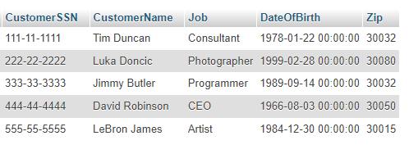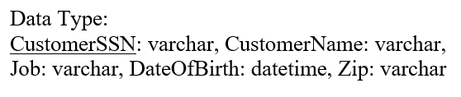

Sample data of Product table
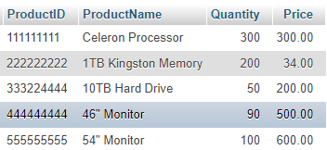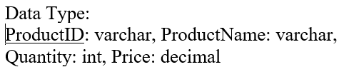

Sample data of Transaction table
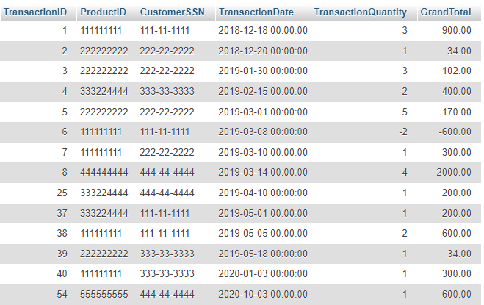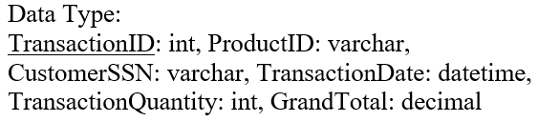

Please download the Assignment3.sql on Canvas under Modules/Assignment and import this SQL file to MySQL. Before you import this SQL file, you need to create an empty database where you are going to import Assignment3.sql to first.

Please write SQL statements (one SQL statement for each question) to solve the following questions based on the sample database:

- (4 points) List all the product ID, Name, Quantity and price.

SELECT ProductID, ProductName, Quantity, Price from Product;

- (6 points) Update Tim Duncan's Zip code to 30075.
UPDATE

- (6 points) List customers’ Name, Job title and zip code for all the customers whose birthday is after December 30, 1984.

SELECT CustomerName, Job, Zip from Customer where DateOfBirth > ‘1984-12-30’;

- (7 points) Tim Duncan bought one new 10TB Hard Drive (Product Id: 333224444) on 10/25/2020. Please add this new transaction in your database.

INSERT INTO transaction(ProductID, CustomerSSN, TransactionDate, TransactionQuantity, GrandTotal) values (‘333224444’, ‘111-11-1111’, ‘2020-10-25’, 1, 200.00)

- (9 points) List customer name, average purchase quantity (transaction quantity) and average purchase amount (i.e., grand total) for each customer (not including refunds).

- (9 points) List all customers’ name and transaction counts for all customers who have made at least two transactions. (Transaction counts refer to how many transactions the customers have conducted. One transaction may include one or more than one transaction quantities).

- (9 points) List all customers’ name and SSN for the customers who have made no transaction in the year 2018.

SELECT CustomerName, CustomerSSN from Customer right join transaction on transaction.CustomerSSN = Customer.CustomerSSN where CustomerSSN NOT IN (SELECT DISTINCT CustomerSSN transaction where year(TransactionDate) = 2018);

- Please download and import Assignment3.sql, which is available on Canvas/Modules/Assignment, to MySQL. Write your SQL codes and get your query results. Copy and paste the SQL statements and the query results (screenshot) into an MS Word document. Then, write your name on the first page, print this document, and turn it in.

- Assignment 3 is not a group project. Thus, you should not consult with your classmates to answer these questions.

SELECT TransactionDate, ProductName, Price from transaction left join product where transaction.productID = product.ProductID where GrandTotal > 0

SELECT DISTINCT CustomerName, CustomerSSN from Customer right join transaction on transaction.CustomerSSN = Customer.CustomerSSN where year(TransactionDate) = 2019;

SELECT CustomerName, ave(TransactionQuantity), avg(GrandTotal) from Customer, Transaction where Customer.CustomerSSN = Transaction.CustomerSSN GROUP BY CustomerName, Customer.CustomerSSN

SELECT ProductName, sum(TransactionQuantity), sum(GrandTotal) from Transaction, product where product.ProductID = transaction.ProductID and group by ProductID, ProductName having sum(transactionQuantity) > 4);

