Database Diagram

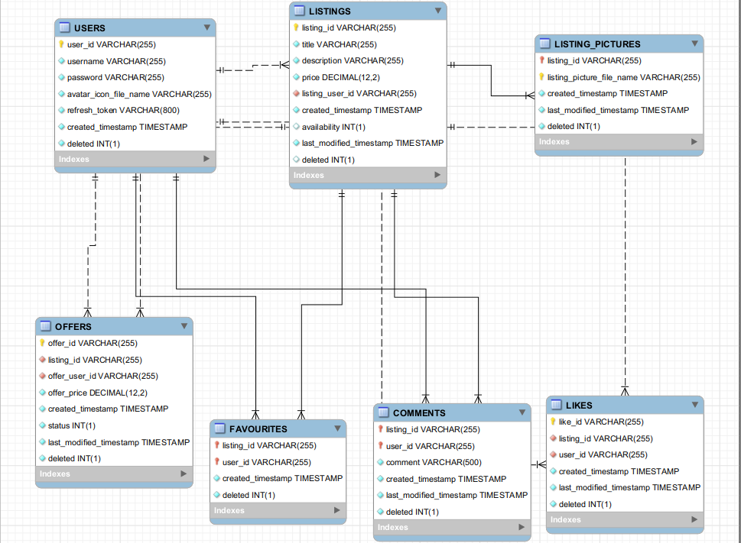

Brief Description:

Main starting point is the USERS table.

LISTINGS is made based on a FK to USERS

LISTING_PICTURES is made based on a FK to LISITNGS

OFFERS is made based on a FK to USERS and LISTINGS

FAVOURITES, COMMENTS and LIKES made based on FK to USERS and LISTINGS