**SCHOOL OF COMPUTING (SoC)**

**DIPLOMA IN INFORMATION TECHNOLOGY**

**ST0503 Back-end Web Development**

**2019/2020 SEMESTER 2**

**ASSIGNMENT 2**

**Instructions and Guidelines:**

1. The assignment **source code** must be submitted before 10th Feb 2020, 9am. You are required to submit your source codes to the BlackBoard. Remember to provide your Class, Group, Admission Number(s) and Name(s) on the softcopy.
2. A word document showing the additional APIs or modifications should be included in the submission. Done
3. You are required to **clearly** provide instructions on how to setup the project on the lecturer's laptop in a text file that is to be included in the softcopy submission. Done
4. Students are to work in a group of 1-2 members.
5. **Students of 2 member group must complete one of the 2 additional features (without extra marks) stated in the document or be penalized 10 marks**.
6. Marks will be given separately for each student in the group, depending on his contribution to the assignment. The assignment will account for **30%** of your final grade*.*
7. The assignment should be implemented using Node JS, Express and MySQL.
8. The interview will be conducted during the lessons in the week of **10th Feb 2020**. You are expected to explain the program logic and modify the program during the interview. **If you are absent, you will be awarded zero mark for the assignment.**
9. Your application will be tested with POSTMAN.
10. **No marks will be awarded**, if the work is copied or you have allowed others to copy your work. Warning: Plagiarism means passing off as one's own the ideas, works, writings, etc., which belong to another person. In accordance with this definition, you are committing plagiarism if you copy the work of another person and turning it in as your own, even if you would have the permission of that person. Plagiarism is a serious offence and disciplinary action will be taken against you. If you are guilty of plagiarism, you may fail all modules in the semester, or even be liable for expulsion.
11. 50% of the marks will be deducted for assignments that are received within ONE (1) calendar day after the submission deadline. No marks will be given thereafter.

Exceptions to this policy will be given to students with valid LOA on medical or

compassionate grounds. Students will need to inform the lecturer as soon as reasonably possible. Students are not to assume on their own that their deadline has been extended.

# Assignment 2

Assignment 2 is built on-top of the SnapSell API you built in assignment 1.

## Assignment Requirements

You are required to fulfil the following basic requirements:

* Front-end for the web application (You are allowed to use open source templates downloaded from the internet) DONE
* Persistent login (and logout) DONE
* View own listed products DONE
* View Offers from other users DONE
* Add product listing DONE
* Search functionality DONE
* Make offer for product DONE

You can add in more APIs or modify your existing APIs or the database structure to satisfy the requirements of the app.

You can produce your own design for your web app.

Some key example web pages are shown below just for reference. Your design/implementation can be different:

1. Login Page

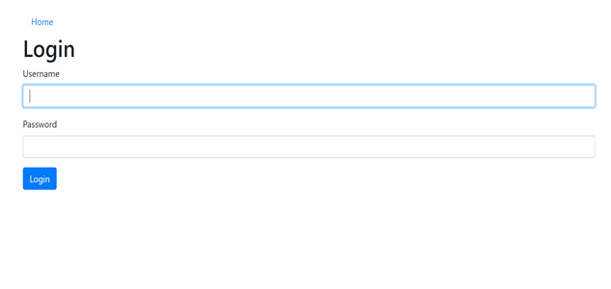

1. Home page

The home page contains the logged in user’s products, as well as all the offers the user has received for their products. User can click on Sell Link to enter their product info to sell or search to view other users’ products. Users can also click log out to log out of the page:

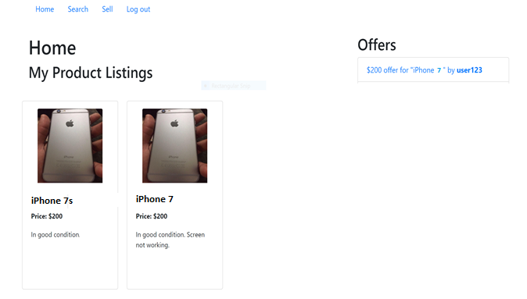

1. Search page

The search page should allow the user to search for products from **other users.** Search field searches for the product by the full or partial title of the listing (Part of the title is sufficient to search the product, eg iphone and retrieve titles like iphone 6s, iphone etc). Clicking on offer should bring up a page allowing user to enter the offer amount which upon submission would allow the posting of the offer to the database through the corresponding web api call:

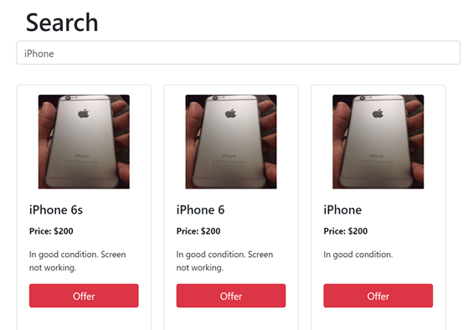

1. Sell page/ Offer Page

The sell page allows the current user to post a product to the database, with details such as price, title, image url and description.

Offer page or pop-up should allow users to make an offer for the selected product

**Grading Guidelines**

The assignment will be assessed based on the following criteria:

* Demonstrate the requirements stated above correctly and effectively (80%)
* Graphical User Interface and user friendliness: (10%)
* Advanced Features (10%)
* Amount of individual contribution to the project
* Question & Answer during the interview

**Bonus Requirements for the web application(You can suggest useful functions for the web app too)**

* Pagination in the search page (matching products numbers can be high in reality) DONE
* Updating and deleting the logged-in user’s product listing DONE
* Liking and unliking a product DONE
* Showing likes count for product when product is shown (implemented together with like/unlike product) DONE
* Provide upload of actual image for product when creating product listing DONE
* Modify Profile info DONE
* Accept/Reject Offers
* Accept/reject offers would generate a message to the person who made the offer