`

2019
School Name: School of Computing Semester:AY1920 semester 2 Course Name: DIT(DSDA) Module Code: ST1502 Module Name: Data Visualization
12/12/2019
DAVI Assignment 2 (CA2)
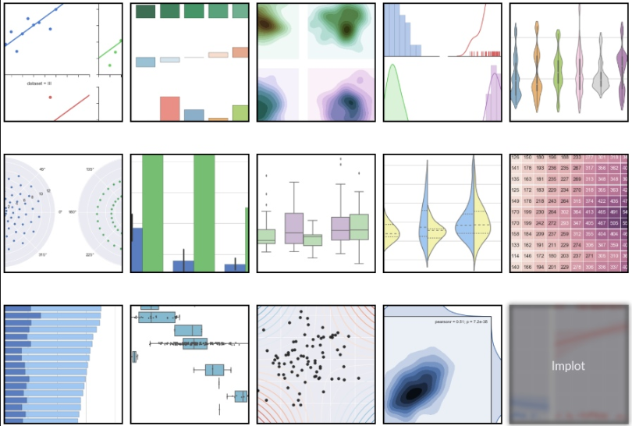

Table of Contents

Section 1 Instructions and Guidelines 2
Section 2 Scope of the assignment 3
Basic Requirements 3
Section 3 Marking Scheme 5
Section 4 Sample outputs expected 6
Example 1 Data Visualization using Seaborn (Univariate) 6
Example 2 Data Visualization using Seaborn ( Bivariate) 7
Example 3 Violin Plot Data Visualization using Seaborn (Trivariate) 8

Section 1
Instructions and Guidelines

- This is an INDIVIDUAL assignment which requires the student to code a Python application that retrieves and combines data from multiple data sources and perform data cleansing, transformation and especially data visualization and data analysis.

- The requirements of this assignment are outlined in Section 2 of this document.

- Submissions should be made via the Blackboard CA2 Assignment Submission link by the stated deadline.

- Deliverable should be a zip file with the following file-naming convention
“YourStudentID-YourName.zip”

- Zip file should include the following items:
- One Jupyter notebook that accomplishes the given tasks using the Python programming language
- A set of Powerpoint slides that summarizes the data insights that you have gained through the Python code you have written
- A self-reflection document that briefly states the learning goals, learning outcomes and challenges you have faced and the take-aways you have gained from doing this assignment

- You will need to give a short presentation / interview using the Powerpoint slides you have prepared. Your module tutor may ask you questions related to Python code and Data visualization during this interview / presentation session.

- This assignment will account for 40% of the module grade.

- No marks will be awarded, if the work is copied or you have allowed others to copy your work.

- 50% of the marks will be deducted for assignments that are received within ONE (1) calendar day after the submission deadline. No marks will be given thereafter.
Exceptions to this policy will be given to students with valid LOA on medical or compassionate grounds. Students in such cases will need to inform the lecturer as soon as reasonably possible. Students are not to assume on their own that their deadline has been extended.

Section 2
Scope of the assignment

In this individual assignment, you are required to write Python programs and produce a data analysis presentation for various datasets based on the requirements as stated below.

Basic Requirements

- Choose “Housing and Development Board” data sets fot the assignment.
You may use the following data sets:
a) HDB price datasets or/and
b) Data sets from this url - https://data.gov.sg/search?q=housing+and+development+board

- You may use not more than 3 datasets. You may use the Pandas package to load the datasets

- State 2 objectives. For each objective, plot at least 2 different types of charts using seaborn package. With 2 objectives, there are at least 4 different types of charts. For 2 objectives, the maximum number of charts is 8 charts.

- Write python program and use seaborn package to generate useful and meaning charts. You will need to generate at least one univariate chart, one bivariate chart and one multivariabe chart
- A univariate chart eg bar chart
- A bivariate chart eg pairplot
- A multivariate chart eg heatmap

A sample of a possible output of this requirement is given in Section 4 of this document.
You are highly encouraged to utilise other graph types that may aid in the understanding and analysis of your chosen datasets.

- Explain the insights of each chart

- Your Python programs should help you to gain deeper insights into the chosen datasets such that you are able to craft a ‘storyline’ or produce an interesting data analysis on it.

Compile your findings into a deck of Powerpoint slides

Your Powerpoint slides should include the following sections:

- A cover page that lists your name and the title of your data analysis
- A slide that lists the URLs of all the datasets you have used
- For each dataset, one slide or more to briefly explain the nature of that dataset (i.e. what is in that dataset) or any pecularities about it you wish to highlight
- For each dataset, one slide or more to explain the process you went through to analyse that dataset. Where possible, you should specifically mention how you used the data visualization library functions to achieve a certain outcome e.g. to transform the data or to produce a certain visualization
- For each dataset, the insights you have gained from analysing the data and any conclusions or recommendations you want to make as a result of the analysis

- Analysing real-world data is not an easy task. Reflect on your challenges and your achievements in completing this assignment and document it using the given “Reflection for CA2” template.

Section 3
Marking Scheme

Marks will be awarded to each student based on the following rubrics.

To score higher marks, you are encouraged to explore and experiment beyond the syllabus and demonstrate your independently-acquired skills via your deliverables / interview. You may access to the online learning platforms such as datacamp or Udemy to learn more about Data visualization using seaborn.

Component | Weightage
- Clarity of project objectives  - The topic is on Housing and Development Board (HDB).  - You will need to plan for 2 learning goals/objectives for this assignment. You will need to state 2 objectives you wish to work on in the context of HDB.  - Explain the nature of the datasets and state the sources of the datasets  - Explain the process you went through from getting the raw data to working on data wrangling and finally working on the final set of data  - Summarise key insights gained from the analysis of the data  - Provide 2 recommendations or conclusions | 30%
- Quality of application (Use Seaborn package to plot 4 different types of charts. Label the axes)  - Technical complexity  - Code quality  - User-friendliness  - Aesthetics  - Creativity | 30%
- Data analysis (Powerpoint Slides)  - Completeness in the analysis of data  - Quality of analysis and presentation | 30%
- Self-reflection (CA2 self-reflection template)  - Explaination of challenges faced  - Explaination of achievements made  - State all library resources you refer to for CA1.  Thank you | 10%

Section 4
Sample outputs expected

This section contains sample screenshots of how your Python programs may look like.

Do note that they are simple examples only, and you are highly encouraged to enhance your own version with more complex features or functionalities than what is shown here.

Example 1
Data Visualization using Seaborn (Univariate)

This sample output uses the Seaborn library to plot a histogram of the tips collected during meal times. The below is using distplot and kde.

To determine the amount of tips collected during meal times

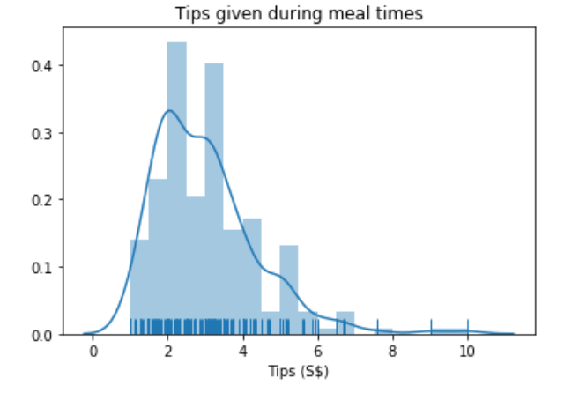
Sample of Analysis:
- Most of the tips collected is about S$2.00 and S$3.00.
- There were very few occasions where the tips collected is more than S$6.00.

Example 2
Data Visualization using Seaborn ( Bivariate)

To determine the total bill collected from the different gender

You may add another dimension to a categorical plot by using a hue semantic.
Code:
sns.catplot(x="day", y="total_bill", hue="sex", kind="swarm", data=tips);
On Thur, more females pay for the total bill. The amount collected on Thursday range from US$8 to US$20. On Sunday, more males pay for the total bill. The amount collected range from US$8 to US$35

Example 3
Violin Plot Data Visualization using Seaborn (Trivariate)

This sample output uses the Seaborn library to plot a static violin chart visualization showing the IQ scores of different test groups.

Seaborn produces much more aesthetically-pleasing charts than Matplotlib.

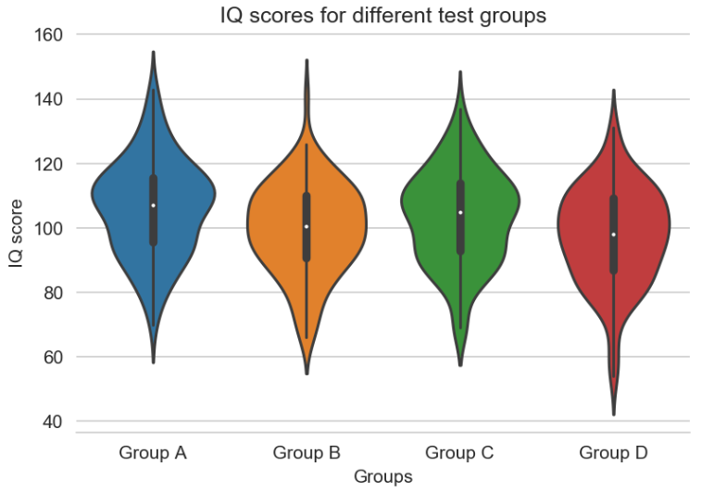

Sample of Analysis:
- The median for Group D is lowest, the IQ score is below 100. Some of the participants has IQ scores of between 40 to 60.
- The median for Group A is the highest, the IQ score is 115. Majority of the participants in Group A has IQ score of about 110.

-- End of Assignment Specifications --

