Database Diagram

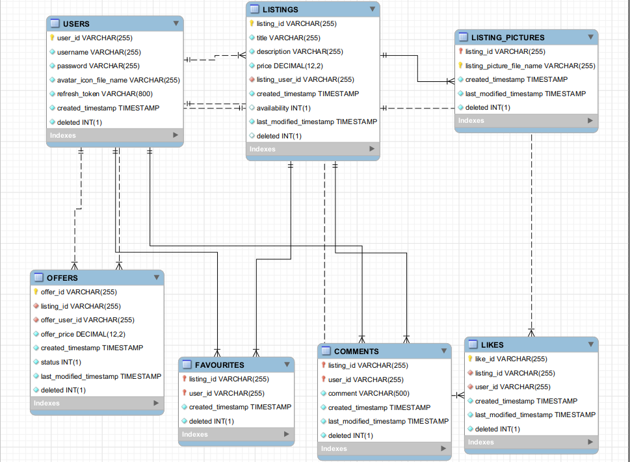
Brief Description:

Main starting point is the USERS table.
LISTINGS is made based on a FK to USERS
LISTING_PICTURES is made based on a FK to LISITNGS
OFFERS is made based on a FK to USERS and LISTINGS
FAVOURITES, COMMENTS and LIKES made based on FK to USERS and LISTINGS

