# HOW TO RUN

This document include the sections such as: “Descriptions, how to run, how to debug” for each question in this project, but “Git repository description” will be the common section for all questions. Please go through one by one.

**Development Environment:**

OS: Windows 10 pro x64

Qt: 5.4.2 mingw491

**Question 1:**

1. Description: Get the text input from application arguments and compress to format of base64.
2. How to run:

Select “Projects option” on the right hand menubar.

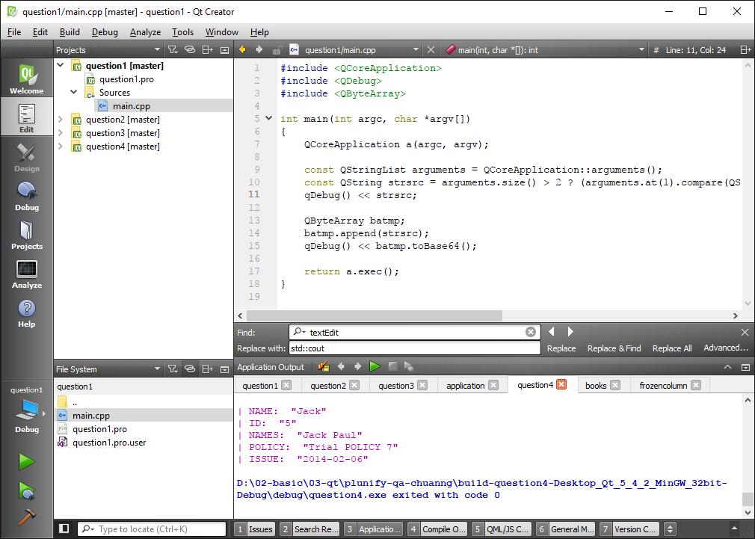

Input the argument in the textbox of arguments. Ex: -i “value”. And select “Run” button on the left hand menu bar to run the application and verify the output on the console.

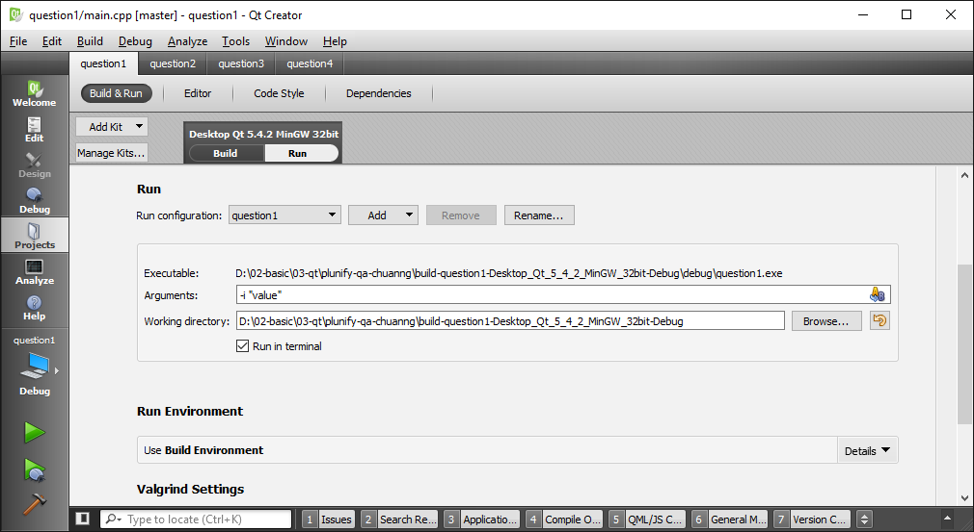

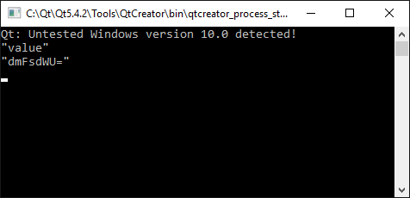

1. How to debug:

In order to run debugger, select the break point on your source code before run debugging.

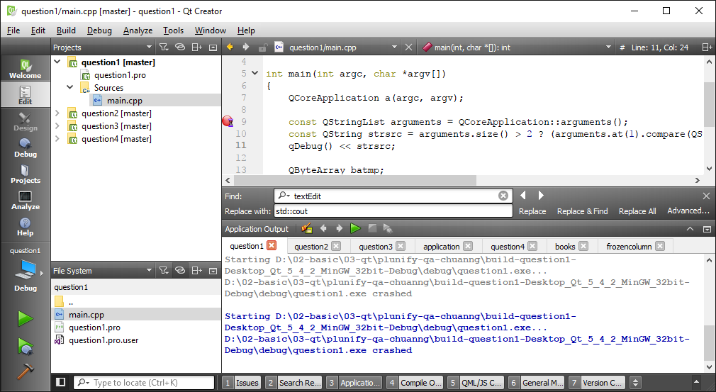

Afterthat, Select the “Debug option” on the right hand menubar.

**Question 2:**

1. Description: Get the path to available database and show the data table to console. Ex: ./question2 –i “people.db”
2. How to run: Please refer to the corresponding section in question 1.
3. How to debug: Please refer to the corresponding section in question 1.

**Question 3:**

1. Description: GUI application with threading process for question1.

Threading process here will be responsible for the translation in the background. After complete the the translation, the result will be transfer to the main thread via **signals** emit and **slot** function.

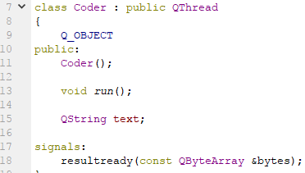

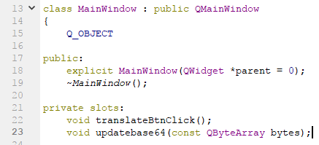

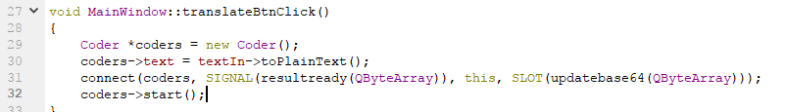

1. How to run:

User input the text into the upper Textbox and select button “Translate”.

One thread will be create and run in background, right after we have the result from background thread, the translation result will be display in the bottom Textbox.

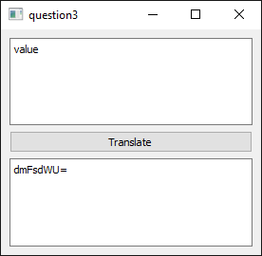

1. How to debug: Please refer to the corresponding section in question 1.

**Question 4:**

1. Description: GUI application with threading process for question2.

Threading process here will be responsible for data querying from database. After complete the query process, the result will be transfer to the main thread which is still responsible for GUI rendering. The transferring also be processed via **signal** emit and **slot** function.

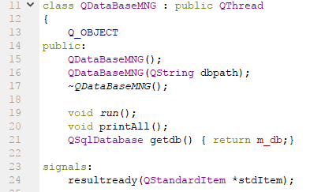

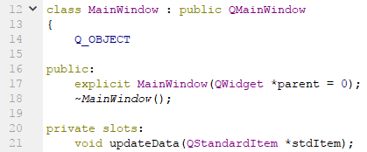

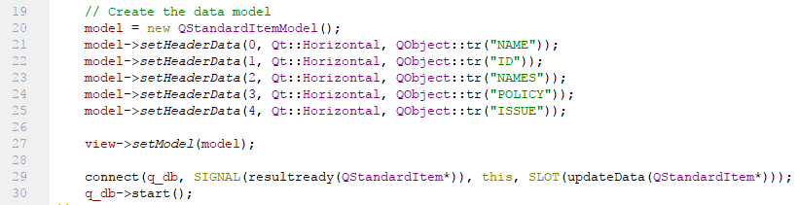

1. How to run:

Refer to the corresponding section in question 1 to input the argument for the application and run, the application GUI will show all data in the database table to the GUI.

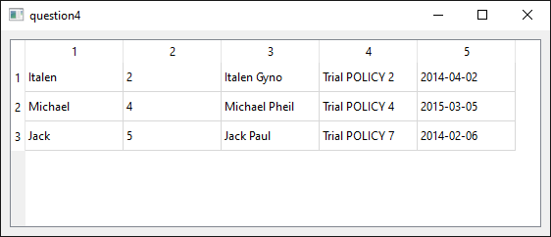

1. How to debug: Please refer to the corresponding section in question 1.

**Git repository description:**

Git reposity is build up follow the structure:

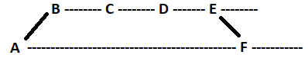

Please go to the github repository and clone to your local:

Link: <https://github.com/chuannguyen/plunify-qa-chuanng/tree/master>

Branch: master

Commit: 66eaa2a26690f07f3f81ead4418dc2404eced574