SC2107 Lab3 Assignment Sheet (to be submitted to NTULearn before next lab)

Name:Chua Qin Di Lab Group: SCEB Date: 3/10/2024

1. Section 6. Exception handling in ARM processor is handle at three levels (Global, NVIC, and Peripheral). Which are the two registers that configure the exception handling at a global level? Explain whether we need to configure these registers in our lab exercise.
   1. The two registers are PRIMASK and BASEPRI. The default value at reset for PRIMASK and BASEPRI are 0x0. This means that by default, global interrupt is enabled and no base priority is applied, allowing interrupts to be triggered.
2. 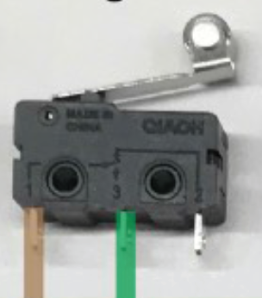Section 6.2. The bump switch used in the lab is shown below. Pin 1 and 3 of the bump switch are connected to the MSP432. Draw the internal circuit of the bump switch and describe how the MSP432 GPIO can be used to detect that the switch is closed?

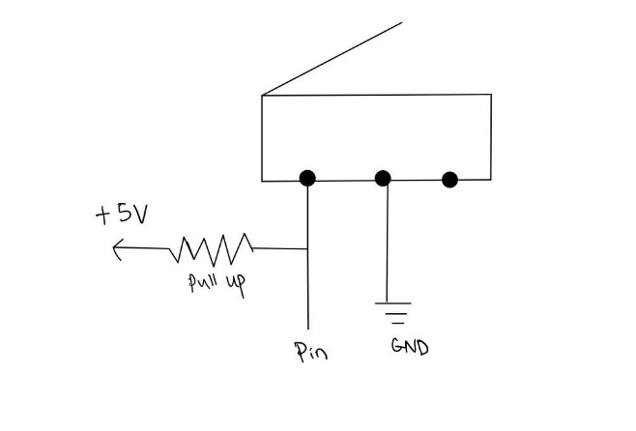

* 1. Configure GPIO input pin with pull-up register to determine the logic state of the bump switch. When the switch is open / not pressed, the pull-up resistor connects the input pin to VCC (logic 1) and the pin goes to logic 0 (ground) when the switch is closed / pressed.

1. Section 6.3. Write down the GPIO configuration used for pins connected to the Bump switches IF they are connected to Pin6.0 to P6.5.
   1. P6->SEL0 &= ~0x3F;   
      P6->SEL1 &= ~0x3F; // GPIO  
      P6->DIR &= ~0x3F; // input  
      P6->REN |= 0x3F; // enable register  
      P6->OUT |= 0x3F; // pull-up  
      P6->IES |= 0x3F; // falling edge  
      P6->IFG &= ~0x3F; // clear flag  
      P6->IE |= 0x3F; // enable interrupt  
      NVIC->IP[10] = (NVIC->IP[10]&0xFFFFFF00) | 0x00000040; // priority 2  
      NVIC->ISER[1] &= 0x00000100; //enable interrupt 40

1. Section 6.3. What is the frequency of the clock source of systick timer? Explain how systick timer is configured to interrupt the system at 1000Hz frequency. Illustrate with detail calculations and APIs used.
   1. Clock source is 48Mhz.

Systick timer generates an interrupt whenever the timer counts down to zero from its configured period in the reload register.   
SysTick_Init(48000,1) is used to configure the system at 1000Hz.  
48000 / 48 000 000 = 0.001

An interrupt is generated every 0.001 seconds i.e. 1000 times in 1 second, therefore the timer is configured at 1000Hz.

1. Section 6.3. What is the advantage the method of reading Reflectance sensor (in Lab3 section 6.3) has compared to the method used in Lab2?
   1. Lab 2 uses a spin loop to implement the time delay before sampling the capacitor discharge status. Spin loops are wasteful as it hogs the CPU.

Lab 3 uses systick timer to trigger periodic interrupts, so the CPU can be freed to perform other tasks during the time delay.

1. Section 6.4. Reference to PWM_Init34() in PWM.c, what is the timer base clock used to increment the counters in Timer_A0? Show the details of how this base clock of Timer_A0 is derived, starting from processor clock. Note that SMCLK=12Mhz.

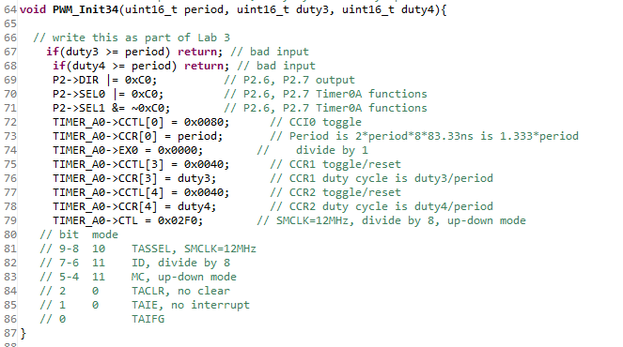

* 1. Timer_A0->CTL = 0x02F0 is used to configure the base clock of Timer_A0.   
     Bit 9-8 selects SMCLK which is 12MHz as the clock source. Bit 7-6 selects the clock divider ratio. In this case, it is divide-by-8.  
     Timer_A0->EX0 = 0x0000 is used to configure the second clock divider ratio. In this case, it is set to further divide-by-1.  
     The final base clock of Timer_A0 is 12/8 = 1.5MHz.

1. Section 6.5. What is the PWM frequency generated to the motor? illustrate with detail working.
   1. Clock of Timer_A0 is 1.5Mhz.

Timer_A0->CCR[0] = period is set to 7500. Since the clock is set to up/down mode and toggle/reset, the timer will count 2*7500 = 15000 for one PWM period.

To calculate the time period, 15 000 / 1 500 000 = 0.01s.

Frequency = 1 / period   
 = 1 / 0.01  
 = 100 Hz

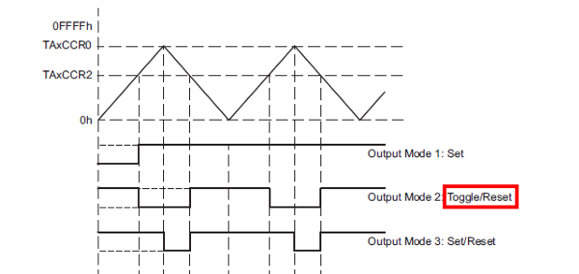

1. Section 6.5. Is interrupt mechanism used in the PWM generation via Timers?
   1. No.

Timer_A0->CTL = 0x02F0.  
Bit 1 is set to 0 which disables interrupt.

1. 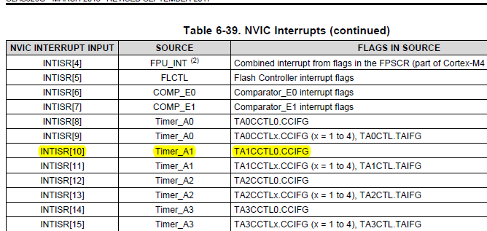Section 6.5. What is the IRQ number you need to reference to if Timer_A2 instead of Timer A1 is used in Lab3_TimerCompare_Motor project? What is the corresponding Exception number?
   1. IRQ 12.

NVIC->ISER[0] = 0x00001000;