SC2107 Lab2 Assignment Sheet (to be submitted to NTULearn before next lab)

Name:Chua Qin Di Lab Group: SCEB Date: 12 Sept 2024

1. Section 6.2. Give a short 2-3 lines description on concept behind the reflectance reading process. Why does the black surface result in slower voltage decay?
   1. A reflectance sensor measures the intensity of light reflected back from a surface. A black surface reflects less IR light than a white surface back to the transistor in the reflectance sensor, causing less current to flow through and discharge the capacitor at a slower rate.
2. Section 6.2. Which parameter do you need to tweak in the Reflectance_Read() if the reflectance sensor reading is not accurate? Hint: check the 8 steps for Reflectance reading.  
   1. “time” parameter in Clock_Delay1us(time).  
      Ensure that the appropriate time is set so that we can observe the different rate of discharge for white and black surface
3. Section 6.2. Write down the procedure to initialise P7.3 to be an input pin without internal pull-up resistor  
   1. P7->SEL0 &= ~0x08;  
      P7->SEL1 &= ~0x08;  
      P7->DIR &= ~0x08;  
      P7->REN &= ~0x08;
4. Section 6.3. Where are the sources of the offset error between actual distance and the estimated distance return by the function Reflectance_Position()?  
   1. 1. External light sources may interfere with the reading of the reflectance sensors

2. The elements in array W [ ], representing the position of the sensors from the centre of the reflectance PCB may have slight inaccuracies.

.

1. Section 7.2.  Figure 7. The robot state toggled between LEFT and CENTER state repeatedly when it is detected that the robot is off to the left of the line (input: ‘01’). If the outputs of the FSM states are connect to the input of the DC motor, how would the input signals to the DC motor looks like? Which wheel will move at a slower speed?  
   1. Right wheel will move at slower speed than left wheel. This will cause robot to turn right.

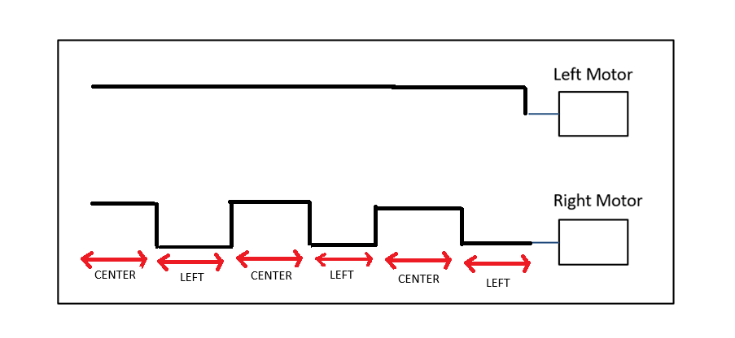

1. Section 7.3. Fix the bug in the 11-state FSM design.  
   A picture containing table

   Description automatically generated
   1. Edited Version:

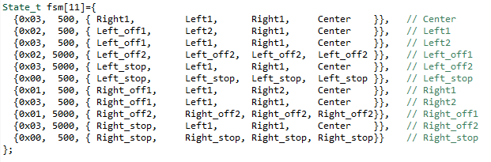

1. Section 7.3. What is the purpose of toggling LED within the main routine or ISR?  
   1. Toggling the LED allows the user to observe the current state and output of the FSM
2. Section 7.4. What hardware and software modifications are required in order for the robot to move within a lane, i.e. between two black lines, instead of following a line? Detail algorithm not required. Just one bullet point each for hardware and software.
   1. Hardware: Use the sensor at both ends of the PCB.   
      Software: Assuming the robot is placed in the center of the lane, when the left sensor senses the left black line, software should output to the motor to turn right. Vice versa for the right sensor.