Robotics II

Day 10: Control Systems II

Chua Tzong Lin

B7TB1703

chuatl@mems.mech.tohoku.ac.jp

The equation of motion of the given system is given as,

$$\left({0 \atop f}\right)= \left(\begin{matrix}I + m_{θ}{l_{g}}^{2} & m_{θ}l_{g}cos(θ) \\ m_{θ}l_{g}cos(θ) & m_{x}+m_{θ}\end{matrix}\right)\left({\ddot{θ} \atop \ddot{x} }\right)-\left({0 \atop m_{θ}l_{g}sin\left(θ\right) {\dot{θ}}^{2} }\right)–\left({m_{θ}{gl}_{g}sin(θ) \atop 0}\right)$$

After Linearization and Laplace Transforming,

$$\left\{\begin{aligned}F(s)=(m_{x}+m_{θ})s^{2}X(s){ + m}_{θ}l_{g}s^{2}θ(s) \\ 0= m_{θ}l_{g}s^{2}X(s)+(I + m_{θ}{l_{g}}^{2})s^{2}θ(s){- m}_{θ}{gl}_{g}θ(s)\end{aligned}\right.$$

The Transfer function is given by the following equation,

$$G\left(s\right)=\frac{θ(s)}{F(s)} \\ G\left(s\right)=\frac{1}{-\left[\frac{I(m_{x}+m_{θ})}{m_{θ}l_{g}}+m_{x}l_{g}\right]s^{2}+(m_{x}+m_{θ})g}$$

By utilizing the control theory for PD control,

$$F\left(s\right)= -K_{p}E\left(s\right)- K_{v}sE(s)$$

$$F\left(s\right)= -K_{p}\left[R\left(s\right)-θ\left(s\right)\right]+ K_{v}s\dot{θ}(s)$$

Taking R(s) as zero for out assumption,

$$F\left(s\right)= K_{p}θ(s)+ K_{v}sθ(s)$$

The combing with the transfer function resulting system is shown as the following equation,

$$\left\{\left[\frac{I\left(m_{x}+m_{θ}\right)}{m_{θ}l_{g}}+m_{x}l_{g}\right]s^{2}+ K_{v} s+\left[K_{p}-\left(m_{x}+m_{θ}\right)g\right]\right\}θ\left(s\right)=0$$

The poles of the system is given by the following equation,

$$s= \frac{-K_{v}±j\sqrt{4\left[\frac{I\left(m_{x}+m_{θ}\right)}{m_{θ}l_{g}}+m_{x}l_{g}\right]\left[K_{p}-\left(m_{x}+m_{θ}\right)g\right]-{K_{v}}^{2}}}{2\left[\frac{I\left(m_{x}+m_{θ}\right)}{m_{θ}l_{g}}+m_{x}l_{g}\right]}$$

1. “Stability Limit” behavior using PD control.

For a system operating at the stability limit, the Kv gain is zero, while the Kp­ gain is that satisfies the condition

$$K_{p}-\left(m_{x}+m_{θ}\right)g>0$$

Under this condition, the system behaves similarly to an un-damped mass spring system, which will oscillate about a given point.

The selected Kp gain values are:

* Kp = 15

The pole values are given as:

* s = 0.0 + 4.963j
* s = 0.0 - 4.963j
* Kp = 30

The pole values are given as:

* s = 0.0 + 8.073j
* s = 0.0 - 8.073j

The implemented python script is included under the filename [InvertedPendulum_odeint_Stability_Limit_1.py](Script/InvertedPendulum_odeint_Stability_Limit_1.py) and [InvertedPendulum_odeint_Stability_Limit_2.py](Script/InvertedPendulum_odeint_Stability_Limit_2.py).

The results are shown in figures 1.1 and 1.2.

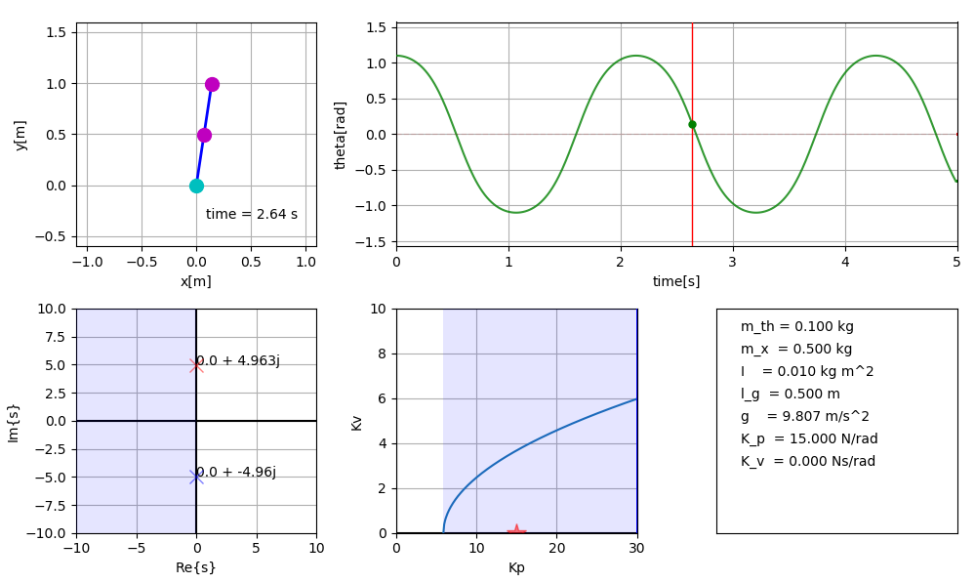

Figure 1.1 “Stability Limit” behavior with Kp­ gain of 15

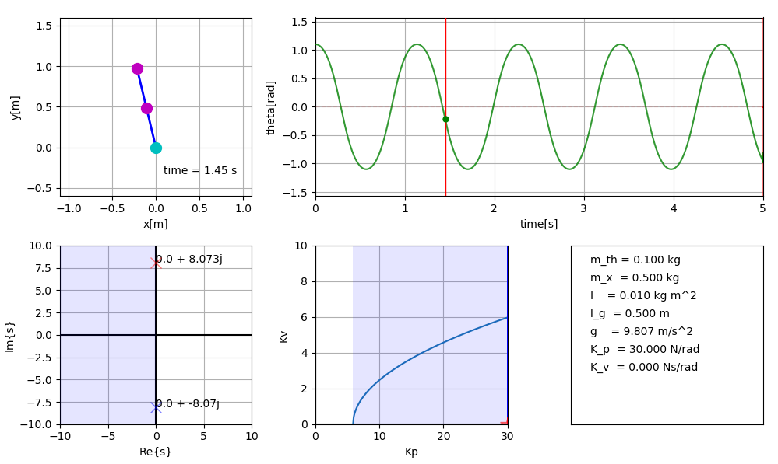

Figure 1.2 “Stability Limit” behavior with Kp­ gain of 30

1. “Critically Damped” behavior using PD control.

For a critically damped system, the Kv and Kp gain is selected to satisfy the following condition.

$$4\left[\frac{I\left(m_{x}+m_{θ}\right)}{m_{θ}l_{g}}+m_{x}l_{g}\right]\left[K_{p}-\left(m_{x}+m_{θ}\right)g\right]-{K_{v}}^{2}=0$$

The selected Kp and Kv gain values are:

* Kp = 15, Kv = 3.673

The pole values are given as:

* s = -4.96 + 0.0j

The implemented python script is included under the filename [InvertedPendulum_odeint_Critically_Damped.py](Script/InvertedPendulum_odeint_Critically_Damped.py).

The results are shown in figure 2.1.

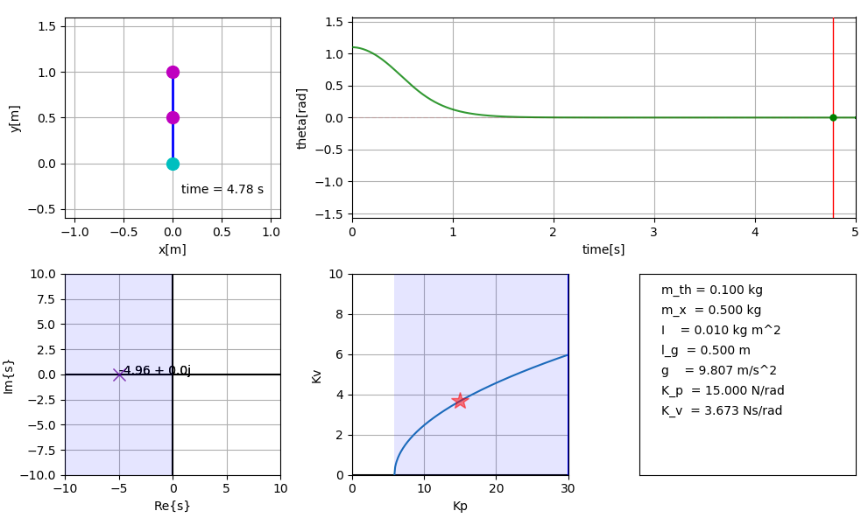

Figure 2.1 “Critically Damped” behavior with Kp­ gain of 15 and Kv­ gain of 3.673

1. “Over-damped” behavior using PD control.

An over-damped system realized when the Kp and Kv gains selected satisfies the following condition.

$$4\left[\frac{I\left(m_{x}+m_{θ}\right)}{m_{θ}l_{g}}+m_{x}l_{g}\right]\left[K_{p}-\left(m_{x}+m_{θ}\right)g\right]-{K_{v}}^{2}<0$$

The selected Kp and Kv gain values are:

* Kp = 15, Kv = 9

The pole values are given as:

* s = -23.2 + 0.0j
* s = -1.05 + 0.0j

The implemented python script is included under the filename [InvertedPendulum_odeint_Overdamped.py](Script/InvertedPendulum_odeint_Overdamped.py).

The results are shown in figure 3.1.

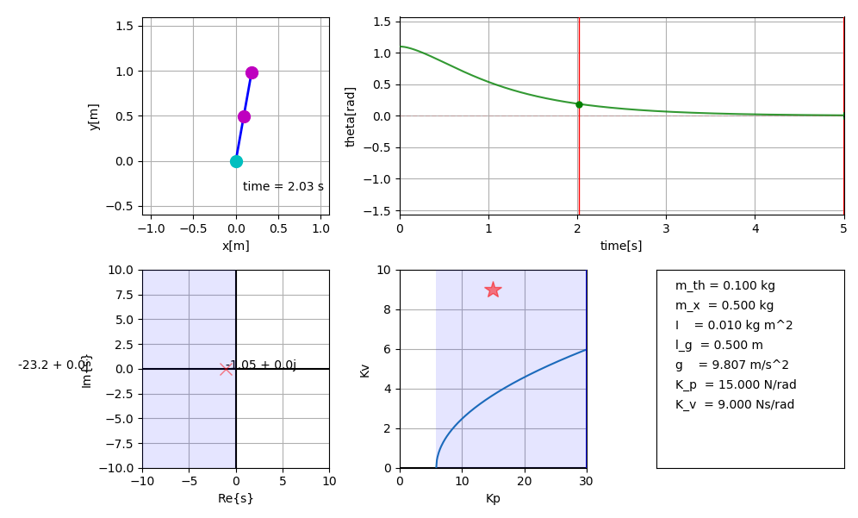

Figure 3.1 “Over-damped” behavior with Kp­ gain of 15 and Kv­ gain of 9

1. “Under-damped” behavior using PD control.

An over-damped system realized when the Kp and Kv gains selected satisfies the following condition.

$$4\left[\frac{I\left(m_{x}+m_{θ}\right)}{m_{θ}l_{g}}+m_{x}l_{g}\right]\left[K_{p}-\left(m_{x}+m_{θ}\right)g\right]-{K_{v}}^{2}>0$$

The selected Kp and Kv gain values are:

* Kp = 15, Kv = 1

The pole values are given as:

* s = 1.35 + 4.776j
* s = 1.35 - 4.776j

The implemented python script is included under the filename [InvertedPendulum_odeint_Underdamped.py](Script/InvertedPendulum_odeint_Underdamped.py).

The results are shown in figure 4.1.

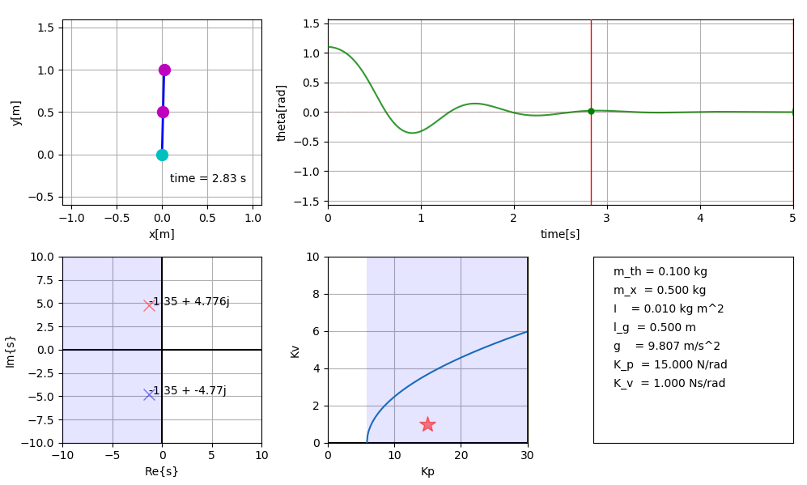

Figure 4.1 “Over-damped” behavior with Kp­ gain of 15 and Kv­ gain of 1