Robotics II

Day 7: Kinematics

1. Inverse Kinematics for 2 Link Mechanism.

The forward kinematics of the 2 Link Mechanism is given as:

$$X_{1}= L_{1 }cos⁡(θ_{1})$$

$$Y_{1}= L_{1 }sin⁡(θ_{1})$$

$$X_{2}=L_{1 }\cos\left(θ_{1}\right)+ L_{2}cos⁡(θ_{1} + θ_{2})$$

$$Y_{2}=L_{1 }\sin\left(θ_{1}\right)+ L_{2}sin⁡(θ_{1} + θ_{2})$$

The inverse kinematics of the 2 Link Mechanism is given as:

$$L= \sqrt{X_{2}^{2}+ Y_{2}^{2}} \\ θ_{1}= \tan^{-1}\left(\frac{Y_{2}}{X_{2}}\right)-\cos^{-1}\left(\frac{L_{1}^{2}+L^{2}-L_{2}^{2}}{2L_{1 }L}\right) \\ θ_{2}= π-\cos^{-1}\left(\frac{L_{1}^{2}+L_{2}^{2}-L^{2}}{2L_{1 }L_{2}}\right)$$

The simulation program is included under the filename [InverseKinematics_2Links.py](Completed/InverseKinematics_2Links.py).

The result is shown in the following figure 1.1.

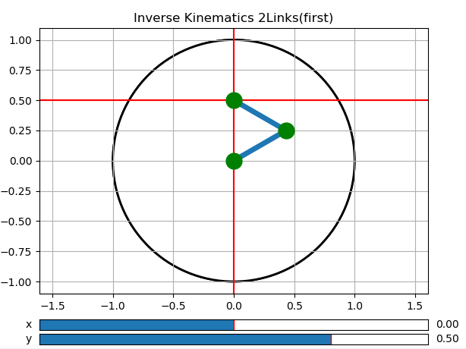

Figure 1.1 Inverse Kinematics for 2 Link Mechanism

1. Forward Kinematics for 4 Link Mechanism.

The forward kinematics of the 4 Link Mechanism in 2D is given as:

$$X_{1}= L_{1 }cos⁡(θ_{1})$$

$$Y_{1}= L_{1 }sin⁡(θ_{1})$$

$$X_{2}=L_{1 }\cos\left(θ_{1}\right)+ L_{2}cos⁡(θ_{1} + θ_{2}) \\ Y_{2}=L_{1 }\sin\left(θ_{1}\right)+ L_{2}sin⁡(θ_{1} + θ_{2})$$

$$X_{3}=L_{1 }\cos\left(θ_{1}\right)+ L_{2}\cos\left(θ_{1} + θ_{2}\right)+ L_{3}cos⁡(θ_{1} + θ_{2}+ θ_{3}) \\ Y_{3}=L_{1 }\sin\left(θ_{1}\right)+ L_{2}\sin\left(θ_{1} + θ_{2}\right)+ L_{3}sin(θ_{1} + θ_{2}+ θ_{3})$$

$$X_{4}=L_{1 }\cos\left(θ_{1}\right)+ L_{2}cos⁡(θ_{1} + θ_{2})+ L_{3}cos⁡(θ_{1} + θ_{2}+ θ_{3})+ L_{4}cos⁡(θ_{1} + θ_{2}+ θ_{3}+θ_{4}) \\ Y_{4}=L_{1 }\sin\left(θ_{1}\right)+ L_{2}sin⁡(θ_{1} + θ_{2})+ L_{3}sin(θ_{1} + θ_{2}+ θ_{3})+ L_{4}sin(θ_{1} + θ_{2}+ θ_{3}+θ_{4})$$

The forward kinematics of the 4 Link Mechanism in 3D is given as:

$$X_{1}= L_{1 }cos⁡(θ_{2})cos⁡(θ_{1}) \\ Y_{1}= L_{1 }cos⁡(θ_{2})sin⁡(θ_{1}) \\ Z_{1}= L_{1 }sin⁡(θ_{2})$$

$$X_{2}= X_{1}+ L_{2 }cos⁡(θ_{2} + θ_{4})cos⁡(θ_{1}+θ_{3}) \\ Y_{2}= Y_{1}+ L_{2 }cos⁡(θ_{2} + θ_{4})sin⁡(θ_{1}+θ_{3}) \\ Z_{2}=Z_{1}+ L_{2 }sin⁡(θ_{2} + θ_{4})$$

$$X_{3}= X_{2}+ L_{3 }cos⁡(θ_{2} + θ_{4}+ θ_{6})cos⁡(θ_{1}+θ_{3}+θ_{5}) \\ Y_{3}= Y_{2}+ L_{3}cos⁡(θ_{2} + θ_{4}+ θ_{6})sin⁡(θ_{1}+θ_{3}+θ_{5}) \\ Z_{3}=Z_{2}+ L_{3 }sin⁡(θ_{2} + θ_{4}+ θ_{6})$$

$$X_{4}= X_{3}+ L_{4 }cos⁡(θ_{2} + θ_{4}+ θ_{6}+θ_{8})cos⁡(θ_{1}+θ_{3}+θ_{5}+θ_{7}) \\ Y_{4}= Y_{3}+ L_{4}cos⁡(θ_{2} + θ_{4}+ θ_{6}+ θ_{8})sin⁡(θ_{1}+θ_{3}+θ_{5}+θ_{7}) \\ Z_{4}=Z_{3}+ L_{4 }sin⁡(θ_{2} + θ_{4}+ θ_{6}+ θ_{8})$$

The simulation program for 4 Link Mechanism is included under the filename [ForwardKinematics_4Links.py](Completed/ForwardKinematics_4Links.py) and [ForwardKinematics_4Links_3D.py](Completed/ForwardKinematics_4Links_3D.py).

The result for 4 Link Mechanism in 2 Dimensions is shown in Figure 2.1.

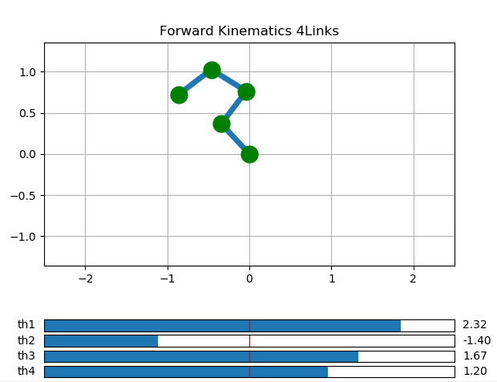

Figure 2.1 Forward Kinematic for 4 Link Mechanism in 2 Dimensions

The result for 4 Link Mechanism in 3 Dimensions is shown in Figure 2.2.

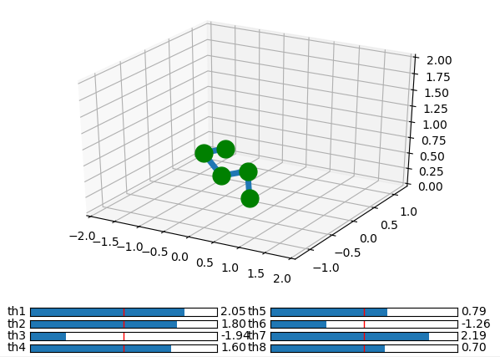

Figure 2.2 Forward Kinematic for 4 Link Mechanism in 3 Dimensions

1. Forward Kinematics for the 1st and 2nd system of a 2 Link Mechanism.

The systems for the 2 exercises are combined in a same system making it a system with 3 degrees of freedom. The forward kinematics of the combined system is similar as the system in Problem 1, however in this case $L_{1 }$ is not a constant but a variable, the Forward Kinematics is given as:

$$X_{1}= L_{1 }cos⁡(θ)$$

$$Y_{1}= L_{1 }sin⁡(θ)$$

$$X_{2}=L_{1 }\cos\left(θ\right)+ L_{2}cos⁡(θ + φ)$$

$$Y_{2}=L_{1 }\sin\left(θ\right)+ L_{2}sin⁡(θ + φ)$$

The simulation program is included under the filename [ForwardKinematics_2Links_Exc2_1st_&_2nd_System_Combined.py](Completed/ForwardKinematics_2Links_Exc2_1st_&_2nd_System_Combined.py).

The result for Forward Kinematics for the combined system is shown in figure 3.1.

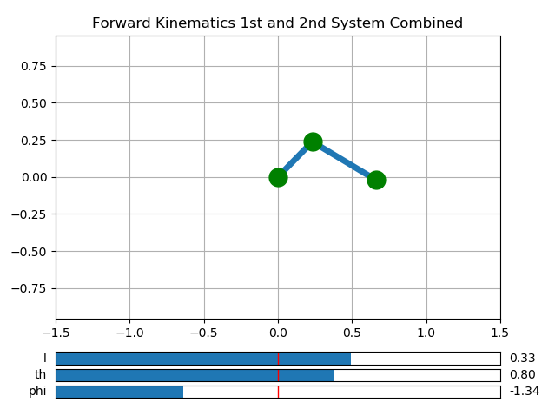

Figure 2.2 Forward Kinematic for the combined system

1. Inverse Kinematics for the 1st and 2nd system of a 2 Link Mechanism.

The Forward Kinematics of the 1st system is given as:

$$X_{1}= L_{1 } \\ Y_{1}= 0$$

$$X_{2}=L_{1 }+ L_{2}cos⁡(θ) \\ Y_{2}=L_{2}sin⁡(θ)$$

The Inverse Kinematics of the 1st system is given as:

$$θ= \left\{\begin{aligned}\sin^{-1}\left(\frac{Y_{2}}{L_{2}}\right) ,{ X}_{2}≥0 \\ {π- sin}^{-1}\left(\frac{Y_{2}}{L_{2}}\right),{ X}_{2}<0\end{aligned}\right.$$

$$L_{1 }= \left\{\begin{aligned}X_{2}- L_{2}cos⁡(θ) ,{ X}_{2}≥0 \\ X_{2}+ |{|L}_{2}cos⁡(θ)||,{ X}_{2}<0\end{aligned}\right.$$

The Forward Kinematics of the 2nd system is given as:

$$X_{1}= L_{1 }cos⁡(θ)$$

$$Y_{1}= L_{1 }sin⁡(θ)$$

$$X_{2}=(L_{1 }+ L_{2})cos⁡(θ) \\ Y_{2}=(L_{1 }+ L_{2})sin⁡(θ)$$

The Inverse Kinematics of the 2nd system is given as:

$$θ= \left\{\begin{aligned}\tan^{-1}\left(\frac{Y_{2}}{X_{2}}\right),{ X}_{2}≥0 \\ π+\tan^{-1}\left(\frac{Y_{2}}{X_{2}}\right), { X}_{2}<0\end{aligned}\right. \\ L_{1 }= \sqrt{X_{2}^{2}+ Y_{2}^{2}}-L_{2}$$

The Inverse Kinematics simulation programs for the 2 systems are included under the filename [InverseKinematics_2Links_Exc2_1st_System.py](Completed/InverseKinematics_2Links_Exc2_1st_System.py) and [InverseKinematics_2Links_Exc2_2nD_System.py](Completed/InverseKinematics_2Links_Exc2_2nD_System.py).

The result for Inverse Kinematics for the 1st and 2nd system is shown in figure 4.1 and figure 4.2 respectively.

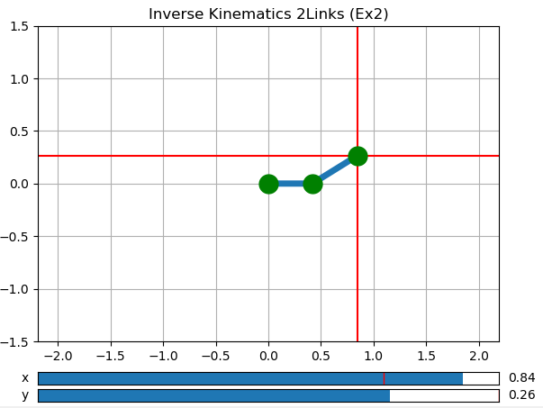

Figure 4.1 Inverse Kinematics for the 1st System

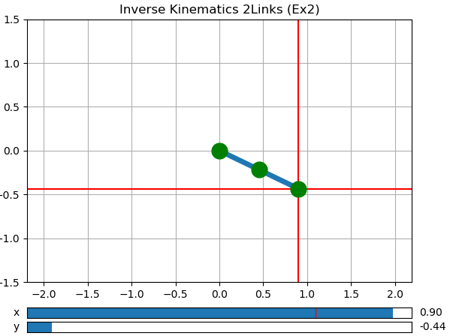

Figure 4.2 Inverse Kinematics for the 2nd System