Test for Normal Data

Test plan: Enter valid StaffID

Test data: 11023

Expected result: Program will accept StaffID and proceed to next data item, Name.

Actual Result: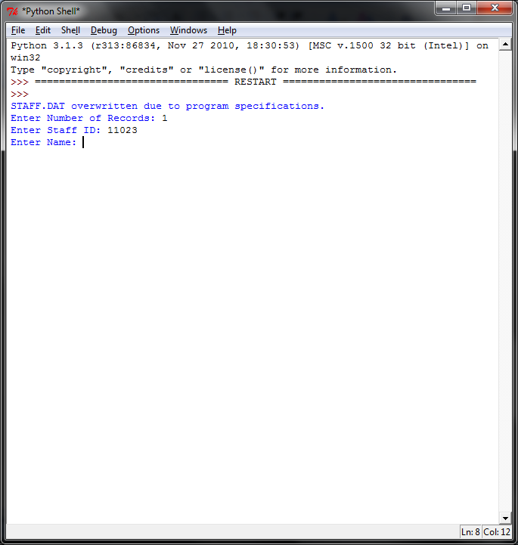

Test for Boundary Data

Test plan: Enter extreme value for StaffID

Test data: 11299, 20801

Expected result: Program will accept StaffID and proceed to next data item, Name.

Actual Result: 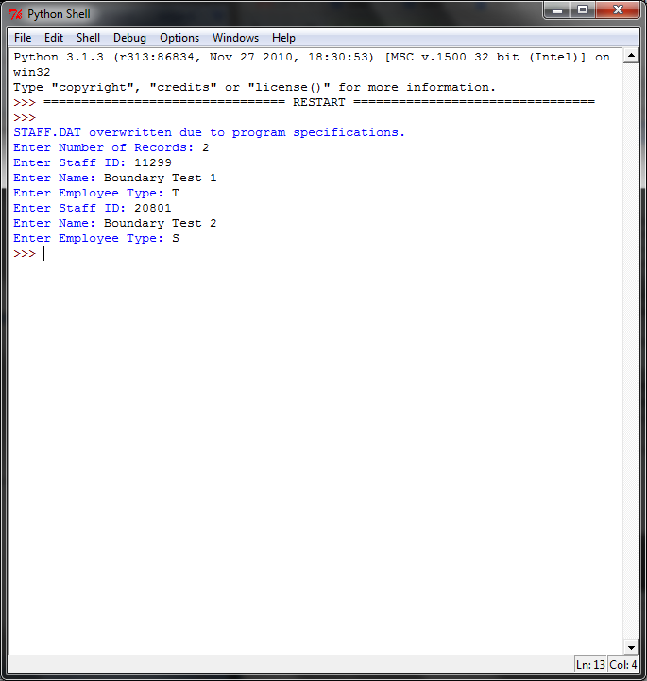

Test for Erroneous Data

Test plan: Enter erroneous value for StaffID

Test data: ifef8h3h, 2038297472849, 01400, 30700

Expected result: Program will not accept StaffID and display error message, prompting user to reenter StaffID

Actual Result: 