50 Filipino Pork Recipes

PART 1: CLASSIC FILIPINO PORK DISHES

1. Pork Adobo
Description: A classic Filipino dish made by simmering pork in soy sauce, vinegar, garlic, peppercorns, and bay leaves until tender and flavorful.
Serving Size: 5–6 persons
Ingredients:
- 1 kg pork belly or pork shoulder, cut into serving pieces
- ½ cup soy sauce
- ½ cup vinegar
- 1 cup water
- 1 whole garlic, crushed
- 1 medium onion, sliced (optional)
- 2 bay leaves
- 1 tsp whole peppercorns
- 1 tbsp cooking oil
- 1 tsp sugar (optional)
How to Cook Pork Adobo:
1. Combine the pork and soy sauce in a bowl. Marinate for at least 30 minutes.
2. Heat oil in a pot. Sauté garlic and onion until fragrant.
3. Add the marinated pork and cook until lightly browned.
4. Pour in the marinade, water, bay leaves, and peppercorns.
5. Bring to a boil, then lower the heat and simmer for 40–50 minutes or until the pork is tender.
6. Add vinegar. Let it simmer uncovered for 5 minutes without stirring.
7. Stir gently and continue cooking until the sauce reaches your preferred consistency.
8. Taste and adjust the seasoning before serving.
Tips in Cooking!
- Use pork belly for a richer, more flavorful adobo.
- Avoid adding too much water if you prefer a concentrated sauce.
- Refrigerate leftovers promptly in a covered container.

2. Pork Sinigang
Description: A comforting Filipino sour soup made with tender pork, tamarind broth, and assorted vegetables.
Serving Size: 5–6 persons
Ingredients:
- 1 kg pork ribs or pork belly
- 1 packet sinigang sa sampalok mix
- 8 cups water
- 1 medium onion, quartered
- 2 medium tomatoes, quartered
- 1 radish, sliced
- 1 eggplant, sliced
- 1 bunch kangkong
- 8–10 pieces string beans, cut into 2-inch pieces
- 2 green chilies
- Fish sauce to taste
How to Cook Pork Sinigang:
1. Place the pork and water in a pot. Bring to a boil and remove the scum that rises to the surface.
2. Add onion and tomatoes. Simmer for 45–60 minutes or until the pork is tender.
3. Add the sinigang mix and stir until dissolved.
4. Add radish and string beans. Cook for 3–5 minutes.
5. Add eggplant and green chilies. Simmer until the vegetables are tender.
6. Add kangkong last and cook for another 1–2 minutes.
7. Season with fish sauce according to taste.
8. Serve hot with steamed rice.
Tips in Cooking!
- Remove the scum regularly to keep the broth clear.
- Add vegetables according to their cooking time to prevent overcooking.
- Adjust the sourness gradually instead of adding the entire seasoning packet immediately.

3. Pork Menudo
Description: A Filipino tomato-based stew made with pork, liver, potatoes, carrots, and hotdogs or sausage.
Serving Size: 5–6 persons
Ingredients:
- 750 g pork shoulder, diced
- 200 g pork liver, diced
- 2 medium potatoes, diced
- 1 medium carrot, diced
- 2 pieces hotdogs, sliced
- 1 medium onion, chopped
- 4 cloves garlic, minced
- 1 cup tomato sauce
- 1 cup water
- ¼ cup soy sauce
- 2 tbsp cooking oil
- ½ cup green peas
- 1 small red bell pepper, diced
- Salt and pepper to taste
How to Cook Pork Menudo:
1. Heat oil in a pan. Sauté garlic and onion until fragrant.
2. Add pork and cook until lightly browned.
3. Pour in soy sauce and tomato sauce. Stir to coat the pork.
4. Add water and bring to a boil. Lower the heat and simmer for 35–45 minutes until tender.
5. Add potatoes and carrots. Cook until almost tender.
6. Add liver and hotdogs. Simmer for 5–7 minutes.
7. Add green peas and bell pepper.
8. Season with salt and pepper. Simmer briefly before serving.
Tips in Cooking!
- Cut the ingredients into uniform sizes for even cooking.
- Avoid overcooking the liver because it can become tough.
- Add a little water if the sauce becomes too thick before the pork is tender.

4. Pork Caldereta
Description: A rich Filipino tomato-based stew with tender pork, potatoes, carrots, bell peppers, and liver spread.
Serving Size: 5–6 persons
Ingredients:
- 1 kg pork shoulder, cubed
- 2 medium potatoes, cubed
- 1 medium carrot, cubed
- 1 red bell pepper, sliced
- 1 green bell pepper, sliced
- 1 medium onion, chopped
- 5 cloves garlic, minced
- 1 cup tomato sauce
- 2 tbsp tomato paste
- ½ cup liver spread
- 2 cups water or pork broth
- ¼ cup soy sauce
- 2 tbsp cooking oil
- 1 small can green peas
- Salt and pepper to taste
How to Cook Pork Caldereta:
1. Heat oil in a pot. Sauté garlic and onion.
2. Add pork and cook until lightly browned.
3. Pour in soy sauce and tomato sauce. Stir well.
4. Add water or broth and bring to a boil.
5. Lower the heat and simmer for 45–60 minutes until the pork is tender.
6. Stir in liver spread and tomato paste.
7. Add potatoes and carrots. Cook until tender.
8. Add bell peppers and green peas.
9. Season with salt and pepper. Simmer for another 3 minutes before serving.
Tips in Cooking!
- Liver spread gives caldereta its characteristic richness and thicker sauce.
- Add bell peppers near the end to retain their color and texture.
- Serve with rice or bread to enjoy the thick sauce.

5. Pork Mechado
Description: A Filipino tomato-based pork stew traditionally flavored with soy sauce, calamansi, garlic, and vegetables.
Serving Size: 5–6 persons
Ingredients:
- 1 kg pork shoulder, cubed
- 2 medium potatoes, quartered
- 1 medium carrot, sliced
- 1 medium onion, chopped
- 5 cloves garlic, minced
- 1 cup tomato sauce
- 2 tbsp tomato paste
- ¼ cup soy sauce
- 2 tbsp calamansi juice
- 2 cups water
- 2 tbsp cooking oil
- 1 bay leaf
- Salt and pepper to taste
How to Cook Pork Mechado:
1. Combine pork, soy sauce, and calamansi juice. Marinate for 30 minutes.
2. Heat oil in a pot. Sauté garlic and onion.
3. Add pork and cook until browned.
4. Pour in the marinade, tomato sauce, tomato paste, water, and bay leaf.
5. Bring to a boil, then simmer for 45–60 minutes until tender.
6. Add potatoes and carrots. Cook until soft.
7. Adjust the seasoning with salt and pepper.
8. Simmer until the sauce thickens slightly.
Tips in Cooking!
- Pork shoulder is suitable because it becomes tender during slow cooking.
- Brown the pork before simmering to develop deeper flavor.
- Keep the heat low to prevent the tomato sauce from scorching.

6. Pork Paksiw na Pata
Description: A savory and slightly sweet Filipino pork dish made with pork hock simmered in vinegar, soy sauce, garlic, and banana blossoms.
Serving Size: 5–6 persons
Ingredients:
- 1 kg pork pata, chopped
- ½ cup vinegar
- ½ cup soy sauce
- 5 cups water
- 1 head garlic, crushed
- 1 medium onion, sliced
- 2 bay leaves
- 1 tsp whole peppercorns
- 3 tbsp brown sugar
- ½ cup dried banana blossoms
- 2 tbsp cooking oil
How to Cook Pork Paksiw na Pata:
1. Wash the pork pata thoroughly and drain.
2. Heat oil in a pot. Sauté garlic and onion.
3. Add pork pata and cook until lightly browned.
4. Pour in vinegar, soy sauce, and water.
5. Add bay leaves and peppercorns. Bring to a boil without stirring for the first few minutes.
6. Lower the heat and simmer for 1½–2 hours or until tender.
7. Add brown sugar and banana blossoms.
8. Continue simmering until the sauce is flavorful and slightly thickened.
Tips in Cooking!
- Use a pressure cooker to shorten the cooking time if available.
- Soak dried banana blossoms before adding them to remove excess salt and impurities.
- Cook until the pork is tender but still holds its shape.

7. Pork Bistek Tagalog
Description: A Filipino-style pork steak cooked in soy sauce and calamansi, topped with tender onion rings.
Serving Size: 4–5 persons
Ingredients:
- 750 g pork shoulder or pork loin, thinly sliced
- ½ cup soy sauce
- ¼ cup calamansi juice
- 1 large onion, sliced into rings
- 4 cloves garlic, minced
- ½ cup water
- 2 tbsp cooking oil
- ½ tsp ground black pepper
- Salt to taste
How to Cook Pork Bistek Tagalog:
1. Combine soy sauce, calamansi juice, and black pepper.
2. Add the pork slices and marinate for 30 minutes.
3. Heat oil in a pan. Fry the onion rings until slightly softened. Remove and set aside.
4. In the same pan, sauté garlic.
5. Add the pork slices and cook until lightly browned.
6. Pour in the marinade and water.
7. Simmer for 15–20 minutes or until the pork is tender.
8. Return the onions to the pan and cook for another 2 minutes.
9. Serve with steamed rice.
Tips in Cooking!
- Slice the pork evenly so it cooks at the same rate.
- Do not overcook thin pork slices because they can become dry.
- Adjust the calamansi and soy sauce according to your preferred balance of sourness and saltiness.

8. Pork Giniling
Description: A simple Filipino ground pork dish cooked with tomato sauce, potatoes, carrots, and peas.
Serving Size: 4–5 persons
Ingredients:
- 500 g ground pork
- 2 medium potatoes, diced
- 1 medium carrot, diced
- 1 small onion, chopped
- 4 cloves garlic, minced
- 1 cup tomato sauce
- ½ cup water
- ¼ cup soy sauce
- ½ cup green peas
- 2 tbsp cooking oil
- Salt and pepper to taste
How to Cook Pork Giniling:
1. Heat oil in a pan. Sauté garlic and onion.
2. Add ground pork and cook until no longer pink.
3. Pour in soy sauce and stir.
4. Add tomato sauce and water. Bring to a simmer.
5. Add potatoes and carrots. Cover and cook until tender.
6. Add green peas and stir.
7. Season with salt and pepper.
8. Simmer until the sauce reaches your preferred consistency.
Tips in Cooking!
- Break up the ground pork while cooking to avoid large lumps.
- Drain excess fat if the dish becomes too oily.
- This dish is suitable for meal preparation because it reheats well when stored properly.

9. Pork Tocino
Description: A sweet and savory Filipino cured pork dish commonly served for breakfast with garlic rice and egg.
Serving Size: 4–5 persons
Ingredients:
- 750 g pork shoulder or pork belly, thinly sliced
- ½ cup brown sugar
- ¼ cup pineapple juice
- ¼ cup soy sauce
- 1 tbsp vinegar
- 5 cloves garlic, minced
- ½ tsp ground black pepper
- ½ tsp salt
- ½ tsp annatto powder (optional)
How to Cook Pork Tocino:
1. Combine brown sugar, pineapple juice, soy sauce, vinegar, garlic, pepper, salt, and annatto powder.
2. Add pork slices and mix until evenly coated.
3. Cover and refrigerate for at least 8 hours, preferably overnight.
4. Place the pork and marinade in a pan.
5. Add enough water to partially cover the pork.
6. Simmer until the liquid evaporates and the pork becomes tender.
7. Add a little oil if needed and cook until lightly caramelized.
8. Ensure the pork is thoroughly cooked before serving.
Tips in Cooking!
- Keep the pork refrigerated while marinating.
- Slice the pork evenly for consistent cooking.
- Use medium-low heat when caramelizing because the sugar can burn quickly.

10. Filipino Pork Longganisa
Description: A Filipino sausage made from ground pork seasoned with garlic, vinegar, sugar, and spices. It can be sweet or savory depending on the preferred style.
Serving Size: Approximately 8–10 pieces
Ingredients:
- 500 g ground pork
- ¼ cup brown sugar
- 2 tbsp soy sauce
- 2 tbsp vinegar
- 1 tbsp minced garlic
- 1 tsp salt
- ½ tsp ground black pepper
- ½ tsp paprika
- 1 tbsp cooking oil
- Sausage casing or food-safe plastic for shaping
How to Cook Filipino Pork Longganisa:
1. Combine ground pork, brown sugar, soy sauce, vinegar, garlic, salt, pepper, and paprika in a bowl.
2. Mix thoroughly until the seasonings are evenly distributed.
3. Cover and refrigerate for at least 4 hours.
4. Shape the mixture into small sausage links or patties. Use food-safe sausage casing if available.
5. Heat a pan over medium-low heat and add the longganisa.
6. Add a little water and cover the pan. Simmer until the water evaporates and the pork is cooked through.
7. Add oil if necessary and fry until browned.
8. Serve with garlic rice and egg.
Tips in Cooking!
- Keep the ground pork cold while preparing the mixture.
- Do not overmix because this can make the sausage dense.
- Cook thoroughly; ground pork should reach an internal temperature of 71°C.

PART 2: FRIED, GRILLED, AND SPECIAL PORK DISHES

11. Lechon Kawali
Description: A popular Filipino dish made with boiled pork belly that is deep-fried until the skin becomes golden and crispy.
Serving Size: 5–6 persons
Ingredients:
- 1 kg pork belly
- 1 tbsp salt
- 1 tsp whole peppercorns
- 3 bay leaves
- 5 cloves garlic
- Water for boiling
- Cooking oil for deep-frying
How to Cook Lechon Kawali:
1. Place pork belly in a pot with enough water to cover it.
2. Add salt, peppercorns, bay leaves, and garlic.
3. Bring to a boil, then simmer for 45–60 minutes or until tender.
4. Remove the pork and let it cool.
5. Pat the skin completely dry with paper towels.
6. Refrigerate uncovered for several hours or overnight to help dry the skin.
7. Heat cooking oil in a deep pot.
8. Carefully fry the pork until golden brown and crispy.
9. Drain excess oil and allow it to rest before slicing.
Tips in Cooking!
- Dry skin is essential for achieving crispiness.
- Avoid overcrowding the pot when frying.
- Use a splatter guard and lower the pork carefully into the oil.

12. Crispy Pata
Description: A Filipino celebration dish made from pork leg that is boiled until tender and deep-fried until the skin becomes crunchy.
Serving Size: 5–6 persons
Ingredients:
- 1 whole pork pata
- 1 tbsp salt
- 1 tsp whole peppercorns
- 3 bay leaves
- 1 head garlic
- 1 onion, quartered
- Water for boiling
- Cooking oil for deep-frying
For the Dipping Sauce:
- ½ cup vinegar
- ¼ cup soy sauce
- 1 small onion, chopped
- 2 cloves garlic, minced
- 1 chili, chopped (optional)
- ½ tsp sugar
- Ground black pepper to taste
How to Cook Crispy Pata:
1. Place the pork pata in a large pot and cover with water.
2. Add salt, peppercorns, bay leaves, garlic, and onion.
3. Simmer for 1½–2 hours or until tender.
4. Remove the pata and drain thoroughly.
5. Let it cool, then refrigerate uncovered until the skin is dry.
6. Heat oil in a deep pot.
7. Carefully deep-fry the pata until the skin is golden and crispy.
8. Drain excess oil and rest briefly before serving.
9. Combine all dipping sauce ingredients in a bowl.
10. Serve the crispy pata with the dipping sauce.
Tips in Cooking!
- Make sure the pata is completely dry before frying.
- Use a large, deep pot to reduce oil splatter.
- Do not leave the frying oil unattended.

13. Filipino Pork Barbecue
Description: Skewered pork slices marinated in a sweet, savory, and slightly tangy mixture, then grilled until caramelized.
Serving Size: 5–6 persons
Ingredients:
- 1 kg pork shoulder or pork kasim, thinly sliced
- ½ cup soy sauce
- ½ cup banana ketchup
- ¼ cup calamansi juice
- ½ cup brown sugar
- 5 cloves garlic, minced
- 1 tsp ground black pepper
- 2 tbsp cooking oil
- Bamboo skewers, soaked in water
How to Cook Filipino Pork Barbecue:
1. Combine soy sauce, banana ketchup, calamansi juice, brown sugar, garlic, pepper, and oil.
2. Add pork slices and mix thoroughly.
3. Cover and refrigerate for at least 4 hours or overnight.
4. Thread the pork slices onto soaked bamboo skewers.
5. Preheat the grill to medium heat.
6. Grill the pork, turning occasionally.
7. Brush with the remaining marinade that has been boiled before use.
8. Continue grilling until the pork is cooked through and lightly caramelized.
9. Serve hot.
Tips in Cooking!
- Cut pork into evenly sized pieces for uniform cooking.
- Soak bamboo skewers to prevent them from burning.
- Never brush cooked meat with marinade that has touched raw pork unless it has been boiled first.

14. Inihaw na Liempo
Description: Grilled pork belly marinated in a savory mixture of soy sauce, calamansi, garlic, and spices.
Serving Size: 5–6 persons
Ingredients:
- 1 kg pork belly, sliced
- ¼ cup soy sauce
- ¼ cup calamansi juice
- 5 cloves garlic, minced
- 1 tbsp brown sugar
- 1 tsp ground black pepper
- 1 tbsp cooking oil
For the Dipping Sauce:
- ¼ cup vinegar
- 1 small onion, chopped
- 2 cloves garlic, minced
- 1 chili, chopped
- Salt and pepper to taste
How to Cook Inihaw na Liempo:
1. Combine soy sauce, calamansi juice, garlic, brown sugar, pepper, and oil.
2. Add pork belly and marinate for at least 2 hours.
3. Preheat the grill to medium heat.
4. Grill the pork belly for approximately 5–8 minutes per side, depending on thickness.
5. Turn occasionally to prevent burning.
6. Continue grilling until fully cooked and lightly charred.
7. Combine the dipping sauce ingredients in a bowl.
8. Rest the pork briefly before slicing and serving.
Tips in Cooking!
- Avoid grilling over excessively high heat because pork belly fat can cause flare-ups.
- Use a meat thermometer to check doneness.
- Allow the meat to rest before slicing to retain its juices.

15. Pork Sisig
Description: A popular Filipino sizzling dish made with chopped pork, onions, chilies, and calamansi, often served on a hot plate.
Serving Size: 4–5 persons
Ingredients:
- 500 g pork face or pork belly, boiled
- 200 g pork liver, cooked
- 1 medium onion, finely chopped
- 3 cloves garlic, minced
- 2–3 green or red chilies, chopped
- 2 tbsp calamansi juice
- 2 tbsp soy sauce
- 1 tbsp mayonnaise (optional)
- 1 tbsp cooking oil
- Salt and pepper to taste
How to Cook Pork Sisig:
1. Boil the pork until tender. Drain and allow it to cool.
2. Grill or pan-fry the pork until the outside becomes slightly crispy.
3. Chop the pork into small pieces.
4. Cook the liver thoroughly, then chop it finely.
5. Heat oil in a pan. Sauté garlic and half of the onion.
6. Add chopped pork and liver.
7. Season with soy sauce, calamansi juice, salt, and pepper.
8. Add chilies and stir well.
9. Mix in mayonnaise if desired.
10. Transfer to a sizzling plate and top with the remaining onion.
Tips in Cooking!
- Use a mixture of pork cuts for different textures.
- Add calamansi gradually to control the sourness.
- Make sure the liver is fully cooked before mixing it into the dish.

16. Pork Humba
Description: A sweet and savory Visayan-style braised pork dish flavored with soy sauce, vinegar, brown sugar, black beans, and banana blossoms.
Serving Size: 5–6 persons
Ingredients:
- 1 kg pork belly, cubed
- ½ cup soy sauce
- ¼ cup vinegar
- ½ cup brown sugar
- 1 cup water
- 1 medium onion, sliced
- 5 cloves garlic, minced
- 2 bay leaves
- 1 tsp whole peppercorns
- 2 tbsp salted black beans (tausi)
- ½ cup dried banana blossoms
- 2 tbsp cooking oil
How to Cook Pork Humba:
1. Heat oil in a pot. Sauté garlic and onion.
2. Add pork belly and cook until lightly browned.
3. Pour in soy sauce and vinegar.
4. Add water, brown sugar, bay leaves, and peppercorns.
5. Bring to a boil, then lower the heat.
6. Simmer for 45–60 minutes or until the pork is tender.
7. Add black beans and banana blossoms.
8. Continue simmering until the sauce thickens and coats the pork.
9. Taste and adjust the sweetness or saltiness before serving.
Tips in Cooking!
- Rinse salted black beans briefly if they are excessively salty.
- Simmer slowly to allow the pork to absorb the sauce.
- Add water as needed to prevent the sauce from drying out too early.

17. Filipino Pork Asado
Description: A Filipino-style braised pork dish cooked in a sweet and savory sauce made with soy sauce, sugar, garlic, and spices.
Serving Size: 5–6 persons
Ingredients:
- 1 kg pork shoulder or pork kasim
- ½ cup soy sauce
- ¼ cup brown sugar
- 1 cup water
- 5 cloves garlic, minced
- 1 medium onion, chopped
- 2 tbsp oyster sauce
- 1 star anise
- 1 tbsp cooking oil
- ½ tsp ground black pepper
How to Cook Filipino Pork Asado:
1. Heat oil in a pot. Sauté garlic and onion.
2. Add pork and brown on all sides.
3. Combine soy sauce, brown sugar, oyster sauce, water, and pepper.
4. Pour the mixture into the pot.
5. Add star anise and bring to a boil.
6. Lower the heat and simmer for 50–60 minutes or until tender.
7. Turn the pork occasionally to coat it evenly.
8. Remove the pork and slice.
9. Simmer the remaining sauce until slightly thickened.
10. Pour the sauce over the sliced pork before serving.
Tips in Cooking!
- Pork shoulder works well for braising because it remains moist.
- Do not add too much sugar at the beginning; adjust after tasting.
- Slice the pork against the grain for a more tender texture.

18. Pork Afritada
Description: A Filipino tomato-based stew made with pork, potatoes, carrots, bell peppers, and tomato sauce.
Serving Size: 5–6 persons
Ingredients:
- 1 kg pork shoulder, cubed
- 2 medium potatoes, quartered
- 1 medium carrot, sliced
- 1 red bell pepper, sliced
- 1 green bell pepper, sliced
- 1 medium onion, chopped
- 5 cloves garlic, minced
- 1½ cups tomato sauce
- 2 cups water
- 2 tbsp soy sauce
- 2 tbsp cooking oil
- Salt and pepper to taste
How to Cook Pork Afritada:
1. Heat oil in a pot. Sauté garlic and onion.
2. Add pork and cook until lightly browned.
3. Pour in soy sauce and tomato sauce.
4. Add water and bring to a boil.
5. Lower the heat and simmer for 40–50 minutes until tender.
6. Add potatoes and carrots. Cook until almost tender.
7. Add bell peppers and simmer for another 3–5 minutes.
8. Season with salt and pepper.
9. Serve hot with rice.
Tips in Cooking!
- Brown the pork before adding liquid to improve flavor.
- Cut vegetables into similar sizes for even cooking.
- Add bell peppers last to keep them from becoming too soft.

19. Pininyahang Baboy
Description: A creamy Filipino pork dish cooked with pineapple chunks, vegetables, and milk or cream for a sweet and savory flavor.
Serving Size: 5–6 persons
Ingredients:
- 750 g pork shoulder, cubed
- 1 cup pineapple chunks
- ½ cup pineapple juice
- 1 medium carrot, sliced
- 1 red bell pepper, sliced
- 1 medium onion, chopped
- 4 cloves garlic, minced
- 1 cup evaporated milk
- ½ cup water
- 2 tbsp cooking oil
- Salt and pepper to taste
How to Cook Pininyahang Baboy:
1. Heat oil in a pot. Sauté garlic and onion.
2. Add pork and cook until lightly browned.
3. Pour in pineapple juice and water.
4. Cover and simmer for 35–45 minutes or until the pork is tender.
5. Add carrots and pineapple chunks.
6. Pour in evaporated milk and stir gently.
7. Add bell pepper and simmer over low heat for 3–5 minutes.
8. Season with salt and pepper.
9. Avoid boiling vigorously after adding the milk.
Tips in Cooking!
- Use unsweetened evaporated milk if you prefer a less sweet sauce.
- Add the milk near the end to reduce the risk of curdling.
- Balance the sweetness with a little salt or pepper.

20. Pork Binagoongan
Description: A savory Filipino pork dish cooked with shrimp paste, tomatoes, garlic, and chilies.
Serving Size: 5–6 persons
Ingredients:
- 750 g pork belly, cubed
- 3 tbsp bagoong alamang
- 3 medium tomatoes, chopped
- 1 medium onion, chopped
- 5 cloves garlic, minced
- 2 green chilies
- ½ cup water
- 1 tbsp vinegar
- 1 tbsp brown sugar (optional)
- 2 tbsp cooking oil
- Ground black pepper to taste
How to Cook Pork Binagoongan:
1. Boil pork belly in water until tender. Drain and reserve some cooking liquid.
2. Heat oil in a pan and sauté garlic and onion.
3. Add tomatoes and cook until softened.
4. Add bagoong alamang and stir.
5. Add the boiled pork and mix until coated.
6. Pour in water and vinegar.
7. Simmer for 10–15 minutes.
8. Add chilies and brown sugar if desired.
9. Season with pepper and serve with rice.
Tips in Cooking!
- Taste the bagoong before adding more because its saltiness varies by brand.
- Fry the boiled pork briefly before adding it for a richer flavor.
- Pair with fresh vegetables to balance the salty taste.

PART 3: FILIPINO PORK SOUPS

21. Pork Nilaga
Description: A simple Filipino boiled pork soup with cabbage, potatoes, corn, and other vegetables in a clear, savory broth.
Serving Size: 5–6 persons
Ingredients:
- 1 kg pork ribs or pork shoulder
- 8 cups water
- 1 medium onion, quartered
- 2 medium potatoes, quartered
- 1 small cabbage, quartered
- 2 pieces corn, cut into portions
- 1 bunch pechay
- 1 tsp whole peppercorns
- 2 tbsp fish sauce
- Salt to taste
How to Cook Pork Nilaga:
1. Place pork and water in a pot.
2. Bring to a boil and remove the scum.
3. Add onion and peppercorns.
4. Simmer for 45–60 minutes until the pork is tender.
5. Add corn and potatoes. Cook until almost tender.
6. Add cabbage and pechay.
7. Season with fish sauce and salt.
8. Simmer for another 2–3 minutes and serve hot.
Tips in Cooking!
- Skim the broth regularly for a cleaner soup.
- Add leafy vegetables last to preserve their color and texture.
- Use pork ribs for a more flavorful broth.

22. Pork Bulalo-Style Soup
Description: A comforting pork shank soup inspired by traditional bulalo, with tender meat, bone marrow, vegetables, and a clear broth.
Serving Size: 5–6 persons
Ingredients:
- 1 kg pork shanks with bone
- 8–10 cups water
- 1 medium onion, quartered
- 1 tsp whole peppercorns
- 2 corn cobs, cut into portions
- 2 medium potatoes, quartered
- 1 small cabbage, quartered
- 1 bunch pechay
- 2 tbsp fish sauce
- Salt to taste
How to Cook Pork Bulalo-Style Soup:
1. Place pork shanks in a large pot and cover with water.
2. Bring to a boil and remove the scum.
3. Add onion and peppercorns.
4. Simmer for 1½–2 hours or until the meat is tender.
5. Add corn and potatoes. Cook until tender.
6. Add cabbage and pechay.
7. Season with fish sauce and salt.
8. Simmer for a few minutes and serve hot.
Tips in Cooking!
- Slow cooking helps extract flavor from the bones.
- Add more hot water if the broth reduces too much.
- Refrigerate leftovers promptly and remove excess hardened fat if desired.

23. Pork Mami
Description: A Filipino noodle soup made with pork broth, egg noodles, sliced pork, and vegetables.
Serving Size: 4–5 persons
Ingredients:
- 500 g pork shoulder or pork bones
- 200 g egg noodles
- 8 cups water
- 1 medium onion, halved
- 4 cloves garlic, minced
- 1 tbsp soy sauce
- 1 tsp whole peppercorns
- 1 bunch pechay
- 2 tbsp cooking oil
- 2 hard-boiled eggs, halved
- Spring onions, chopped
- Salt to taste
How to Cook Pork Mami:
1. Boil pork in water with onion and peppercorns until tender.
2. Remove the pork, slice it thinly, and set aside.
3. Strain the broth if necessary.
4. Heat oil in a separate pan and sauté garlic until golden.
5. Add the garlic and soy sauce to the broth.
6. Season with salt.
7. Cook egg noodles according to package instructions.
8. Place noodles in serving bowls and add sliced pork.
9. Pour hot broth over the noodles.
10. Top with pechay, boiled egg, and spring onions.
Tips in Cooking!
- Use pork bones for a richer broth.
- Cook noodles separately to prevent the broth from becoming cloudy or starchy.
- Prepare toppings before serving to keep the noodles from becoming soggy.

24. Pork Monggo
Description: A nutritious Filipino mung bean stew cooked with pork, garlic, onion, tomatoes, and leafy vegetables.
Serving Size: 5–6 persons
Ingredients:
- 1 cup mung beans
- 250 g pork belly, diced
- 6 cups water
- 1 medium onion, chopped
- 3 cloves garlic, minced
- 2 medium tomatoes, chopped
- 1 bunch malunggay or spinach leaves
- 2 tbsp fish sauce
- 2 tbsp cooking oil
- Salt and pepper to taste
How to Cook Pork Monggo:
1. Rinse the mung beans thoroughly.
2. Place mung beans and water in a pot.
3. Boil for 30–40 minutes or until soft.
4. Heat oil in a separate pan. Sauté garlic, onion, and tomatoes.
5. Add pork and cook until lightly browned.
6. Add fish sauce and cook briefly.
7. Transfer the pork mixture to the cooked mung beans.
8. Simmer for 10–15 minutes.
9. Add malunggay or spinach leaves.
10. Season with salt and pepper before serving.
Tips in Cooking!
- Soaking mung beans for several hours can reduce cooking time.
- Stir occasionally to prevent the beans from sticking to the bottom.
- Add leafy vegetables near the end to retain their nutrients and color.

25. Pork Batchoy
Description: A flavorful noodle soup inspired by La Paz batchoy, traditionally made with pork, liver, noodles, broth, and crunchy toppings.
Serving Size: 4–5 persons
Ingredients:
- 300 g pork shoulder, thinly sliced
- 100 g pork liver, thinly sliced
- 200 g fresh miki noodles
- 8 cups pork broth or water
- 4 cloves garlic, minced
- 1 medium onion, chopped
- 2 tbsp fish sauce
- 1 tbsp soy sauce
- 2 tbsp cooking oil
- ½ tsp ground black pepper
- Crushed chicharon for topping
- Spring onions, chopped
- Fried garlic for topping
How to Cook Pork Batchoy:
1. Heat oil in a pot. Sauté garlic and onion.
2. Add pork and cook until lightly browned.
3. Pour in pork broth and bring to a boil.
4. Add fish sauce, soy sauce, and black pepper.
5. Simmer until the pork is tender.
6. Add liver and cook thoroughly.
7. Cook the miki noodles according to package instructions.
8. Place noodles in serving bowls.
9. Pour hot broth and pork mixture over the noodles.
10. Top with crushed chicharon, fried garlic, and spring onions.
Tips in Cooking!
- Avoid overcooking the liver because it can become tough.
- Prepare the noodles separately if they are likely to absorb too much broth.
- Add chicharon immediately before serving to maintain its crunch.

26. Pork Sinampalukang Baboy
Description: A sour Filipino pork soup made with tamarind, tomatoes, ginger, and leafy vegetables.
Serving Size: 5–6 persons
Ingredients:
- 750 g pork ribs or pork shoulder
- 8 cups water
- 1 cup tamarind pulp or 1 packet tamarind soup mix
- 1 medium onion, sliced
- 2 medium tomatoes, quartered
- 1 thumb-sized ginger, sliced
- 1 bunch kangkong
- 8 pieces string beans
- 2 green chilies
- 2 tbsp fish sauce
- Salt to taste
How to Cook Pork Sinampalukang Baboy:
1. Place pork and water in a pot. Bring to a boil and remove the scum.
2. Add ginger, onion, and tomatoes.
3. Simmer for 45–60 minutes or until the pork is tender.
4. Add tamarind pulp or soup mix and stir.
5. Add string beans and green chilies.
6. Simmer until the vegetables are nearly tender.
7. Add kangkong.
8. Season with fish sauce and salt.
9. Serve hot.
Tips in Cooking!
- Adjust the tamarind gradually to avoid making the soup too sour.
- Fresh tamarind can be boiled and strained to make a more natural sour broth.
- Avoid overcooking the leafy vegetables.

27. Pork Misua Soup
Description: A light Filipino noodle soup made with thin misua noodles, ground pork, garlic, onion, and patola or sponge gourd.
Serving Size: 4–5 persons
Ingredients:
- 250 g ground pork
- 100 g misua noodles
- 1 medium patola, peeled and sliced
- 6 cups water or pork broth
- 1 medium onion, chopped
- 4 cloves garlic, minced
- 2 tbsp fish sauce
- 1 tbsp cooking oil
- Ground black pepper to taste
- Spring onions, chopped
How to Cook Pork Misua Soup:
1. Heat oil in a pot. Sauté garlic and onion.
2. Add ground pork and cook until no longer pink.
3. Add fish sauce and black pepper.
4. Pour in water or broth and bring to a boil.
5. Add patola and cook until slightly tender.
6. Add misua noodles and stir gently.
7. Cook for 2–3 minutes or according to package instructions.
8. Adjust the seasoning.
9. Garnish with spring onions and serve hot.
Tips in Cooking!
- Add misua only near the end because it cooks quickly.
- Use enough broth because misua absorbs liquid.
- Serve immediately to prevent the noodles from becoming too soft.

28. Pork Sopas
Description: A creamy Filipino macaroni soup made with pork, milk, cabbage, carrots, and elbow macaroni.
Serving Size: 5–6 persons
Ingredients:
- 250 g pork shoulder, diced
- 1½ cups elbow macaroni
- 6 cups water or pork broth
- 1 cup evaporated milk
- 1 medium carrot, diced
- 1 small cabbage, shredded
- 1 medium onion, chopped
- 4 cloves garlic, minced
- 2 tbsp cooking oil
- Salt and pepper to taste
How to Cook Pork Sopas:
1. Heat oil in a pot. Sauté garlic and onion.
2. Add pork and cook until lightly browned.
3. Pour in water or broth and bring to a boil.
4. Simmer until the pork is tender.
5. Add elbow macaroni and cook according to package instructions.
6. Add carrots and cook until tender.
7. Pour in evaporated milk and stir gently.
8. Add cabbage and simmer for 2–3 minutes.
9. Season with salt and pepper.
10. Serve while warm.
Tips in Cooking!
- Avoid overcooking macaroni because it continues absorbing liquid.
- Add milk over low heat to prevent scorching.
- Add more broth when reheating because the pasta thickens the soup.

29. Pork Upo Soup
Description: A light and comforting Filipino soup made with pork, bottle gourd, garlic, onion, and a clear savory broth.
Serving Size: 4–5 persons
Ingredients:
- 300 g pork shoulder, thinly sliced
- 1 medium upo, peeled and sliced
- 6 cups water
- 1 medium onion, sliced
- 4 cloves garlic, minced
- 2 tbsp fish sauce
- 1 tbsp cooking oil
- Ground black pepper to taste
- Spring onions, chopped
How to Cook Pork Upo Soup:
1. Heat oil in a pot. Sauté garlic and onion.
2. Add pork and cook until lightly browned.
3. Add fish sauce and stir.
4. Pour in water and bring to a boil.
5. Simmer until the pork is tender.
6. Add sliced upo and cook for 5–8 minutes or until tender.
7. Season with black pepper.
8. Garnish with spring onions and serve hot.
Tips in Cooking!
- Avoid overcooking upo because it softens quickly.
- Choose a fresh, firm bottle gourd.
- Cut the upo into uniform pieces for even cooking.

30. Pork Sinabawang Repolyo
Description: A simple Filipino cabbage soup with pork slices, garlic, onion, and a light savory broth.
Serving Size: 4–5 persons
Ingredients:
- 300 g pork shoulder, thinly sliced
- 1 small cabbage, cut into wedges
- 6 cups water
- 1 medium onion, sliced
- 4 cloves garlic, minced
- 1 medium carrot, sliced
- 2 tbsp fish sauce
- 1 tbsp cooking oil
- Ground black pepper to taste
How to Cook Pork Sinabawang Repolyo:
1. Heat oil in a pot. Sauté garlic and onion.
2. Add pork and cook until lightly browned.
3. Pour in water and bring to a boil.
4. Simmer until the pork is tender.
5. Add carrots and cook for 3–4 minutes.
6. Add cabbage and simmer until slightly softened.
7. Season with fish sauce and black pepper.
8. Serve hot.
Tips in Cooking!
- Add cabbage near the end to preserve its texture.
- Use pork ribs or pork shoulder for a more flavorful broth.
- Avoid cooking the cabbage for too long because it can become mushy.

PART 4: REGIONAL AND TRADITIONAL FILIPINO PORK DISHES

31. Bicol Express
Description: A spicy Filipino dish from the Bicol region made with pork, coconut milk, chilies, and shrimp paste.
Serving Size: 5–6 persons
Ingredients:
- 750 g pork belly, sliced
- 2 cups coconut milk
- 1 cup coconut cream
- 3 tbsp bagoong alamang
- 1 medium onion, chopped
- 5 cloves garlic, minced
- 1 thumb-sized ginger, minced
- 5–8 pieces red or green chilies, sliced
- 1 tbsp cooking oil
- Ground black pepper to taste
How to Cook Bicol Express:
1. Heat oil in a pan. Sauté garlic, onion, and ginger.
2. Add pork and cook until lightly browned.
3. Add bagoong alamang and stir.
4. Pour in coconut milk.
5. Bring to a gentle boil, then simmer for 30–40 minutes until the pork is tender.
6. Add chilies and coconut cream.
7. Continue simmering over low heat until the sauce thickens.
8. Adjust the seasoning and serve with rice.
Tips in Cooking!
- Adjust the number of chilies according to your preferred spice level.
- Taste the bagoong before adding additional salt.
- Simmer gently after adding coconut cream to prevent separation.

32. Laing with Pork
Description: A traditional Bicolano dish made with dried taro leaves simmered in coconut milk, pork, chilies, and shrimp paste.
Serving Size: 5–6 persons
Ingredients:
- 100 g dried taro leaves
- 300 g pork belly, diced
- 2 cups coconut milk
- 1 cup coconut cream
- 2 tbsp bagoong alamang
- 1 medium onion, chopped
- 5 cloves garlic, minced
- 1 thumb-sized ginger, sliced
- 3–5 pieces chilies
- 1 cup water
How to Cook Laing with Pork:
1. Place pork, garlic, onion, ginger, and water in a pot.
2. Simmer until the pork is tender.
3. Add bagoong alamang and stir.
4. Pour in coconut milk.
5. Add dried taro leaves on top. Do not stir immediately.
6. Cover and simmer over low heat for 25–30 minutes.
7. Once the leaves have softened, stir gently.
8. Add chilies and coconut cream.
9. Continue simmering until the sauce thickens and the leaves are fully cooked.
10. Serve with steamed rice.
Tips in Cooking!
- Do not eat raw or undercooked taro leaves; cook them thoroughly to reduce irritating calcium oxalate crystals.
- Avoid stirring the leaves too early because this can make the dish gritty.
- Use low heat to prevent the coconut milk from scorching.

33. Pinakbet with Pork
Description: A traditional Filipino vegetable stew made with pork, bagoong, squash, eggplant, okra, bitter melon, and other vegetables.
Serving Size: 5–6 persons
Ingredients:
- 300 g pork belly, sliced
- 1 cup squash, cubed
- 1 medium eggplant, sliced
- 1 cup okra
- 1 small ampalaya, sliced
- 1 cup string beans, cut into portions
- 2 medium tomatoes, chopped
- 1 medium onion, sliced
- 4 cloves garlic, minced
- 2 tbsp bagoong alamang
- 1 cup water
- 1 tbsp cooking oil
How to Cook Pinakbet with Pork:
1. Heat oil in a pot. Sauté garlic, onion, and tomatoes.
2. Add pork and cook until lightly browned.
3. Add bagoong alamang and stir.
4. Pour in water and bring to a simmer.
5. Add squash and string beans.
6. Cover and cook for 5 minutes.
7. Add eggplant, okra, and ampalaya.
8. Simmer until the vegetables are tender but not mushy.
9. Adjust the seasoning and serve.
Tips in Cooking!
- Add vegetables according to their cooking time.
- Avoid excessive stirring to keep the vegetables intact.
- Use fresh seasonal vegetables to make the dish more affordable.

34. Pork Dinakdakan
Description: An Ilocano pork dish made with grilled or boiled pork parts, onions, chilies, vinegar, and a creamy dressing traditionally made with pig brain.
Serving Size: 4–5 persons
Ingredients:
- 500 g pork belly or pork face
- 200 g pork ears (optional)
- 1 medium onion, sliced
- 2–3 chilies, chopped
- ¼ cup vinegar
- 2 tbsp calamansi juice
- 1 tbsp soy sauce
- ½ tsp ground black pepper
- 2 tbsp mayonnaise as an accessible alternative to traditional brain dressing
- Salt to taste
How to Cook Pork Dinakdakan:
1. Boil pork belly and pork ears in water until tender.
2. Drain and allow the pork to cool.
3. Grill or pan-fry the pork until lightly charred.
4. Slice the pork into bite-sized pieces.
5. In a bowl, combine vinegar, calamansi juice, soy sauce, and black pepper.
6. Add sliced pork, onion, and chilies.
7. Mix in mayonnaise if using.
8. Toss until evenly coated.
9. Adjust the seasoning and serve.
Tips in Cooking!
- Grill the pork for a smoky flavor.
- Add the dressing gradually to avoid making the dish too sour or creamy.
- Keep the prepared dish refrigerated if it will not be served immediately.

35. Bagnet
Description: A traditional Ilocano deep-fried pork belly dish known for its crispy skin and tender meat.
Serving Size: 5–6 persons
Ingredients:
- 1 kg pork belly
- 1 tbsp salt
- 1 tsp whole peppercorns
- 3 bay leaves
- 5 cloves garlic
- Water for boiling
- Cooking oil for deep-frying
For the Dipping Sauce:
- ¼ cup vinegar
- 1 small onion, chopped
- 2 tomatoes, chopped
- 1 chili, chopped
- Salt and pepper to taste
How to Cook Bagnet:
1. Place pork belly in a pot and cover with water.
2. Add salt, peppercorns, bay leaves, and garlic.
3. Simmer for 45–60 minutes until tender.
4. Remove the pork and drain thoroughly.
5. Let it cool, then refrigerate uncovered until the skin is dry.
6. Heat oil in a deep pot.
7. Carefully fry the pork until the skin becomes golden and crispy.
8. Drain excess oil and allow it to rest.
9. Combine the dipping sauce ingredients in a bowl.
10. Slice the bagnet and serve with the sauce.
Tips in Cooking!
- Drying the pork skin is important for crispiness.
- Fry carefully because moisture on the pork can cause oil splattering.
- Store leftovers in the refrigerator and reheat thoroughly.

36. KBL (Kadyos, Baboy, Langka)
Description: A traditional Ilonggo soup made with pigeon peas, pork, and unripe jackfruit, often flavored with batwan or another souring ingredient.
Serving Size: 5–6 persons
Ingredients:
- 500 g pork ribs or pork belly
- 1 cup kadyos (pigeon peas)
- 2 cups unripe jackfruit, sliced
- 8 cups water
- 1 medium onion, quartered
- 2 medium tomatoes, quartered
- 4–6 pieces batwan or 1 packet sinigang mix
- 2 tbsp fish sauce
- Salt to taste
How to Cook KBL (Kadyos, Baboy, Langka):
1. Rinse the kadyos thoroughly.
2. Place pork, kadyos, and water in a pot.
3. Bring to a boil and remove the scum.
4. Simmer until the pork and beans are tender. This may take longer if the beans are not soaked.
5. Add onion and tomatoes.
6. Add unripe jackfruit and cook until tender.
7. Add batwan or souring mix.
8. Season with fish sauce and salt.
9. Simmer briefly and serve hot.
Tips in Cooking!
- Soak dried kadyos overnight to reduce cooking time.
- Check the beans regularly because cooking time varies.
- Add souring ingredients after the beans are tender to help control the flavor.

37. Pork Kilawin
Description: A Filipino-style pork dish made with thoroughly cooked or grilled pork mixed with vinegar, onions, ginger, and chilies.
Serving Size: 4–5 persons
Ingredients:
- 500 g pork belly or pork shoulder
- ½ cup vinegar
- 1 medium onion, sliced
- 1 thumb-sized ginger, minced
- 2 chilies, chopped
- 2 tbsp calamansi juice
- ½ tsp ground black pepper
- Salt to taste
How to Cook Pork Kilawin:
1. Boil the pork in water until fully cooked and tender.
2. Drain and allow it to cool.
3. Grill or pan-fry the pork until lightly browned.
4. Slice the pork into bite-sized pieces.
5. In a bowl, combine vinegar, calamansi juice, onion, ginger, chilies, and pepper.
6. Add the cooked pork and toss well.
7. Season with salt.
8. Allow the mixture to rest briefly in the refrigerator before serving.
Tips in Cooking!
- This version uses fully cooked pork rather than raw pork.
- Keep the dish refrigerated and do not leave it at room temperature for extended periods.
- Adjust the vinegar and calamansi according to your preferred sourness.

38. Pork Embutido
Description: A Filipino steamed or baked meatloaf made with ground pork, vegetables, raisins, cheese, and hard-boiled eggs.
Serving Size: 6–8 persons
Ingredients:
- 500 g ground pork
- 1 small carrot, finely grated
- ½ cup raisins
- ½ cup grated cheese
- ½ cup breadcrumbs
- 2 eggs
- 1 small onion, finely chopped
- 3 cloves garlic, minced
- 2 tbsp soy sauce
- ½ tsp ground black pepper
- 2 hard-boiled eggs, peeled
- 2 hotdogs, sliced lengthwise
- Aluminum foil
How to Cook Pork Embutido:
1. Combine ground pork, carrot, raisins, cheese, breadcrumbs, raw eggs, onion, garlic, soy sauce, and pepper.
2. Mix until the ingredients are evenly distributed.
3. Lay a sheet of aluminum foil on a flat surface.
4. Spread a portion of the mixture over the foil.
5. Place hard-boiled egg halves and hotdog slices in the center.
6. Roll the mixture tightly into a log and seal the foil.
7. Steam for 45–60 minutes or until fully cooked.
8. Allow the embutido to cool before unwrapping and slicing.
9. Pan-fry slices if a browned exterior is desired.
Tips in Cooking!
- Avoid overmixing the meat to maintain a tender texture.
- Wrap the embutido tightly to help it retain its shape.
- Cool completely before slicing to prevent crumbling.

39. Lumpiang Shanghai
Description: A popular Filipino appetizer made with seasoned ground pork and vegetables wrapped in thin spring roll wrappers, then deep-fried until crispy.
Serving Size: Approximately 25–30 pieces
Ingredients:
- 500 g ground pork
- 1 small carrot, finely grated
- 1 medium onion, finely chopped
- 3 cloves garlic, minced
- 1 egg
- 2 tbsp soy sauce
- ½ tsp ground black pepper
- 1 tbsp chopped spring onions
- 25–30 lumpia wrappers
- Water for sealing
- Cooking oil for frying
How to Cook Lumpiang Shanghai:
1. Combine ground pork, carrot, onion, garlic, egg, soy sauce, pepper, and spring onions.
2. Mix until evenly combined.
3. Place a small amount of filling near the edge of each wrapper.
4. Fold the sides inward and roll tightly.
5. Moisten the edge with water to seal.
6. Heat cooking oil in a deep pan.
7. Fry the lumpia in batches until golden brown and fully cooked.
8. Drain on a wire rack or paper towels.
9. Serve with sweet chili sauce or banana ketchup.
Tips in Cooking!
- Avoid adding too much filling because it can cause the wrappers to break.
- Keep unused wrappers covered with a damp cloth to prevent drying.
- Ground pork filling must reach an internal temperature of 71°C.

40. Pork Siomai
Description: A Filipino-Chinese-inspired dumpling made with seasoned ground pork, vegetables, and wonton wrappers, usually served with soy sauce and calamansi.
Serving Size: Approximately 20 pieces
Ingredients:
- 500 g ground pork
- ½ cup finely chopped shrimp (optional)
- ½ cup grated carrot
- 1 small onion, finely chopped
- 3 cloves garlic, minced
- 2 tbsp soy sauce
- 1 tbsp oyster sauce
- 1 tsp sesame oil
- ½ tsp ground black pepper
- 1 egg
- 20 siomai or wonton wrappers
How to Cook Pork Siomai:
1. Combine ground pork, shrimp, carrot, onion, garlic, soy sauce, oyster sauce, sesame oil, pepper, and egg.
2. Mix until evenly combined.
3. Place a spoonful of filling in the center of each wrapper.
4. Gather the sides of the wrapper around the filling, leaving the top open.
5. Arrange the siomai in a lightly greased steamer.
6. Steam for approximately 15–20 minutes or until the pork is fully cooked.
7. Remove carefully and serve with soy sauce, calamansi, and chili garlic sauce.
Tips in Cooking!
- Do not overfill the wrappers.
- Leave enough space between dumplings to allow steam to circulate.
- Keep uncooked siomai refrigerated or frozen until ready to cook.

PART 5: EVERYDAY AND SPECIAL-OCCASION PORK RECIPES
41. Pork Kilayin (Kapampangan)
Description: A traditional Kapampangan pork dish made with pork, liver, and vinegar, cooked with garlic, onions, and spices. It has a savory and slightly tangy flavor.
Serving Size: 4–5 persons
Ingredients:
- 500 g pork shoulder, diced
- 150 g pork liver, diced
- ¼ cup vinegar
- ¼ cup water
- ¼ cup pork broth or water
- 1 medium onion, chopped
- 5 cloves garlic, minced
- 2 tbsp cooking oil
- 2 tbsp soy sauce
- 1 tsp whole peppercorns
- 2 bay leaves
- ½ tsp salt, or to taste
- ½ tsp ground black pepper
How to Cook Pork Kilayin (Kapampangan):
1. Wash and prepare the pork and liver. Cut them into small, bite-sized cubes.
2. Heat cooking oil in a pan. Sauté the garlic and onion until fragrant and softened.
3. Add the pork and cook until lightly browned.
4. Pour in the vinegar and allow it to boil uncovered for about 2–3 minutes without stirring.
5. Add the soy sauce, water, pork broth, peppercorns, bay leaves, salt, and ground black pepper.
6. Cover and simmer for 35–45 minutes or until the pork becomes tender. Add water if the mixture becomes too dry.
7. Add the pork liver and cook for another 5–8 minutes or until fully cooked.
8. Adjust the seasoning according to taste. Continue simmering until the sauce reaches your preferred consistency.
9. Serve hot with steamed rice.
Tips in Cooking!
- Cut the pork and liver into similar-sized pieces for even cooking.
- Avoid overcooking the liver because it can become tough.
- Allow the vinegar to boil before stirring to reduce its sharp smell and taste.
42. Lucban Hardinera (Quezon)
Description: A well-known dish from Lucban, Quezon, made with diced pork, vegetables, pineapple, and tomato sauce. The mixture is placed in a llanera or mould, topped with eggs, and steamed until firm.
Serving Size: 4–6 persons
Ingredients:
- 500 g pork shoulder, diced
- ½ cup tomato sauce
- ½ cup pineapple chunks, drained and chopped
- ½ cup carrots, diced
- ½ cup potatoes, diced
- ¼ cup green peas
- ¼ cup raisins
- 1 medium onion, chopped
- 4 cloves garlic, minced
- 2 tbsp cooking oil
- 2 tbsp soy sauce
- 1 tbsp calamansi juice
- ½ cup water
- 3 eggs, beaten
- 2 hard-boiled eggs, sliced
- ½ tsp salt, or to taste
- ½ tsp ground black pepper
How to Cook Lucban Hardinera (Quezon):
1. Heat cooking oil in a pan. Sauté the garlic and onion until fragrant.
2. Add the diced pork and cook until lightly browned.
3. Pour in the soy sauce, calamansi juice, tomato sauce, and water. Stir to combine.
4. Cover and simmer for 30–40 minutes or until the pork becomes tender.
5. Add the carrots and potatoes. Cook for about 5–7 minutes or until slightly tender.
6. Add the pineapple chunks, green peas, and raisins. Mix well and cook for another 3–5 minutes.
7. Season with salt and ground black pepper. Remove from heat and allow the mixture to cool slightly.
8. Lightly grease individual llaneras or a heatproof mould. Arrange the sliced hard-boiled eggs at the bottom.
9. Mix the beaten eggs into the cooled pork mixture. Transfer everything into the prepared moulds and press gently to remove air pockets.
10. Cover each mould with foil and steam for 30–40 minutes or until the mixture is firm and fully set.
11. Allow to rest for a few minutes before carefully unmoulding onto a serving plate.
12. Serve warm.
Tips in Cooking!
- Cut the pork and vegetables into small, uniform pieces for a better texture.
- Drain the pineapple well to prevent the mixture from becoming too watery.
- Grease the moulds properly to make unmoulding easier.

43. Adobong Tumbong ng Baboy
Description: A Filipino-style adobo dish made with pork large intestines, thoroughly cleaned and simmered until tender in a savory and tangy mixture of vinegar, soy sauce, garlic, and spices.
Serving Size: 4–6 persons
Ingredients:
- 1 kg pork large intestines (tumbong ng baboy), thoroughly cleaned
- ½ cup soy sauce
- ½ cup vinegar
- 1 cup water or beef broth
- 3 tbsp oyster sauce
- 1 medium onion, sliced
- 1 head garlic, minced
- 2 pcs bay leaves
- 1 tsp whole peppercorns
- 2 pcs red or green chili peppers (optional)
- 2 tbsp cooking oil
- 1 tsp brown sugar (optional)
- Salt and ground black pepper to taste
How to Cook Adobong Tumbong ng Baboy:
1. Clean the pork intestines thoroughly under running water. Remove any unwanted residue and odor.
2. Place the intestines in a pot with enough water to cover them.
3. Boil for approximately 1½–2 hours or until tender. Add more water as needed.
4. Drain, allow to cool, and cut the intestines into bite-sized pieces.
5. Heat cooking oil in a pan.
6. Sauté garlic and onion until fragrant.
7. Add the boiled intestines and cook for a few minutes.
8. Pour in the soy sauce, vinegar, and beef broth.
9. Add oyster sauce, bay leaves, and peppercorns. Allow the vinegar to boil uncovered for 3–5 minutes before stirring.
10. Cover and simmer for 15–20 minutes to allow the flavors to blend.
11. Add chili peppers and brown sugar, if desired. Season with salt and ground black pepper.
12. Simmer for another 3–5 minutes or until the sauce reaches your preferred consistency.
13. Serve hot with steamed rice.
Tips in Cooking!
- Clean the pork intestines thoroughly before cooking to remove unwanted residue and odor.
- Boil the intestines until tender before adding the adobo sauce.
- Avoid adding too much salt because soy sauce and oyster sauce already provide saltiness.
- Let the vinegar boil uncovered before stirring to develop a balanced adobo flavor.
- Adjust the amount of chili depending on your preferred level of spiciness.
- Refrigerate leftovers within two hours of cooking.

44. Filipino-Style Pork Curry
Description: A Filipino-style curry made with tender pork, potatoes, carrots, bell peppers, curry powder, and coconut milk or evaporated milk.
Serving Size: 5–6 persons
Ingredients:
- 750 g pork shoulder, cubed
- 2 medium potatoes, cubed
- 1 medium carrot, sliced
- 1 red bell pepper, sliced
- 1 medium onion, chopped
- 4 cloves garlic, minced
- 2 tbsp curry powder
- 1 cup coconut milk or evaporated milk
- 1 cup water or broth
- 2 tbsp cooking oil
- Salt and pepper to taste
How to Cook Filipino-Style Pork Curry:
1. Heat oil in a pot. Sauté garlic and onion.
2. Add pork and cook until lightly browned.
3. Add curry powder and stir until fragrant.
4. Pour in water or broth.
5. Simmer for 40–50 minutes or until the pork is tender.
6. Add potatoes and carrots.
7. Cook until the vegetables are nearly tender.
8. Pour in coconut milk or evaporated milk.
9. Add bell pepper and simmer gently until the sauce thickens.
10. Season with salt and pepper before serving.
Tips in Cooking!
- Add curry powder while sautéing to release its aroma.
- Use coconut milk for a richer flavor.
- Avoid boiling vigorously after adding milk.

45. Pork with Tausi
Description: A savory Chinese-Filipino-inspired pork dish cooked with fermented black beans, garlic, onion, and a flavorful sauce.
Serving Size: 4–5 persons
Ingredients:
- 750 g pork shoulder, thinly sliced
- 3 tbsp salted black beans (tausi)
- 1 medium onion, sliced
- 4 cloves garlic, minced
- 1 tbsp ginger, minced
- 2 tbsp soy sauce
- 1 tbsp oyster sauce
- 1 cup water or broth
- 1 tsp cornstarch mixed with 2 tbsp water
- 2 tbsp cooking oil
- ½ tsp ground black pepper
How to Cook Pork with Tausi:
1. Rinse the black beans briefly if they are very salty.
2. Heat oil in a pan.
3. Sauté garlic, onion, and ginger.
4. Add pork and cook until lightly browned.
5. Add black beans, soy sauce, and oyster sauce.
6. Pour in water or broth.
7. Simmer until the pork is tender.
8. Add the cornstarch mixture and stir until the sauce thickens.
9. Season with black pepper.
10. Serve with steamed rice.
Tips in Cooking!
- Black beans are naturally salty, so adjust the soy sauce accordingly.
- Slice pork thinly to reduce cooking time.
- Add the cornstarch slurry gradually to control the sauce consistency.

46. Sweet and Sour Pork with Pineapple
Description: A popular sweet and sour pork dish made with crispy pork pieces coated in a tangy sauce with pineapple, bell peppers, and onions.
Serving Size: 4–5 persons
Ingredients:
For the Pork:
- 500 g pork shoulder, cut into bite-sized pieces
- ½ cup all-purpose flour
- ¼ cup cornstarch
- 1 egg
- ½ tsp salt
- ½ tsp ground black pepper
- Cooking oil for frying
For the Sauce:
- ½ cup pineapple chunks
- ¼ cup pineapple juice
- ¼ cup vinegar
- ¼ cup ketchup
- 3 tbsp sugar
- ½ cup water
- 1 tbsp soy sauce
- 1 small red bell pepper, sliced
- 1 small green bell pepper, sliced
- 1 small onion, sliced
- 1 tbsp cornstarch mixed with 2 tbsp water
How to Cook Sweet and Sour Pork with Pineapple:
1. Season pork with salt and pepper.
2. Dip the pork pieces in beaten egg.
3. Coat with flour and cornstarch.
4. Heat oil and fry the pork until golden brown and fully cooked.
5. Remove and drain excess oil.
6. In a separate pan, combine pineapple juice, vinegar, ketchup, sugar, water, and soy sauce.
7. Bring to a simmer.
8. Add pineapple chunks, bell peppers, and onion.
9. Add the cornstarch mixture and stir until the sauce thickens.
10. Add the fried pork and toss until coated.
11. Serve immediately.
Tips in Cooking!
- Fry the pork in batches to maintain the oil temperature.
- Add the fried pork just before serving to preserve its crispiness.
- Adjust the sugar and vinegar to achieve your preferred sweet-and-sour balance.

47. Sinantolan with Pork (Southern Luzon)
Description: A traditional Southern Luzon dish made with grated or shredded santol rind, pork, coconut milk, and shrimp paste. It has a creamy, savory, and slightly tangy flavor, often with a spicy kick.
Serving Size: 4–5 persons
Ingredients:
- 500 g santol, peeled and grated or finely shredded
- 250 g pork belly, diced
- 2 cups coconut milk
- ½ cup coconut cream
- 2 tbsp bagoong alamang
- 1 medium onion, chopped
- 5 cloves garlic, minced
- 2 tbsp cooking oil
- 2–3 pieces red or green chilies, sliced
- 1 cup water
- ½ tsp ground black pepper
- Salt, to taste
How to Cook Sinantolan with Pork (Southern Luzon):
1. Peel the santol and remove the seeds. Grate or finely shred the flesh and rind, depending on the variety and local preparation.
2. Squeeze the shredded santol to remove some of its excess juice. Set aside.
3. Heat cooking oil in a pan. Sauté the garlic and onion until fragrant.
4. Add the pork belly and cook until lightly browned and some of its fat has rendered.
5. Add the bagoong alamang and stir for about 1–2 minutes.
6. Add the shredded santol and mix well with the pork.
7. Pour in the water and coconut milk. Stir to combine.
8. Cover and simmer for 20–30 minutes or until the pork is tender and the santol has softened.
9. Add the coconut cream, sliced chilies, and ground black pepper.
10. Continue cooking uncovered for 5–10 minutes until the sauce thickens.
11. Taste and adjust the seasoning. Add salt only if needed because the bagoong is already salty.
12. Serve hot with steamed rice.
Tips in Cooking!
- Squeeze the santol properly to reduce excess liquid and some of its bitterness.
- Adjust the amount of bagoong according to your preferred saltiness.
- Add more chilies if you prefer a spicier dish.
- Use santol that is suitable for cooking; the flavor and texture can vary depending on its variety and ripeness.

48. Pork Hamonado
Description: A Filipino sweet-style pork dish braised in pineapple juice, soy sauce, garlic, and sugar until tender and flavorful.
Serving Size: 5–6 persons
Ingredients:
- 1 kg pork shoulder or pork belly
- 1½ cups pineapple juice
- ½ cup pineapple chunks
- ¼ cup soy sauce
- ¼ cup brown sugar
- 5 cloves garlic, minced
- 1 medium onion, sliced
- 1 bay leaf
- ½ tsp ground black pepper
- 1 tbsp cooking oil
- ½ cup water, if needed
How to Cook Pork Hamonado:
1. Combine pineapple juice, soy sauce, brown sugar, and black pepper.
2. Marinate the pork in the mixture for at least 1 hour in the refrigerator.
3. Heat oil in a pot and sauté garlic and onion.
4. Add the pork and brown on all sides.
5. Pour in the marinade and add the bay leaf.
6. Bring to a boil, then simmer over low heat for 45–60 minutes or until tender.
7. Add water if the sauce becomes too concentrated before the pork is tender.
8. Add pineapple chunks during the last 10 minutes.
9. Simmer until the sauce thickens and coats the pork.
10. Slice and serve with the sauce.
Tips in Cooking!
- Pineapple juice helps give the dish its sweet and tangy flavor.
- Do not add the pineapple chunks too early because they may become mushy.
- Adjust the sugar according to the sweetness of the pineapple juice.

49. Sinantomas (Quezon)
Description: A Quezon-style pork dish featuring tender pork ribs simmered in a sweet and savory sauce made with pineapple juice, banana ketchup, garlic, and spices. It is commonly served with rice during family meals and special occasions.
Serving Size: 4–5 persons
Ingredients:
- 750 g pork ribs, cut into serving pieces
- 1 cup pineapple juice
- ½ cup banana ketchup
- ½ cup water
- 1 medium onion, chopped
- 5 cloves garlic, minced
- 2 tbsp soy sauce
- 2 tbsp cooking oil
- 2 medium potatoes, cut into chunks
- 1 small carrot, sliced (optional)
- ½ tsp ground black pepper
- ½ tsp salt, or to taste
- ¼ cup grated cheese (optional)
How to Cook Sinantomas (Quezon):
1. Wash and drain the pork ribs. Season them with salt and ground black pepper.
2. Heat cooking oil in a pot. Sauté the garlic and onion until fragrant.
3. Add the pork ribs and cook until lightly browned on all sides.
4. Pour in the pineapple juice, banana ketchup, soy sauce, and water. Stir until the sauce is evenly combined.
5. Bring to a boil, then lower the heat and cover the pot.
6. Simmer for 45–60 minutes or until the ribs become tender. Add a little water if necessary.
7. Add the potatoes and carrots. Continue cooking for 10–15 minutes or until the vegetables are tender.
8. Taste the sauce and adjust the seasoning as needed.
9. Add the grated cheese, if desired, and stir until incorporated.
10. Simmer uncovered for another 2–3 minutes until the sauce thickens slightly.
11. Transfer to a serving dish and serve hot with steamed rice.
Tips in Cooking!
- Brown the pork ribs first to develop a richer flavor.
- Simmer over low heat to make the ribs tender without drying them out.
- Adjust the sweetness by adding more or less banana ketchup.
- Add the cheese sparingly so it does not overpower the sauce.

50. Pork Kare-Kare
Description: A traditional Filipino stew made with tender pork, vegetables, and a rich peanut-based sauce, usually served with bagoong alamang.
Serving Size: 5–6 persons
Ingredients:
- 1 kg pork pata or pork shoulder
- 8 cups water
- ½ cup peanut butter
- ¼ cup ground toasted rice or rice flour
- 1 tbsp annatto powder or annatto oil
- 1 medium onion, chopped
- 4 cloves garlic, minced
- 1 eggplant, sliced
- 1 bunch pechay
- 1 cup string beans, cut into portions
- 1 banana blossom, sliced (optional)
- 2 tbsp cooking oil
- Salt to taste
- Bagoong alamang for serving
How to Cook Pork Kare-Kare:
1. Place pork in a pot and cover with water.
2. Bring to a boil and remove the scum.
3. Simmer for 1–1½ hours or until the pork is tender. Reserve the broth.
4. Heat oil in a separate pot.
5. Sauté garlic and onion until fragrant.
6. Add annatto powder or annatto oil.
7. Add peanut butter and stir.
8. Gradually pour in 3–4 cups of reserved pork broth.
9. Add ground toasted rice or rice flour and stir until the sauce thickens.
10. Add the cooked pork and simmer for 10–15 minutes.
11. Cook the eggplant, string beans, banana blossom, and pechay separately or add them according to their cooking times.
12. Arrange the vegetables with the pork and peanut sauce.
13. Serve hot with bagoong alamang on the side.
Tips in Cooking!
- Add broth gradually to control the thickness of the peanut sauce.
- Use unsweetened peanut butter for a more traditional savory flavor.
- Serve bagoong separately so everyone can adjust the saltiness to taste.
- Cook vegetables separately when possible to preserve their color and texture.

GENERAL MEAL MANAGEMENT AND FOOD SAFETY GUIDE

1. Menu Planning
- Choose dishes based on the number of people, budget, available ingredients, and occasion.
- Balance rich pork dishes with vegetables, fruits, and lighter side dishes.
- Consider preparation and cooking time when planning meals.
- Use ingredients that can be shared across multiple recipes to minimize food waste.

2. Food Selection and Purchasing
- Buy pork from clean and reputable meat shops or suppliers.
- Choose pork that is fresh-looking, properly chilled, and free from unpleasant odors.
- Check the packaging and expiration or use-by dates of processed ingredients.
- Select fresh vegetables that are firm, clean, and free from signs of spoilage.

3. Proper Food Storage
Food | Recommended Storage
Fresh whole-cut pork | Refrigerator at 4°C or below; generally 3–5 days
Ground pork | Refrigerator at 4°C or below; generally 1–2 days
Cooked pork dishes | Refrigerate within 2 hours; generally 3–4 days
Frozen pork | Freezer at -18°C or below
- Store raw pork in sealed containers on the lowest refrigerator shelf to prevent its juices from dripping onto other food.
- Separate raw pork from cooked food and ready-to-eat ingredients.
- Thaw frozen pork in the refrigerator, in cold water using a sealed bag, or in the microwave—not on the kitchen counter.

4. Proper Cooking Temperatures
- Whole cuts of pork: at least 63°C, followed by a 3-minute rest.
- Ground pork: at least 71°C.
- Leftovers: reheat to 74°C.
- Use a food thermometer to check the internal temperature at the thickest part of the meat.

5. Portion Control and Healthy Eating
- Serve appropriate portions based on the number of people.
- Balance pork dishes with vegetables and fiber-rich foods.
- Choose leaner cuts when preparing everyday meals.
- Limit excessive amounts of salt, sugar, and cooking oil.
- Use grilling, steaming, boiling, or braising as alternatives to frequent deep-frying.

6. Budget Management
- Compare prices before purchasing ingredients.
- Buy ingredients according to the planned number of servings.
- Choose seasonal vegetables and locally available ingredients.
- Use leftover ingredients in other dishes when they are still safe to consume.
- Prepare a shopping list to avoid unnecessary purchases.

7. Kitchen Sanitation and Food Safety
- Wash hands before and after handling raw pork.
- Clean and sanitize knives, chopping boards, and countertops.
- Use separate chopping boards for raw meat and vegetables when possible.
- Never reuse raw pork marinade as a dipping sauce unless it has been thoroughly boiled.
- Keep hot food hot and cold food cold.
- Refrigerate perishable food promptly and discard food that shows signs of spoilage.
End of 50 Filipino Pork Recipes.
- Pork Adobo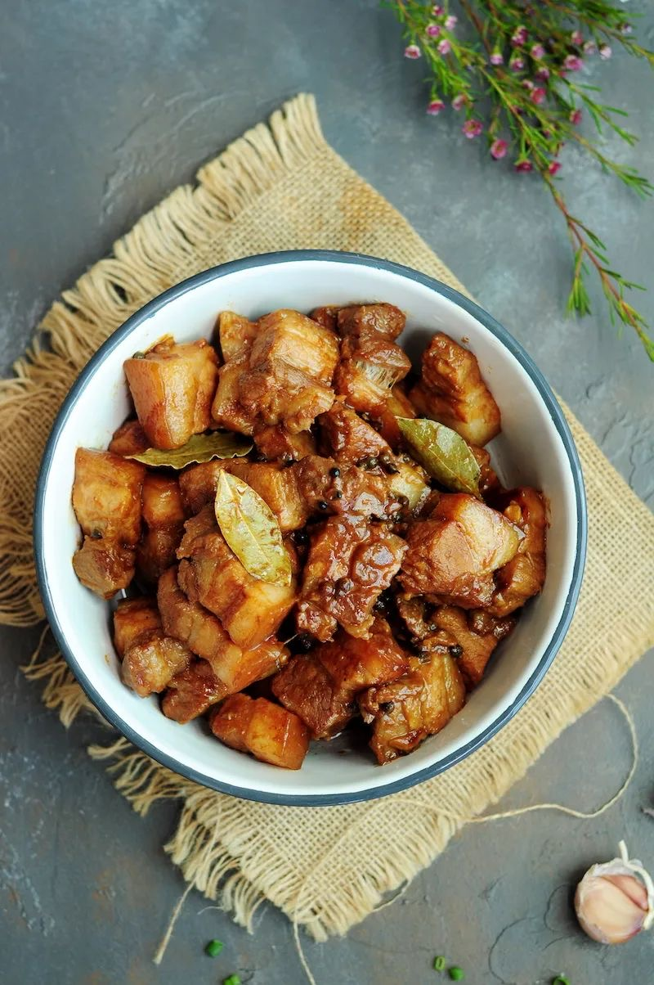

- Pork Sinigang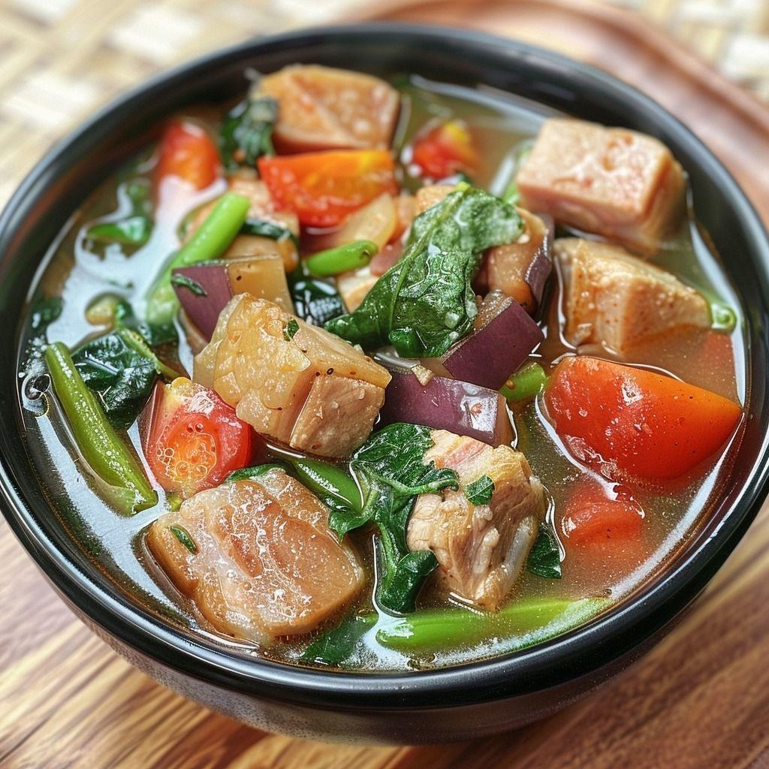

- Lechon Kawali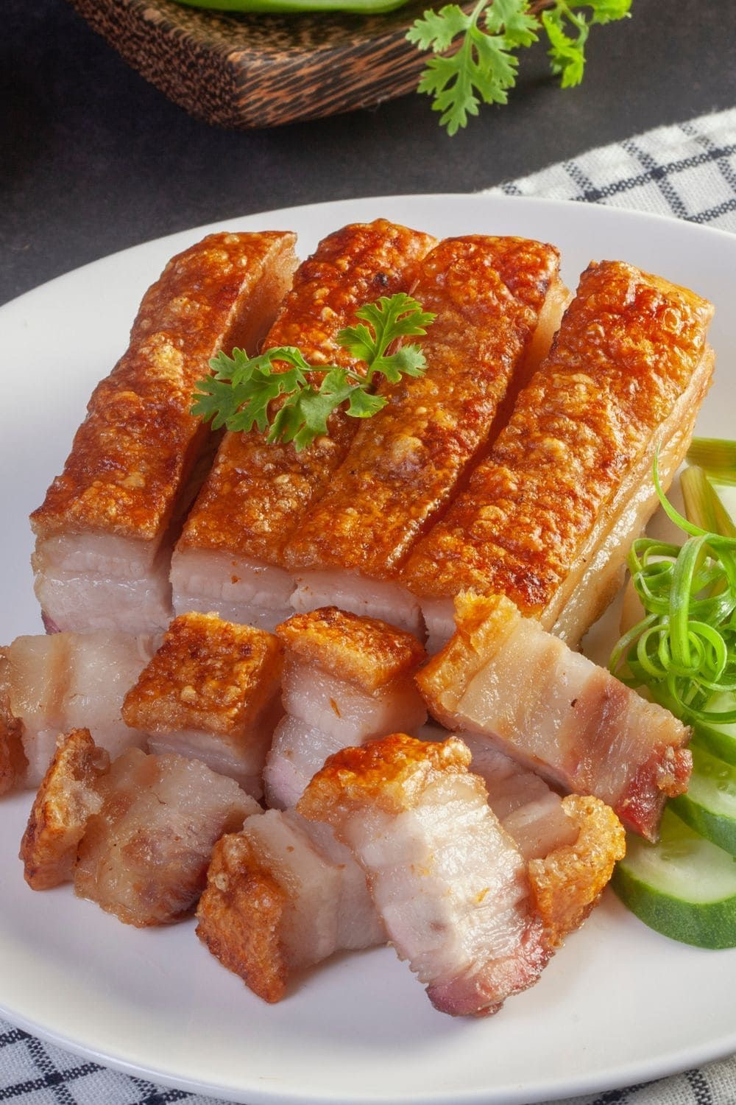

- Bicol Express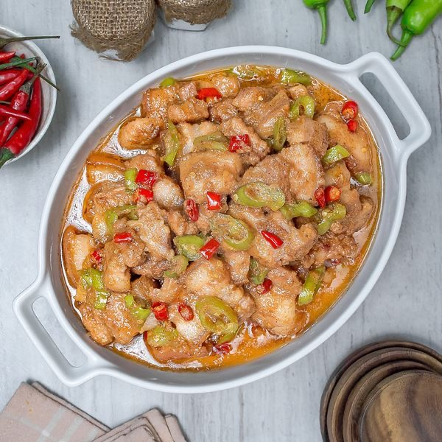

- Pork Menudo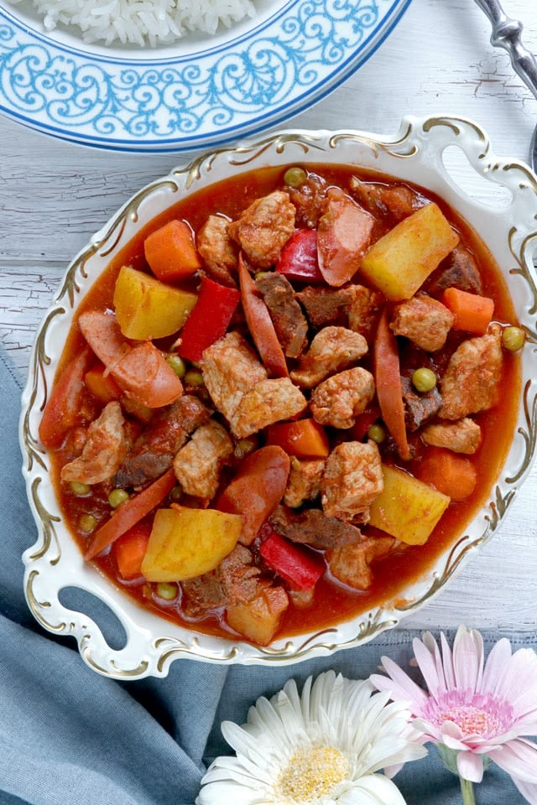

- Pork Afritada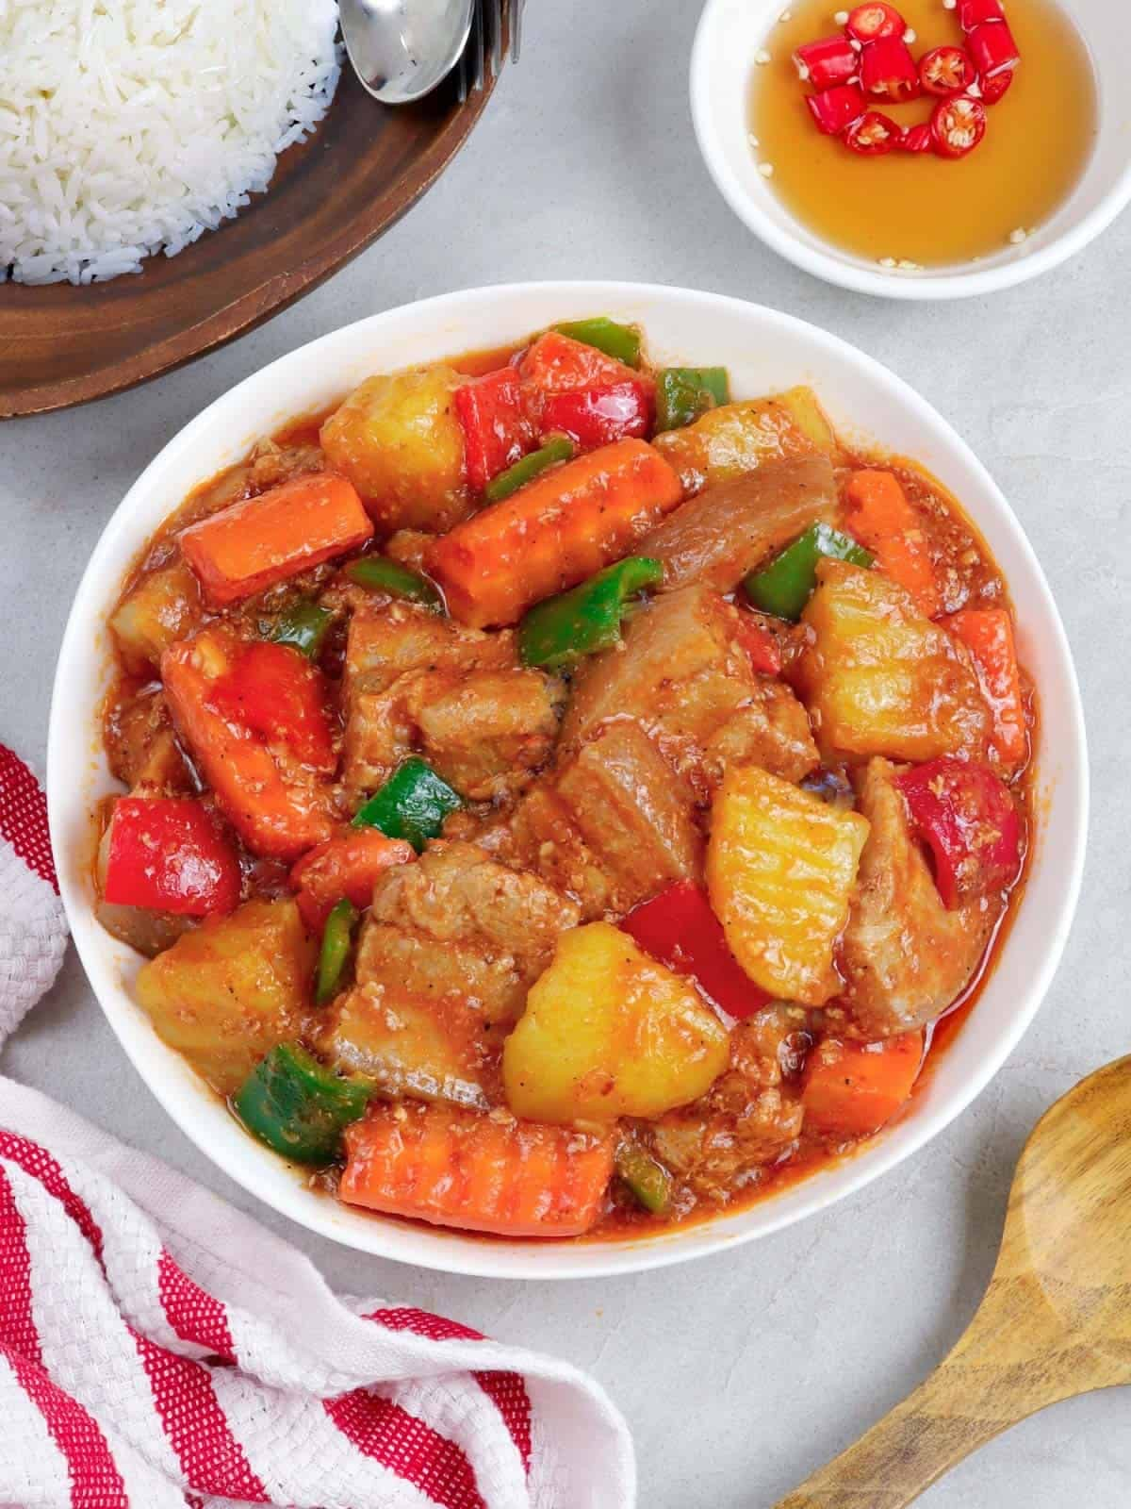

- Pork Kaldereta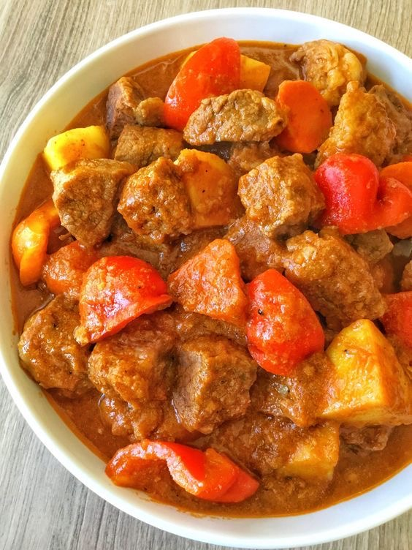

- Paksiw na Pata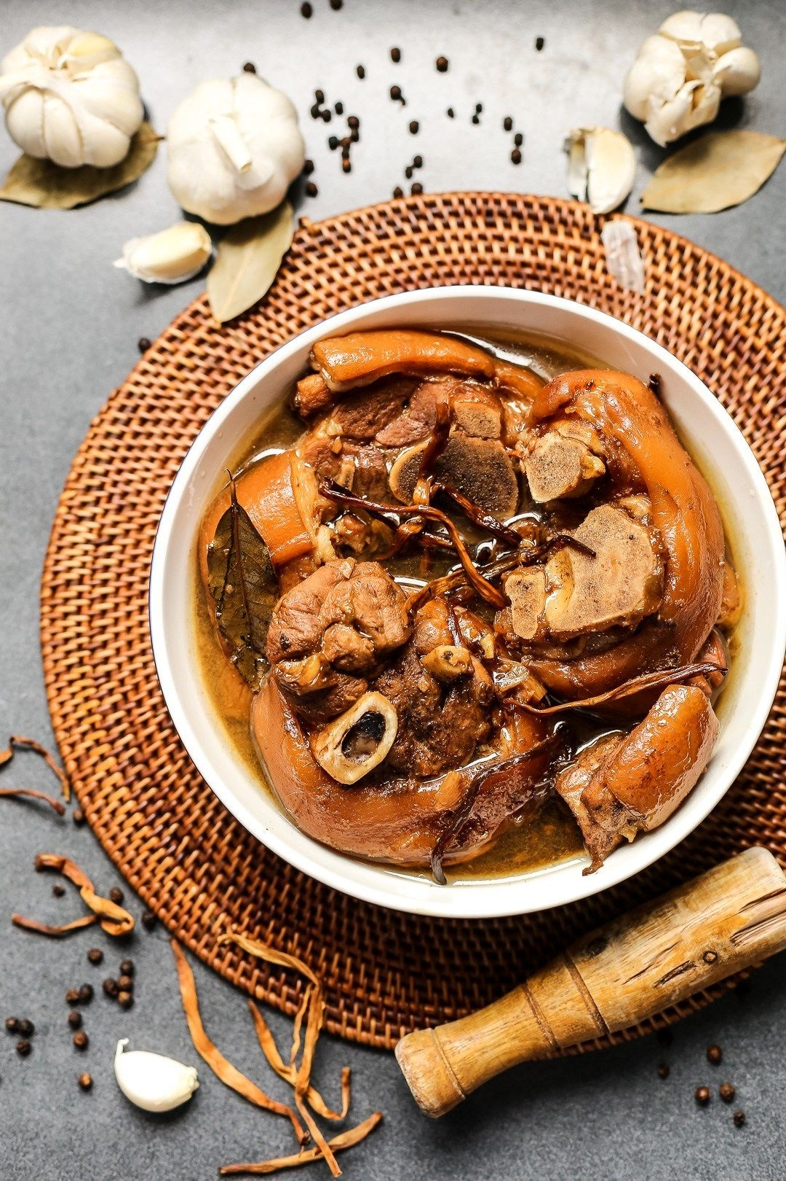

- Humba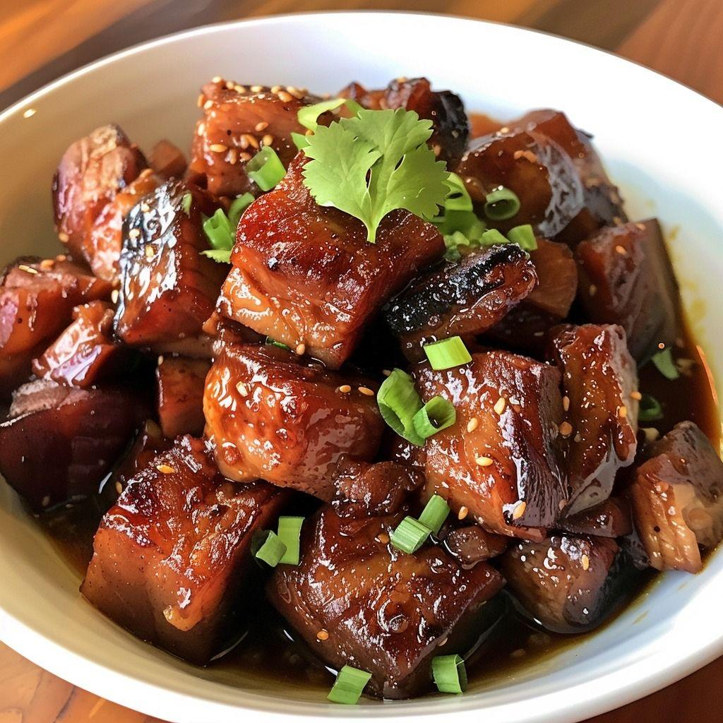

- Pork Binagoongan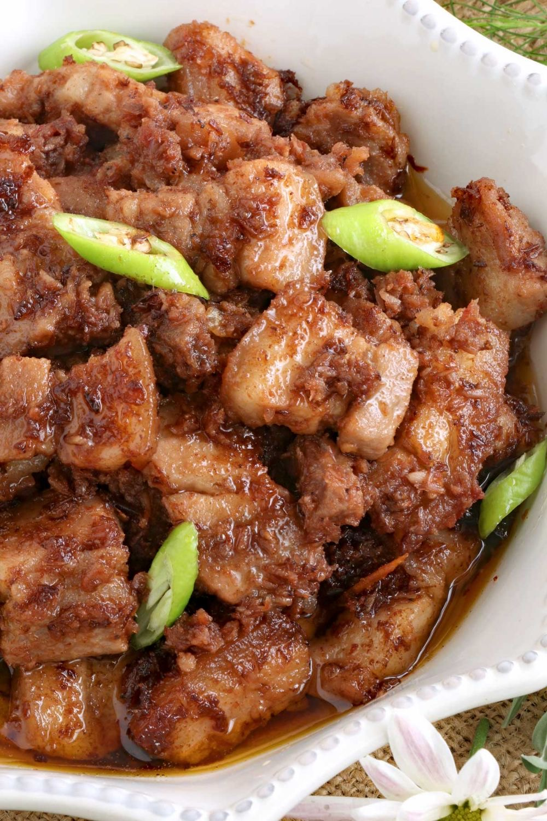

- Pork Sisig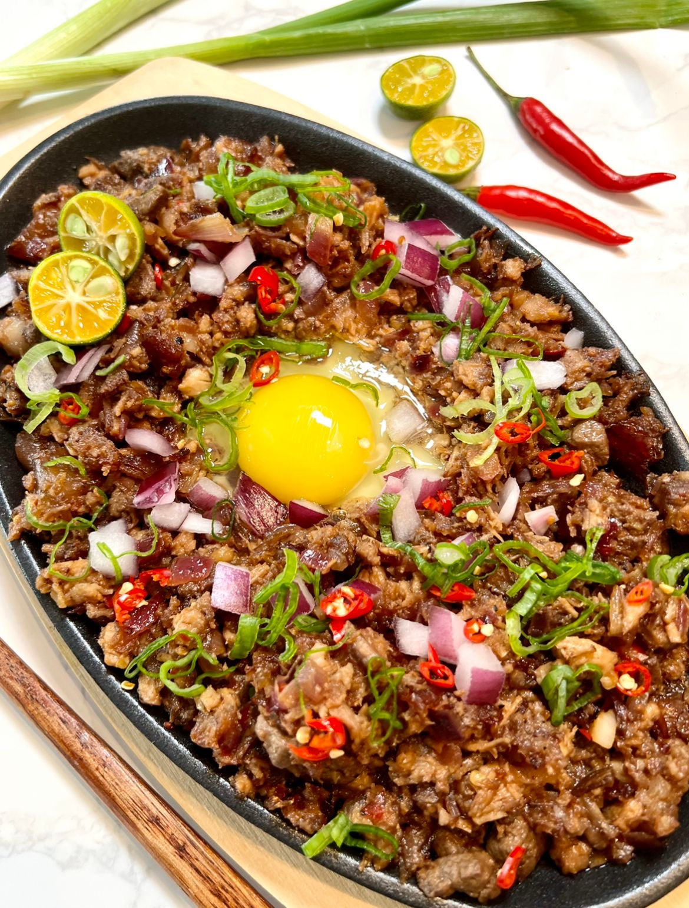

- Crispy Pata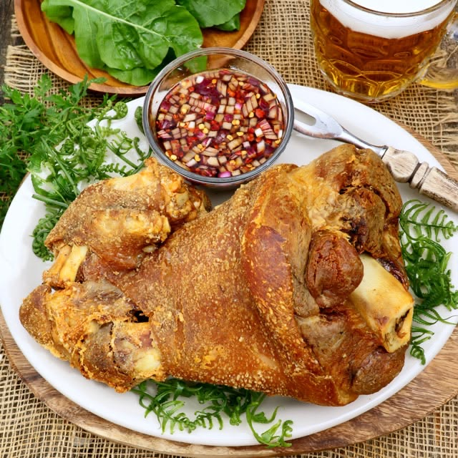

- Pork Embutido

- Pork Lumpiang Shanghai

- Pork Tocino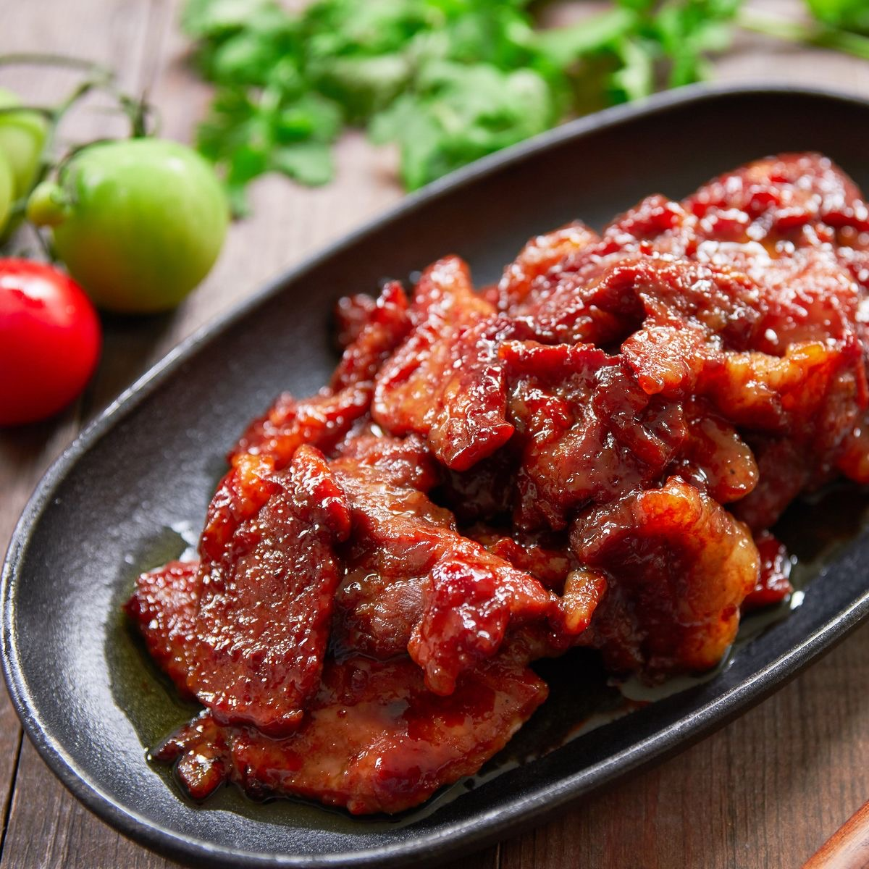

- Pork Humba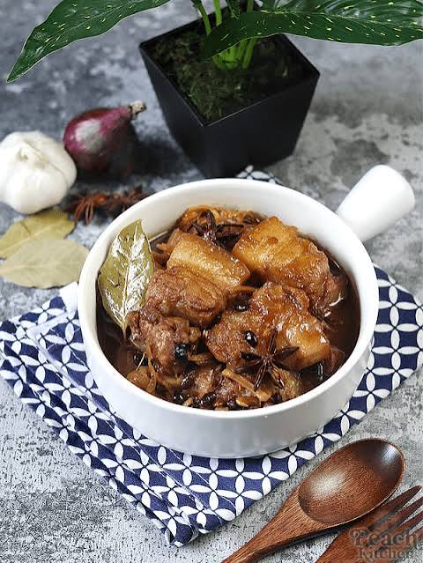

- Filipino Pork Asado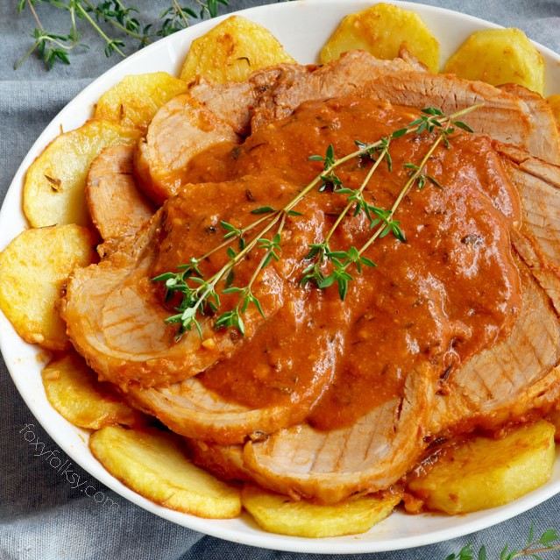

- Pork Afritada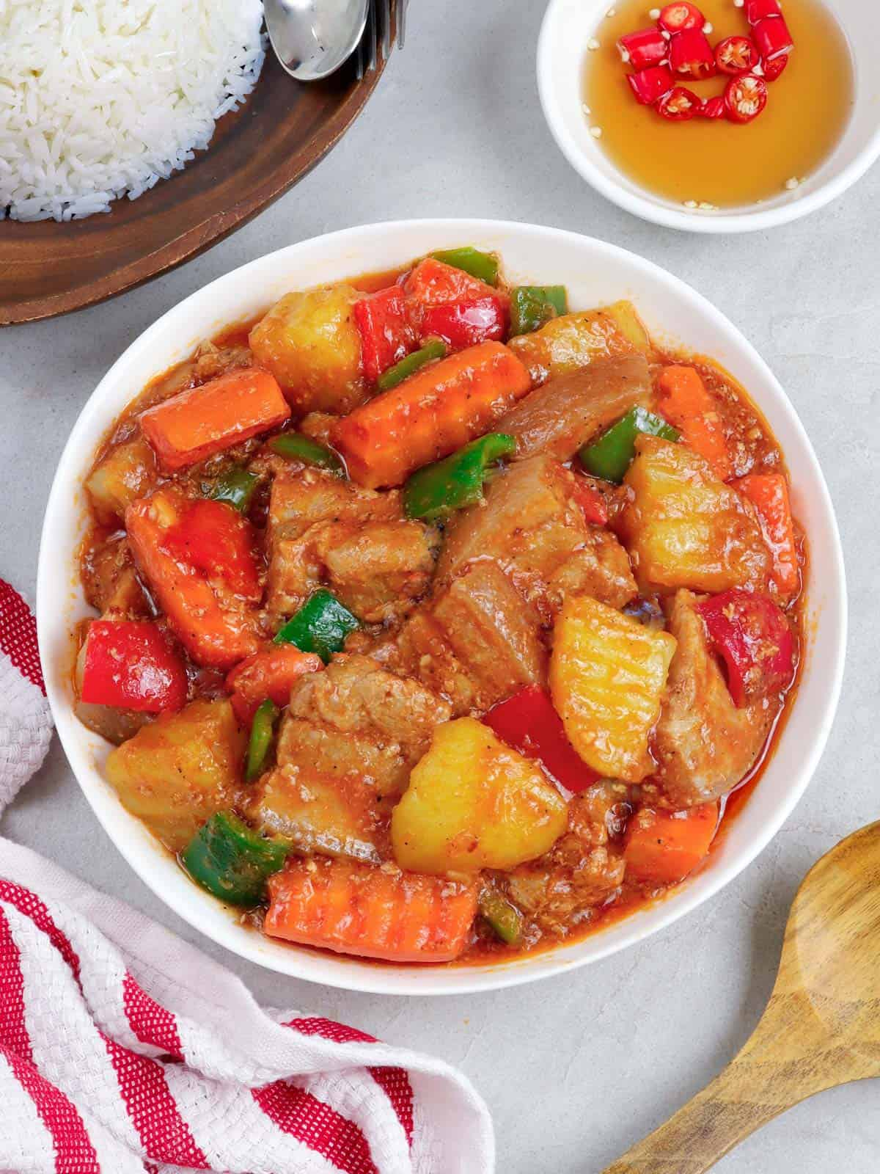

- Pininyahang Baboy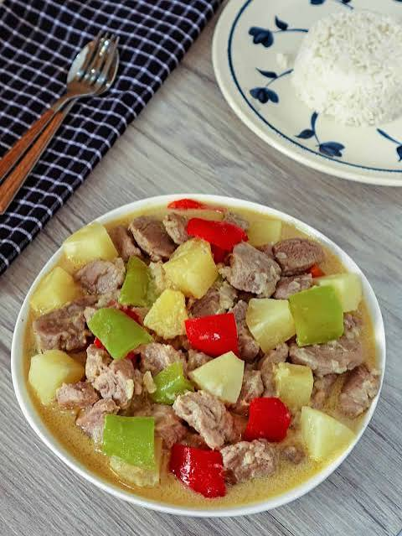

- Pork Binagoongan

- Pork Nilaga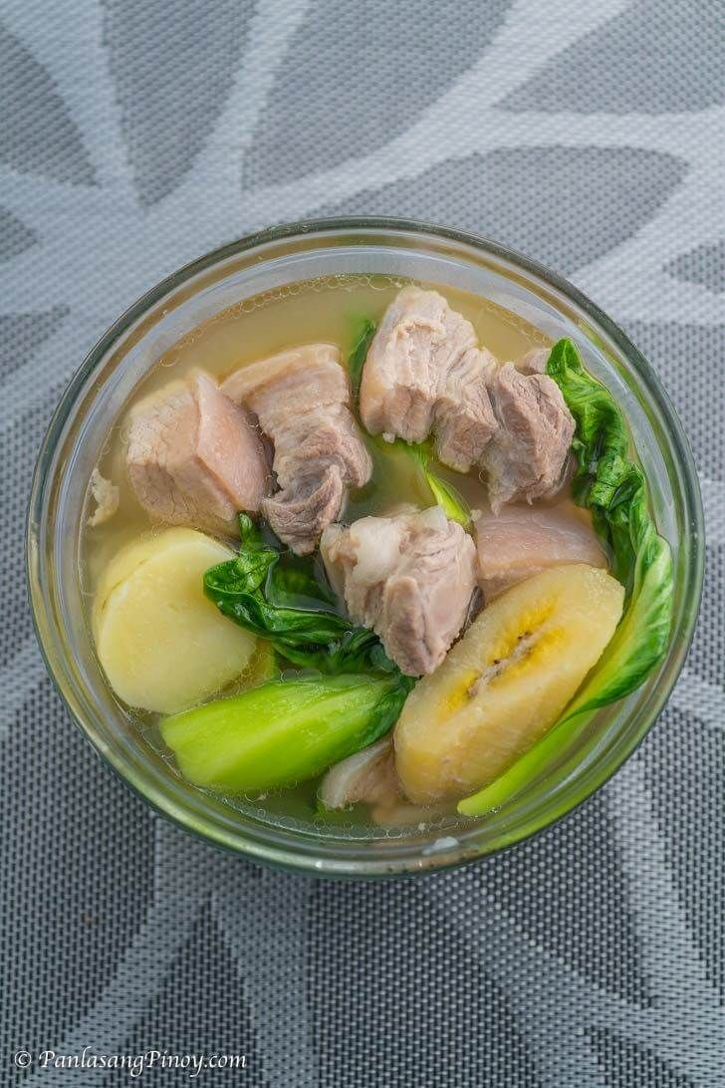

- Pork Bulalo

