Lab 3

Ben Chu

February 6, 2018

### Loading data and packages.

load("C:/Users/Branly Mclanbry/Downloads/lab3.RData")  
lab3 <- lab3 %>% janitor::clean_names()

## Q1

### Descriptive statistics

## vars n mean sd median trimmed mad min max range skew  
## subjno 1 465 317.38 194.16 314 313.26 256.49 1 758 757 0.14  
## timedrs 2 465 7.90 10.95 4 5.61 4.45 0 81 81 3.23  
## phyheal 3 465 4.97 2.39 5 4.72 2.97 2 15 13 1.02  
## menheal 4 465 6.12 4.19 6 5.81 4.45 0 18 18 0.60  
## stress 5 465 204.22 135.79 178 191.74 133.43 0 920 920 1.04  
## kurtosis se  
## subjno -0.99 9.00  
## timedrs 12.88 0.51  
## phyheal 1.08 0.11  
## menheal -0.31 0.19  
## stress 1.75 6.30

### Functions for plots

### QQ Plots

walk2(p_list,names,pphehe)

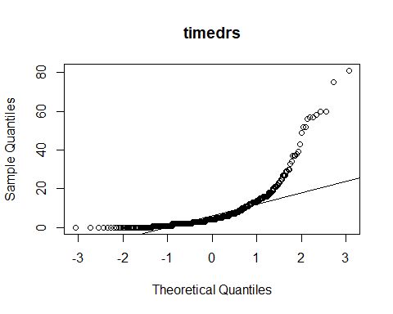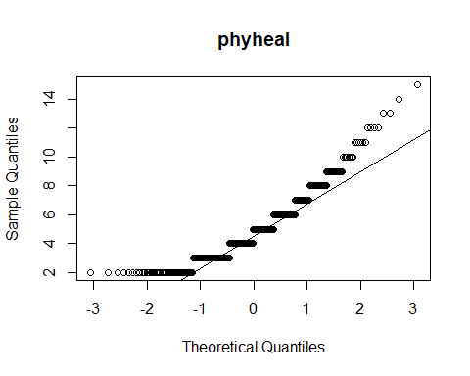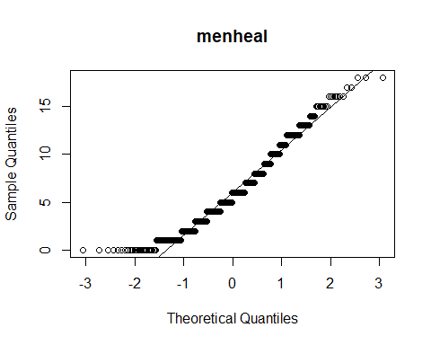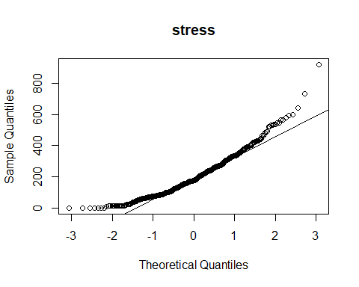 ###Density Plots

walk2(p_list,names,denss)

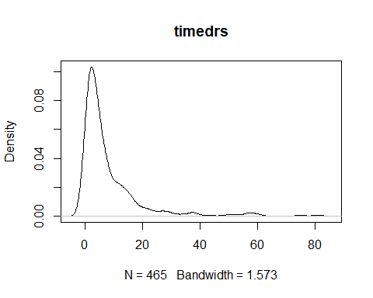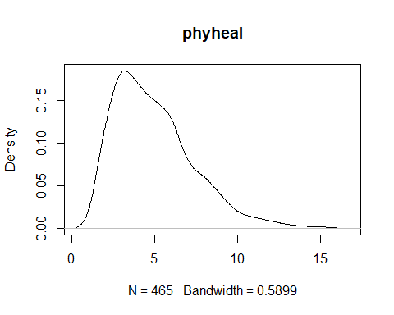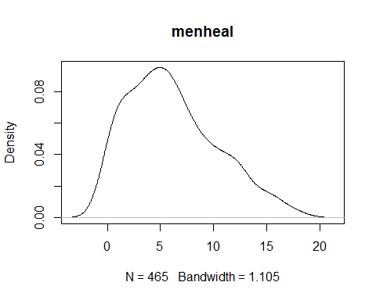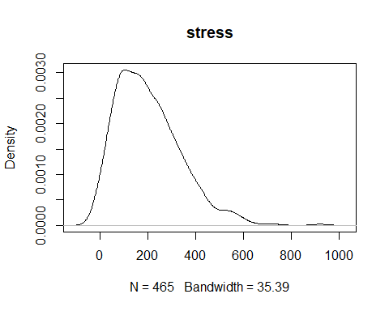 ###Function for Skew and Kurtosis

skurt <-function(x) {  
 DescTools::Skew(x, method = 2, conf.level = .99)  
}  
skurt(lab3$timedrs)

## Warning in norm.inter(t, adj.alpha): extreme order statistics used as  
## endpoints

## skew lwr.ci upr.ci   
## 3.248117 2.636055 4.003766

map(p_list,skurt)

## Warning in norm.inter(t, adj.alpha): extreme order statistics used as  
## endpoints  
  
## Warning in norm.inter(t, adj.alpha): extreme order statistics used as  
## endpoints

## [[1]]  
## skew lwr.ci upr.ci   
## 3.248117 2.654765 4.197724   
##   
## [[2]]  
## skew lwr.ci upr.ci   
## 1.0313360 0.7484067 1.4012697   
##   
## [[3]]  
## skew lwr.ci upr.ci   
## 0.6024595 0.4316153 0.8271488   
##   
## [[4]]  
## skew lwr.ci upr.ci   
## 1.0431408 0.6770118 1.6730317

transform <- function(x){  
print("squareroot")  
squareroot <- (x+1)^.5  
print(round(Skew(squareroot,na.rm=TRUE, method=2,conf.level=.99),2))  
print("log")  
log <- log10(x+1)  
print(round(Skew(log,na.rm=TRUE, method=2,conf.level=.99),2))  
print("inverse")  
inverse <- 1/(x+1)  
print(round(Skew(inverse,na.rm=TRUE, method=2,conf.level=.99),2))  
}

transform(lab3$timedrs)

## [1] "squareroot"  
## skew lwr.ci upr.ci   
## 1.63 1.31 2.01   
## [1] "log"  
## skew lwr.ci upr.ci   
## 0.23 0.03 0.45   
## [1] "inverse"  
## skew lwr.ci upr.ci   
## 1.75 1.45 2.04