

**Module name:** WEB BASED MOBILE APPLICATION DEVELOPMENT

**Module code:** CST3145

**Submission Date:** 19/11/2020

**Project title:** COURSEWORK 1

**Student name:** Chubiyojo Adejoh

**Student MISIS:** M00796245

**Module Coordinator:** CHINNU MARY GEORGE

**School of Science & Technology**

**Department of Computer Engineering and Informatics**

Github Link: <https://github.com/chubi-x/coursework1>

Github Pages: <https://chubi-x.github.io/coursework1/>

CSS Library: Bootstrap

Javascript Library (for boostrap functionality); Jquery, Popperjs

**SCREENSHOTS**

1. **Normal Page**

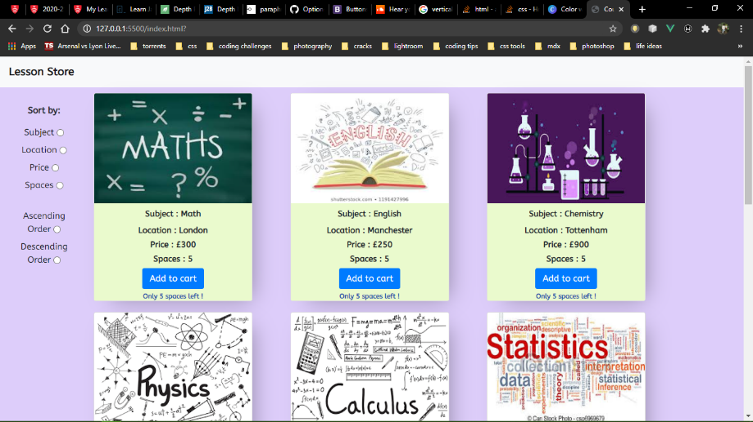

1. **Sort by Subject in Ascending order**

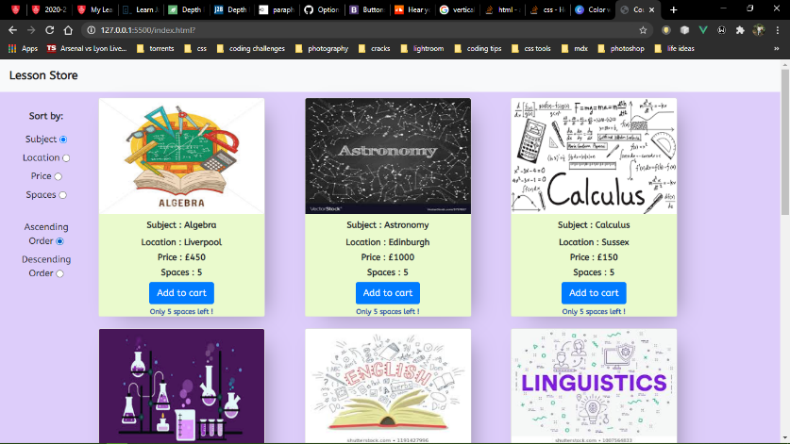

1. **Sort by Location in ascending order**

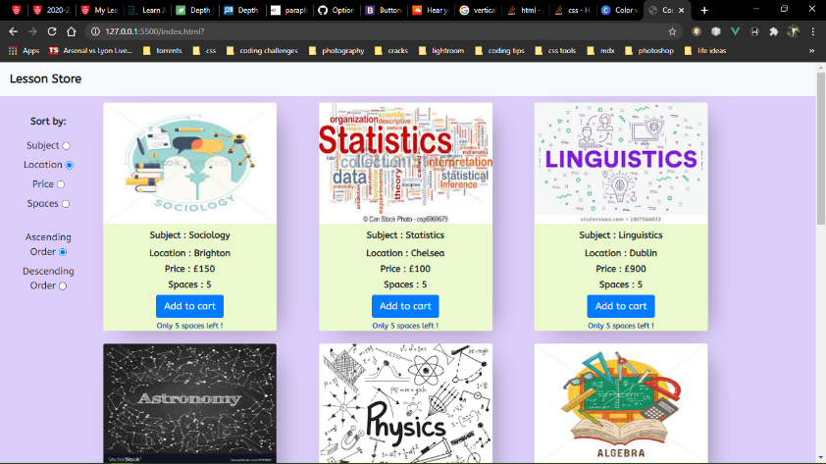

1. **Sort by Price in ascending order**

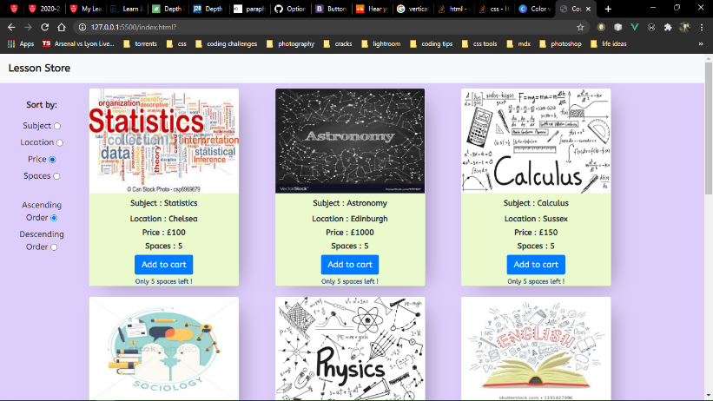

1. **Sort by price in descending order**

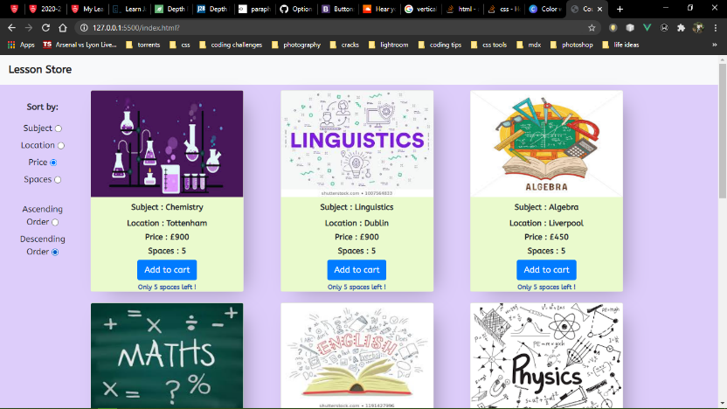

1. **Sort by location in descending order**

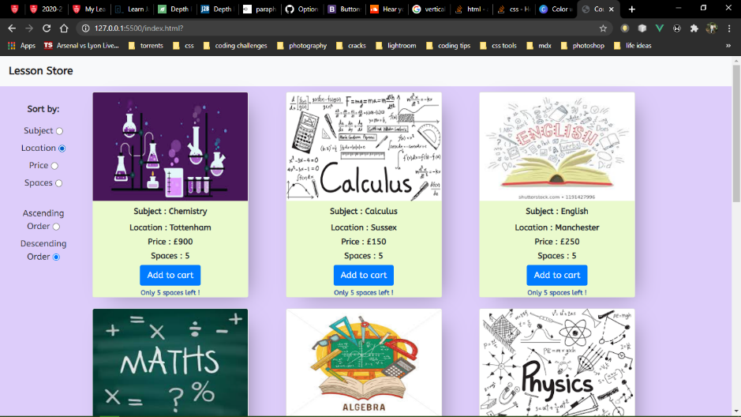

1. **Sort by subject in descending order**

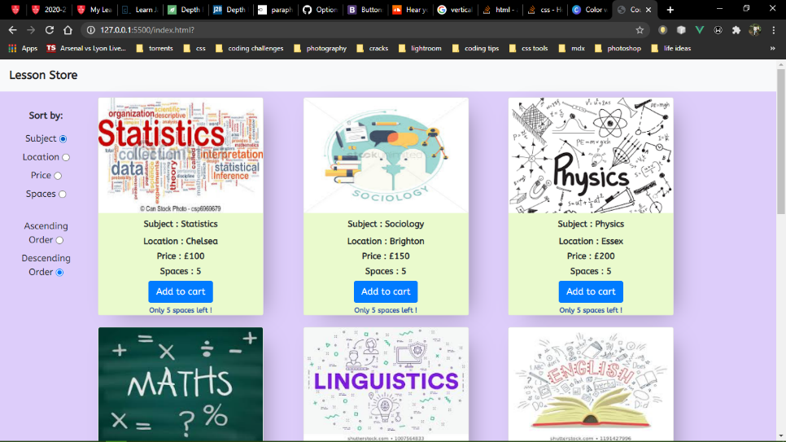

1. **Add to cart**

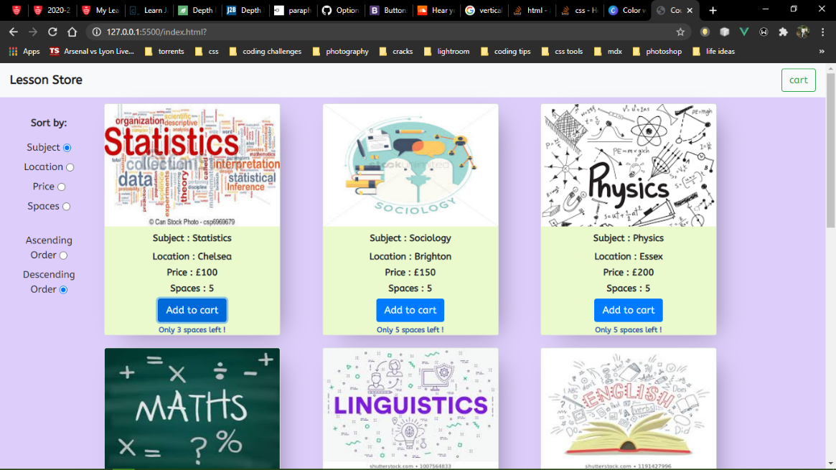

1. **Shopping cart**

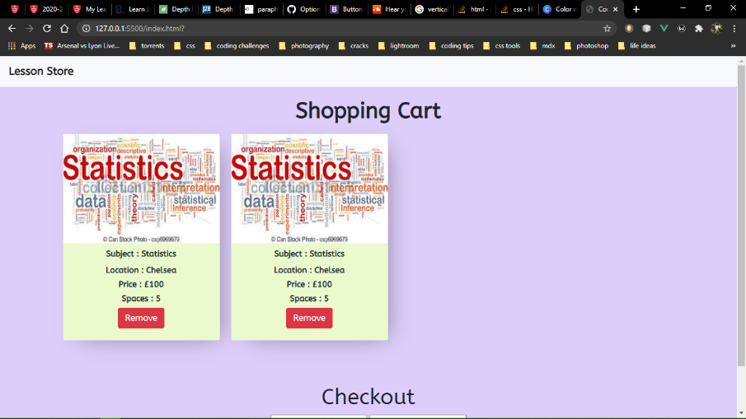

1. **Remove from cart**

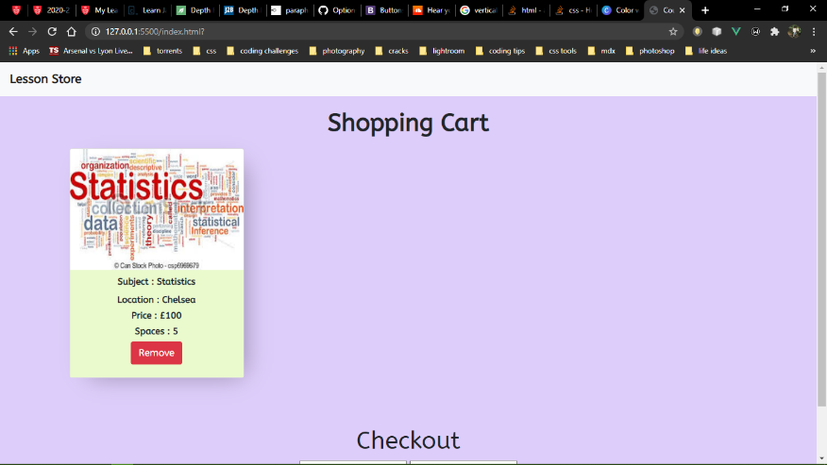

1. **Checkout**

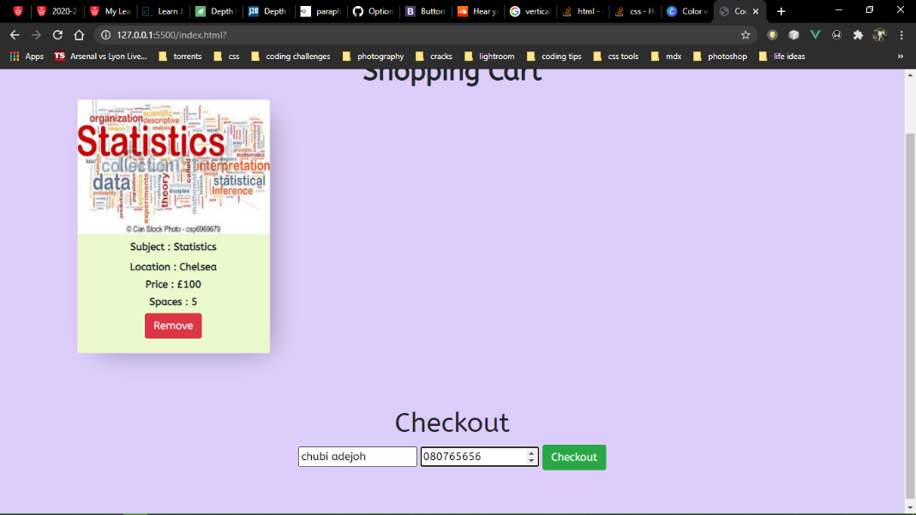

1. **Checkout alert**

