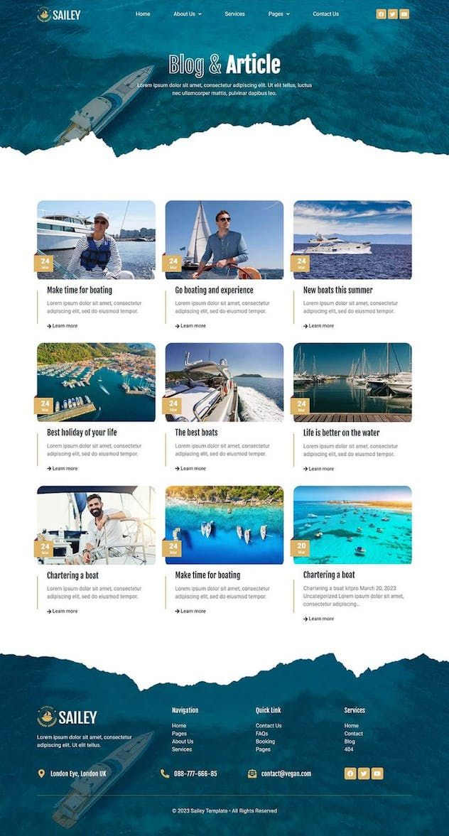



<!DOCTYPE html>

<html lang="en">

<head>

<meta charset="UTF-8">

<meta name="viewport" content="width=device-width, initial-scale=1.0">

<title>Sailey</title>

<link rel="stylesheet" href="Formulating.htmlSW2L">

<style>

.header

{

}

.content

{

}

.post

{

}

.footer

{

}

</style>

</head>

<body>

<body style= "background-color: powderblue;">

<h1 style="front-family: arial;" style="font size: 200%;">Bjea Marelle Dantic</h1>

div id= "header"

div id= "content"

div class= "post"

div id= "footer"

</body>

</html>