**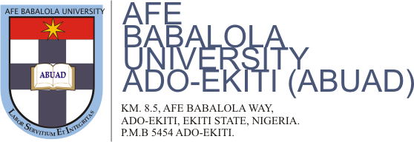*OFFICE OF THE PROVOST***

***COLLEGE OF MEDICINE AND HEALTH SCIENCES***

***Date: December 24, 2020.***

***.***

**Our Ref: ABUAD/CMHS/122020**

NAME: CHUBIYOJO BARNABAS AKOJI

MATRIC NO: 13/MHS01/024

C/o: College of Medicine and Health Sciences

Afe Babalola University,

Ado-Ekiti.

**NOTIFICATION OF FIRST DEGREE (MBBS) RESULT**

I am pleased to inform you that since you have fulfilled the relevant requirements and passed the prescribed final examinations in Medicine, Surgery and Community Medicine conducted in December 2020, Senate, at its 66th Regular Meeting on December 22, 2020, has approved that the degree of Bachelor of Medicine and Bachelor of Surgery (MB.BS) of this University be awarded to you.

Accept our congratulations.



**Professor Joseph Olurotimi SANYA.**

***MB.BCh(Cal); M.Sc.(Ife); Ph.D.(Ilorin); NPOM.***

**PROVOST**