1. Create the server with nodejs

Server.js

//import module http

const http = require('http');

//create instance

//inside the function we have access to two (2) objects

//objects are req and res

//the request find the Url, also get and post request

//response to the user

const server = http.createServer((req, res) => {

console.log('listening for request on port 3000')

});

After creating the server, we have to implement the listen with the server DNS(IP) and the port

Now, we go to the console and run node server,

Then we get 'listening for request on port 3000

Once, we open the browser and enter localhost:3000, we don’t get info into the browser but we send to the backend ‘require made’

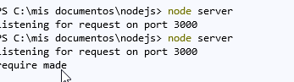

We get nothing into the browser because the command is running in backend no in the browser

In short, when we sent the request to the port 3000, the function:

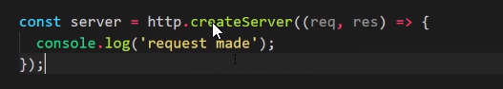

Is triggered