1. Site

<https://www.npmjs.com/>

1. Nodemon

Allow to update the server automatically

npm install -g nodemon

run as:

nodemon server

1. Json packets

Npm init

It will create a json file with all the details of the project

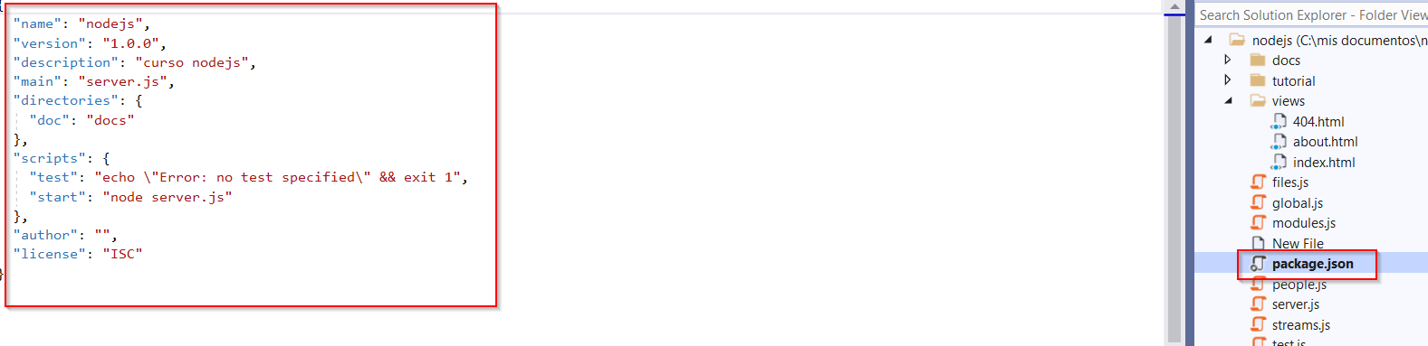

1. Lodash

npm i --save lodash

Inside the package.json it adds a new dependency for lodash

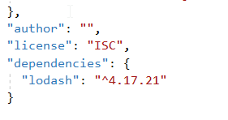

We call the module

const _ = require('lodash');

underscore means lodash

then, I new folder named node_modules appears

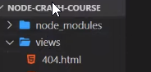

//lodash methods

//first method generate random number every time we refresh the web

const num = _.random(0, 20);

console.log(num);

//second method once() run the function only once

const greet = _.once(() => {

console.log('hello');

});

greet();

greet();

1. Dependencies

If we want to install all the packets for our project, we go to the package.json file, we check the dependencies area

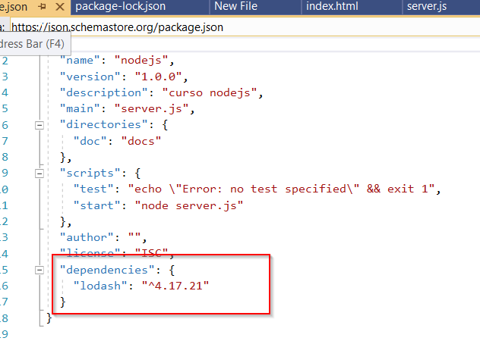

And we type npm install

It will look into the dependencies and it will install all the packet needed