report of AI_HW3 109550027紀竺均

1. implementation and explanation

Part 1 : Adversarial search

Part 1-1: Minimax Search (10%)

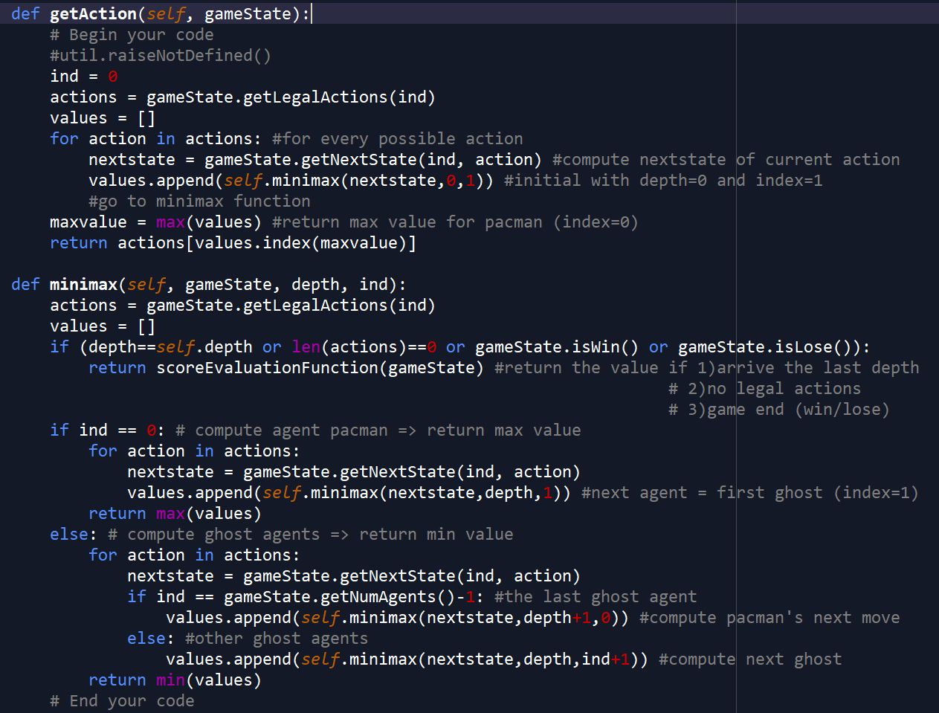

Part 1-2: Expectimax Search (10%)

Almost same as minimax search, but instead of return min value for ghost agents, return the average values. This is because we assume the ghosts will choose their action randomly, every action will have the same probability.

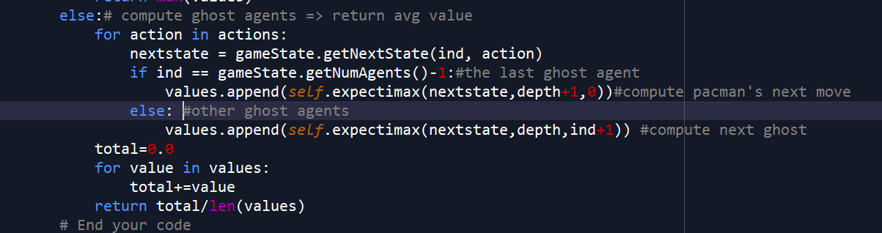

Part 2 : Q-learning

Part 2-1: Value Iteration (10%)