Report of Intro to Machine Learning, Homework 4

109550027紀竺均

**Part. 1, Coding (50%)**:

In this coding assignment, you need to implement the cross-validation and grid search using only NumPy, then train the [SVM model from scikit-learn](https://scikit-learn.org/stable/modules/generated/sklearn.svm.SVC.html) on the provided dataset and test the performance with testing data.

1. (10%) K-fold data partition: Implement the K-fold cross-validation function. Your function should take K as an argument and return a list of lists (*len(list) should equal to K*), which contains K elements. Each element is a list containing two parts, the first part contains the index of all training folds (index_x_train, index_y_train), e.g., Fold 2 to Fold 5 in split 1. The second part contains the index of the validation fold, e.g., Fold 1 in split 1 (index_x_val, index_y_val)
2. (20%) Grid Search & Cross-validation: using [sklearn.svm.SVC](https://scikit-learn.org/stable/modules/generated/sklearn.svm.SVC.html) to train a classifier on the provided train set and conduct the grid search of “C” and “gamma,” “kernel’=’rbf’ to find the best hyperparameters by cross-validation. Print the best hyperparameters you found.

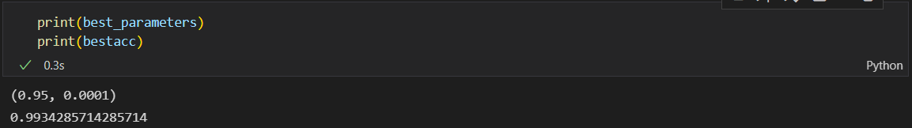

1. (10%) Plot the grid search results of your SVM. The x and y represent “gamma” and “C” hyperparameters, respectively. And the color represents the average score of validation folds.

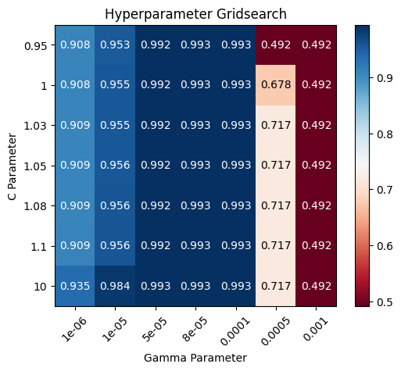

1. (10%) Train your SVM model by the best hyperparameters you found from question 2 on the whole training data and evaluate the performance on the test set.

**Part. 2, Questions (50%):**

(10%) Show that the kernel matrix K=kxn,xmnm should be positive semidefinite is the necessary and sufficient condition for k(x,x') to be a valid kernel.

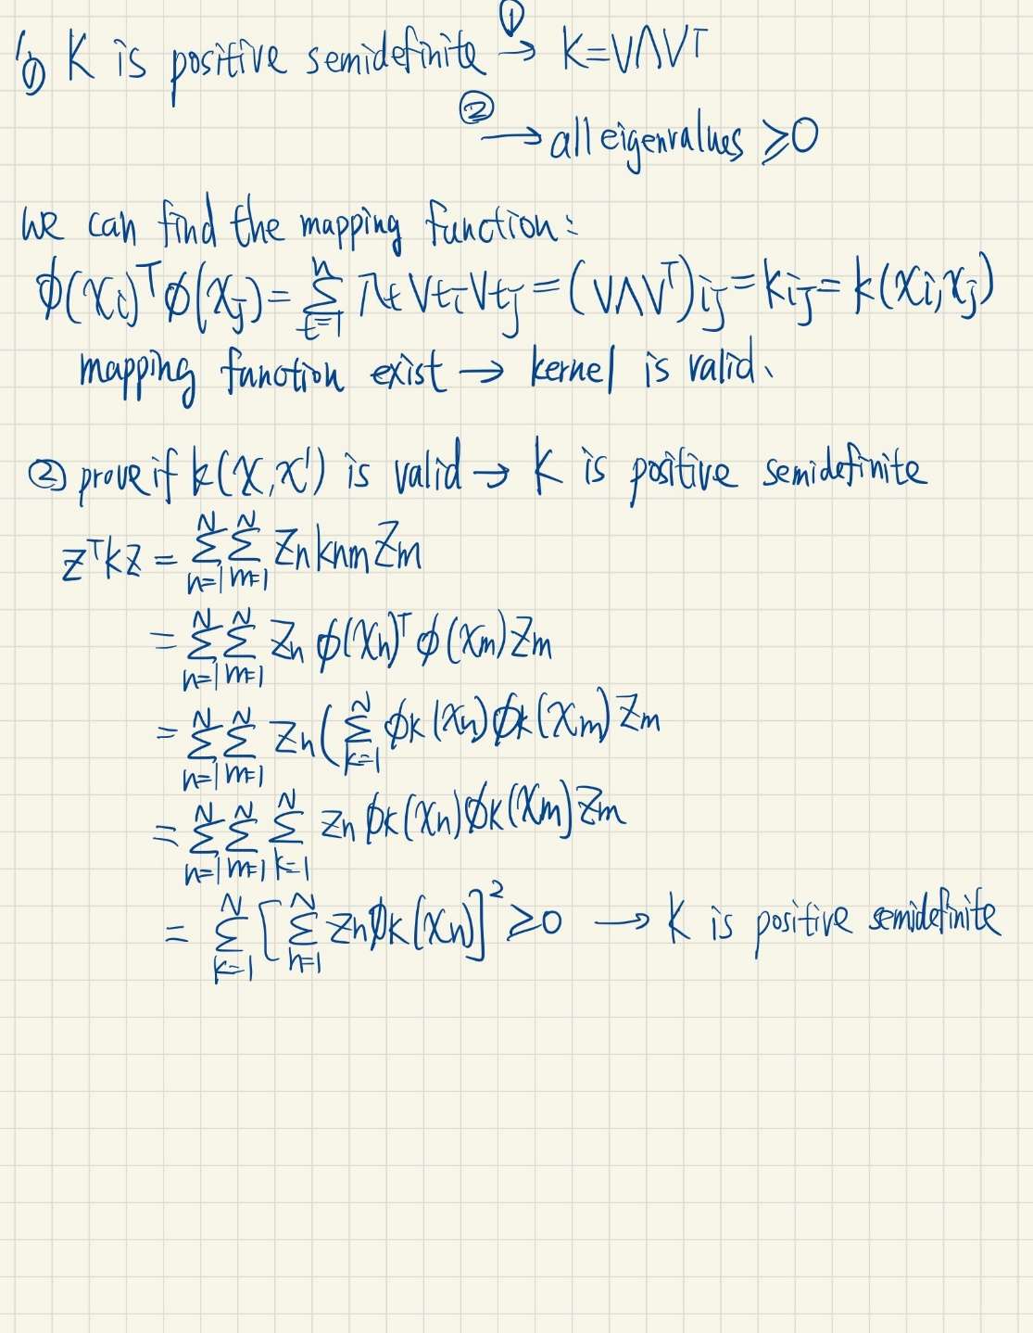

(10%) Given a valid kernel k1(x,x'), explain that kx, x'= exp(k1x,x') is also a valid kernel. Your answer may mention some terms like ____ series or ____ expansion.

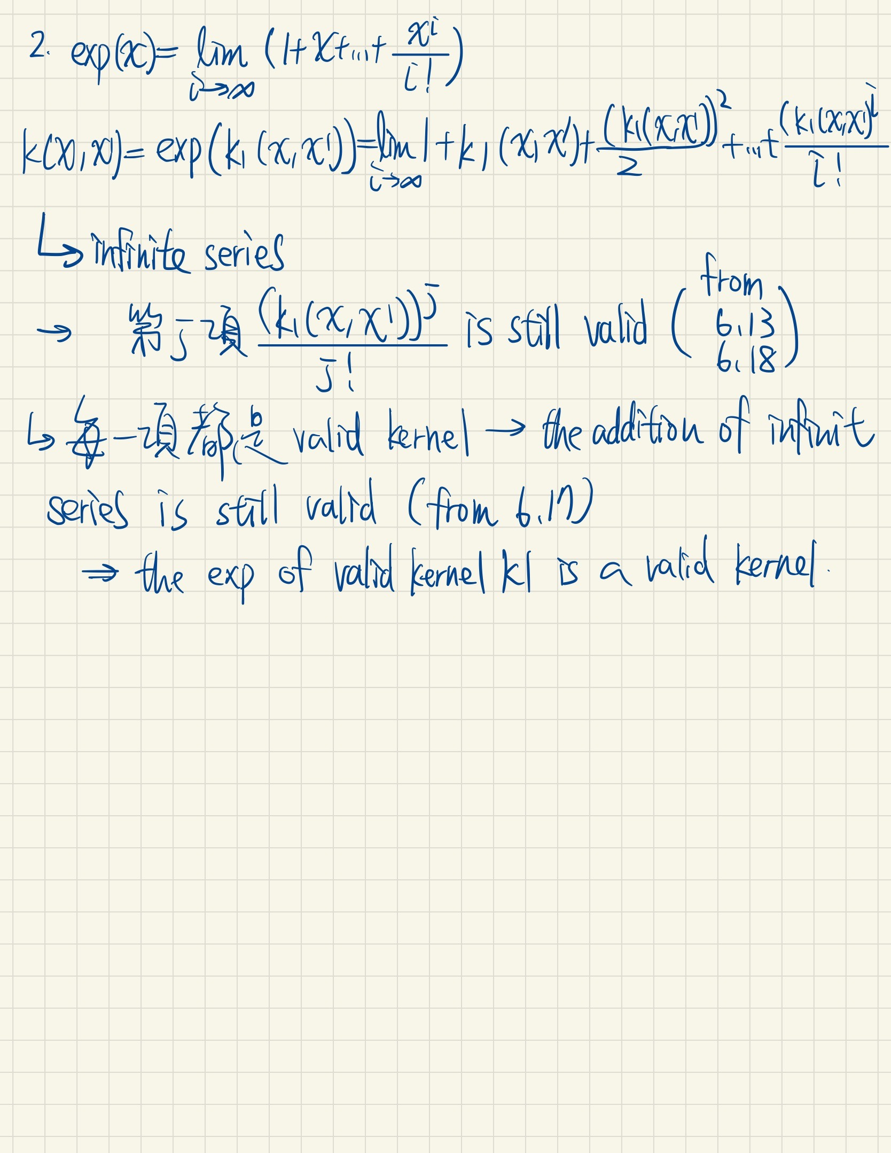

(20%) Given a valid kernel k1(x,x'), prove that the following proposed functions are or are not valid kernels. If one is not a valid kernel, give an example of k(x,x') that the corresponding K is not positive semidefinite and show its eigenvalues.

1. kx, x'= k1x, x'+1
2. kx, x'= k1x,x'-1
3. kx, x'= k1x,x'2+exp‖x‖2*exp(‖x'‖2)
4. kx, x'= k1x,x'2+expk1x,x'-1

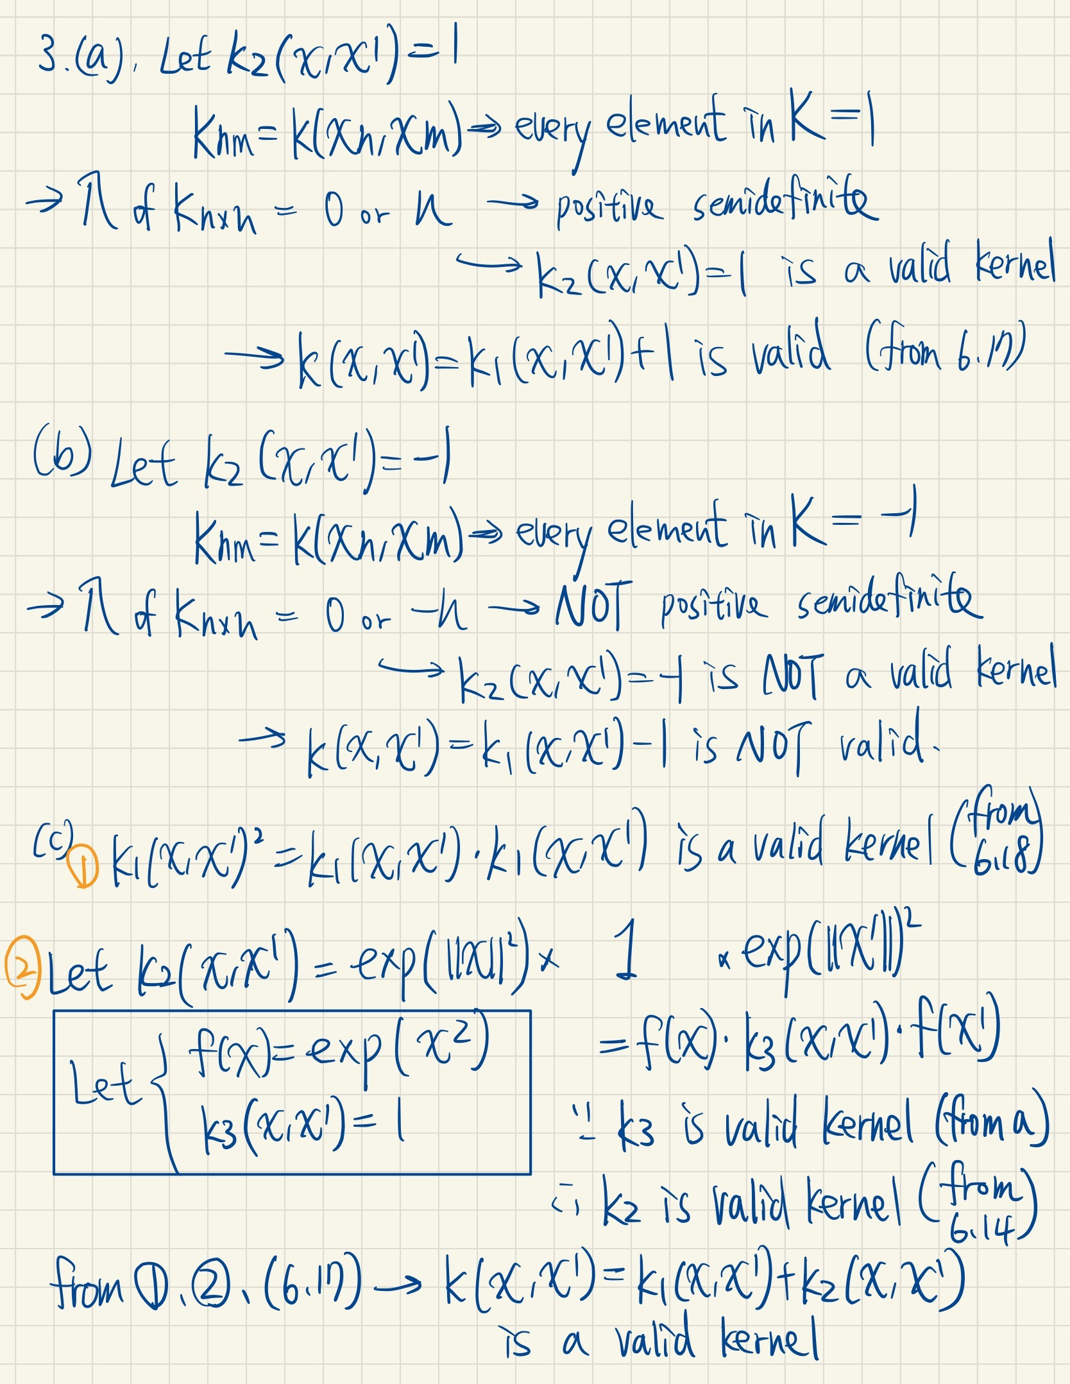

(10%) Consider the optimization problem

minimize x- 22

subject to x+3x-1 3

State the dual problem.

