

Login

Login

# Admin Login

Username

Password

Login

|  |  |  |  |  |  |
| --- | --- | --- | --- | --- | --- |
| ID | Name | Description | Price | Price (Bulk) | Stock  (QOH) |
| 001 | Brush | Does Brushing | $100 | $20 per 500 | 5000 |
| 002 | Guitar | Does Guitaring | $9001 | $200 per 600 | 10000 |
| … | … | … | … | … | … |
| … | … | … | … | … | … |
| 999 | Pants | Does the Pants Stuff | $19.99 | $5 per 100 | 20000 |

My Products

Hover drop down box?

New Admin

Edit/Delete Admin

# MyKart Products

My Products



Logout

New Products

Search Products

Edit | Remove

Edit | Remove

Edit | Remove

Search Products



Logout

New Products

Search Products

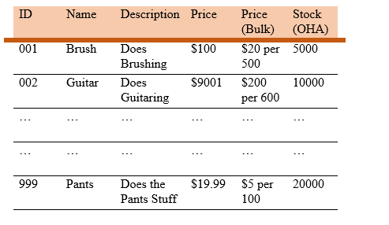

New Admin

Edit/Delete Admin

My Products

# Search <USER’S> Products

Search By… <ID, Name, Category, … >

<ID, Name, Category, … >

Search

Clear

Edit | Remove

Edit | Remove

Edit | Remove

|  |  |  |  |  |  |  |
| --- | --- | --- | --- | --- | --- | --- |
| Product Number | Name | Description | Price | Price (Bulk) | Bulk  (Min Amt) | Stock  (QOH) |
| 001 | Brush | Does Brushing | $100 | $20 per 500 |  | 5000 |
| 002 | Guitar | Does Guitaring | $9001 | $200 per 600 |  | 10000 |
| … | … | … | … | … |  | … |
| … | … | … | … | … |  | … |
| 999 | Pants | Does the Pants Stuff | $19.99 | $5 per 100 |  | 20000 |



Login/Logout

New Products

My Products

Search Products

New Admin

Edit/Delete Admin

PN

Name

Desc

Price

Price Blk

Blk Amt

QOH

PN

Name

Desc

Price

Price Blk

Blk Amt

QOH

PN

Name

Desc

Price

Price Blk

Blk Amt

QOH

Add Row

Add Products

Clear All

# Add Product