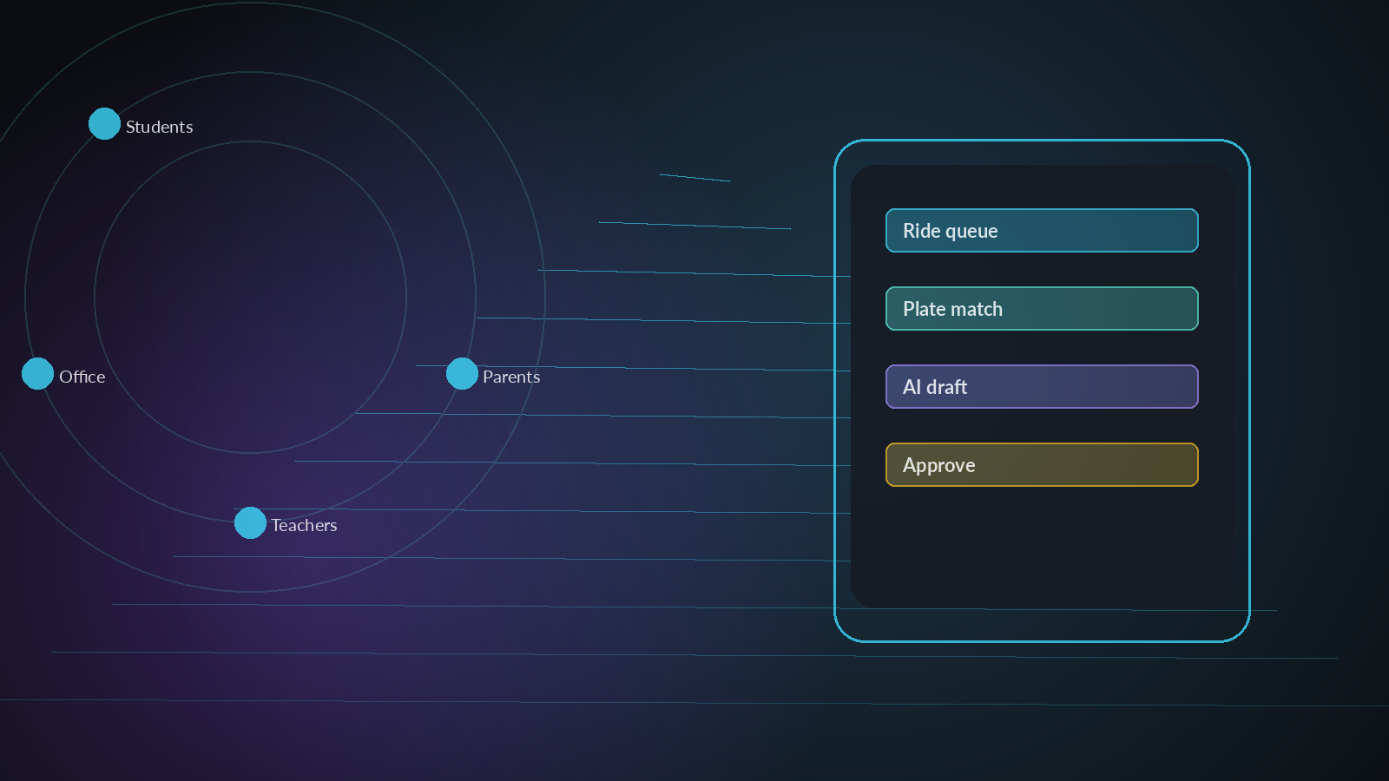
Kelyra Production System,
Monetization & Go-to-Market
Spring Baptist Academy trial → paid production
Edition: Dark visual edition · 2026-09-24
Confidential — Chuck Broaddus / Kelyra

Recommended stack wordmarks (styled pills).
1. Executive summary
Kelyra is already a real multi-role school app (Expo + Supabase + Gemini Edge Functions + Ride/LPR), not a slide deck. The gap to a Spring Baptist trial is ops and distribution, not a rewrite.
Cost snapshot
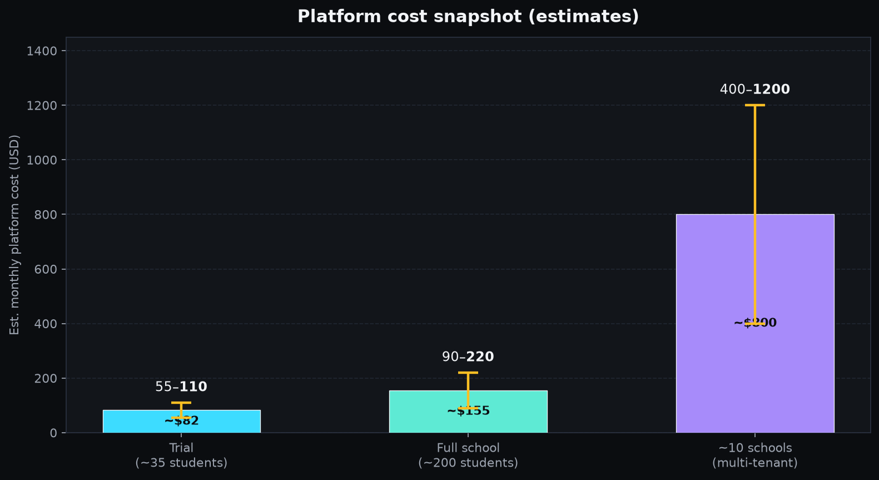
Est. monthly platform cost — Trial $55–110 · Full school $90–220 · ~10 schools $400–1,200.
Scale | Est. monthly platform cost
Trial (~35 students) | ~$55–110 / mo
Full Spring Baptist (~200) | ~$90–220 / mo
~10 similar schools | ~$400–1,200 / mo
Recommended pricing
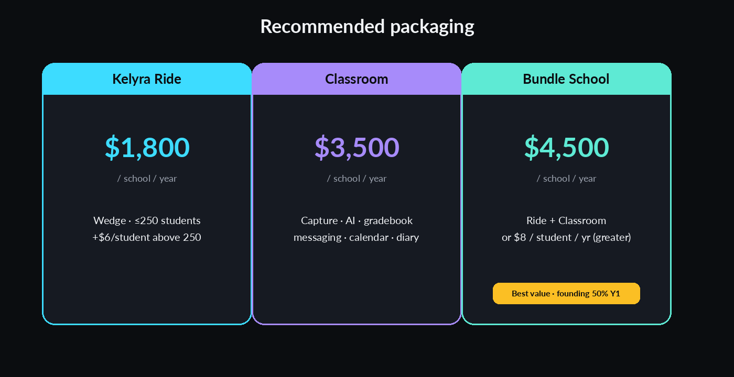
Ride $1,800 · Classroom $3,500 · Bundle $4,500 (or $8/student/yr).
Ride module (wedge): $1,800 / school / year for ≤250 students.
Kelyra School (full suite): $4,500 / school / year or $8 / student / year (whichever greater).
Spring Baptist trial: free through end of spring semester; founding renewal at 50% of list for year 1 paid.
Top risks
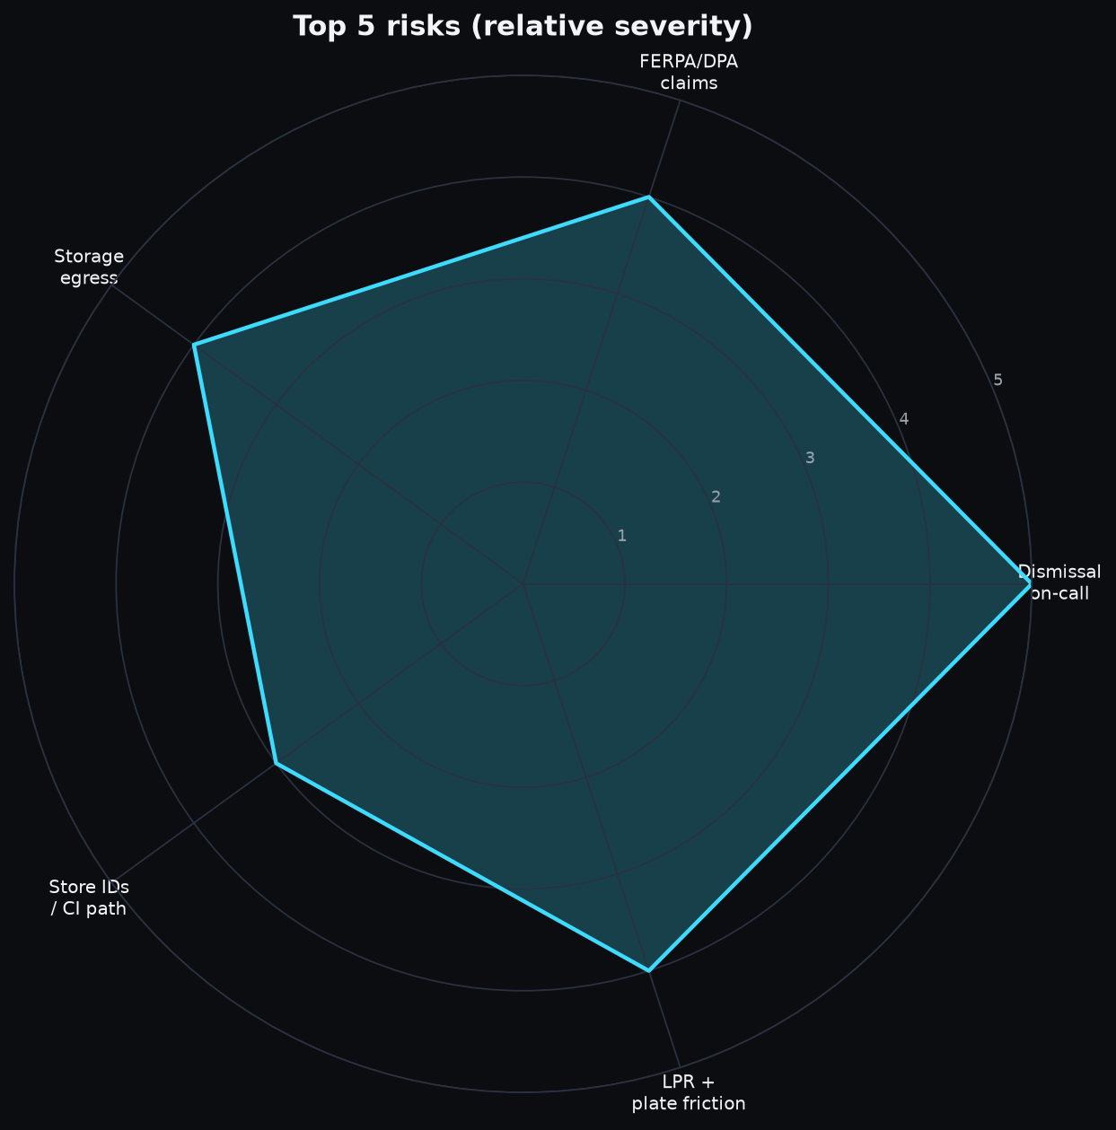
Relative severity of top production risks.
• Solo-founder on-call during dismissal window (3:00–4:00 PM CT) if Realtime/LPR fails.
• Claiming FERPA “school official” without a DPA.
• Storage egress already burned Free plan in Aug 2026.
• Missing store identifiers / no CI promotion path.
• Car-line LPR accuracy + parent plate registration friction.
3. Recommended production architecture
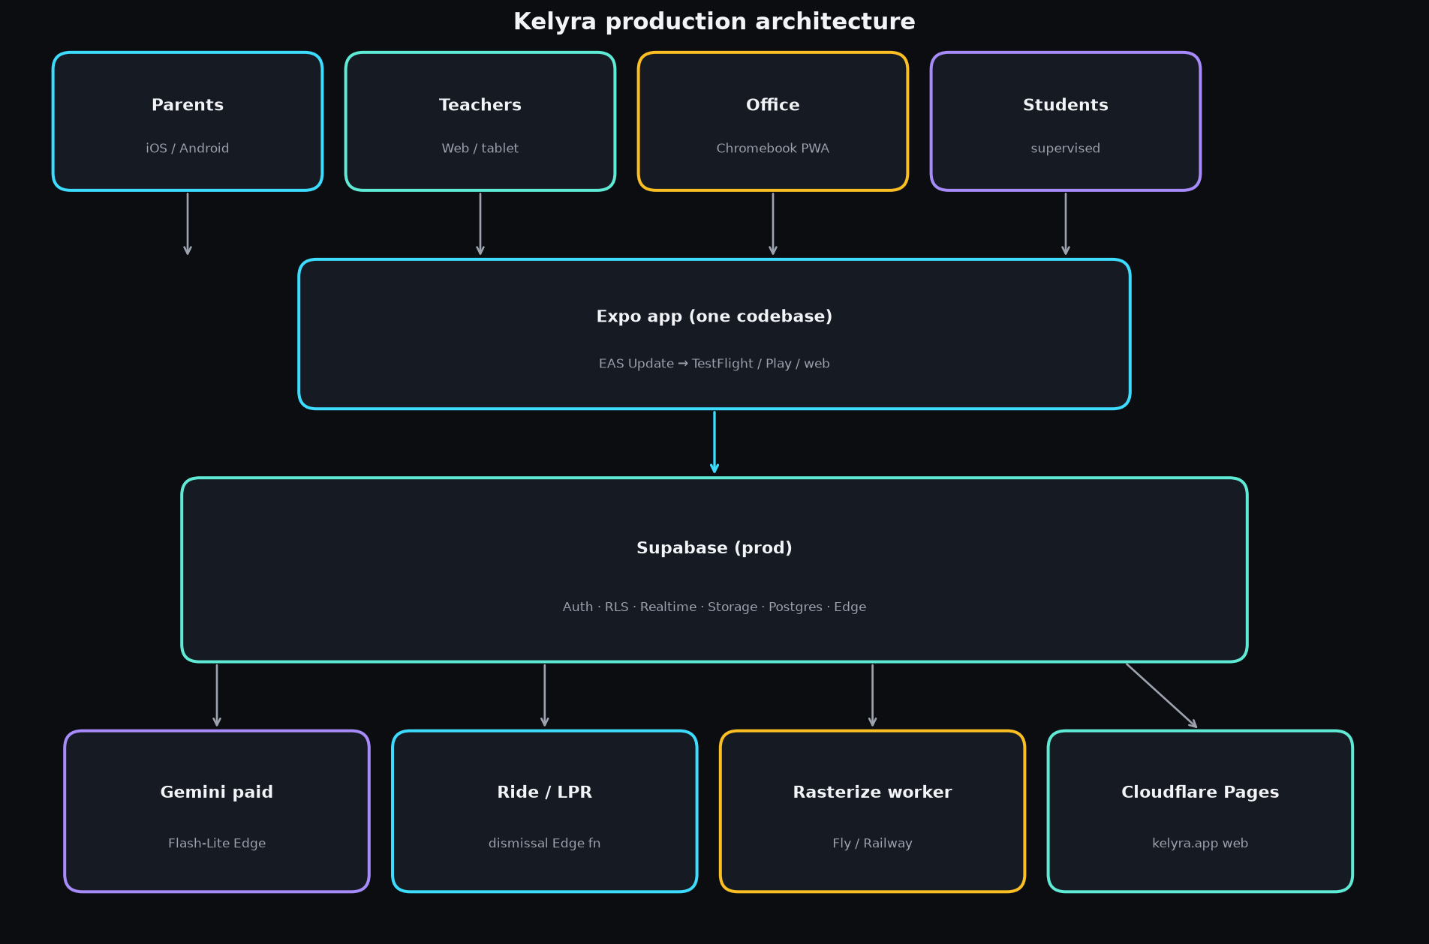
Parents/Teachers/Office/Students → Expo → Supabase → Gemini / Ride / Worker / Pages.
Keep: Expo+Supabase+Edge AI adapter+RLS+Approve gate+private buckets+Ride design.
Change/add: staging; Cloudflare Pages; production worker; Sentry; paid Gemini; Resend; CI promote.
Do not: rewrite to Next.js for trial; public buckets; free-tier Gemini in prod; claim HIPAA/FERPA school-official on Pro alone.
5. Deployment per platform
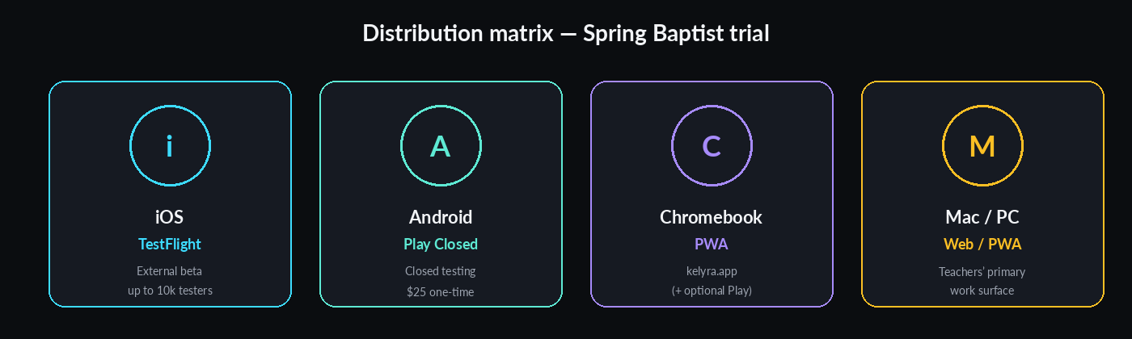
iOS TestFlight · Android Play Closed · Chromebook PWA · Mac/PC web.
8. Monetization recommendation
1. Kelyra Ride — $1,800/yr (≤250 students); +$6/student above 250.
2. Kelyra Classroom — $3,500/yr or $8/student/yr.
3. Bundle School — $4,500/yr (≤250) = Ride + Classroom; founding discount available.
4. AI credits soft cap; overage $10 / 1k jobs.
5. Author packs free for trial; marketplace later.
10. 90-day GTM
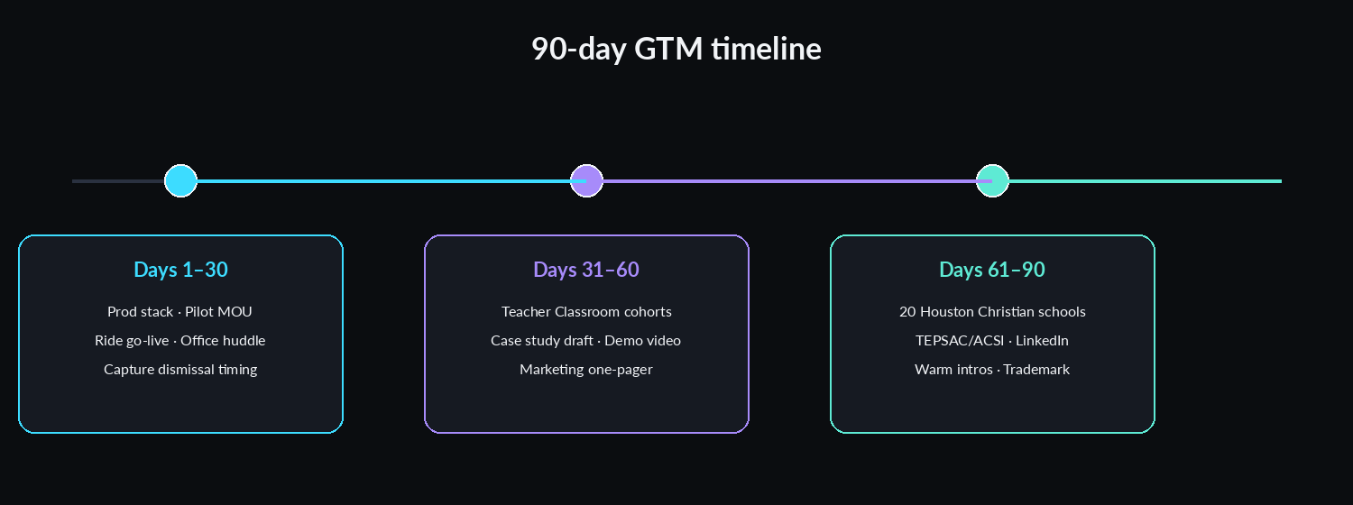
Days 1–30 / 31–60 / 61–90 GTM phases.
Days 1–30: finish prod stack; pilot MOU; Ride go-live; weekly office huddle.
Days 31–60: teacher Classroom cohorts; case study; demo video; marketing page.
Days 61–90: outreach to 20 Houston-area Christian schools; TEPSAC/ACSI; LinkedIn; trademark search.
12. Automating with Kelyra Company OS
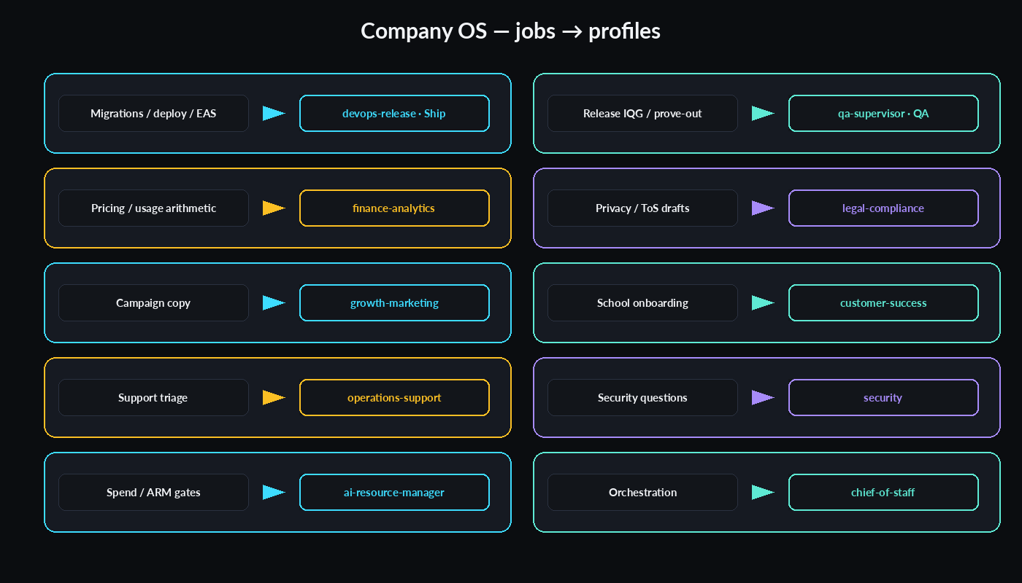
Recurring jobs mapped to Company OS profiles / agents.
13. Open questions
1. Trial start date and whether Ride-only week 1 or Ride+Classroom together?
2. School consent for under-13 accounts, or parent-only student access?
3. Retention period for Ride walk photos / LPR crops?
4. Devices: office Chromebooks only, or staff phones for walk photo?
5. Any existing dismissal vendor contract to replace?
6. Is the school FERPA-bound (federal funds)?
7. Preferred invoice entity name / who signs MOU?
8. OK to use anonymized timing data publicly in a case study?
9. Promote current Supabase project to prod, or fresh prod + migrate?
10. SMS for car-line exceptions (Twilio) — yes/no for v1?
Appendix A — Sources
See full markdown for complete source list (Supabase, Gemini, Expo, Cloudflare, Sentry, NCES, etc.). Access ~2026-09-23/24 CT.
Dark visual edition · 2026-09-24 · Confidential — Chuck Broaddus / Kelyra
Note: Word page background set via w:background (#0B0D10). Some Word/Google Docs viewers may still show white canvas; paragraph shading and dark table cells preserve the dark theme in most cases. Full prose is in the companion MD/PDF.

