**Deployment Instruction**

The link on AWS is: <http://ec2-13-211-202-133.ap-southeast-2.compute.amazonaws.com:8000>

You can click the link to access this application.

Environment Setup:

In this introduction, the default system is windows 10.

1. Download openjdk 15.0.1 from <https://jdk.java.net/15/> and install it. Then set JAVA_HOME and PATH environmental variables for the JDK
2. Choose the proper version according to your system and download Node.js 14.15.4 from <https://nodejs.org/en/download/> and install it.
3. Install angular/cli:

**npm install -g @angular/cli**

1. Choose the proper version according to your system and download yarn 1.22.5 from <https://classic.yarnpkg.com/en/docs/install/#windows-stable> and install it.
2. Download the last stable version of maven from <https://maven.apache.org/download.cgi> and install it.
3. Download the zip package of the source codes from GitHub: <https://github.com/chucklhw/MyLastFm>
4. The version of angular and CLI is:

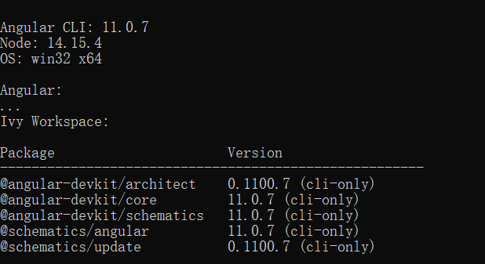

1. Unzip this package and enter this new folder, and then you will see the structure of this project.

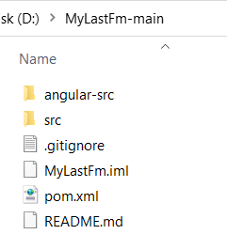

Java codes are in the src folder and angular part is in the angular-src folder.

Enter the MyLastFm-main\src\main and create Angular project with the command followed:

**ng new LastFmWeb**

1. When the angular LastFmWeb is created under src\main folder, you will see the src folder in the LastFmWeb as followed.

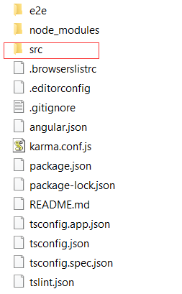

delete this src in the LastFmWeb and copy the src folder in angular-src into the LastFmWeb.

The final folder structure of folders in src/main is like this:

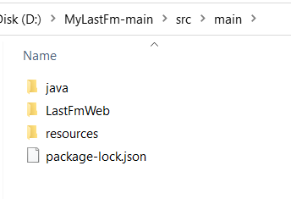

1. Now, enter the root folder MyLastFm-main, execute the mvn on the commond line:

**mvn package**

Your maven will package the entire application and create MyLastFm-1.0-SNAPSHOT.jar in the target folder.

1. Now, enter the target and run application:

**java -jar MyLastFm-1.0-SNAPSHOT.jar**

After successfully running the application locally, you can access the application with url <http://127.0.0.1:8000>

1. You can enter the country name and click search button, and then popular artists will be listed on the page with pagination. When you click the thumbnail of an artist, a new page will be opened with the top tracks of this artist you click.