Project Document

**Java backend:**

The java backend of this project uses Spring boot and Spring MVC. The following illustration is the package structure of this project:

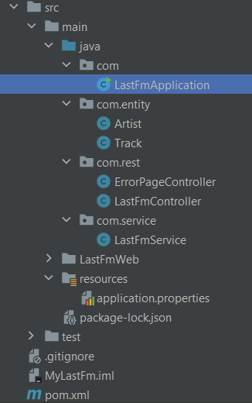

**LastFmApplication.java** is the startup class of the application.

The classes in the com.entity are entity objects whose properties are used to map the elements of JSON object returned from Last.fm APIs.

There are two controllers in the com.rest package. The **ErrorPageController.java** processes request for the /error.

**This is LastFmController.java**:

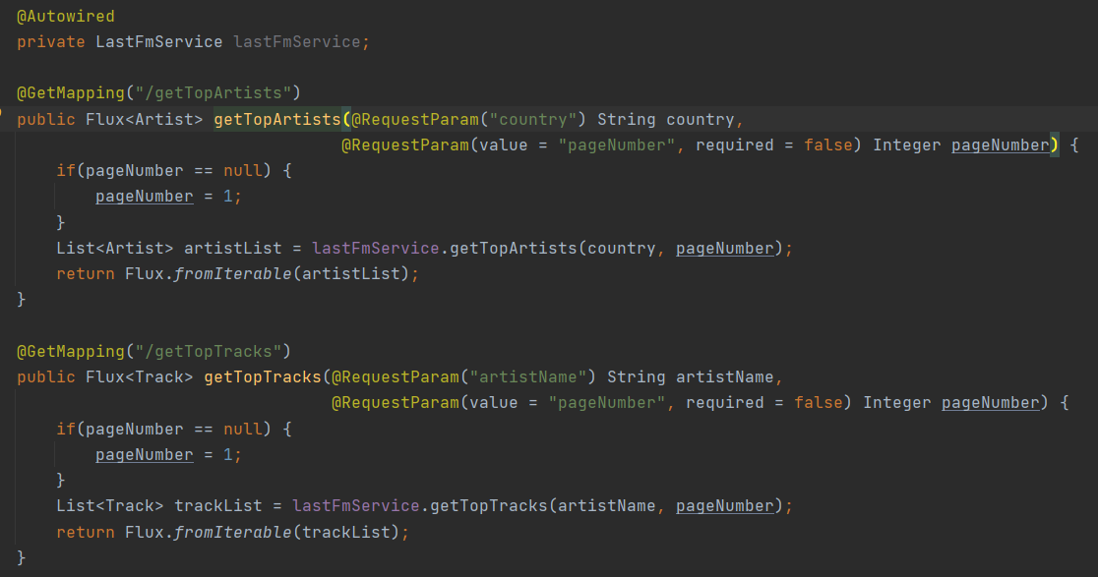

The method getTopArtists is used to process request for obtaining popular artists according to country. The method getTopTracks is for request for obtaining the top tracks of a specific artist.

**LastFmService.java** in the com.sevice contain main business logic which contains five method.

LastFmService.**getTopArtists**: fetch the artist data from Last.fm.

LastFmService. **getTopTracks**: fetch the top track data from Last.fm

LastFmService. **getArtistList**: transform the artist data from JSON to Java objects.

LastFmService. **getTrackList**: transform the track data from JSON to Java objects.

LastFmService. **getHttpResult**: send requests to Last.fm to fetch the data through http.

application.properties is configuration file for spring.



The first line in this file is the server port and the second is the resource and class path for the application.

**Angular frontend:**

This is the package structure of frontend:

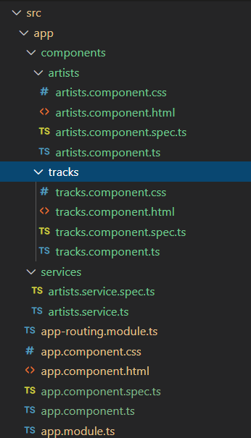

The **artists.component** under artists folder is the first page which is to obtain and present artist data according to country.

The **tracks.component** under tracks folder is the second page which is to present the popular tracks of a specific artist.

The **artists.service** under services are used to send requests to the spring backend.

The pagination codes in the first page:

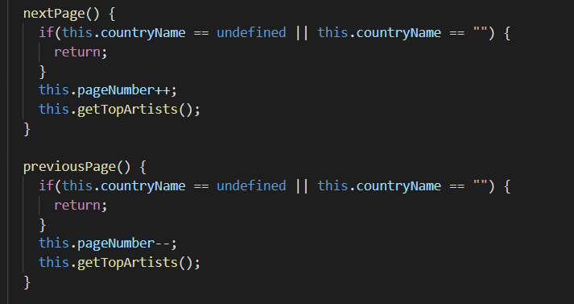The variable **pageNumber** specifies which page is the currently displayed page. Its index starts from 1 which means this is the first page.

This part is to open a new page for the tracks of an artist:



In the popular track page, originally it only displays 20 tracks. Users can click the more button to get more tracks, which makes the page work more efficiently. The following codes in **TracksComponent** is “more” button event:

