Professional Builds In Moments, Not Days
http://projectuppercut.org

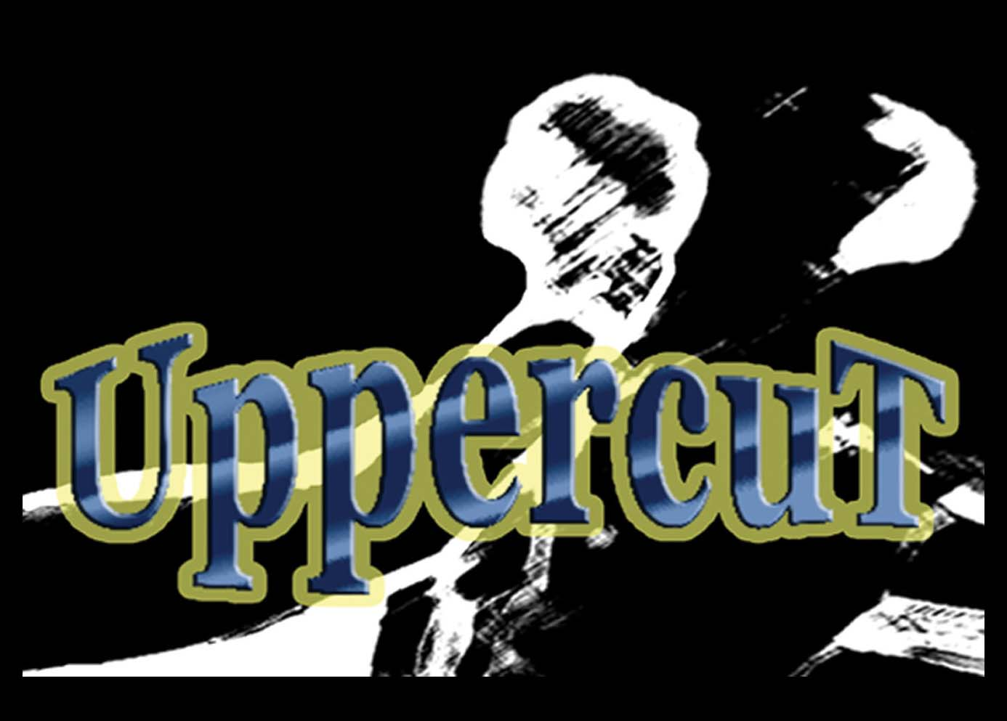
UppercuT | Hudson Integration

Contents
Summary 3
Create a Job 3
Run the Build Project 9
Code Drop / Artifacts 10

Summary
Integrating UppercuT with Hudson is actually very easy. We will go through the steps to set up and run a build.

Create a Job
- Log into Hudson.
- Click on New Job.
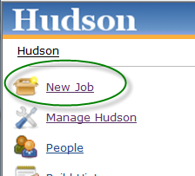
- Type a name for your job. Choose [Build a free-style software project]. Click {OK}.
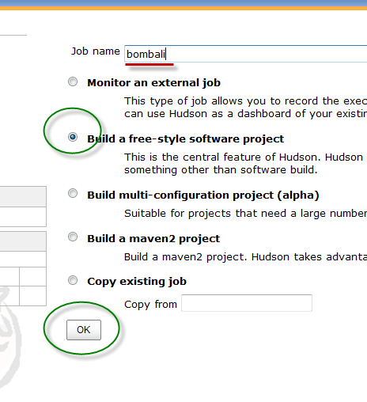
- This will take you to the job setup. You can type a description if you want.
- Head down to the Source Control Management section. Choose what is most appropriate for you. Just make sure that [Local module directory (optional)] has a “.” in it to use the local workspace directory.
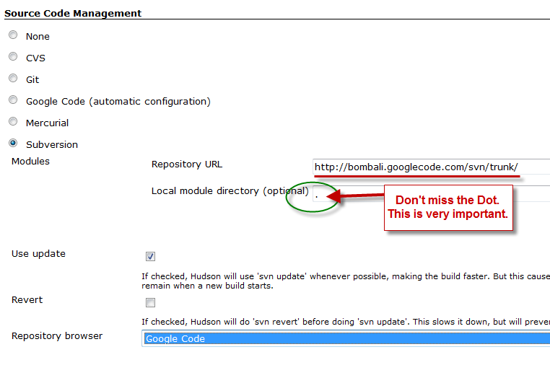
- Head down to the Build Triggers section. Click on [Poll SCM] and in [Schedule] add “* * * * *”. This means it’s going to check the source control system every one minute.
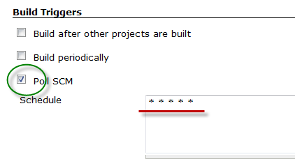
- Head down to [Build Environment]. Click on [Abort the build if it’s stuck]. Choose an appropriate amount of [Timeout minutes]. Check [Fail the build]. Check [Show screenshot during build]. These are plugins that are available through the manage plugins section of Hudson Management.
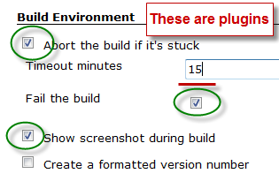
- Go to the Build section. Click {Add build step}. Select [Execute Windows batch command].
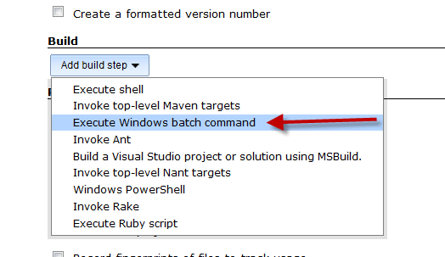
- In [Command] type “zip.bat”.
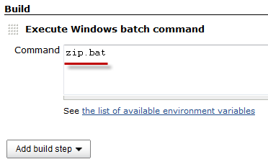
- Go to Post-build Actions section. Refer to the image below for these settings.
  - Check [Archive the artifaces]. In [Files to archive], put in “code_drop/*.zip”.
  - Check [Activate Chuck Norris]. This is a plugin you may need to install first.
  - Check [Publisher NCover HTML report]. Also a plugin.
    - In [Coverage HTML Directory], put build_output/build_artifacts/ncover.
    - In [Report(s) to display (comma separated)], put projectName.CodeCoverageSummary-results.html. The project name here is the one you defined in the uppercut.config file. That property is project.name.
    - Check [Keep past coverage reports].
  - Check [Publish testing tools result report]. NOTE: This option may not work. If this is what fails your build, please uncheck this box and resave.
    - Choose Gallio (MbUnit) or NUnit.
    - In [Pattern] enter one of the following values:
      - MbUnit - build_output/build_artifacts/mbunit2/*.xml
      - Gallio - build_output/build_artifacts/gallio/*.xml
      - NUnit - build_output/build_artifacts/nunit/*.xml
    - Uncheck [Fail the build if test results were not updated this run].
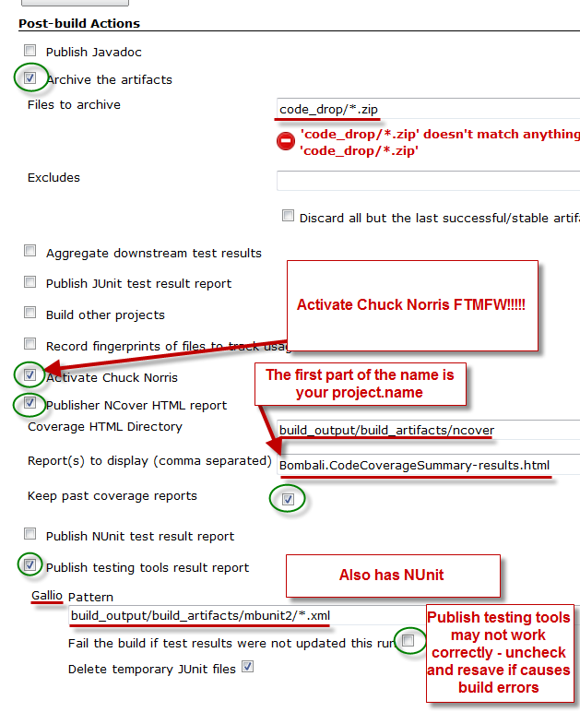
- When we are done getting everything set up, we click on {Save}.
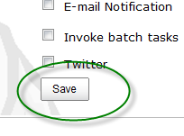
- This completes the setup.

Run the Build Project
- Now that we have our project defined, let’s run our build.
- From the job page, click on [Build Now].
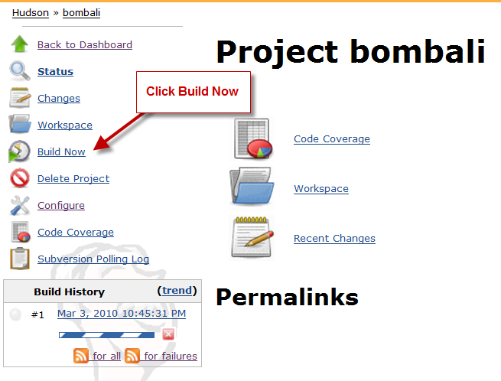
- This kicks off the build and you can see what is going on in [Build History] section or from the main screen.

Code Drop / Artifacts
What we have after a successful build is a .zip file as an artifact available for download.
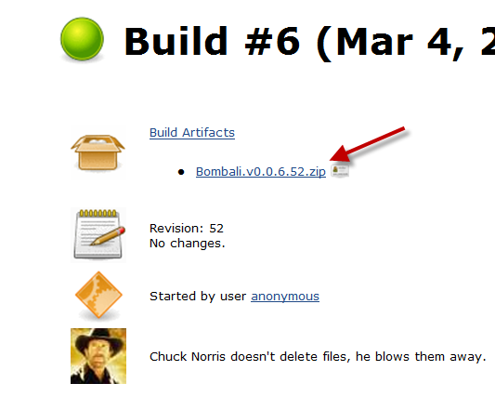
This is why we called zip.bat instead of build.bat. We have to download the items from Hudson and want to just download the one file.

