During this week’s homework assignment, you will be adding a user interface (UI) interaction to an HTML element using jQuery on your portfolio site.

Before you begin coding, you will first design a UI interaction in Adobe XD, then code it using jQuery.

To conclude this week’s homework, you will polish the visual design of your portfolio site, seek feedback, and iterate on your design.  
  
What is a UI interaction exactly? It can be defined in a number of ways. A UI interaction could be:

1. An animation that directs your user’s attention to a call to action (e.g., a button with the text “click me”) or prompts the user to perform an action like [scroll down your page](https://codepen.io/bisaillonyannick/pen/pvZeGg). The call to action could be a way for a potential employer to download your resume, contact you, or view your work.
2. An HTML element that the user can interact with. This could be an [accordion](https://www.w3schools.com/howto/howto_js_accordion.asp) that reveals different skills you possess when a user clicks or [tabs](https://www.w3schools.com/w3css/w3css_tabulators.asp) that display different skills or facts about you.

***Note:*** *Remember, if you’re using a content management system like Wix or Squarespace to build your portfolio, you MUST still complete and submit this assignment. You are allowed to have just two incomplete homework assignments at the end of the UX/UI Boot Camp.*

*If you did not complete the Unit 18 homework or were not happy with the outcome, you can use this starter* [*template*](https://drive.google.com/open?id=1jxp639Ro7k6EaVW2J__EjfboLfMwhG0n)*. Be sure to style it to match your design from Unit 16.*

*Be sure to read through this document in its entirety.*

## 

## **Week 19: Add Interactive Elements to Your Portfolio**

**User Story:** Catching your user’s attention is important, but it is more important to direct their attention to your call to action. When recruiters and potential employers view your portfolio, it’s important to direct their attention to something, whether it be your best work, your resume, Contact Me form, or social media links. UI interactions are one way to catch your user’s attention. If it moves, animates, or can be interacted, it’ll grab their attention and bring them one step closer to getting in touch with you.

## **Requirements (~12 hours to complete)**

* **Part 1: Create a UI Interaction for Your Portfolio Site Design Using Adobe XD (2 hours)**
* **Part 2: Create a New GitHub Repository for the Unit 19 Homework (15 minutes)**
* **Part 3: Code Your UI Interaction With jQuery Using a jQuery Event Listener (6 hours)**
* **Part 4: Update the Visual Design of Your Website, Receive Feedback, and Iterate (3 hours)**
* **Part 5: Upload Your Coded UI Interaction and Polished Portfolio Site to GitHub and Publish on GitHub Pages (30 minutes)**

## **Instructions**

**Part 1: Create a UI Interaction for Your Portfolio Site Design Using Adobe XD (2 hours)**

1. Using Adobe XD, prototype a simple UI interaction to direct users to a call to action on your portfolio design file.   
     
   *Note: Keep your interaction simple if you are new to jQuery. You will build your UI interaction with code in the upcoming steps.*   
     
    Here is a list of common interactive elements you can code using jQuery:
   1. [Tabs](https://jqueryui.com/tabs/)
   2. [Accordions](https://www.w3schools.com/jquery/tryit.asp?filename=tryjquery_slide_down)
   3. [Elements That Fade](https://www.w3schools.com/jquery/jquery_fade.asp)
   4. [Modals](https://www.w3schools.com/howto/howto_css_modals.asp)
   5. [UI Elements That Move or Animate](https://www.w3schools.com/jquery/jquery_animate.asp)
   6. [Background Image That Animates](https://codepen.io/subz/pen/GgPrJP)
   7. [Smooth Scrolling](https://www.w3schools.com/howto/howto_css_smooth_scroll.asp)
2. Create a gif of your UI interaction using [giphy](https://giphy.com/) or a similar tool.

**Resources**

To get your creative juices flowing, view some previous student work with examples of UI animations:

* 1. <http://www.arishdubash.com/>
  2. <https://www.gracehpark.info/>
  3. <https://www.ashleychen.io/>
  4. <https://www.lamonttran.com/>
  5. <https://www.serg.design/>

**Part 2: Create a New GitHub Repository for the Unit 19 Homework (15 minutes)**

1. Before we start coding, create a new repository on [GitHub](https://www.github.com). Name it “UX_UI_HW_19.”
2. Clone the blank repository to your desktop using GitHub Desktop.
3. Copy and paste your homework files from UX_UI_HW_18 into UX_UI_HW_19.   
   You want to be able to show how your code abilities have grown during the course of the code section. Having multiple versions will allow you to show employers how your skills have matured in the UX/UI Bootcamp.
4. Update your UX_UI_HW_19 repository with the new files.
5. Publish your site on GitHub Pages.
6. Scroll down to the GitHub Pages area in settings and select the master branch.
7. Check the URL after the page refreshes and you're ready to code!

**Part 3: Code Your UI Interaction With jQuery Using a jQuery Event Listener (6 hours)**

**Create the Folder Structure and Files for Writing jQuery**

1. Create a folder named “js” in the root folder of your portfolio site.
2. Create an index.js file inside the js folder.   
   Your folder structure should look like this:

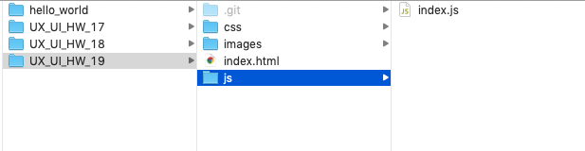

1. Create a [<script>](https://www.w3schools.com/js/js_whereto.asp) tag before your closing HTML tag that links your JavaScript file to your HTML file.

*Note: JavaScript files that manipulate HTML elements must be loaded at the bottom of the document. The reason is that if you load a JavaScript file that manipulates an HTML element first, the HTML you are attempting to manipulate has not even been loaded on your page, resulting in a JavaScript error or worse—you see nothing happen without an error message*.

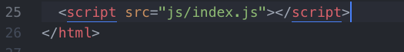

1. In your index.js file, test to make sure your JavaScript file is loaded correctly using [console.log](https://www.w3schools.com/jsref/met_console_log.asp).

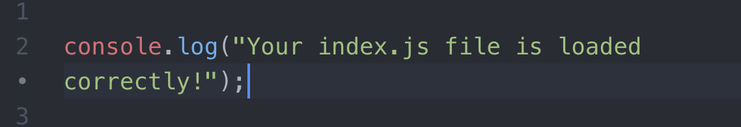

1. If your file is loaded correctly in the console tab, you will see the following message in the console tab of Chrome’s web inspector:

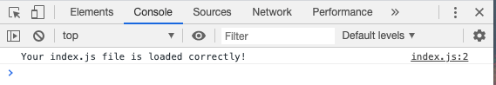

1. Now that your script file is correctly linked to your HTML file, it’s time to create your UI interaction using jQuery.

**Create a jQuery Event Listener That Triggers a UI Interaction**

1. Create an [event listener](https://www.w3schools.com/jquery/jquery_events.asp) that is triggered by a click or another event listener.   
   Click the following link to view all the different [event listener types](https://api.jquery.com/category/events/).
   1. The most common types of event listeners are:
      1. [clicks](https://api.jquery.com/click/)
      2. [hovers](https://api.jquery.com/hover/)
      3. When a [page loads](https://api.jquery.com/ready/)
      4. When a user [scrolls](https://api.jquery.com/scroll/)
2. Test your event listener using the [console.log function](https://www.w3schools.com/jsref/met_console_log.asp) to make sure your event listener is correctly connected to your HTML element.

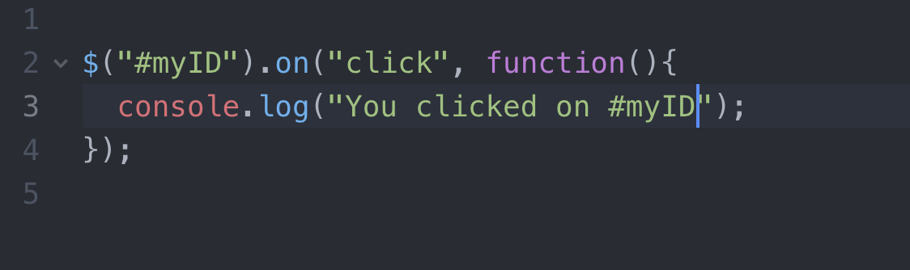

1. Between the curly braces, write your jQuery code that will animate or manipulate your UI.

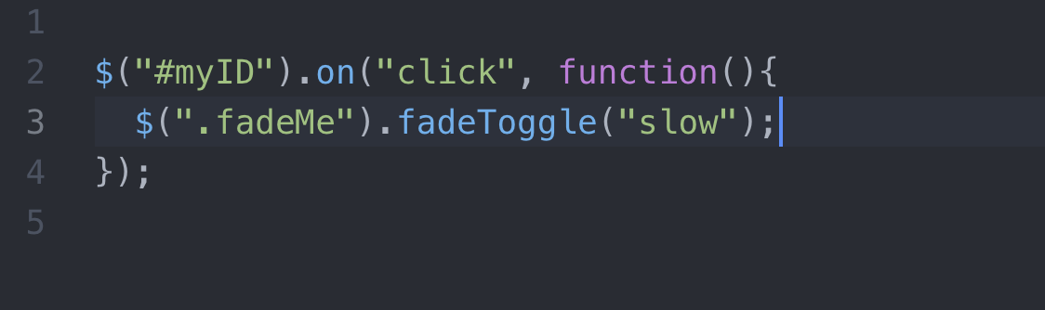

*Note: This is just a basic sample of how you will build your UI interaction. The code you write will require research, patience, and testing to get it 100% correct.*

1. Test your UI interaction. If you are not 100% happy with the result, keep working on it until your UI interaction works like the way you designed it to.   
   *Note: Remember to research possible solutions, post a question onto* [*https://stackoverflow.com/*](https://stackoverflow.com/)*, or ask your instructional staff for assistance via Slack or office hours.*
2. When you are finished coding, update your GitHub repository with the updated index.html, style.css, and index.js files so you can receive feedback on your work.
3. Publish your repository using GitHub Pages so that your webpage can be reviewed and critiqued.

**Bonus: Use a jQuery Library to Build Animation Into Your Portfolio Site**

1. There are many jQuery libraries available on the web for you to use when creating interactions on your portfolio site. Here is a list of different jQuery/JavaScript libraries for you to experiment with:
   1. [Particles.js](https://vincentgarreau.com/particles.js/)
   2. [ScrollReveal.js](https://scrollrevealjs.org/)
   3. [Wow Scroll Reveal](https://www.delac.io/wow/)
   4. [GreenSock](https://greensock.com/)
   5. [AniJS](https://anijs.github.io/)
   6. [Threejs](https://threejs.org/)
2. If you use a library to create your interaction, make sure you push the updated files to your GitHub repo and publish with GitHub pages so your peers can see your updated portfolio site.

*Note: If you use a library, you will need to study the documentation and experiment with the code to achieve the desired effect. Remember to use Google and be sure to include the name of the plugin you are using.*

**Part 4: Update the Visual Design of Your Website, Receive Feedback, and Iterate (3 hours)**

Now that you have added a UI interaction to your homepage, continue to polish the CSS of your portfolio site. Creating a website that looks professional takes time and dedication.

1. Open the Adobe XD design file of your portfolio site.
2. Take a screenshot or export a jpg of your current visual design. You will be iterating on this file and using it to show how you’ve changed your design based on the feedback you received.
3. Polish the CSS of your homepage so that it perfectly matches your visual design. If you are already happy with how your portfolio site looks, feel free to move onto the next step.
4. Seek feedback from your peers or instructional staff on how you can improve upon the user experience (UX) of your page.
   1. Receive feedback from three to five people on the visual design of your homepage.
   2. Create a Google Document containing at least three key insights you gained from the feedback from your peers. Make sure you set the sharing setting to be a public link so the instructional staff can view your work!
5. Iterate the design file of your portfolio site based on the feedback you received.
6. Take a screenshot or export a jpg of your updated design file.
7. Update the CSS and HTML (if necessary) of your portfolio site to match your iterated design file.

**Part 5: Upload Your Coded UI Interaction and Polished Portfolio Site to GitHub and Publish on GitHub Pages (30 minutes)**

1. Upload your modified webpage to GitHub using GitHub Desktop.
2. Open your published GitHub Pages URL to make sure your changes are applied.
3. Copy the URL and have it ready for when you submit your homework via Bootcamp Spot.

## **Tips**

The following are general developer workflow tips to help you speed up your development process when building a webpage:

* Search for examples of the UI interaction you are trying to create. Simple search terms are best for finding the interaction you are creating. For example, “jQuery tabs example” will display multiple examples of how you can create jQuery tabs.
* Don’t be afraid to Google a lot! There are many nuances to front-end development, and you will undoubtedly encounter problems when practicing coding. Using Google to search for answers is a normal part of the workflow.
* Create an account at Stack Overflow (<https://stackoverflow.com/>), a community forum for developers. It is a great resource to help answer all your developer questions.

### **How to Submit Your Homework**

Use Google Drive (G-drive) and GitHub to turn in your homework assignment. Double-check that your sharing permissions are set to “Anyone with the link can view” when using G-drive to submit your homework.

Submit the following links to <https://www.bootcampspot.com>:

* A link to a G-drive folder containing:
  + The gif of your UI interaction
  + A screenshot of your original design file
  + The Google Document containing the key insights from the feedback you received from your peers
  + An updated jpg or screenshot of your iterated design file
* A link to your hosted GitHub Pages portfolio site showcasing your animation/interaction
* A link to your GitHub repo

### **Submit Your Portfolio to Career Services**

Submit your GitHub Pages link of your portfolio site to<https://bootcampspot.com/>under the Career Services tab so your profile coach can also review your portfolio.

* Include your GitHub Pages link in your submission.
* Sign into Bootcamp Spot and go to the Career Services tab.
* Submit your GitHub Pages link to Milestone 5. A profile coach will look at your portfolio and review your content. Within 48 hours, they will give you feedback to help ensure you’re employer-ready.