**Demura algorithm**

**DLL Guide**

 

**Preliminary Version**

**Byung Geun (BG) Jun**

**This document contains confidential information of Meta Platforms, LLC. No part of this document may be reproduced, copied, or transmitted without the prior written approval of Meta Platforms.**

**Meta Demura Process Flow**

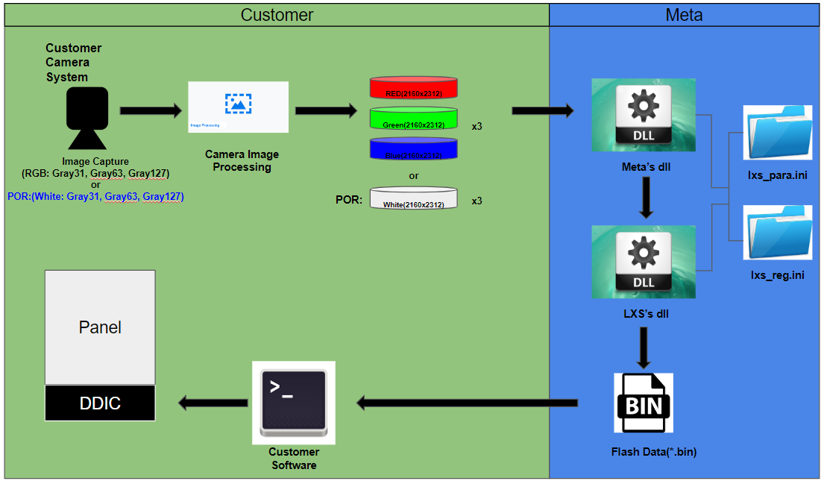

**Folder Hierarchy**

**Input**

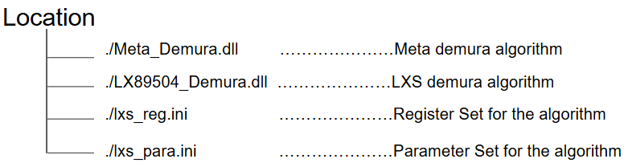

**\* All Files above needs to locate in same path.**

**\* The DLL file doesn’t include version information.**

**Output**

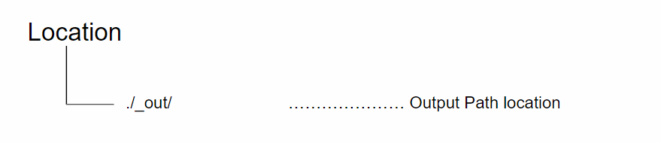

**\* Output Folder path needs to be created.**

**Demura Algorithm Interface Guide**

**META’s DLL - META_Demura.dll   
: void (*ProcessImageFunc)(double** img[3][3]);**

| **Arguments** | **I/O** | **Description** |
| --- | --- | --- |
| **img** | **I** | **RGB Raw Camera Data**  **- Format: double\*\***  **- All Camera Data from both planes and colors is stored an 2-dimensional array**  **<DMR_MODE 0>**   | **[Plane0][R]** | **[Plane0][G]** | **[Plane0][B]** | | --- | --- | --- | | **[Plane1][R]** | **[Plane1][G]** | **[Plane1][B]** |   **<DMR_MODE 1>**   | **[Plane0][R]** | **[Plane0][G]** | **[Plane0][B]** | | --- | --- | --- | | **[Plane1][R]** | **[Plane1][G]** | **[Plane1][B]** | | **[Plane2][R]** | **[Plane2][G]** | **[Plane2][B]** |   **<DMR_MODE 2>**   | **[Plane0][W]** | **[Plane0][W]** | **[Plane0][W]** | | --- | --- | --- | | **[Plane1][W]** | **[Plane1][W]** | **[Plane1][W]** | | **[Plane2][W]** | **[Plane2][W]** | **[Plane2][W]** | |

**LXS’s DLL - LX89504_Demura.dll  
: typedef bool (*DLL_MAIN)(double** img[3][3], wchar_t* output_path);**

| **Arguments** | **I/O** | **Description** |
| --- | --- | --- |
| **img** | **I** | **RGB Raw Camera Data**  **- Format: double\*\***  **- All Camera Data from both planes and colors is stored an 2-dimensional array**  **<DMR_MODE 0>**   | **[Plane0][R]** | **[Plane0][G]** | **[Plane0][B]** | | --- | --- | --- | | **[Plane1][R]** | **[Plane1][G]** | **[Plane1][B]** |   **<DMR_MODE 1>**   | **[Plane0][R]** | **[Plane0][G]** | **[Plane0][B]** | | --- | --- | --- | | **[Plane1][R]** | **[Plane1][G]** | **[Plane1][B]** | | **[Plane2][R]** | **[Plane2][G]** | **[Plane2][B]** |   **<DMR_MODE 2>**   | **[Plane0][W]** | **[Plane0][W]** | **[Plane0][W]** | | --- | --- | --- | | **[Plane1][W]** | **[Plane1][W]** | **[Plane1][W]** | | **[Plane2][W]** | **[Plane2][W]** | **[Plane2][W]** | |
| **output_path** | **O** | **LUT data(.bin) is generated in output_path.**  **[Example]**  **Output location -> ./_out/LUT.bin**  **Output_path creation required -> ./_out** |

**Demura Algorithm Platform**



**x64: for 64bit machine**