Project Plan

Arc Transit: Transit Operations Fleet Intelligence Platform

Document Revision #: 1
Date of Issue: July 7, 2026

Chuckz Española
Project Developer
Table of Contents
1. Project Overview 1
1.1 Purpose, Scope, and Objectives 1
1.2 Assumptions and Constraints 1
1.3 Project Deliverables 2
1.4 Schedule and Budget Summary 2
1.5 Evolution of the Plan 2
1.6 References 2
1.7 Definitions and Acronyms 3
2. Project Organization 4
2.1 External Interfaces 4
2.2 Internal Structure 4
2.3 Roles and Responsibilities 4
3. Managerial Process Plans 5
3.1 Startup Plan 5
3.1.1 Estimates 5
3.1.2 Staffing 5
3.1.3 Resource Acquisition 5
3.1.4 Project Staff Training 6
3.2 Work Plan 6
3.2.1 Work Breakdown Structure 6
3.2.2 Schedule Allocation 7
3.2.3 Resource Allocation 7
3.2.4 Budget Allocation 7
3.3 Project Tracking Plan 8
3.3.1 Requirements Management 8
3.3.2 Schedule Control 8
3.3.3 Budget Control 8
3.3.4 Quality Control 9
3.3.5 Reporting 9
3.3.6 Project Metrics 9
3.4 Risk Management Plan 9
3.5 Project Closeout Plan 10
4. Technical Process Plans 11
4.1 Process Model 11
4.2 Methods, Tools, and Techniques 11
4.3 Infrastructure 11
4.4 Product Acceptance 12
5. Supporting Process Plans 13
5.1 Configuration Management 13
5.2 Verification and Validation 13
5.3 Documentation 14
5.4 Quality Assurance 14
5.5 Reviews and Audits 14
5.6 Problem Resolution 15
5.7 Subcontractor Management 15
5.8 Process Improvement 15
6. Additional Plans 16
Annex A 18
Annex B 19

Document Change Control
This section provides control for the development and distribution of revisions to the Project Charter up to the point of approval. The Project Charter does not change throughout the project life cycle, but rather is developed at the beginning of the project (immediately following project initiation approval, and in the earliest stages of project planning). The Project Charter provides an ongoing reference for all project stakeholders. The table below includes the revision number, the date of update/issue, the author responsible for the changes, and a brief description of the context and/or scope of the changes in that revision.
Revision Number | Date of Issue | Author(s) | Brief Description of Change
1

Project Overview
Arc Transit System is an intelligence transit-fleet operations command platform for managing bus fleets, drivers, fixed routes, dispatch assignments, status incidents, and operational reporting from one dashboard.

Purpose, Scope and Objectives

Project Scope
- A web-based operations dashboard accessed through a browser over a secure HTTPS web protocol.
- Current operational visibility based on manually submitted fleet status updates, service alerts, incident reports, and route schedule information.
- Fleet management: create, update, audit, and view the status of active fleet records.
- Bus unit and driver management, active route management, dispatch assignment management, maintenance tracking, and operational status alerts.
- Analytics dashboard with operational counts for active fleet units, delayed vehicles, open incidents, and units under maintenance.
- Role-Based Access Control (RBAC) and audit logging.
- PostgreSQL persistence with Flyway migrations.
- Dockerized local and cloud-VM deployment.
- Technical documentation, system architecture diagram, database schema design, and benchmark performance report
Furthermore, the following methods are considered out of scope A separate mobile driver application.
GPS device integration and real-time vehicle telemetry. Fare and payment processing system. Public passenger-facing mobile application. Production transit authority deployment or integration with live transit networks. Microservices architecture. Replacement for commercial fleet systems such as Geotab or Samsara.

Objectives
The objective is to build and evaluate a working transit operations prototype that demonstrates modular Java architecture, role-based access control, PostgreSQL-backed workflows, a usable operations dashboard, and measurable performance using simulated or manually submitted data.

Requirements Analysis

Functional Requirements
- The system shall allow administrators to create, update, archive, and view fleet unit records including plate number, vehicle type, capacity, and operational status.
- The system shall allow dispatch users to assign a vehicle and driver to a fixed route schedule, and flag schedule conflicts or unavailable vehicle status.
- The system shall allow operations staff to submit incident reports containing severity level, associated route, timestamp, description, and resolution status.
- The system shall allow authorized users to filter fleet records by status (Active, Inactive, Under Maintenance) and search by plate number or vehicle type.
- The system shall maintain an audit log capturing every status change and assignment action, recording the user, timestamp, action type, and affected record.
- The system shall restrict administrator-only actions through role-based access control and display a clear access-denied response when an unauthorized user attempts the action.
- The system shall display an operational dashboard showing summary counts for active fleet units, vehicles with delayed status, open incidents, and units under maintenance.
- The system shall display static route maps with stop markers and route polylines based on configured route data. No live GPS tracking is included.
- The system shall enforce secure HTTPS web protocol for all browser connections and restrict PostgreSQL access to the application container only. No database port shall be publicly exposed.
- The system shall enforce role-based access control using Spring Security, restricting each page and action to the permitted roles defined in the user role specification.

Non-Functional Requirements
- Dashboard initial page load shall complete within 3 seconds with a dataset of 500 fleet records, measured using browser developer tools under a single user session.
- Fleet search and filter operations shall complete within 300 ms at p95 latency when tested against the benchmark dataset with indexed search fields.
- User login shall complete within 500 ms at p95 latency under a test load of 50 concurrent virtual users.
- The system shall show clear field-level or form-level validation messages without exposing stack traces or internal implementation details.
- The system shall record login attempts, access denials, state-changing business actions, and unexpected errors with a timestamp, user identity, action, and correlation identifier.
- The system shall support Docker-based local deployment using Docker Compose with a defined arc-app service and a postgres service.
- The system shall have no unresolved critical-severity dependency vulnerabilities before final release, verified using the OWASP Dependency-Check Maven plugin.
- The system shall pass the full Maven test suite (unit and integration tests) with zero failures as part of the CI build pipeline before any deployment.

Trade-off Analysis
Arc Transit System is a personal enterprise application project. Its purpose is to demonstrate system design, modular Java development, database engineering, security, testing, and deployment. The features below are excluded from the initial prototype setup so the project remains achievable within the twelve-week development period.

Excluded Features
Excluded feature | Why it is not included | Method of Approach
GPS tracking and live telemetry | Requires vehicle devices, continuous location ingestion, mapping, validation, and real-time data processing. | Use manually submitted location and service-status updates. Fixed routes and stops remain visible on the map.
Separate mobile driver application | Adds a second client application, mobile authentication, external APIs, push notifications, and another release process. | Operations Staff use the web application. Drivers remain managed records rather than authenticated users.
Microservices | Introduces distributed deployment, service discovery, tracing, gateways, and message-broker operations that are unnecessary for one application and one developer. | Use a Spring Modulith modular monolith with clear internal module boundaries.
Fare and payment processing | Introduces financial workflows, payment-gateway integration, refunds, and PCI-DSS concerns outside the transit-operations domain. | Keep the system focused on internal fleet, route, dispatch, incident, and maintenance operations.
Live transit-authority deployment | The project has no partner authority, production users, or live operational data source. | Demonstrate the system with local and cloud-VM deployment using simulated data.
Advanced reporting and BI integration | Scheduled reports, time-series analysis, and external BI tools would require a separate reporting layer. | Provide dashboard counts and basic operational summaries through PostgreSQL queries.
Multi-tenant operation | Supporting several organizations would require tenant-aware security, data isolation, and tenant-specific configuration. | Use one simulated transit organization and keep module ownership clear for possible future extension.

Assumptions and Constraints

Design – UX/UI Prototyping

Target Users
Arc Transit System uses two account categories. This keeps access control understandable while still separating system administration from daily operations.
- System Admin. Manages user accounts, role assignments, system configuration, audit records, and all operational modules. The administrator can create, update, archive, and review master and operational records.
- Operations Staff. Handles daily operations such as viewing fleet and driver records, checking routes and schedules, creating dispatch assignments, submitting fleet status updates, reporting incidents, updating maintenance work, and viewing dashboard metrics. Operations Staff cannot manage user accounts, roles, or system configuration.

Sample UX/UI visual prototype
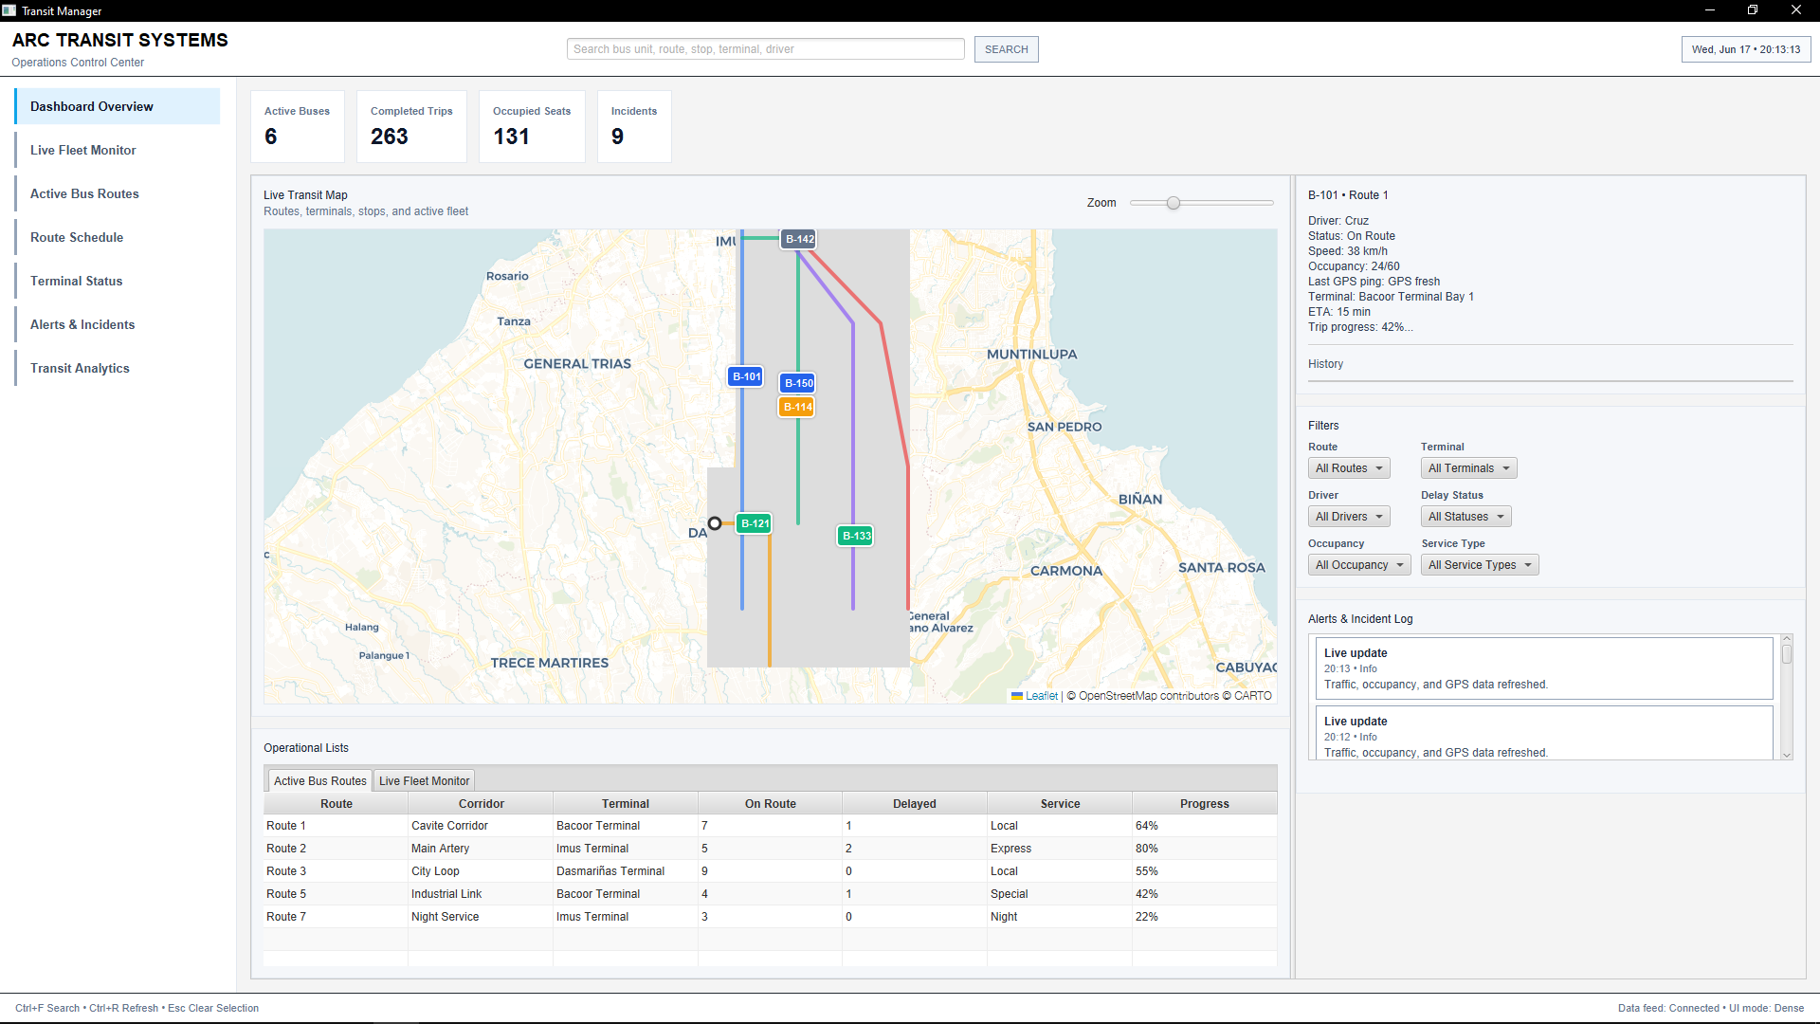

Conceptual Prototype User Flow Diagrams
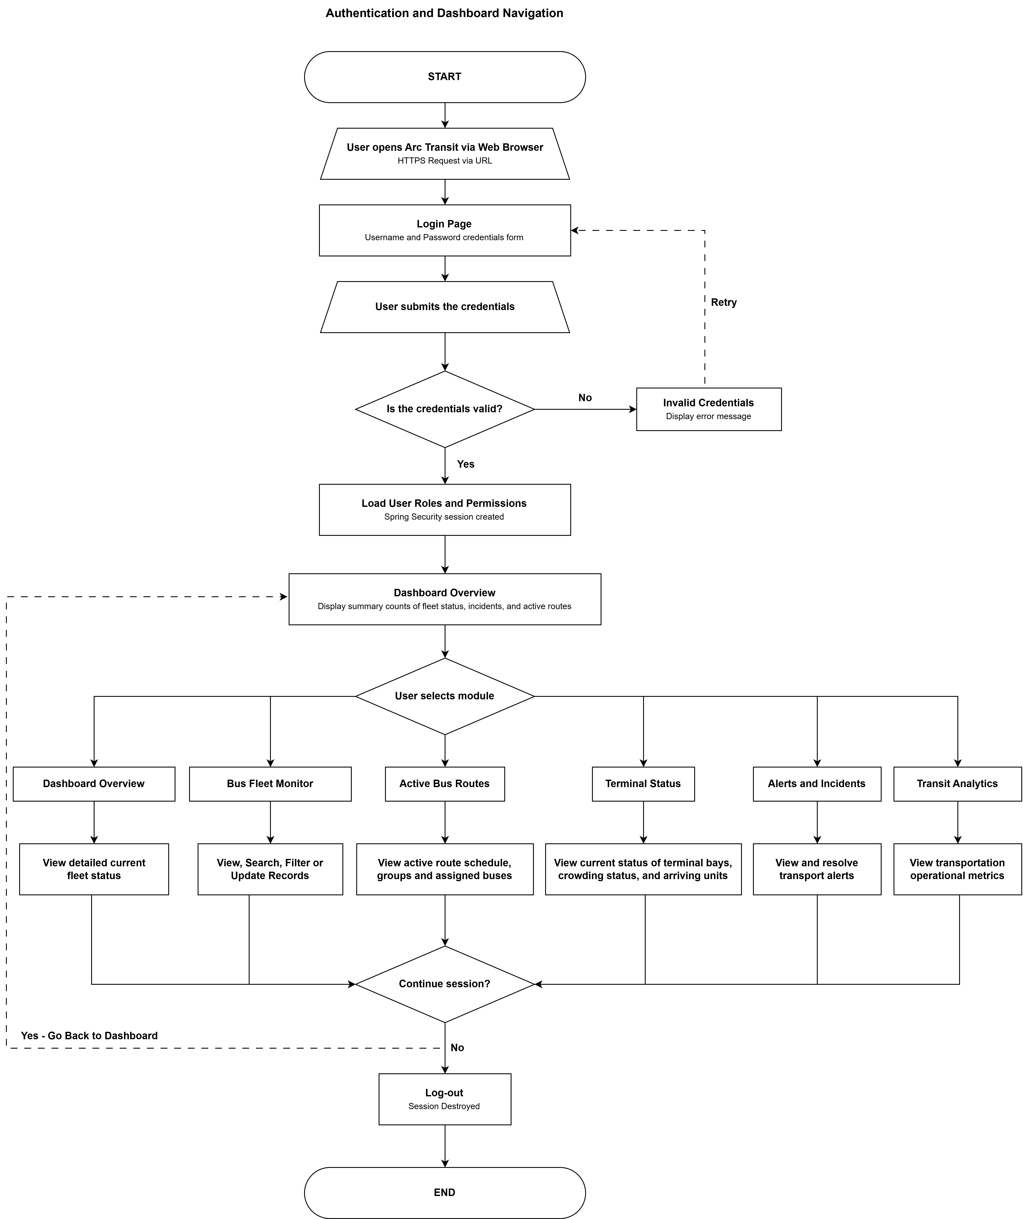

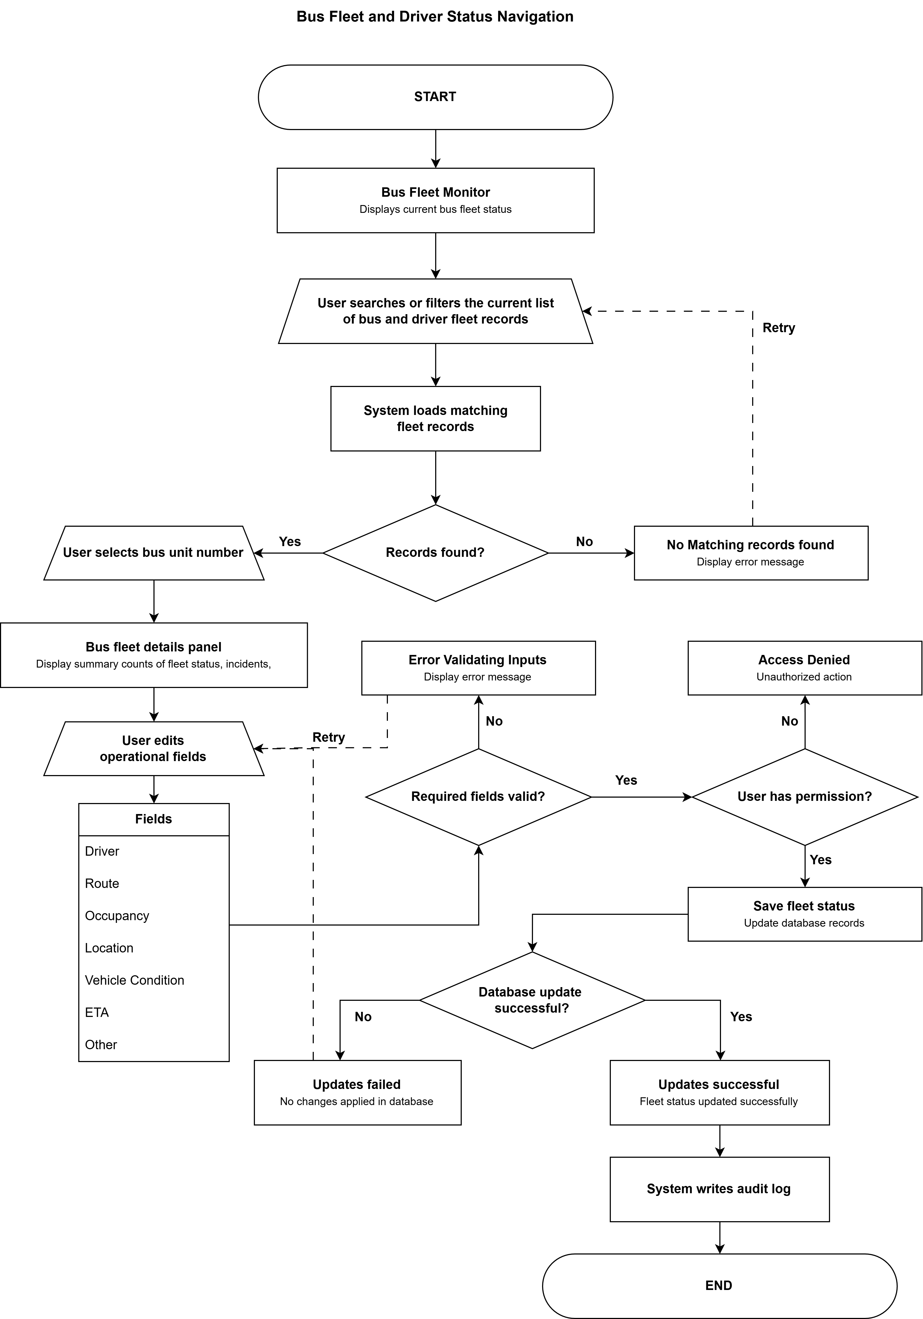
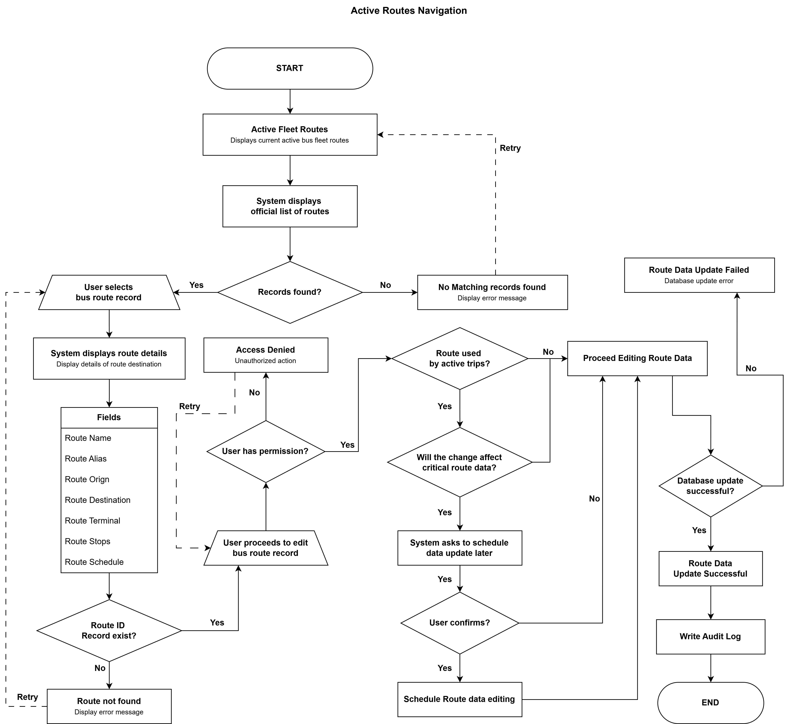

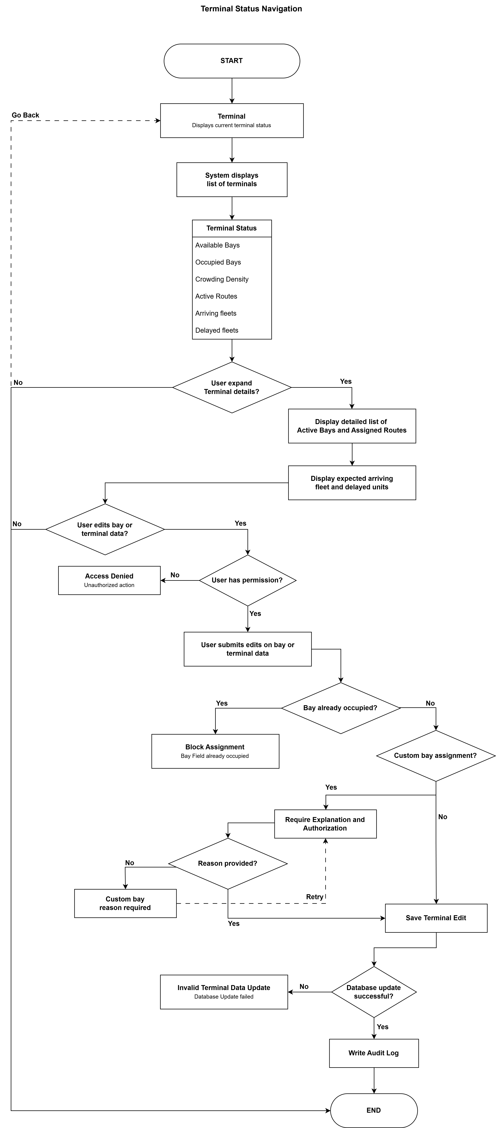
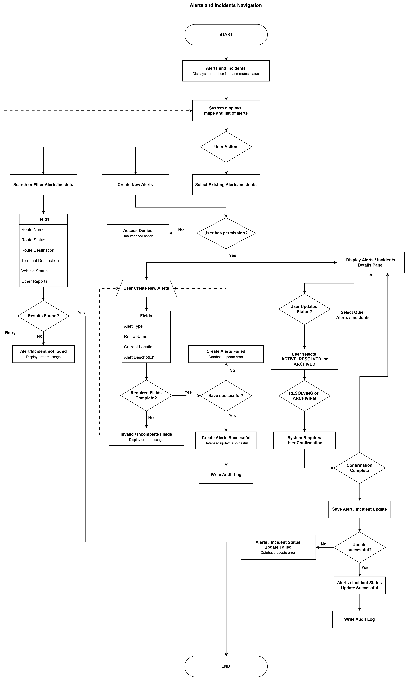
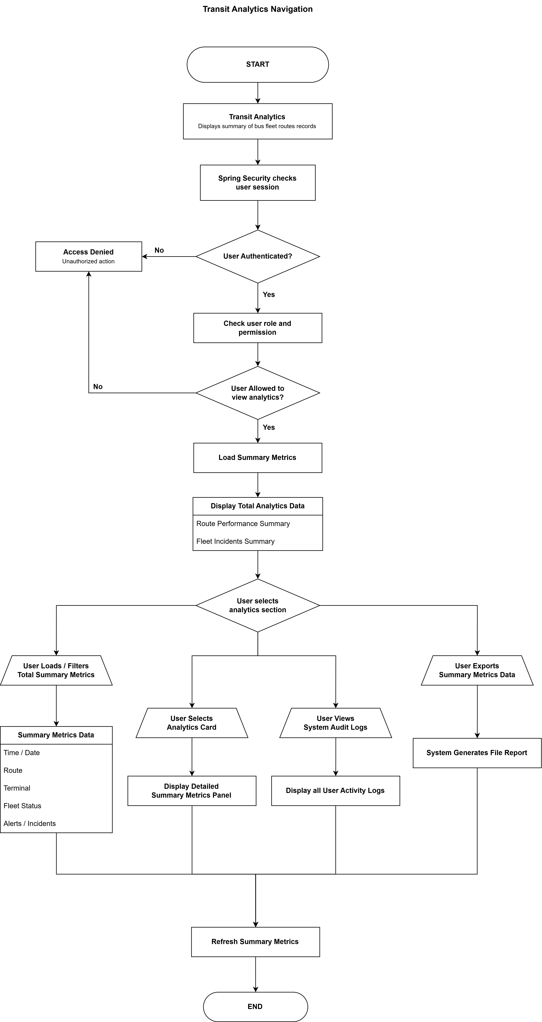

Design - System Architecture

Architecture Overview
Arc Transit System uses a modular monolith architecture implemented with Spring Modulith. The application is deployed as one Spring Boot JAR, but its business functions are separated into modules with defined responsibilities and interfaces. Vaadin views call application services, application services apply business rules, module-owned repositories persist data, and PostgreSQL stores the final records.
RUNTIME FLOW
Web Browser → HTTPS → Spring Boot and Vaadin Flow → Spring Modulith modules → Spring Data JPA or JDBC → PostgreSQL.
This structure keeps deployment simple while preventing the application from becoming one tightly coupled codebase.

Technology Stack
Technology | How the software is used
Java 21 | LTS Java baseline used for the application, domain model, and Vaadin user interface.
Spring Boot 3.0 | Application runtime, dependency injection, configuration, transactions, and production support.
Spring Modulith | Defines and verifies module boundaries inside the single deployable application.
Vaadin Flow | Builds the server-side web interface in Java without a separate JavaScript frontend project.
Spring Security | Provides session-based login, role checks, CSRF protection, and protected navigation.
PostgreSQL | Stores relational operational data with transactions, constraints, and indexed queries.
Spring Data JPA / JDBC | Handles repository access and selected reporting queries.
Flyway | Applies versioned SQL database migrations in a controlled order.
Maven | Builds, tests, and packages the application.
Docker Compose | Runs the application and PostgreSQL consistently for local development and cloud-VM deployment.

System Modules
Module | Main responsibility | Primary records or output
Auth | Staff accounts, roles, login access, and user administration. | app_users, roles, user_roles
Fleet | Bus-unit registry, administrative availability, and manual operational status reports. | fleet_units, fleet_status_updates
Driver | Driver identity, license validity, employment status, and availability checks. | drivers
Route | Fixed routes, ordered stops, and recurring schedule templates. | routes, route_stops, route_schedules
Dispatch / Assignment | Assigns one vehicle and one driver to a route schedule for a service date and manages the assignment lifecycle. | dispatch_assignments
Incident | Records operational incidents, severity, progress, and resolution details. | incidents
Maintenance | Tracks scheduled and corrective work that affects vehicle availability. | maintenance_records
Analytics | Produces read-only dashboard counts and operational summaries from current data. | Dashboard and summary views
Audit | Records important business changes and authorization outcomes. | audit_log

Architecture Decisions
The following decisions define the initial prototype system implementation. Each choice was made for the current project scope rather than to imitate the infrastructure of a much larger organization.
Decision area | Selected approach | Alternatives considered and trade-off
Application architecture | Spring Modulith modular monolith. Modules remain separate in code while the application is packaged and deployed as one JAR. | A traditional layered monolith offers weaker domain boundaries. Microservices architecture add network, deployment, and operational overhead that this project does not need.
Database | PostgreSQL for relational data, transactions, foreign keys, constraints, and indexed operational queries. | MySQL could support the project but offers no clear benefit here. MongoDB does not match the strongly relational data model. H2 is not used as the authoritative integration database.
Database migrations | Flyway with ordered SQL files stored under src/main/resources/db/migration. | Liquibase adds another change-set format. Hibernate auto-DDL does not provide a safe, reviewable migration history.
User interface | Vaadin Flow inside the Spring Boot application. | React or Angular would require a separate frontend and API layer. Thymeleaf would provide less suitable interaction for a dense operations dashboard.
Authentication and authorization | Spring Security with server-side sessions, CSRF protection, and two roles: SYSTEM_ADMIN and OPERATIONS_STAFF. | JWT is unnecessary without an external client. OAuth2/OIDC may be considered later if an external identity provider is introduced.
Data access | Spring Data JPA for transactional CRUD and selected JDBC queries for reporting or aggregation. | jOOQ and MyBatis provide more explicit SQL control but add setup and maintenance that are not required for the current scope.
Module communication | Published application-service interfaces for direct use cases and Spring application events for decoupled notifications. | Modules do not import another module’s repository. Kafka or RabbitMQ are unnecessary for communication inside one JVM.
Build and deployment | Maven, an executable Spring Boot JAR, Docker, and Docker Compose. | Gradle is viable but not needed for this standard build. Kubernetes and manual server setup add operational complexity without improving the portfolio outcome.
Java version | Java 21, an LTS release with strong Spring Boot support and modern language features. | Java 17 remains viable but provides fewer newer language and runtime features. Older versions are not selected for a new project.
Testing | JUnit 5, Mockito, Spring Boot Test, Spring Modulith tests, and PostgreSQL Testcontainers. | H2-only testing can hide PostgreSQL-specific behavior. TestNG offers no project-specific advantage over the Spring Boot default test stack.

System Benchmarks
The benchmarks below are planned performance targets for the completed prototype. They are included so the project produces measurable numerical results instead of general claims about speed. Actual results will be recorded after implementation; until then, these values remain targets.
Two seed-data profiles are planned. The demo profile contains 50 vehicles, 20 drivers, 12 routes, 500 assignments, and sample incident and audit records. A larger benchmark profile provides 500 fleet records and additional related data for the performance tests. Flyway migrations or a development DataLoader will create these records.

Metric | Target | Test conditions | Measurement method
Dashboard initial load | Under 3 seconds | Benchmark profile with 500 fleet records and one authenticated session. | Measure the first dashboard load in the browser Network panel after a short warm-up.
User login | p95 under 500 ms | 50 concurrent virtual users over a two-minute test period. | Run the Spring Security login submission through k6 or JMeter.
Fleet search | p95 under 300 ms | 500 fleet records and 500 measured search iterations after warm-up. | Run a JUnit 5 integration benchmark with PostgreSQL Testcontainers and a Micrometer timer.
Route lookup | p95 under 300 ms | 50 routes with configured stops and schedules and 500 measured lookups. | Measure RouteApplicationService.getRouteDetails(routeCode) with PostgreSQL Testcontainers.

System Flowchart

System Architecture Diagram
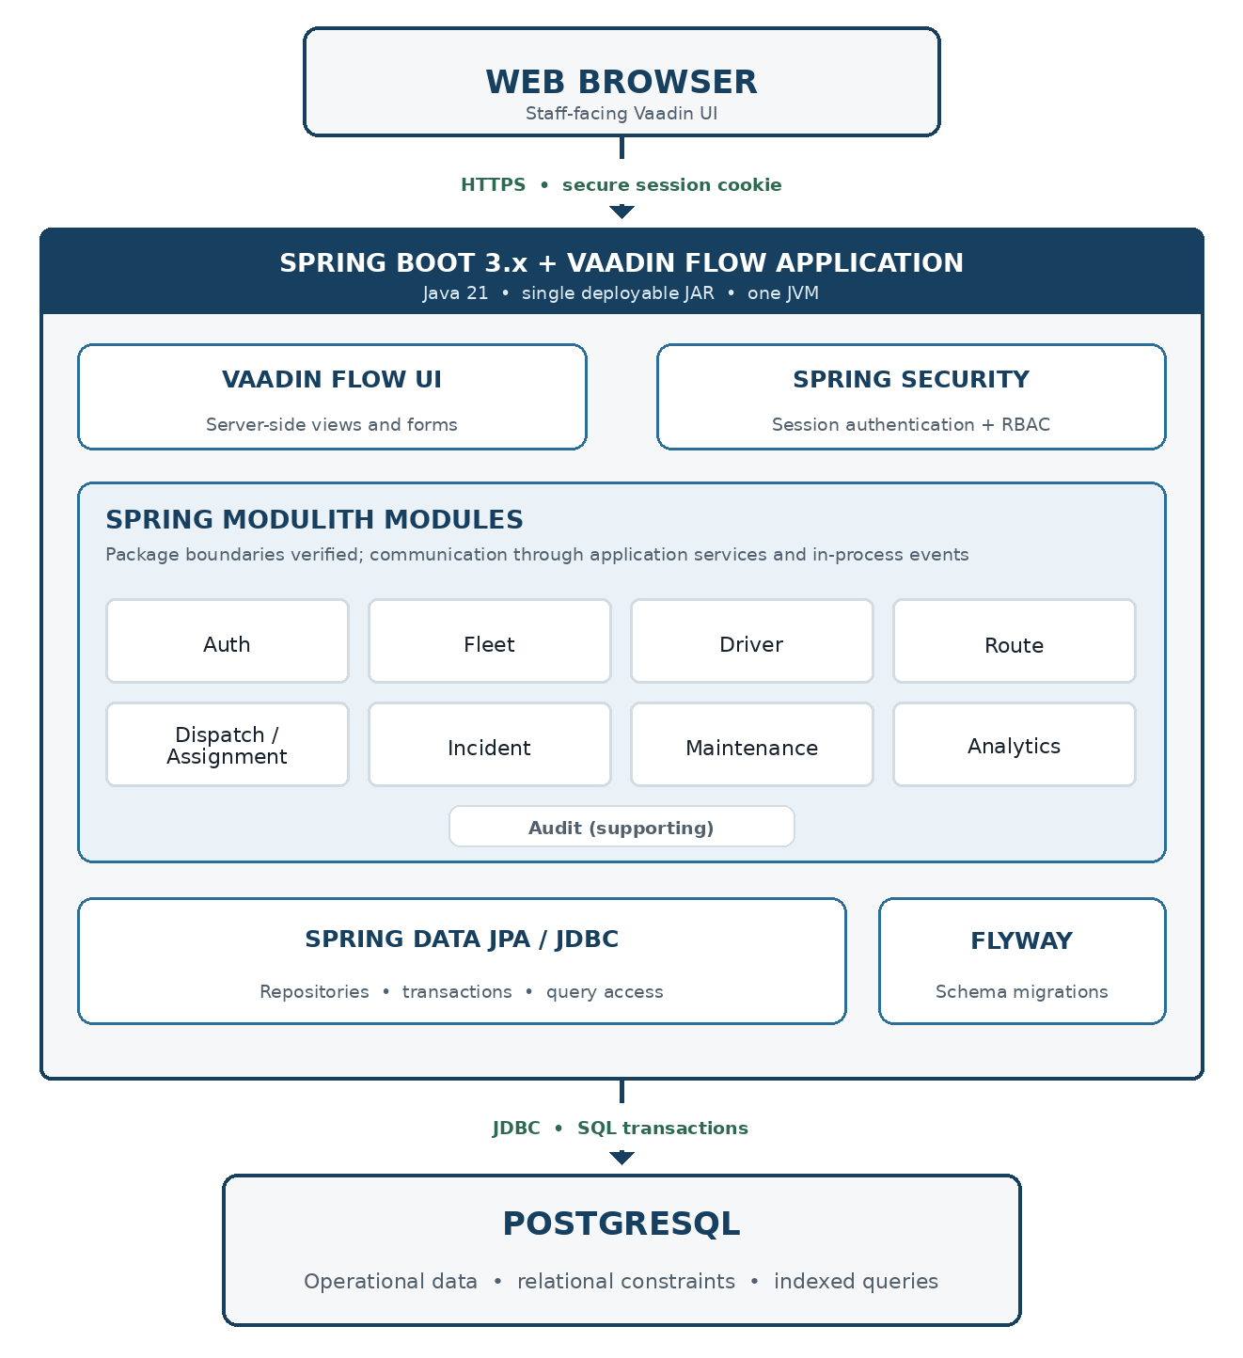

Design - Database Design

Entity Relationship Diagram (ERD)
The database design is shown in two logical diagrams so the relationships remain readable. Both diagrams describe one PostgreSQL database used by the same modular-monolith application.

Core Operations ERD
The core operations diagram shows how the main transit records connect. Fleet units, drivers, and route schedules meet in dispatch_assignments, which represents a vehicle and driver scheduled for a route on a specific service date. Fleet status updates preserve manually reported operating conditions. Incidents and maintenance records attach to the relevant route, assignment, or fleet unit so the system retains a complete operational history.
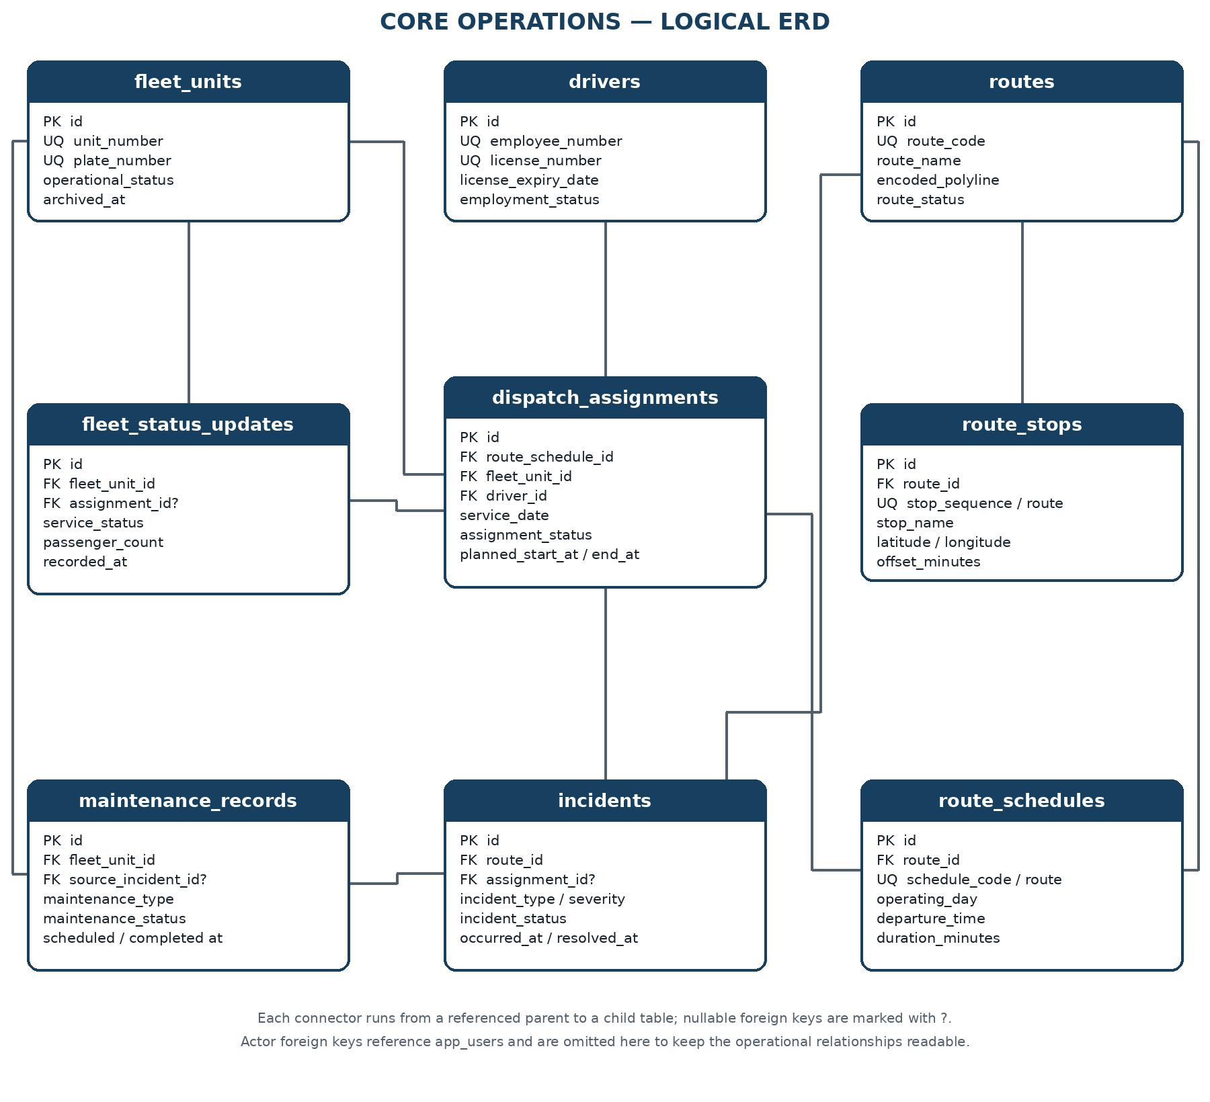

Security and Audit ERD
The security and audit diagram are separated because staff accounts and permissions support the application but are not transit-operation records. app_users stores authenticated staff accounts, roles and user_roles define whether the account is a System Admin or Operations Staff, and audit_log records who changed a business record, what action occurred, and when. Drivers remain operational records and do not automatically receive login accounts.
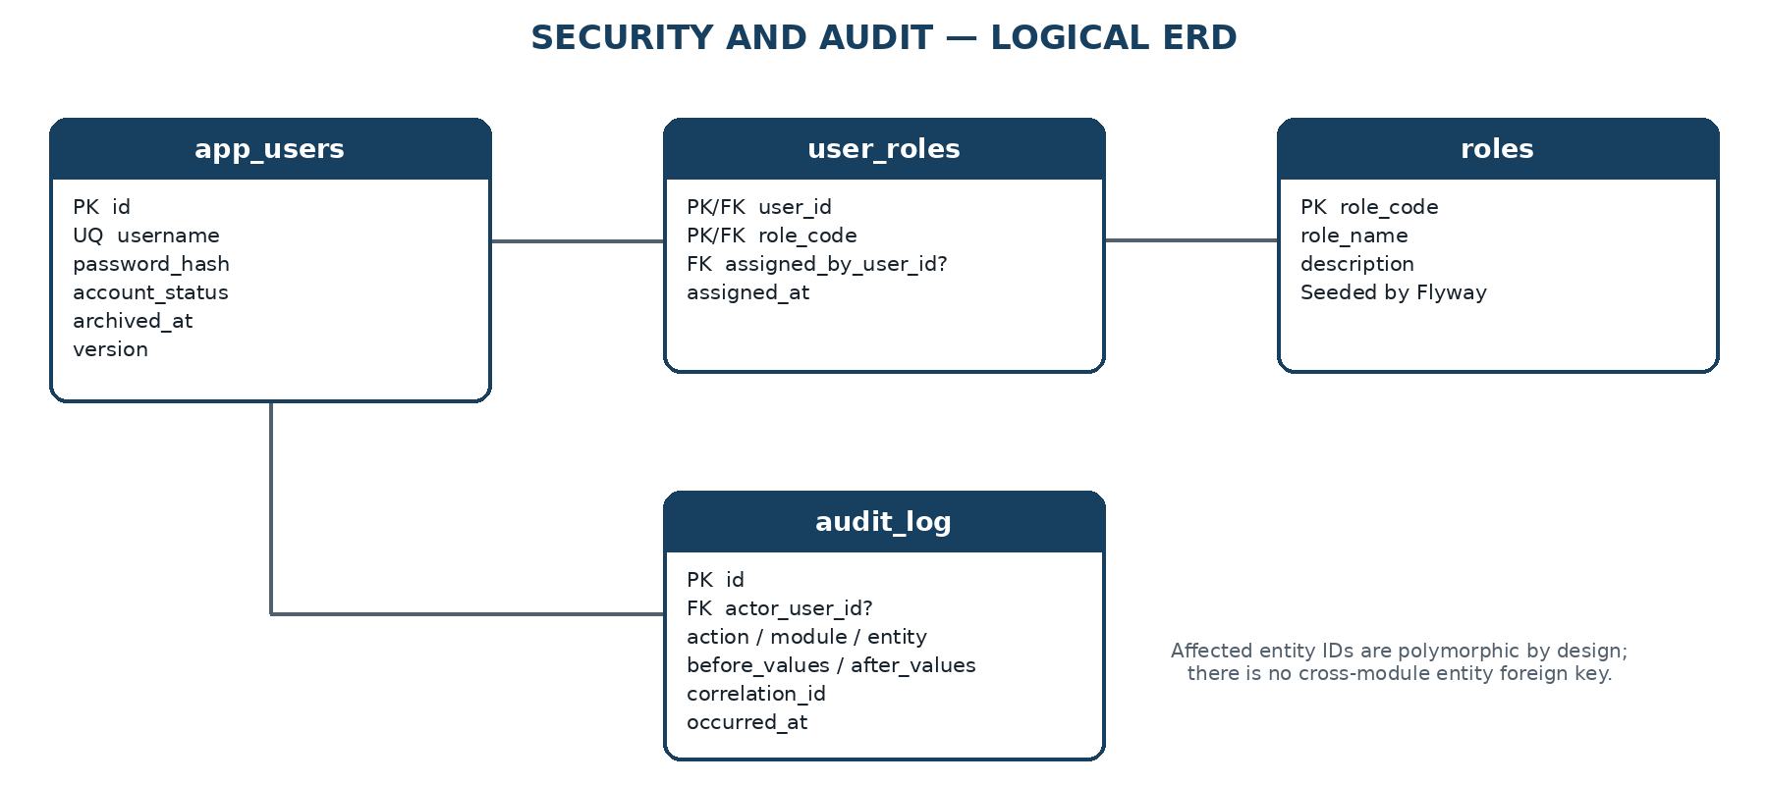
- Spring Security authenticates app_users through a server-side session.
- Drivers do not inherit user accounts. A staff account is created only when a person needs authorized browser access.
- The two role codes, SYSTEM_ADMIN and OPERATIONS_STAFF, are seeded by Flyway. Administrators assign roles to accounts but do not create new role definitions.
- audit_log stores important business changes and access outcomes. Technical request and error logs remain in the application log files.

Database Schema
PostgreSQL uses one application schema named arc. Tables are owned logically by Spring Modulith modules, but there is no schema-per-module or database-per-module split. The design is normalized for transactional integrity, while dashboard values are computed through indexed queries and read projections.
Module | Table | Responsibility
Auth | app_users | Authenticated staff accounts; drivers remain domain records, not login accounts.
Auth | roles | Seeded RBAC role codes used by Spring Security.
Auth | user_roles | Many-to-many assignment of staff accounts to roles.
Fleet | fleet_units | Bus-unit master data and current administrative availability state.
Fleet | fleet_status_updates | Append-only manual operational reports for location, load, delay, ETA, and vehicle condition.
Driver | drivers | Driver identity, license, and employment availability data.
Route | routes | Fixed route master data and optional encoded static-map polyline.
Route | route_stops | Ordered stop markers and coordinates for each fixed route.
Route | route_schedules | Recurring schedule templates by route, ISO weekday, departure time, and duration.
Dispatch | dispatch_assignments | Dated vehicle-and-driver assignment to a route schedule, including lifecycle timestamps.
Incident | incidents | Reported operational incidents, severity, workflow status, and resolution details.
Maintenance | maintenance_records | Scheduled or corrective work against a fleet unit, optionally originating from an incident.
Audit | audit_log | Append-only business audit events. Request logs remain structured application logs, not database rows.

Physical conventions
- Table and column names use lowercase snake_case. Java entities map explicitly to the arc schema.
- Entity keys use BIGINT identity columns. UUID is reserved for correlation_id, where distributed trace identity is useful.
- TIMESTAMPTZ stores instants in UTC. Asia/Manila is applied only when converting schedule templates and service dates for the UI.
- Mutable aggregates use a version column for optimistic locking. Manual fleet status and audit rows are append-only.
- VARCHAR plus named CHECK constraints is preferred over PostgreSQL enum types to keep state changes easy to migrate with Flyway.
- No PostGIS extension is required. Static maps use ordered stop coordinates and an optional encoded polyline.
- Flyway creates the arc schema and tables in dependency order. Demo reference data and simulated records are kept in separate migrations or profiles.

Data Dictionary
The dictionary below is the physical design baseline for Flyway and JPA mapping. Nullable means the database permits NULL; application services may impose stronger workflow rules before commit.

app_users
Column | PostgreSQL type | Null | Meaning / rule
id | BIGINT IDENTITY | No | Primary key.
username | VARCHAR(50) | No | Lowercase login name; unique.
password_hash | VARCHAR(100) | No | BCrypt hash only; never written to audit snapshots.
display_name | VARCHAR(120) | No | Human-readable staff name.
email | VARCHAR(254) | Yes | Optional contact address; case-insensitive unique when present.
account_status | VARCHAR(20) | No | ACTIVE, DISABLED, or LOCKED.
last_login_at | TIMESTAMPTZ | Yes | Most recent successful login.
created_at | TIMESTAMPTZ | No | Insert timestamp in UTC.
updated_at | TIMESTAMPTZ | No | Last modification timestamp in UTC.
archived_at | TIMESTAMPTZ | Yes | Soft-deactivation timestamp.
version | BIGINT | No | JPA optimistic-lock version.

roles
Column | PostgreSQL type | Null | Meaning / rule
role_code | VARCHAR(40) | No | Primary key, e.g. SYSTEM_ADMIN or OPERATIONS_STAFF.
role_name | VARCHAR(80) | No | Display label.
description | VARCHAR(255) | Yes | Permitted responsibility summary.

user_roles
Column | PostgreSQL type | Null | Meaning / rule
user_id | BIGINT | No | FK to app_users; composite primary key part.
role_code | VARCHAR(40) | No | FK to roles; composite primary key part.
assigned_by_user_id | BIGINT | Yes | FK to the administrator who granted the role.
assigned_at | TIMESTAMPTZ | No | Grant timestamp in UTC.

fleet_units
Column | PostgreSQL type | Null | Meaning / rule
id | BIGINT IDENTITY | No | Primary key.
unit_number | VARCHAR(30) | No | Internal fleet identifier; unique.
plate_number | VARCHAR(20) | No | Vehicle registration number; unique.
vehicle_type | VARCHAR(30) | No | Configured class such as BUS or MINIBUS.
capacity | SMALLINT | No | Maximum passenger count; greater than zero.
operational_status | VARCHAR(30) | No | ACTIVE, INACTIVE, UNDER_MAINTENANCE, or OUT_OF_SERVICE.
created_at | TIMESTAMPTZ | No | Insert timestamp in UTC.
updated_at | TIMESTAMPTZ | No | Last modification timestamp in UTC.
archived_at | TIMESTAMPTZ | Yes | Soft-delete timestamp; archived units cannot be dispatched.
version | BIGINT | No | JPA optimistic-lock version.

fleet_status_updates
Column | PostgreSQL type | Null | Meaning / rule
id | BIGINT IDENTITY | No | Primary key.
fleet_unit_id | BIGINT | No | FK to fleet_units.
assignment_id | BIGINT | Yes | FK to dispatch_assignments when the report is trip-specific.
service_status | VARCHAR(20) | No | NORMAL, DELAYED, INCIDENT, or OUT_OF_SERVICE.
passenger_count | SMALLINT | Yes | Manual count; non-negative. Capacity validation is performed by the service.
reported_location | VARCHAR(160) | Yes | Human-entered landmark, terminal, or stop; not GPS telemetry.
estimated_arrival_at | TIMESTAMPTZ | Yes | Optional manually supplied ETA.
fuel_level_percent | NUMERIC(5,2) | Yes | Manual value from 0 through 100.
engine_condition | VARCHAR(20) | No | NORMAL, WARNING, CRITICAL, or UNKNOWN.
tire_condition | VARCHAR(20) | No | NORMAL, WARNING, CRITICAL, or UNKNOWN.
notes | VARCHAR(1000) | Yes | Traffic, delay, or operational remarks.
submitted_by_user_id | BIGINT | No | FK to the staff account that submitted the report.
recorded_at | TIMESTAMPTZ | No | Operational observation time.
created_at | TIMESTAMPTZ | No | Database insert time; records are append-only.

drivers
Column | PostgreSQL type | Null | Meaning / rule
id | BIGINT IDENTITY | No | Primary key.
employee_number | VARCHAR(30) | No | Internal driver identifier; unique.
first_name | VARCHAR(80) | No | Given name.
last_name | VARCHAR(80) | No | Family name.
license_number | VARCHAR(40) | No | Driver-license identifier; unique.
license_class | VARCHAR(20) | No | Configured license classification.
license_expiry_date | DATE | No | Expired licenses fail dispatch validation.
employment_status | VARCHAR(20) | No | ACTIVE, INACTIVE, SUSPENDED, or ON_LEAVE.
contact_number | VARCHAR(30) | Yes | Optional operational contact.
created_at | TIMESTAMPTZ | No | Insert timestamp in UTC.
updated_at | TIMESTAMPTZ | No | Last modification timestamp in UTC.
archived_at | TIMESTAMPTZ | Yes | Soft-delete timestamp.
version | BIGINT | No | JPA optimistic-lock version.

routes
Column | PostgreSQL type | Null | Meaning / rule
id | BIGINT IDENTITY | No | Primary key.
route_code | VARCHAR(30) | No | Stable route identifier; unique.
route_name | VARCHAR(120) | No | Human-readable route name.
origin_name | VARCHAR(120) | No | Configured origin.
destination_name | VARCHAR(120) | No | Configured destination.
encoded_polyline | TEXT | Yes | Static map path; no live position data and no PostGIS dependency.
route_status | VARCHAR(20) | No | ACTIVE or INACTIVE.
created_at | TIMESTAMPTZ | No | Insert timestamp in UTC.
updated_at | TIMESTAMPTZ | No | Last modification timestamp in UTC.
archived_at | TIMESTAMPTZ | Yes | Soft-delete timestamp.
version | BIGINT | No | JPA optimistic-lock version.

route_stops
Column | PostgreSQL type | Null | Meaning / rule
id | BIGINT IDENTITY | No | Primary key.
route_id | BIGINT | No | FK to routes.
stop_sequence | SMALLINT | No | One-based order within the route.
stop_code | VARCHAR(30) | Yes | Optional operator-specific stop identifier.
stop_name | VARCHAR(120) | No | Map marker label.
latitude | NUMERIC(9,6) | No | Static latitude from -90 through 90.
longitude | NUMERIC(9,6) | No | Static longitude from -180 through 180.
offset_minutes | SMALLINT | Yes | Planned minutes from route departure; non-negative.
created_at | TIMESTAMPTZ | No | Insert timestamp in UTC.
updated_at | TIMESTAMPTZ | No | Last modification timestamp in UTC.
version | BIGINT | No | JPA optimistic-lock version.

route_schedules
Column | PostgreSQL type | Null | Meaning / rule
id | BIGINT IDENTITY | No | Primary key.
route_id | BIGINT | No | FK to routes.
schedule_code | VARCHAR(30) | No | Stable code unique within a route.
operating_day | SMALLINT | No | ISO weekday: 1 Monday through 7 Sunday.
departure_time | TIME | No | Local scheduled departure in Asia/Manila.
duration_minutes | SMALLINT | No | Planned positive duration; supports trips crossing midnight.
active | BOOLEAN | No | Whether new dated assignments may use the template.
created_at | TIMESTAMPTZ | No | Insert timestamp in UTC.
updated_at | TIMESTAMPTZ | No | Last modification timestamp in UTC.
version | BIGINT | No | JPA optimistic-lock version.

dispatch_assignments
Column | PostgreSQL type | Null | Meaning / rule
id | BIGINT IDENTITY | No | Primary key.
assignment_code | VARCHAR(30) | No | Human-readable reference; unique.
route_schedule_id | BIGINT | No | FK to route_schedules.
fleet_unit_id | BIGINT | No | FK to fleet_units.
driver_id | BIGINT | No | FK to drivers.
service_date | DATE | No | Operating date in Asia/Manila.
planned_start_at | TIMESTAMPTZ | No | Resolved schedule start instant.
planned_end_at | TIMESTAMPTZ | No | Resolved schedule end instant.
actual_start_at | TIMESTAMPTZ | Yes | Recorded dispatch/start time.
actual_end_at | TIMESTAMPTZ | Yes | Recorded completion time.
assignment_status | VARCHAR(20) | No | PLANNED, DISPATCHED, IN_SERVICE, COMPLETED, or CANCELLED.
assigned_by_user_id | BIGINT | No | FK to the dispatcher or administrator.
cancellation_reason | VARCHAR(500) | Yes | Required by the service when status becomes CANCELLED.
notes | VARCHAR(1000) | Yes | Dispatch remarks.
created_at | TIMESTAMPTZ | No | Insert timestamp in UTC.
updated_at | TIMESTAMPTZ | No | Last modification timestamp in UTC.
version | BIGINT | No | JPA optimistic-lock version.

incidents
Column | PostgreSQL type | Null | Meaning / rule
id | BIGINT IDENTITY | No | Primary key.
incident_number | VARCHAR(30) | No | Human-readable incident reference; unique.
route_id | BIGINT | No | FK to the affected route.
assignment_id | BIGINT | Yes | FK to a trip when the incident is assignment-specific.
incident_type | VARCHAR(30) | No | DELAY, BREAKDOWN, ACCIDENT, SECURITY, MEDICAL, or OTHER.
severity | VARCHAR(20) | No | LOW, MEDIUM, HIGH, or CRITICAL.
incident_status | VARCHAR(20) | No | OPEN, ACKNOWLEDGED, IN_PROGRESS, RESOLVED, or CLOSED.
description | VARCHAR(2000) | No | Operational facts reported by staff.
occurred_at | TIMESTAMPTZ | No | Reported event time.
reported_at | TIMESTAMPTZ | No | Submission time.
resolved_at | TIMESTAMPTZ | Yes | Required for RESOLVED or CLOSED status.
resolution_notes | VARCHAR(2000) | Yes | Required by the service before closure.
reported_by_user_id | BIGINT | No | FK to reporting staff account.
assigned_to_user_id | BIGINT | Yes | Optional owner responsible for resolution.
created_at | TIMESTAMPTZ | No | Insert timestamp in UTC.
updated_at | TIMESTAMPTZ | No | Last modification timestamp in UTC.
version | BIGINT | No | JPA optimistic-lock version.

maintenance_records
Column | PostgreSQL type | Null | Meaning / rule
id | BIGINT IDENTITY | No | Primary key.
maintenance_number | VARCHAR(30) | No | Human-readable work reference; unique.
fleet_unit_id | BIGINT | No | FK to the unit receiving service.
source_incident_id | BIGINT | Yes | Optional FK to the incident that triggered the work.
maintenance_type | VARCHAR(30) | No | INSPECTION, PREVENTIVE, CORRECTIVE, or REPAIR.
maintenance_status | VARCHAR(20) | No | SCHEDULED, IN_PROGRESS, COMPLETED, or CANCELLED.
summary | VARCHAR(200) | No | Short work description.
details | VARCHAR(2000) | Yes | Inspection findings or repair notes.
scheduled_start_at | TIMESTAMPTZ | Yes | Planned service time.
started_at | TIMESTAMPTZ | Yes | Actual start time.
completed_at | TIMESTAMPTZ | Yes | Required when status is COMPLETED.
handled_by_user_id | BIGINT | Yes | FK to maintenance staff owner.
created_by_user_id | BIGINT | No | FK to the staff account that opened the record.
created_at | TIMESTAMPTZ | No | Insert timestamp in UTC.
updated_at | TIMESTAMPTZ | No | Last modification timestamp in UTC.
version | BIGINT | No | JPA optimistic-lock version.

audit_log
Column | PostgreSQL type | Null | Meaning / rule
id | BIGINT IDENTITY | No | Primary key; monotonically increasing storage identity.
actor_user_id | BIGINT | Yes | FK to app_users; null only for controlled system events.
actor_username | VARCHAR(50) | No | Immutable username snapshot; SYSTEM for controlled system events.
action_type | VARCHAR(50) | No | Business action such as ASSIGNMENT_CREATED or STATUS_CHANGED.
module_name | VARCHAR(40) | No | Owning application module.
entity_type | VARCHAR(60) | No | Affected aggregate type.
entity_id | VARCHAR(64) | No | Affected record identifier; intentionally polymorphic.
outcome | VARCHAR(20) | No | SUCCESS, DENIED, or FAILED.
correlation_id | UUID | No | Request or use-case correlation identifier.
request_method | VARCHAR(10) | Yes | Optional HTTP method context.
request_path | VARCHAR(500) | Yes | Optional Vaadin/request path context.
response_status | SMALLINT | Yes | Optional HTTP response status.
before_values | JSONB | Yes | Whitelisted changed fields before the action; no secrets.
after_values | JSONB | Yes | Whitelisted changed fields after the action; no secrets.
ip_address | INET | Yes | Optional request source address.
occurred_at | TIMESTAMPTZ | No | Immutable event time in UTC.

Relationships
Foreign keys preserve module ownership without converting the modular monolith into distributed services. Cross-module writes are coordinated by application services; domain events are used when the receiving module does not need to participate in the initiating transaction.
- app_users and roles have a many-to-many relationship through user_roles. Role rows are reference data seeded by Flyway.
- fleet_units has many fleet_status_updates, dispatch_assignments, and maintenance_records. Master rows are archived instead of hard-deleted.
- drivers has many dispatch_assignments. A driver is a managed domain entity and is not automatically an app_users account.
- routes has many route_stops, route_schedules, and incidents. Stop order is unique within each route.
- route_schedules has many dispatch_assignments across different service dates; a schedule is a reusable template, not a trip instance.
- dispatch_assignments belongs to exactly one route schedule, fleet unit, and driver. It may have many manual status updates and incidents.
- incidents may reference one dispatch assignment and may originate zero or more maintenance records. A route remains mandatory for reporting and aggregation.
- audit_log references app_users only for the actor. Its entity_type/entity_id pair is deliberately not a foreign key because one audit table covers multiple modules.
- Analytics owns no tables in Version 1. Dashboard counts are projections over active assignments, the latest fleet status update, open incidents, and maintenance status.

Indexes
Indexes are limited to uniqueness rules and demonstrated query paths. PostgreSQL primary-key indexes are implicit and are not repeated below. Index names shown here are the intended Flyway names; final EXPLAIN ANALYZE results may justify adjustment.
Table | Index | Columns / predicate | Purpose
app_users | ux_users_username | Username | Case-normalized login uniqueness.
app_users | ux_users_email | lower(email) WHERE email IS NOT NULL | Optional email uniqueness.
fleet_units | ux_fleet_unit_number | unit_number | Direct unit lookup and uniqueness.
fleet_units | ux_fleet_plate_number | plate_number | Plate lookup and uniqueness.
fleet_units | ix_fleet_active_status | operational_status WHERE archived_at IS NULL | Fleet filter and dashboard counts.
fleet_status_updates | ix_status_unit_recorded | fleet_unit_id, recorded_at DESC | Latest report for a unit.
fleet_status_updates | ix_status_service_recorded | service_status, recorded_at DESC | Delayed/out-of-service dashboard queries.
drivers | ux_driver_employee_no | employee_number | Direct driver lookup and uniqueness.
drivers | ux_driver_license_no | license_number | License uniqueness.
drivers | ix_driver_employment | employment_status WHERE archived_at IS NULL | Dispatch availability filter.
routes | ux_route_code | route_code | Direct route lookup and uniqueness.
routes | ix_route_active | route_status WHERE archived_at IS NULL | Active route list.
route_stops | ux_stop_route_sequence | route_id, stop_sequence | Stable stop ordering.
route_schedules | ux_schedule_code | route_id, schedule_code | Schedule-template uniqueness.
route_schedules | ix_schedule_lookup | route_id, operating_day, departure_time WHERE active = TRUE | Daily schedule selection.
dispatch_assignments | ux_assignment_code | assignment_code | Direct reference lookup.
dispatch_assignments | ux_active_schedule_date | route_schedule_id, service_date WHERE assignment_status <> 'CANCELLED' | One active assignment per schedule instance.
dispatch_assignments | ix_assignment_vehicle_window | fleet_unit_id, planned_start_at, planned_end_at WHERE assignment_status IN ('PLANNED', 'DISPATCHED', 'IN_SERVICE') | Vehicle overlap check.
dispatch_assignments | ix_assignment_driver_window | driver_id, planned_start_at, planned_end_at WHERE assignment_status IN ('PLANNED', 'DISPATCHED', 'IN_SERVICE') | Driver overlap check.
dispatch_assignments | ix_assignment_service_status | service_date, assignment_status | Operations board and daily counts.
incidents | ux_incident_number | incident_number | Direct incident lookup.
incidents | ix_incident_open_queue | incident_status, severity, occurred_at DESC | Prioritized unresolved incident queue.
incidents | ix_incident_route_time | route_id, occurred_at DESC | Route incident history.
maintenance_records | ux_maintenance_number | maintenance_number | Direct work-record lookup.
maintenance_records | ix_maintenance_unit_status | fleet_unit_id, maintenance_status | Unit maintenance history and active work.
maintenance_records | ix_maintenance_schedule | scheduled_start_at WHERE maintenance_status = 'SCHEDULED' | Upcoming maintenance list.
audit_log | ix_audit_entity_time | entity_type, entity_id, occurred_at DESC | Affected-record audit history.
audit_log | ix_audit_actor_time | actor_user_id, occurred_at DESC | User activity review.
audit_log | ix_audit_correlation | correlation_id | Trace one use case across audit events.

Index validation rule
Fleet search and dispatch conflict queries must be checked with EXPLAIN (ANALYZE, BUFFERS) against the seeded benchmark dataset. Unused or redundant indexes are removed before the portfolio release because every additional index increases write cost.

Constraints
Database constraints protect facts that are always invalid, while the application layer enforces workflow rules that require current state, permissions, or cross-table comparison. This avoids both weak integrity and an unmaintainable database workflow engine.

Identity and deletion
- BIGINT GENERATED BY DEFAULT AS IDENTITY is used for entity primary keys. roles uses role_code, and user_roles uses a composite key.
- fleet_units, drivers, routes, and app_users use archived_at for reversible deactivation. Transactional and audit history is not hard-deleted by normal application flows.
- Foreign keys use RESTRICT for operational ownership and SET NULL only for optional actor/assignee references where history must survive account retirement.

Controlled states
- Lifecycle columns use VARCHAR plus named CHECK constraints rather than PostgreSQL enum types, keeping Flyway changes straightforward.
- Role codes are limited to SYSTEM_ADMIN and OPERATIONS_STAFF for Version 1.
- The service layer owns valid state transitions; database CHECK constraints reject unknown terminal values but do not attempt to encode the full workflow graph.

Numeric and temporal integrity
- capacity must be greater than zero; passenger_count and offset_minutes cannot be negative; fuel_level_percent is between 0 and 100.
- Static stop coordinates are constrained to valid latitude and longitude ranges. No telemetry or geospatial extension is introduced.
- planned_end_at must be later than planned_start_at; actual_end_at cannot precede actual_start_at; completed maintenance and resolved incidents require completion timestamps.
- All instants use TIMESTAMPTZ and are stored in UTC. service_date and schedule time are interpreted in Asia/Manila before conversion to an instant.

Dispatch conflict handling
- A partial unique constraint prevents more than one non-cancelled assignment for the same schedule and service date.
- Driver and vehicle overlap checks run inside the assignment application service using indexed time-window queries and optimistic locking. For this single-dispatcher portfolio scope, a PostgreSQL btree_gist exclusion constraint is intentionally deferred.
- The assignment service rejects archived/unavailable units, inactive or unlicensed drivers, inactive schedules, and overlapping active assignments before commit.
- For redundant operational context, the service verifies that a fleet status update references the same fleet unit as its assignment and that an incident route matches its referenced assignment route.

Audit and privacy
- audit_log is append-only from the application perspective. Corrections are represented by a compensating event, not UPDATE or DELETE.
- Audit JSON contains only whitelisted changed fields. Password hashes, session identifiers, secrets, and full sensitive payloads are never persisted in before_values or after_values.
- Every business status change and dispatch action creates an audit event in the same transaction. General authenticated-request logs are emitted as structured application logs to avoid unbounded database growth.

Design - Application Service Contracts

Application Service Boundary
The Java application-service interfaces form the boundary between Vaadin views and the Spring Modulith domain modules. Vaadin views submit commands and queries to these services, while repositories and JPA entities remain internal to the module that owns them. This keeps business rules in one testable application layer and prevents UI code from bypassing module boundaries.
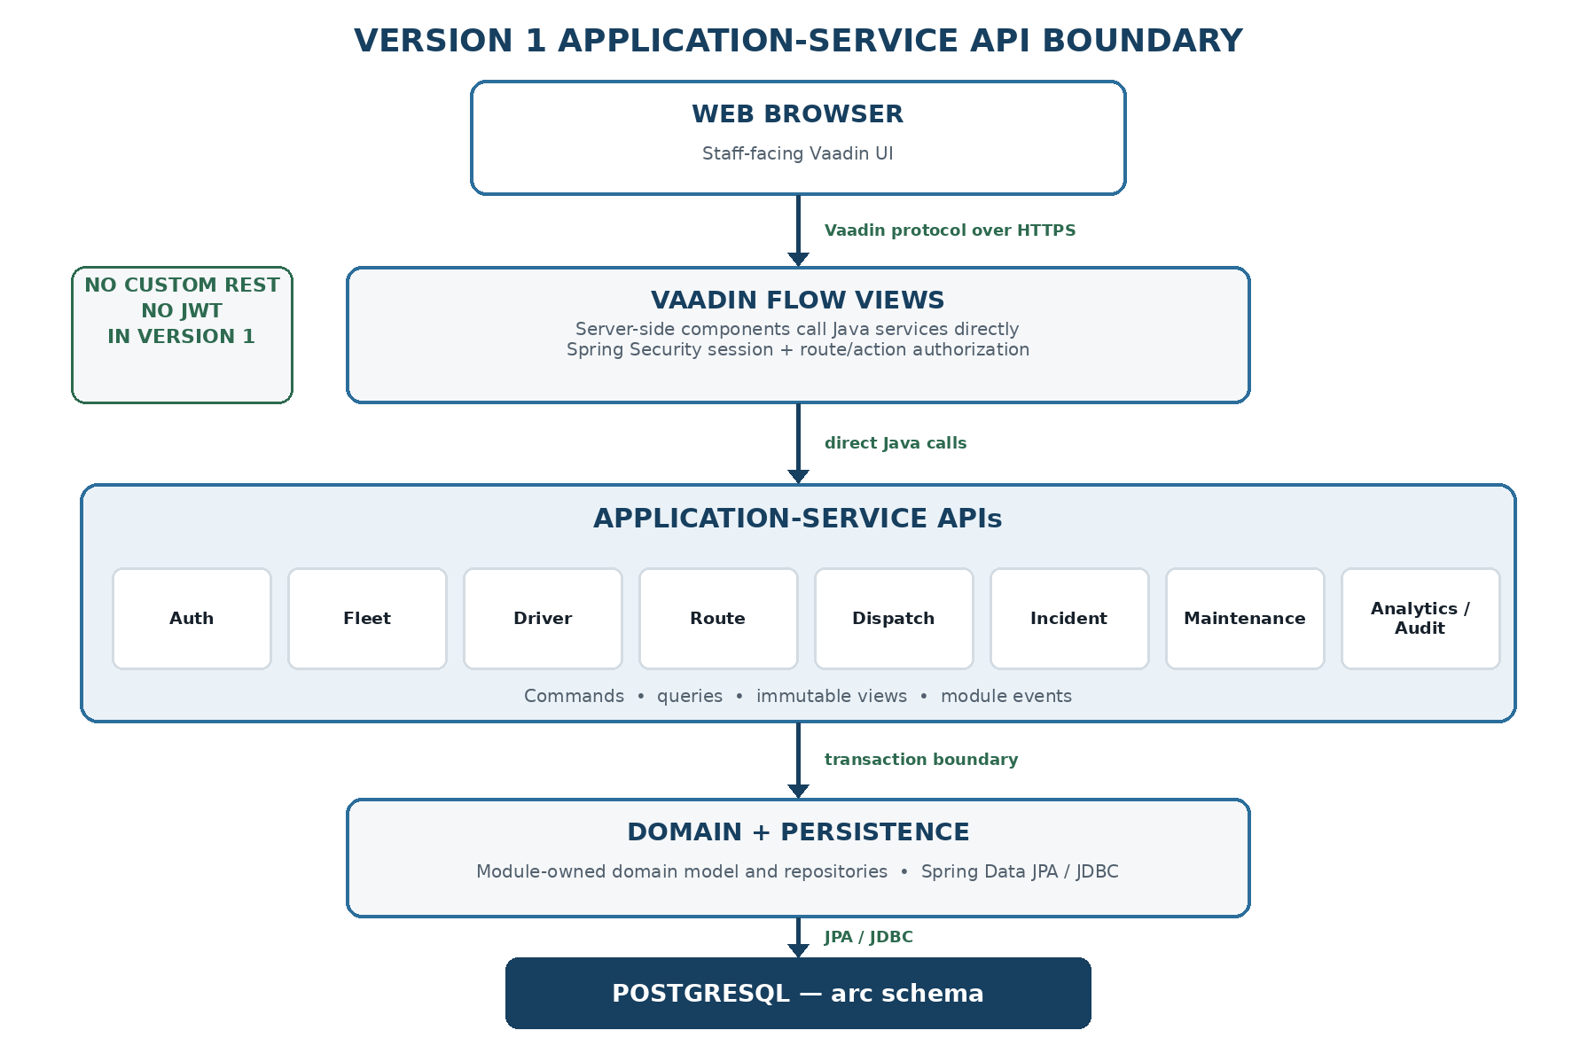
Figure 5.1 — Vaadin-to-application-service interaction boundary.
- Vaadin views inject service interfaces and exchange commands, queries, and immutable view records.
- Views never access Spring Data repositories or expose JPA entities directly.
- Spring Security enforces route access and method-level authorization; services remain the authoritative action boundary.

Authentication and User Administration
Spring Security owns login, logout, session creation, CSRF protection, and navigation access. There is no custom login API. UserAdministrationService covers only account and role-management use cases.
Operation | Java contract | Allowed roles | Key rule
Current user | CurrentUserView currentUser() | Authenticated | Read-only session principal and effective roles.
Search users | Page<UserSummaryView> searchUsers(UserQuery, Pageable) | SYSTEM_ADMIN | Read-only; never returns password hashes.
Create user | UserView createUser(CreateUserCommand) | SYSTEM_ADMIN | Hashes the supplied password and writes an audit event.
Account status | UserView changeAccountStatus(ChangeAccountStatusCommand) | SYSTEM_ADMIN | ACTIVE, DISABLED, or LOCKED; requires expectedVersion.
Replace roles | UserView replaceRoles(ReplaceUserRolesCommand) | SYSTEM_ADMIN | Validates seeded role codes; audited in the same transaction.

Fleet Application Service
FleetApplicationService manages fleet master data and append-only manual status submissions. Administrative status and trip status remain distinct: fleet_units stores dispatchability, while fleet_status_updates stores operational observations.
Operation | Java contract | Allowed roles | Key rule
Create unit | FleetUnitView createUnit(CreateFleetUnitCommand) | SYSTEM_ADMIN | Validates unique unit and plate numbers.
Update unit | FleetUnitView updateUnit(UpdateFleetUnitCommand) | SYSTEM_ADMIN | Requires expectedVersion; rejects stale writes.
Archive unit | void archiveUnit(ArchiveFleetUnitCommand) | SYSTEM_ADMIN | Rejected while an active assignment or maintenance rule blocks archival.
Get unit | FleetUnitView getUnit(long unitId) | SYSTEM_ADMIN, OPERATIONS_STAFF | Read-only; excludes archived rows unless explicitly requested.
Search units | Page<FleetUnitSummaryView> searchUnits(FleetQuery, Pageable) | SYSTEM_ADMIN, OPERATIONS_STAFF | Filters status, unit number, plate number, and vehicle type.
Submit status | FleetStatusView submitStatus(SubmitFleetStatusCommand) | SYSTEM_ADMIN, OPERATIONS_STAFF | Append-only; validates assignment and fleet-unit consistency.
Latest status | Optional<FleetStatusView> latestStatus(long unitId) | SYSTEM_ADMIN, OPERATIONS_STAFF | Uses fleet_unit_id + recorded_at descending index.

Driver Application Service
DriverApplicationService owns driver identity, license, employment state, archival, and dispatch-availability checks. Drivers are domain records, not authenticated accounts.
Operation | Java contract | Allowed roles | Key rule
Create driver | DriverView createDriver(CreateDriverCommand) | SYSTEM_ADMIN | Validates employee and license-number uniqueness.
Update driver | DriverView updateDriver(UpdateDriverCommand) | SYSTEM_ADMIN | Requires expectedVersion.
Archive driver | void archiveDriver(ArchiveDriverCommand) | SYSTEM_ADMIN | Rejected while the driver has an active assignment.
Get driver | DriverView getDriver(long driverId) | SYSTEM_ADMIN, OPERATIONS_STAFF | Read-only driver details.
Search drivers | Page<DriverSummaryView> searchDrivers(DriverQuery, Pageable) | SYSTEM_ADMIN, OPERATIONS_STAFF | Filters employment and license validity.
Availability | DriverAvailabilityView checkAvailability(DriverAvailabilityQuery) | Internal module call | Internal module API for license, status, and time-window checks.

Route Application Service
RouteApplicationService owns fixed-route master data, ordered static stops, encoded polylines, and recurring schedule templates. Existing dated assignments keep their resolved timestamps when a template changes.
Operation | Java contract | Allowed roles | Key rule
Create route | RouteView createRoute(CreateRouteCommand) | SYSTEM_ADMIN | Creates route master data only.
Update route | RouteView updateRoute(UpdateRouteCommand) | SYSTEM_ADMIN | Requires expectedVersion.
Archive route | void archiveRoute(ArchiveRouteCommand) | SYSTEM_ADMIN | Rejected when future active assignments reference its schedules.
Replace stops | RouteDetailsView replaceStops(ReplaceRouteStopsCommand) | SYSTEM_ADMIN | Atomically validates sequence, coordinates, and offset ordering.
Create schedule | RouteScheduleView createSchedule(CreateRouteScheduleCommand) | SYSTEM_ADMIN | Validates ISO weekday, departure time, and positive duration.
Update schedule | RouteScheduleView updateSchedule(UpdateRouteScheduleCommand) | SYSTEM_ADMIN | Requires expectedVersion; does not rewrite existing assignments.
Deactivate schedule | void deactivateSchedule(DeactivateScheduleCommand) | SYSTEM_ADMIN | Stops new assignments while preserving history.
Get route | RouteDetailsView getRouteDetails(String routeCode) | SYSTEM_ADMIN, OPERATIONS_STAFF | Returns route, ordered stops, and active schedule summaries.
Search routes | Page<RouteSummaryView> searchRoutes(RouteQuery, Pageable) | SYSTEM_ADMIN, OPERATIONS_STAFF | Read-only active-route lookup.

Dispatch and Assignment Service
DispatchApplicationService is the orchestration boundary for a dated trip assignment. It validates the route schedule, fleet unit, driver, license validity, maintenance state, and overlapping time windows before committing.
Operation | Java contract | Allowed roles | Key rule
Check availability | AssignmentAvailabilityView checkAvailability(AssignmentWindowQuery) | SYSTEM_ADMIN, OPERATIONS_STAFF | Calls route, fleet, and driver module APIs; no repositories are imported across modules.
Create assignment | AssignmentView createAssignment(CreateAssignmentCommand) | SYSTEM_ADMIN, OPERATIONS_STAFF | One transaction; rejects schedule, vehicle, or driver conflicts.
Dispatch | AssignmentView dispatch(DispatchAssignmentCommand) | SYSTEM_ADMIN, OPERATIONS_STAFF | PLANNED to DISPATCHED; records actual dispatch time.
Start service | AssignmentView startService(StartServiceCommand) | SYSTEM_ADMIN, OPERATIONS_STAFF | DISPATCHED to IN_SERVICE.
Complete | AssignmentView complete(CompleteAssignmentCommand) | SYSTEM_ADMIN, OPERATIONS_STAFF | IN_SERVICE to COMPLETED; records actual end time.
Cancel | AssignmentView cancel(CancelAssignmentCommand) | SYSTEM_ADMIN, OPERATIONS_STAFF | Requires cancellation reason; terminal transition.
Daily board | List<AssignmentSummaryView> dailyBoard(LocalDate serviceDate) | SYSTEM_ADMIN, OPERATIONS_STAFF | Read-only operations projection ordered by planned start.

Incident and Maintenance Services
IncidentApplicationService manages the incident workflow. MaintenanceApplicationService manages inspection and repair work. The two modules share identifiers and events but retain separate tables and lifecycle rules.
Operation | Java contract | Allowed roles | Key rule
Report | IncidentView reportIncident(ReportIncidentCommand) | SYSTEM_ADMIN, OPERATIONS_STAFF | Validates route and optional assignment context; publishes IncidentReported.
Acknowledge | IncidentView acknowledge(AcknowledgeIncidentCommand) | SYSTEM_ADMIN, OPERATIONS_STAFF | OPEN to ACKNOWLEDGED.
Start resolution | IncidentView startResolution(StartIncidentResolutionCommand) | SYSTEM_ADMIN, OPERATIONS_STAFF | ACKNOWLEDGED to IN_PROGRESS.
Resolve | IncidentView resolve(ResolveIncidentCommand) | SYSTEM_ADMIN, OPERATIONS_STAFF | Requires resolution notes and resolvedAt.
Close | IncidentView close(CloseIncidentCommand) | SYSTEM_ADMIN, OPERATIONS_STAFF | RESOLVED to CLOSED.
Search | Page<IncidentSummaryView> searchIncidents(IncidentQuery, Pageable) | SYSTEM_ADMIN, OPERATIONS_STAFF | Filters status, severity, route, and time range.

Maintenance contract
Operation | Java contract | Allowed roles | Key rule
Schedule | MaintenanceView scheduleMaintenance(ScheduleMaintenanceCommand) | SYSTEM_ADMIN, OPERATIONS_STAFF | Validates fleet unit and optional source incident.
Start | MaintenanceView startMaintenance(StartMaintenanceCommand) | SYSTEM_ADMIN, OPERATIONS_STAFF | Marks work IN_PROGRESS and makes the unit non-dispatchable.
Complete | MaintenanceView completeMaintenance(CompleteMaintenanceCommand) | SYSTEM_ADMIN, OPERATIONS_STAFF | Requires completion details; re-evaluates unit availability.
Cancel | MaintenanceView cancelMaintenance(CancelMaintenanceCommand) | SYSTEM_ADMIN, OPERATIONS_STAFF | SCHEDULED to CANCELLED.
Unit history | List<MaintenanceSummaryView> unitHistory(long unitId) | SYSTEM_ADMIN, OPERATIONS_STAFF | Read-only chronological history.

Analytics and Audit Query Services
Analytics is a read-model module over operational tables. Audit is append-only and queryable only by administrators. Neither service exposes mutable analytics or audit entities.
Operation | Java contract | Allowed roles | Key rule
Dashboard | DashboardSummaryView dashboardSummary() | SYSTEM_ADMIN, OPERATIONS_STAFF | Read-only counts; owns no analytics table.
Fleet summary | FleetOperationalSummaryView fleetSummary(FleetAnalyticsQuery) | SYSTEM_ADMIN, OPERATIONS_STAFF | Aggregates fleet state and latest manual reports.
Route summary | RouteOperationalSummaryView routeSummary(RouteAnalyticsQuery) | SYSTEM_ADMIN, OPERATIONS_STAFF | Aggregates assignments, delays, and incidents by route.
Audit search | Page<AuditEventView> searchAudit(AuditQuery, Pageable) | SYSTEM_ADMIN | Read-only actor, entity, action, outcome, and time filters.

Command, Query, and View Models
Application contracts use immutable Java records. JPA entities remain internal to the owning module, preventing lazy-loading leaks and accidental persistence changes from the UI layer.
Model | Examples | Rule
Command | CreateAssignmentCommand, SubmitFleetStatusCommand | Immutable Java record; carries intent and validated input, not JPA entities.
Update command | UpdateFleetUnitCommand(id, ..., expectedVersion) | Includes aggregate ID and optimistic-lock version.
Query | FleetQuery, IncidentQuery, AssignmentWindowQuery | Immutable optional filters; pagination and sorting are explicit.
View | FleetUnitView, AssignmentView, DashboardSummaryView | Immutable projection returned to Vaadin; contains no lazy JPA proxies.
Page | Page<T> with Spring Data Pageable | Used only for potentially large lists; detail and command operations are not paginated.
Event | AssignmentCreated, FleetStatusSubmitted, IncidentResolved | Past-tense immutable record published after a successful domain change.
Time | Instant, LocalDate, LocalTime | Instant for events; LocalDate for service day; LocalTime for recurring schedule template.
Identifier | long / Long | Matches BIGINT database keys; UUID is reserved for audit correlation IDs.

Transaction and Module Boundary Rules
The application service is the unit of work. It authorizes the use case, validates input, loads aggregates, performs the transition, saves through module-owned repositories, and emits audit/domain events.
Layer / interaction | Allowed responsibility | Not allowed
Vaadin view | May depend on application-service interfaces and view models. | Must not import repositories or JPA entities.
Application service | Owns authorization checks, orchestration, transaction boundary, and DTO mapping. | Command methods use @Transactional; query methods use @Transactional(readOnly = true).
Domain model | Owns invariants and valid state transitions. | Must not depend on Vaadin or controller types.
Repository | Owned by one Spring Modulith module. | Never imported directly by another module or a Vaadin view.
Cross-module call | Uses a public interface in the providing module's api package. | Dispatch uses route, fleet, and driver availability APIs.
Domain event | Used for audit and non-return-value reactions. | Synchronous in Version 1; no Kafka, RabbitMQ, or asynchronous broker.

Validation and Error Handling
Expected failures are translated into stable application exceptions. Vaadin views display safe messages and keep diagnostic details on the server. Every unexpected failure receives a correlation ID that can be matched to logs and audit context.
Failure | Application exception | Vaadin behavior | Rule
Input validation | CommandValidationException | Show field-level messages and keep the form open. | Jakarta Bean Validation plus command-specific checks.
Not found | ResourceNotFoundException | Show a neutral not-found notice and return to the list. | Never expose database identifiers or stack traces unnecessarily.
Business conflict | BusinessConflictException | Show the conflict and require user correction. | Examples: assignment overlap, archived unit, expired license.
Stale write | OptimisticLockingFailureException | Warn that another update won; reload the current record. | Raised from @Version mismatch.
Access denied | Spring Security AccessDeniedException | Navigate to an access-denied view; log DENIED outcome. | Do not duplicate role checks only in the UI.
Persistence conflict | DataIntegrityViolationException | Translate to a stable business conflict. | Do not leak SQL, constraint internals, or stack traces.
Unexpected | Unhandled exception + correlation ID | Show a generic failure message and log the correlation ID. | Detailed diagnostic data remains server-side.

Development - Methodology and Timeline

Agile-Kanban Method
Arc Transit System uses an Agile-Kanban approach to divide the twelve-week project into manageable tasks, show current progress, and adjust priorities when development or learning takes longer than expected. Work is reviewed at the end of each two-week iteration, but tasks continue to move through the board as soon as they are ready.

Working Rules
- Work on one primary implementation task at a time so partially completed features do not accumulate.
- Complete database and application-service work before spending time on visual polish.
- Test each module and workflow before starting a dependent feature.
- Update the documentation when the architecture, database, or behavior changes.
- Record actual test and benchmark results; performance targets are not presented as completed results.
- Keep Version 1 within the approved scope. New ideas are placed in the future roadmap.
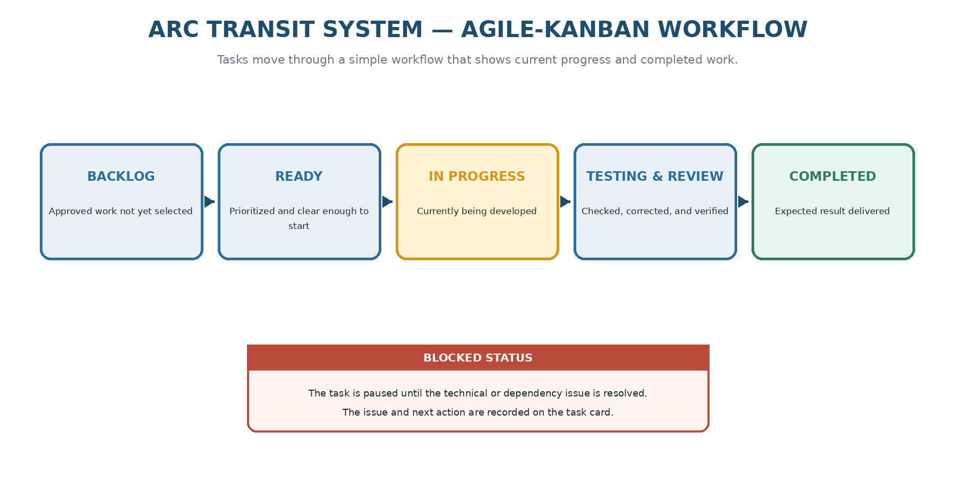
Figure 6.1. Agile-Kanban workflow used to track project progress.

Kanban Workflow
Each task is placed in the state that matches its current condition. A task moves forward when its expected output is ready for the next step. Blocked work remains visible until the issue is resolved.
State | Meaning
Planned | Approved project work that has not yet been selected for the current iteration.
Ready | Prioritized work with a clear objective, expected result, and known dependencies.
In Progress | The task is currently being designed, implemented, or documented.
Testing and Review | The output is being tested, checked, corrected, and compared with the task objective.
Completed | The expected result has been produced and the related code, tests, or documentation are updated.
Blocked | The task is temporarily paused because a technical or dependency issue prevents progress.

Development Timeline
The project is planned across twelve weeks. Two-week iterations provide regular progress checks, while individual tasks may move when learning, debugging, or integration requires more time. Weeks 1-4 established the documented design baseline. Week 5 begins implementation with the runnable application foundation.

Project Milestones
Milestone | Target | Expected accomplishment | Status
Requirements and Architecture | Week 2 | Scope, requirements, user flows, module structure, security approach, and system architecture are documented. | Completed
Database and Service Design | Week 4 | ERDs, data types, constraints, indexes, and application-service contracts are complete and consistent. | Completed
Application Foundation | Week 6 | The application runs with PostgreSQL, Flyway, login, role checks, audit support, and the first Fleet workflow. | In Progress
Core Operations | Week 8 | Fleet, Driver, Route, and Dispatch workflows operate through the Vaadin interface. | Planned
Operations Dashboard | Week 10 | Incident, Maintenance, manual status updates, dashboard metrics, and route presentation are complete. | Planned
Final Release | Week 12 | Testing, defect correction, benchmarks, Docker deployment, README, screenshots, and release documentation are complete. | Planned

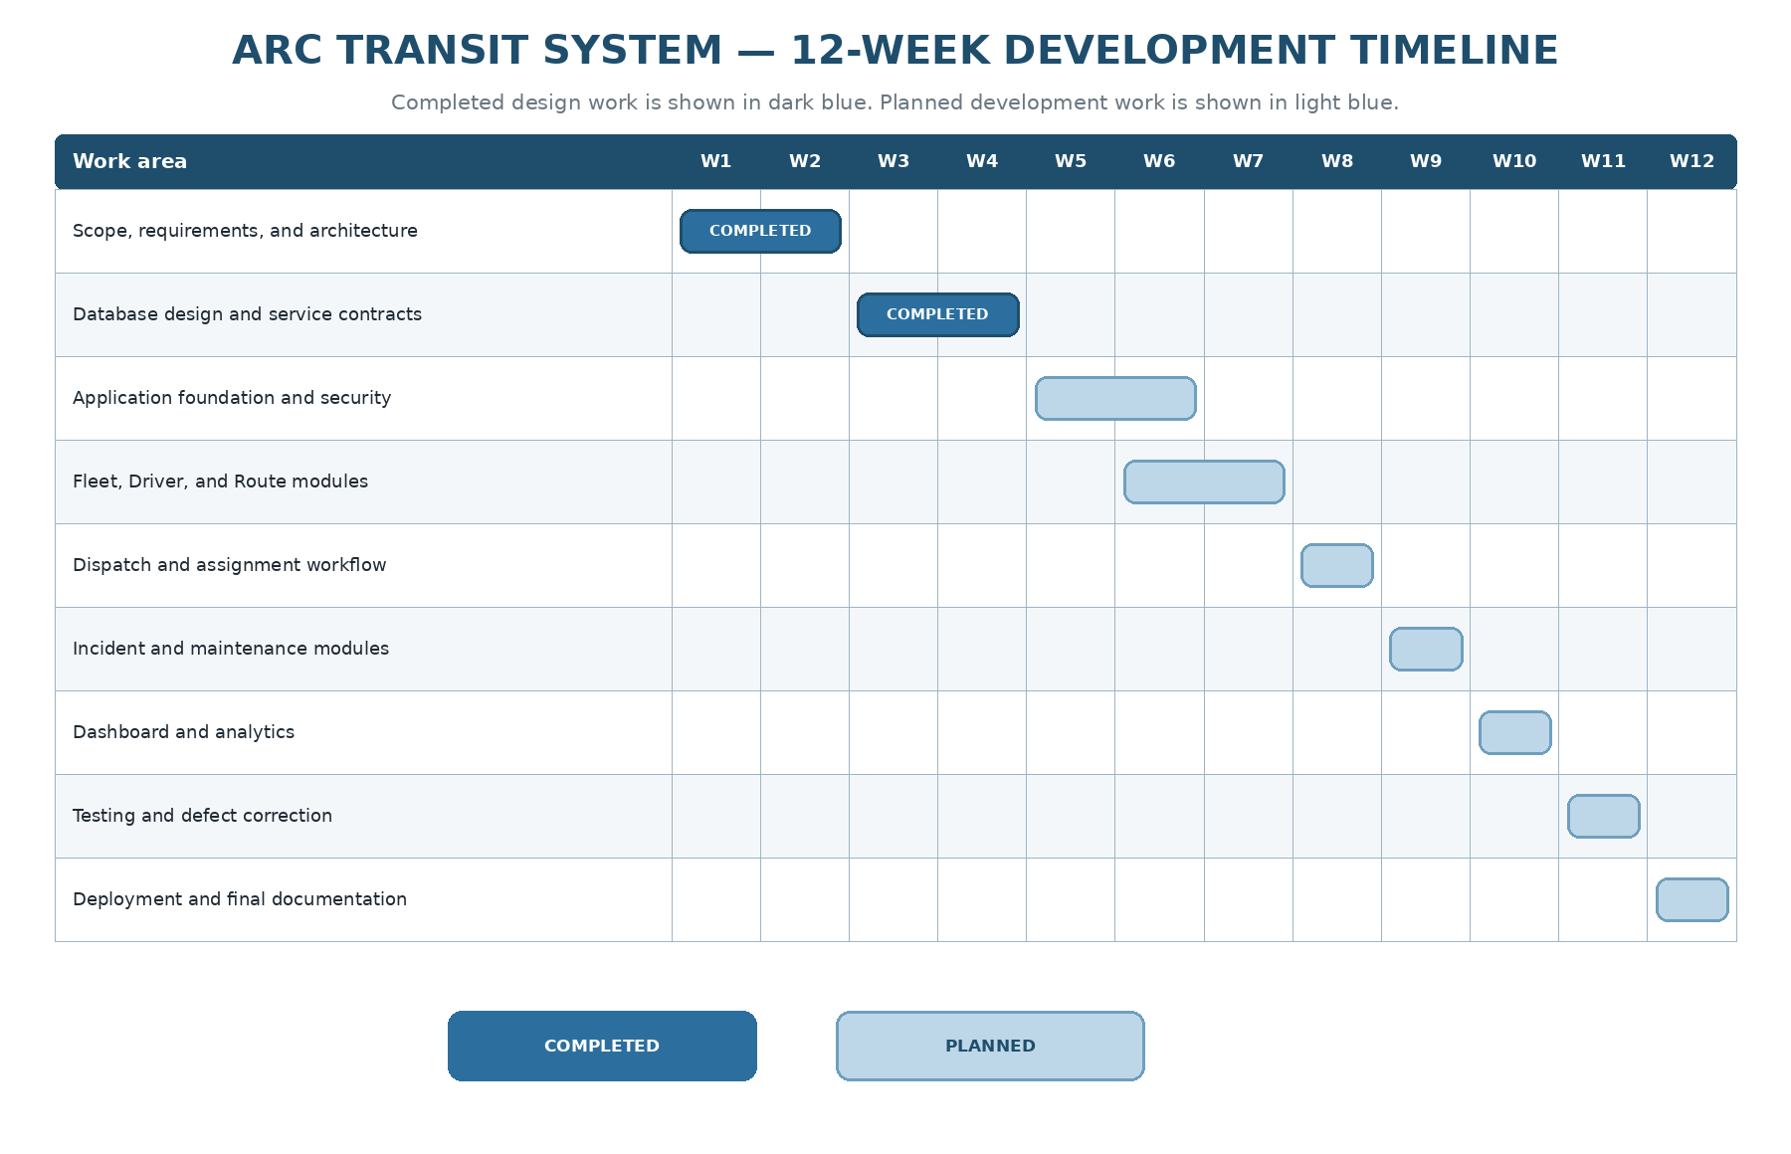
Figure 6.2. 12-week development timeline.

Detailed Weekly Work Plan
The weekly plan turns each milestone into specific work and an expected result. The status column is updated as the project progresses, making the document useful as both a plan and an accomplishment record.
Week | Main focus | Planned work | Expected result
Week 1 | Scope and requirements | Finalize objectives, users, functional requirements, non-functional requirements, and exclusions. | Approved Version 1 scope and requirements.
Week 2 | Architecture and UX design | Finalize user flows, technology choices, module responsibilities, security approach, and architecture diagrams. | Architecture and UX design baseline.
Week 3 | Database design | Complete ERDs, tables, columns, PostgreSQL types, keys, relationships, constraints, indexes, and audit fields. | Database design ready for Flyway and JPA mapping.
Week 4 | Application-service contracts | Define module interfaces, commands, queries, view models, permissions, transactions, errors, and internal events. | Backend contracts aligned with the database and requirements.
Week 5 | Application foundation | Create the Maven project, Spring Boot configuration, module packages, PostgreSQL Docker service, Flyway baseline, and Vaadin application shell. | Runnable project with verified module structure and database connection.
Week 6 | Security, audit, and Fleet | Implement session login, two roles, protected navigation, audit support, fleet registry, status updates, and Fleet UI. | First complete workflow from Vaadin to PostgreSQL.
Week 7 | Driver and Route | Implement driver records, license checks, routes, stops, schedules, search, forms, and validation. | Driver and Route modules available in the application.
Week 8 | Dispatch and assignment | Implement availability checks, assignment creation, conflict detection, lifecycle actions, cancellation, and daily assignment view. | Working dispatch workflow with integration tests.
Week 9 | Incident and Maintenance | Implement incident reporting and resolution, maintenance scheduling and completion, and vehicle-availability updates. | Incident and Maintenance workflows integrated with Fleet and Dispatch.
Week 10 | Dashboard and analytics | Implement summary cards, filters, manual status reporting, route presentation, operational queries, and audit search. | Completed staff-facing operations dashboard.
Week 11 | Testing and correction | Complete unit, PostgreSQL integration, module-boundary, security, migration, workflow, and performance tests; correct major defects. | Stable release candidate with recorded test and benchmark results.
Week 12 | Deployment and portfolio release | Finalize Docker deployment, environment guide, backup and rollback notes, README, screenshots, known limitations, and release tag. | Reproducible final portfolio release.

Development - Backend Layout

Diagram Module Layout
[Fill in this section]

Authentication and User Administration Module
[Fill in this section]

Fleet Module
[Fill in this section]

Driver Module
[Fill in this section]

Route Module
[Fill in this section]

Dispatch and Assignment Module
[Fill in this section]

Incident Module
[Fill in this section]

Maintenance Module
[Fill in this section]

Analytics Module
[Fill in this section]

Development - Frontend User Interface

Dashboard Overview
- Implemented MainLayout using Vaadin with a top header, brand section ("ARC TRANSIT SYSTEMS"), and a global search bar.
- Created DashboardView which displays "Active bus routes" and "Live Fleet Monitor" using Vaadin Grid and ListDataProvider.
- Integrated a SearchEvent bus utilizing ComponentUtil.addListener for cross-view communication (allowing the MainLayout search bar to filter grids in DashboardView seamlessly).
- Applied custom CSS styling to match an enterprise Operations Command design.

Fleet Management UI
[Fill in this section]

Driver Management UI
[Fill in this section]

Route Management UI
[Fill in this section]

Dispatch Management UI
[Fill in this section]

Incident Management UI
[Fill in this section]

Maintenance Management UI
[Fill in this section]

Analytics UI
[Fill in this section]

Fixed Route Mapping UI
[Fill in this section]

Testing and Debugging

Debugging
Utilized automated Browser Subagents for UI interaction testing (e.g., verifying that the global search bar filters the grid correctly and that row selection populates the details pane).

Unit Testing
[Fill in this section]

Integration Testing
[Fill in this section]

Application Service Testing
[Fill in this section]

Bug Tracking
[Fill in this section]

Test Results
[Fill in this section]

Deployment

Deployment Architecture
[Fill in this section]

Docker Configuration
[Fill in this section]

Oracle Cloud Configuration
[Fill in this section]

Environment Variables
[Fill in this section]

Deployment Procedure
[Fill in this section]

Rollback Procedure
[Fill in this section]

Documentation

GitHub Repository Structure
[Fill in this section]

README
[Fill in this section]

Architecture Artifacts
[Fill in this section]

Screenshots
[Fill in this section]

Lessons Learned
[Fill in this section]

Future Roadmap
[Fill in this section]

Developed By
Chuckz Española

