AI virtual environment set up guideline

The basis for AI work is the virtual environment. Data scientist should build models in a virtual environment. This document states how to set up a standard and basic AI environment by Anaconda.

Step 1: Install Anaconda on Win10

1. Check your operation system is Win10 64-bits and you have not previously installed Anaconda and Python. If you already installed these software, please uninstall them.
2. Double-click the Anaconda3-5.2.0-Windows-x86_64.exe file in “Virtual_environment_file” Folder.
3. Follow the instructions on the screen. When you reach the “Advance installation Options”, please follow the picture 1 to tick the options, which can add Anaconda to PATH environment variable and register Anaconda as default Python 3.6. When installation is finished, from the Start menu, open the Anaconda Prompt.

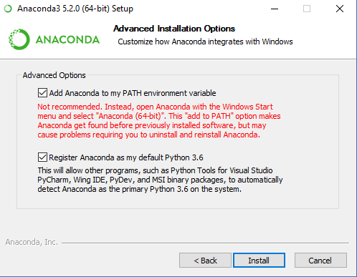

Picture 1：Advanced Installation Options

1. To test your installation, in your Terminal window or Anaconda Prompt, run the command conda list. For a successful installation, a list of installed packages appears. Picture 2 is an example of command “conda list” in Terminal window.

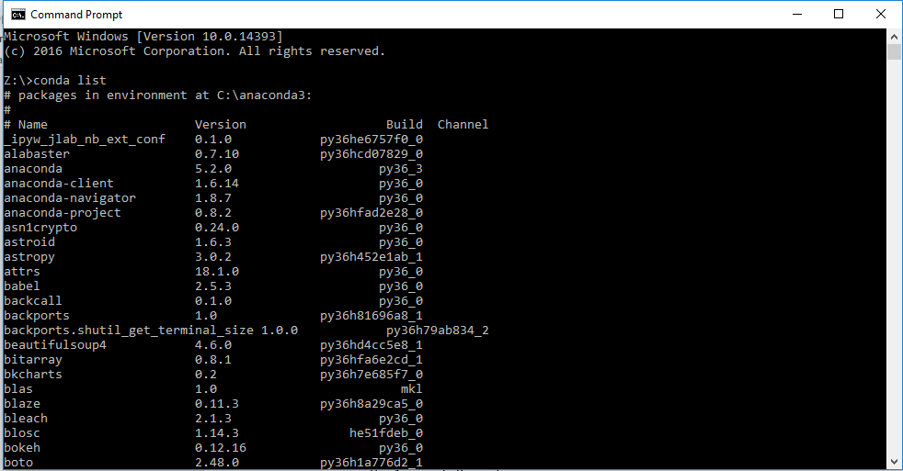

Picture 2: An example of command “conda list” in Terminal window

Step 2: Install IDE

1. PyCharm:
2. Double-click the pycharm-professional-2018.1.4.exe file in “Virtual_environment_file\IDE” Folder.
3. Follow the instructions on the screen. When you reach the “Installation Options”, please follow the picture 3 to tick the options. When you reach the “Complete Installation”, please follow the picture 4 to tick the options. When you reach the “PyCharm License Activation”, please follow the picture 5 to tick the options.

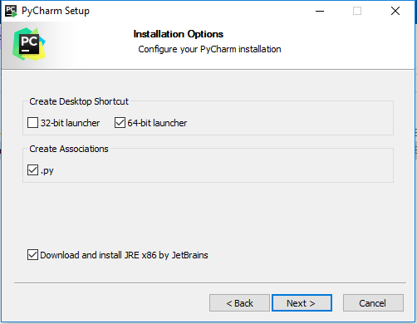

Picture 3: Pycharm Installation Options

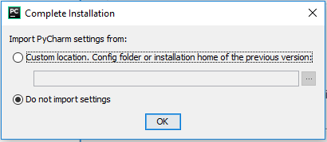

Picture 4: Complete Installation

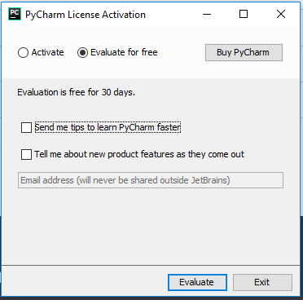

Picture 5: PyCharm License Activation

1. Jupyter Notebook and Spyder

You can run Anaconda Navigator after installing Anaconda. Double-click the “Launch” button can launch Jupyter notebook or Spyder in Anaconda Navigator.

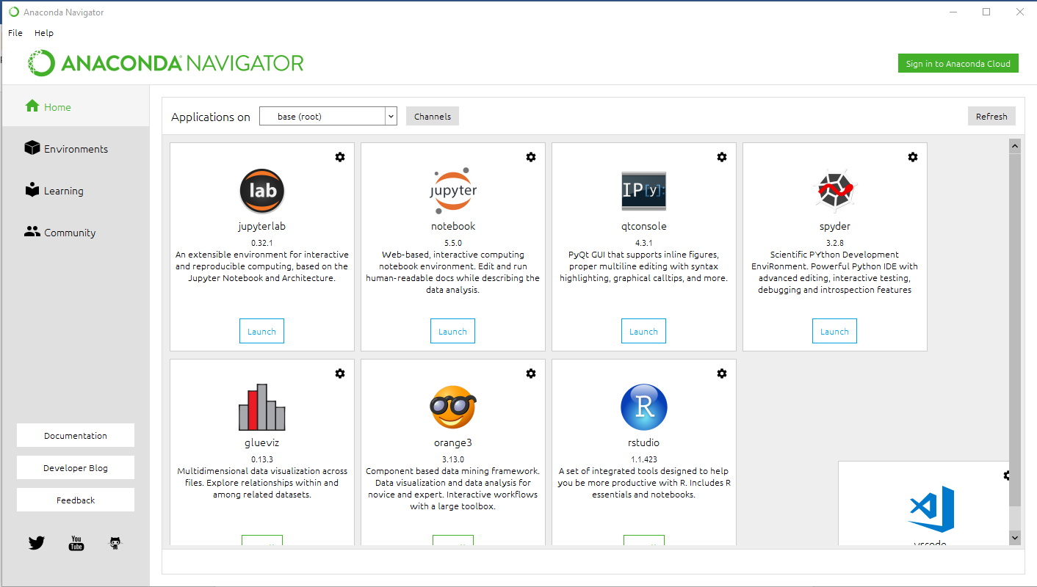

Picture 6: Anaconda Navigator Interface

Step 3: Set up and activate new environment in Anaconda

1. Use the Terminal or an Anaconda Prompt for the following steps.
   * 1. To create an environment:

conda create --name myenv

NOTE: Replace myenv with the environment name.

* + 1. When conda asks you to proceed, type y:

proceed ([y]/n)?

This creates the myenv environment in /envs/. This environment uses the same version of Python that you are currently using, because you did not specify a version.

1. Activate new environment to do work.

In your Anaconda Prompt, run activate myenv to activate an environment. After that, you can install necessary python packages and build AI model on this environment.

Step 4: Install python packages

First open a console then cd to where you've downloaded your file like some-package.whl and use

pip install some-package.whl

Note: if pip.exe is not recognized, you may find it in the "Scripts" directory from where python has been installed.

All of necessary .whl file have downloaded in Virtual_environment_file\Packages folder.