* Problem 2.2.5

Source code:

Test case 1: b != 0

Test case 2: b = 0

* Problem 2.2.6

Source code of sub-problem 1:

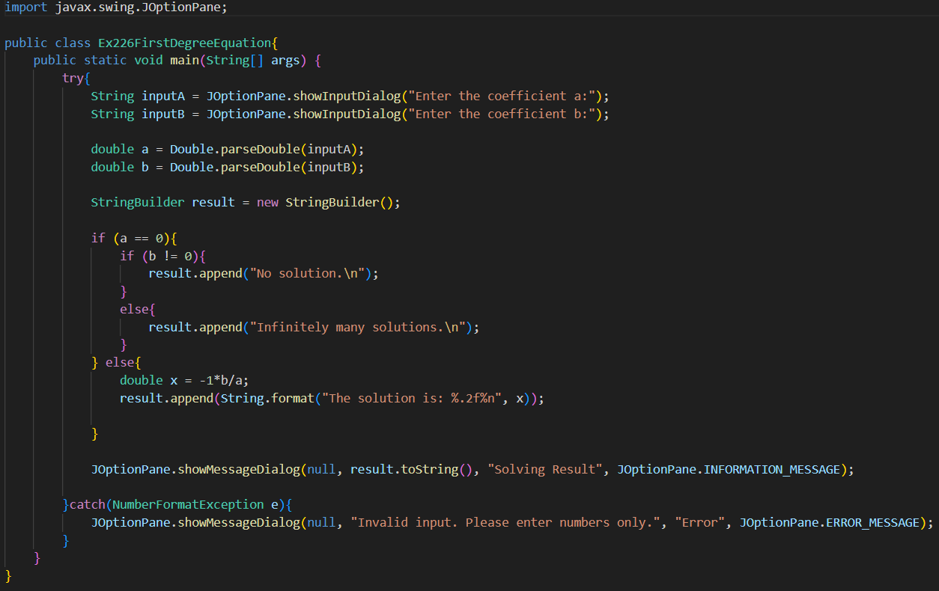

Test case 1: a = 0; b = 0

Test case 2: a = 0; b != 0

Test case 3: a != 0

Source code of sub-problem 2:

Test case 1: det != 0 and det1 != 0 and det2 != 0

Test case 2: det = 0 and det1 != 0 and det 2 != 0

Test case 3: det = 0 and det1 = 0 and det 2 = 0

Source code of sub-problem 3:

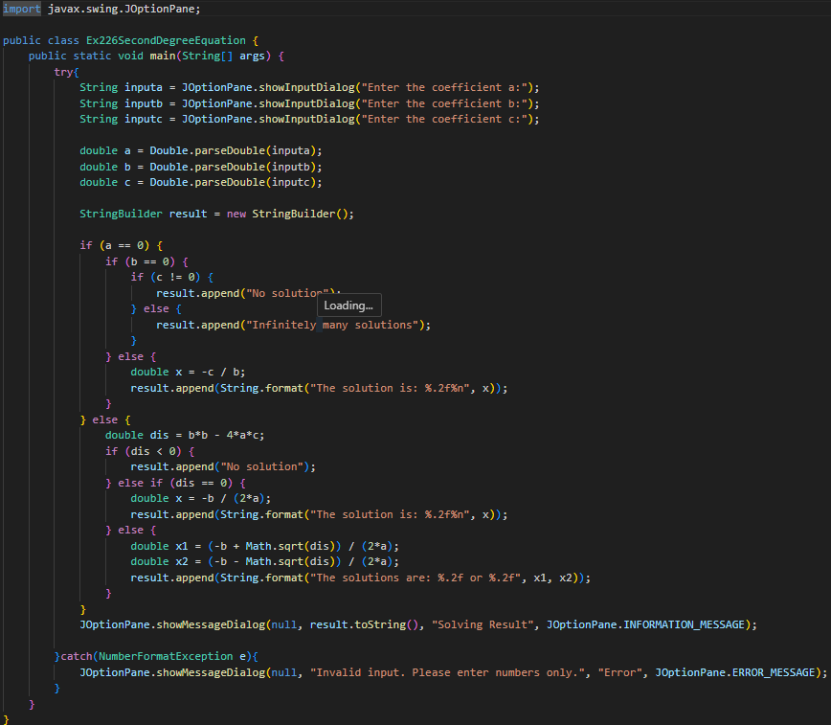

Test case 1: a = 0 and b = 0 and c = 0

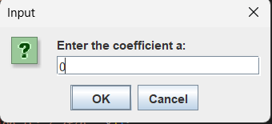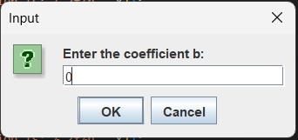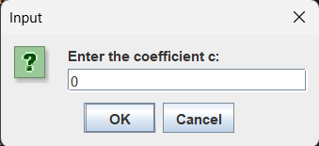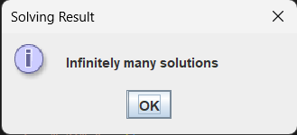

Test case 2: a = 0 and b = 0 and c != 0

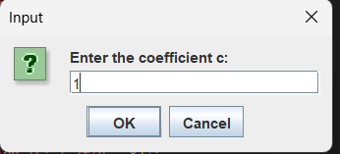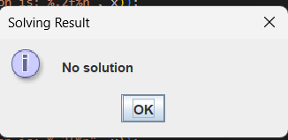

Test case 3: a != 0 and dis > 0

Test case 4: a! = 0 and dis = 0

Test case 5: a != 0 and dis < 0

* Problem 6.1

- In the code, the program only checks for the **“Yes”** case, so any other choice (including “No” and “Cancel”) will result in the message:

You’ve chosen: No

- To customize the options shown to users, use the **JOptionPane.showOptionDialog()** method, which lets you define your own button texts such as “Yes” and “No” or “I do” and “I don’t”.

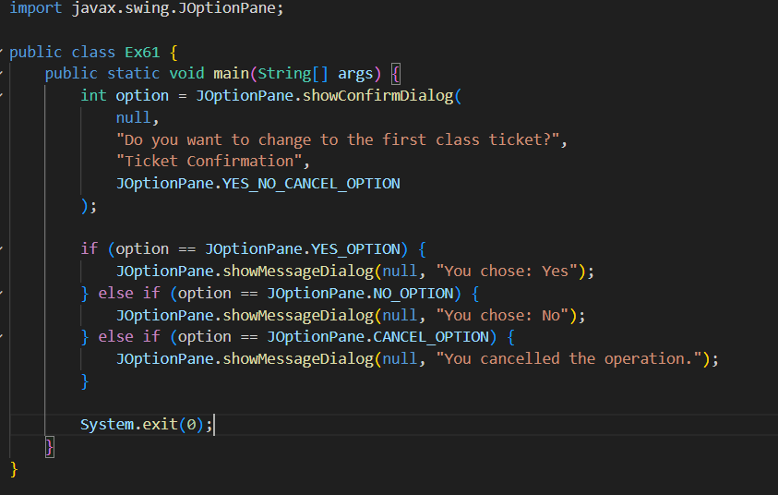

* Problem 6.2

Source code:

Terminal:

* Problem 6.3

Source code:

Terminal:

* Problem 6.4

Source code:

Terminal:

* Problem 6.5

Source code:

Terminal:

* Problem 6.6

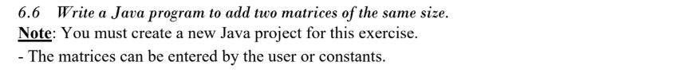

Source code:

Terminal:

