**Abstract**

Submarine canyon directly links continental shelfs with deep-sea plains through transporting sediments and organic matters (OM); as a result, it plays an important role in providing energy to the food-deprived deep sea ecosystem. The Gaoping submarine canyon (GPSC) off southwestern Taiwan connects the Gaoping River to deep South China Sea (SCS), carrying massive fluxes of 14-49 MT sediments every year (Hsu et al., 2014). While previous studies suggested that most of the organic carbon (OC) is exported down through GPSC and buried into SCS, this view completely ignores the biological function of sediment benthos.

In this study, we measured both of the standing stocks of living (i.e. biomass of benthos) and no non-living components (i.e. detritus OC). Also, sediment community oxygen consumption (SCOC) were measured in both in-situ and ship-board incubation. Combining the estimated fluxes of particle organic carbon (POC) input and OC burial, we can construct benthic predator-prey relationships with carbon flows by linear inverse model (LIM). We expect that carbon cycling in the GPSC would be drastically different from other studied sites due to the high energy settings of GPSC (Liu et al., 2013; 2016) and peculiar biological conditions (Chen 2018; Liao et al., 2017; 2020).

**Introduction**

Submarine canyons are steep-sided valleys which cut into the seabed of continental margins, directly linking continental shelfs with deep-sea plains by transporting terrestrial and marine sediments and organic matters (OM) (Vetter and Dayton, 1999; Epping et al., 2002; Canals et al., 2006; de Stigter et al., 2007; Harris and Whiteway, 2011); therefore, the transportation and accumulation of OM through or in the canyon may provide essential energy to the undernourished deep-sea ecosystem (Rex et al., 2006; Wei et al., 2010a).

The Gaoping submarine canyon (GPSC) off southwestern Taiwan is nearly connected to the Gaoping River (GPR), which is reported to transport 14-49 MT sediments each year (Hsu et al., 2014). More than 27 g m-2 d-1 of sediments are accumulated on the upper GPSC seafloor, which is approximately 4 to 270 times less than the mass flux measured from the sediment traps (Hsu et al., 2014; Huh et al., 2009). Previous studies suggested that if organic carbon (OC) in both estimates are equal, most of the OC is likely exported down the canyon and buried in the deep South China Sea (Hsu et al., 2014; Kao et al., 2014; Liu et al., 2013; 2016). However, this view completely ignores the biological role of sediment benthos, which remineralize OC through feeding, burrowing, respiration, and predation and it may lead to mistaken estimates of the OC cycling on the seabed (Snelgrove et al., 2017).

To the best of our knowledge, only two studies had attempted to construct comprehensive benthic carbon food webs in the submarine canyons to date. Rowe et al (2008) constructed the biomass structure and estimated carbon flows in food webs for 7 sites of the head of the Mississippi Canyon and the adjacent mid-slope in the northern Gulf of Mexico. On the other hand, carbon flows in food web models of 3 sections of the Nazare Canyon were constructed by van Oevelen et al (2011). In the Gulf of Mexico,

(Kelly-Gerreyn et al. 2014) A major challenge to understanding benthic ecology and carbon flow, especially in the deep sea, is appropriate characterization of both community composition and its underlying dynamics. There now exists, however, a large volume of body-sized based research suggesting that it may not be necessary to resort to characterizing food web complexity and differences in functional groups in order to determine energy flow in ecological communities (e.g. Dickie et al., 1987).

We highly expect that carbon cycling in the submarine canyons off the Southern West Taiwan would be drastically different from the two studied areas due to the high energy settings of GPSC (Liu et al., 2013; 2016) and peculiar biological conditions (Chen 2018; Liao et al., 2017; 2020).

**Material and Method**

Sampling site selection:

-採樣點地圖

Standing stocks:

Calculate biomass stocks (換算成C(in g/m2)

Calculate detritus (organic carbon) stocks

From reference:

-physiological parameters

-physical parameters

Model:

-Stella/ithink

-pest calibration

-LIM in R

SCOC

**Sediment carbon budget:**

In the deep-sea sediments, the total inventory of OC can be divided into the living and non-living components (Fig.1).

The living component of OC is mainly contributed by the biomass of prokaryotes (mainly bacteria), protozoan (mainly foraminifera), meiofauna (> 0.04 mm in length) and macrofauna (> 0.3 mm in length) (Rex et al., 2006; Rowe, 1983; Wei et al., 2010). The non-living component of OC includes labile (i.e., fresh phytodetritus or chlorophyll-a contents), semi-labile (i.e., lipid, protein, and carbohydrate), and refractory OC (i.e., humic and fulvic acids, structural carbohydrates, and “black” carbon) (Danovaro, 2010). The source of OC is mainly supplied by the slow rain of particulate organic carbon (POC) from the euphotic zone or lateral advection of POC from terrestrial or marine organics. The loss of OC balances the source through carbon remineralization (SCOC), biological utilization of labile OC, the predation among living components of OC, long-term burial of the refractory OC and down-slope OC export (i.e., by turbidity currents).

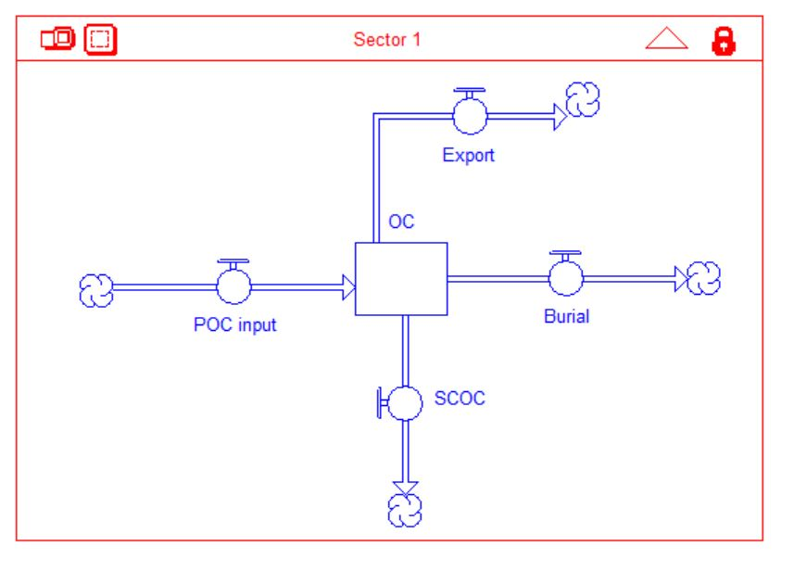

Fig.1 Conceptual model of carbon budget and cycling in the deep-sea sediment modified from Rowe et al. (2008).

|  |  |  |  |  |  |  |  |  |
| --- | --- | --- | --- | --- | --- | --- | --- | --- |
| Station | Cruise | From incubation and oxygen profiling | | |  | Respiration calculated based on mass | | TOU-(Macro+Meio)  (µgC/m2/day) |
| TOU  (mmol O2/m2/day) | DOU  (mmol O2/m2/day) | BMU  (µgC/m2/day) |  | Macrofauna  (µgC/m2/day) | Meiofauna  (µgC/m2/day) |
| GC1 | OR1_1128 | -7.0668 | -0.0012 | -53014.8159 |  | 590.25433 | 323.7572 | 71167.1986 |
|  | OR1_1151 | -6.8205 | -0.0009 | -53459.7580 |  | 67.45080 |  | 69501.5520 |
|  | OR1_1190 | -8.4986 | -0.0078 | -63205.6372 |  | 251.89428 |  | 86434.2873 |
| GS1 |  |  |  |  |  |  |  |  |
|  | OR1_1114 | -23.6172 |  |  |  | 14289.8524 | 1571.6950 | 225033.8413 |
|  | OR1_1126 | -20.7527 | -0.0007 | -170325.5134 |  | 3439.7432 | 3013.2270 | 205224.4000 |
|  | OR1_1190 | -5.6613 | -0.0011 | -41056.6542 |  | 43.5657 |  | 57701.2300 |

一、論文次序

1.封面（含側邊）【詳附件1】

2.論文口試委員審定書【詳附件2】

3.序言或 謝辭

4.中文摘要及關鍵詞5-7個

5.英文摘要及關鍵詞5-7個

6.目錄【詳附件3】

7.圖目錄

8.表目錄

9.論文正文

10.參考文獻

11.附錄

12.封底