RF_label5_t8_round.plk

abs(cosine similarity) > 0.8

120秒切每0.5秒共240格

Output Dataset: 'G:\Proiect_fullness\收集之資料\0126\threshold8_round.csv'

Label:

* 0 (0%): index 14
* 1 (30%): index 12
* 2 (50%): index 6
* 3 (80%): index 17
* 4 (unknow)

資料比例:

* 0 (0%): 534筆
* 1 (30%): 212筆
* 2 (50%): 628筆
* 3 (80%): 632筆
* 4 (unknow): 1834筆
* ALL: 3840筆

Acc:

* Random Forest = 0.79

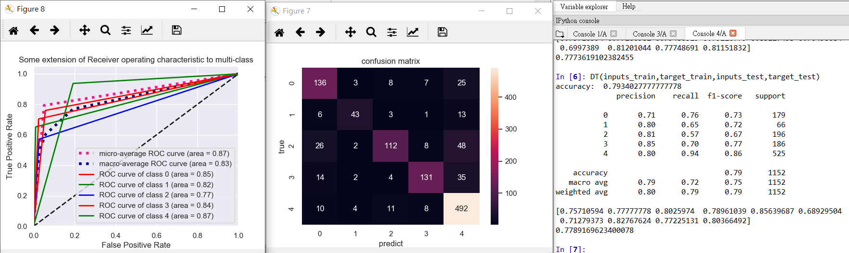

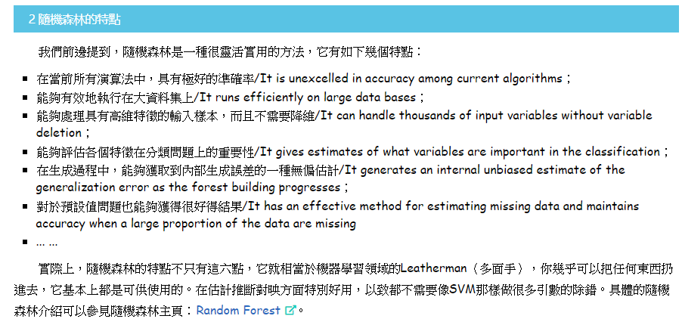

RF_label5_diff_thre_round_cut25_.plk

120秒切每0.25秒共480格

Output Dataset: ' D:\減肥專題論文\2020503\mydataset_each_diff_threshold.csv'

Label:

* 0 (0%): index 29, thre=0.8
* 1 (30%): index 14, thre=0.7
* 2 (50%): index 16, thre=0.8
* 3 (80%): index 196, thre= 0.7
* 4 (unknow)

Threshold:

* 0 (0%): 0.8
* 1 (30%): 0.7
* 2 (50%): 0.8
* 3 (80%): 0.7
* 4 (unknow)

資料比例:

* 0 (0%): 1392筆
* 1 (30%): 1346筆
* 2 (50%): 1279筆
* 3 (80%): 429筆
* 4 (unknow): 3234筆
* ALL: 7680筆

Acc:

* Random Forest = 0.78 (CROSS完)

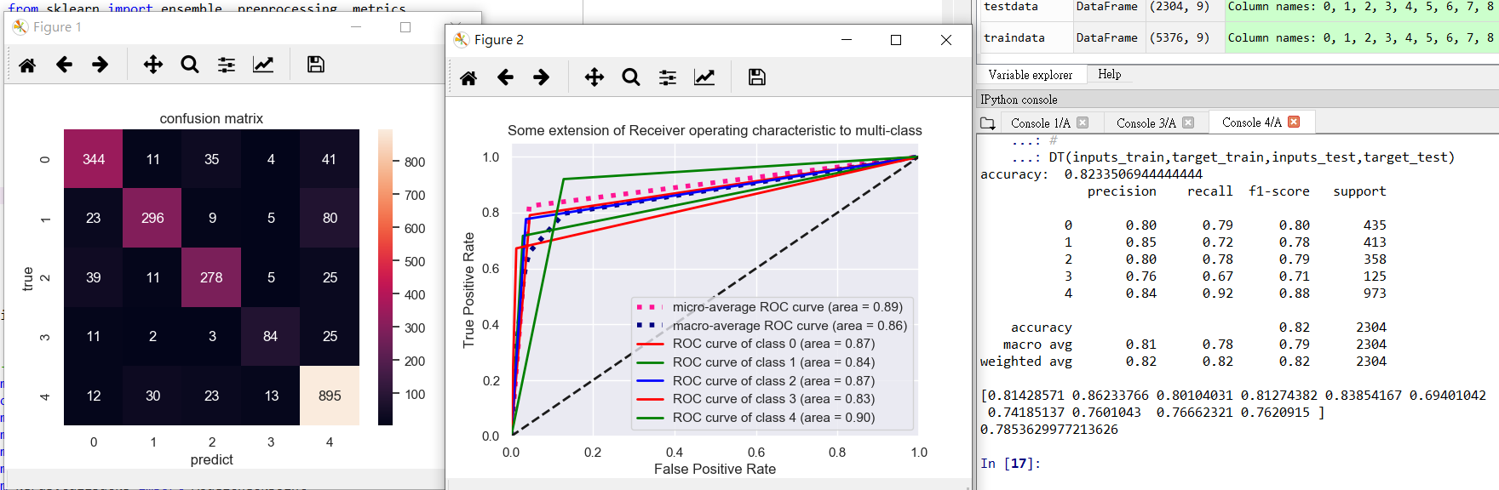

**Hungry**

Demo: RF_label5_t8_round.plk

|  |  |  |  |  |  |  |
| --- | --- | --- | --- | --- | --- | --- |
|  | Yuche | Peiwen | Jarwy | Chinghui | Hsinting | Yuche0129 |
| 0 | 117 | 118 | 74 | 184 | 31 | 36 |
| 1 | 2 | 1 | 0 | 2 | 5 | 2 |
| 2 | 11 | 2 | 2 | 2 | 6 | 8 |
| 3 | 2 | 2 | 5 | 1 | 21 | 72 |
| 4 | 108 | 117 | 159 | 51 | 177 | 122 |

Demo: RF_label5_diff_thre_round_cut25_.plk

|  |  |  |  |  |  |  |
| --- | --- | --- | --- | --- | --- | --- |
|  | Yuche | Peiwen | Jarwy | Chinghui | Hsinting | Yuche0129 |
| 0 | 316 | 292 | 277 | 418 | 66 | 39 |
| 1 | 3 | 4 | 3 | 3 | 53 | 17 |
| 2 | 24 | 6 | 6 | 1 | 19 | 12 |
| 3 | 1 | 2 | 1 | 0 | 17 | 41 |
| 4 | 136 | 176 | 193 | 58 | 325 | 371 |

**30%**

Demo: RF_label5_t8_round.plk

|  |  |  |  |  |  |  |
| --- | --- | --- | --- | --- | --- | --- |
|  | Yuche | Peiwen | Jarwy | Chinghui | Hsinting | Yuche0129 |
| 0 | 0 | 1 | 4 | 9 | 3 | 37 |
| 1 | 88 | 34 | 32 | 36 | 1 | 3 |
| 2 | 3 | 0 | 0 | 2 | 94 | 8 |
| 3 | 1 | 1 | 1 | 2 | 1 | 41 |
| 4 | 148 | 204 | 203 | 191 | 141 | 151 |

Demo: RF_label5_diff_thre_round_cut25_.plk

|  |  |  |  |  |  |  |
| --- | --- | --- | --- | --- | --- | --- |
|  | Yuche | Peiwen | Jarwy | Chinghui | Hsinting | Yuche0129 |
| 0 | 4 | 1 | 2 | 16 | 5 | 209 |
| 1 | 355 | 257 | 335 | 288 | 27 | 19 |
| 2 | 4 | 0 | 1 | 4 | 309 | 18 |
| 3 | 0 | 0 | 2 | 3 | 0 | 2 |
| 4 | 117 | 222 | 140 | 169 | 139 | 232 |

**50%**

Demo: RF_label5_t8_round.plk

|  |  |  |  |  |  |  |
| --- | --- | --- | --- | --- | --- | --- |
|  | Yuche | Peiwen | Jarwy | Chinghui | Hsinting | Yuche0129 |
| 0 | 18 | 1 | 4 | 2 | 14 | 97 |
| 1 | 1 | 0 | 0 | 1 | 28 | 2 |
| 2 | 120 | 122 | 160 | 144 | 13 | 7 |
| 3 | 1 | 4 | 1 | 2 | 37 | 13 |
| 4 | 100 | 113 | 75 | 91 | 148 | 121 |

Demo: RF_label5_diff_thre_round_cut25_.plk

|  |  |  |  |  |  |  |
| --- | --- | --- | --- | --- | --- | --- |
|  | Yuche | Peiwen | Jarwy | Chinghui | Hsinting | Yuche0129 |
| 0 | 25 | 9 | 3 | 3 | 78 | 285 |
| 1 | 2 | 4 | 3 | 4 | 148 | 11 |
| 2 | 288 | 297 | 361 | 260 | 34 | 12 |
| 3 | 1 | 1 | 3 | 0 | 29 | 1 |
| 4 | 164 | 169 | 110 | 213 | 191 | 171 |

**80%**

Demo: RF_label5_t8_round.plk

|  |  |  |  |  |  |  |
| --- | --- | --- | --- | --- | --- | --- |
|  | Yuche | Peiwen | Jarwy | Chinghui | Hsinting | Yuche0129 |
| 0 | 3 | 2 | 2 | 7 | 41 | 29 |
| 1 | 0 | 0 | 0 | 2 | 4 | 4 |
| 2 | 1 | 1 | 3 | 0 | 10 | 17 |
| 3 | 124 | 137 | 192 | 124 | 34 | 22 |
| 4 | 112 | 100 | 43 | 107 | 151 | 168 |

Demo: RF_label5_diff_thre_round_cut25_.plk

|  |  |  |  |  |  |  |
| --- | --- | --- | --- | --- | --- | --- |
|  | Yuche | Peiwen | Jarwy | Chinghui | Hsinting | Yuche0129 |
| 0 | 6 | 5 | 1 | 10 | 49 | 84 |
| 1 | 3 | 6 | 5 | 7 | 45 | 25 |
| 2 | 3 | 7 | 2 | 3 | 14 | 91 |
| 3 | 113 | 164 | 85 | 39 | 19 | 4 |
| 4 | 355 | 298 | 387 | 421 | 353 | 276 |

**Hungry**

Demo: RF_label5_t8_round.plk

|  |  |  |  |  |  |
| --- | --- | --- | --- | --- | --- |
|  | 0 | 1 | 2 | 3 | 4 |
| Yuche | 117 | 2 | 11 | 2 | 108 |
| Peiwen | 118 | 1 | 2 | 2 | 117 |
| Jarwy | 74 | 0 | 2 | 5 | 159 |
| Chinghui | 184 | 2 | 2 | 1 | 51 |
| Hsinting | 31 | 5 | 6 | 21 | 177 |
| Yuche0129 | 36 | 2 | 8 | 72 | 122 |

Demo: RF_label5_diff_thre_round_cut25_.plk

|  |  |  |  |  |  |
| --- | --- | --- | --- | --- | --- |
|  | 0 | 1 | 2 | 3 | 4 |
| Yuche | 316 | 3 | 24 | 1 | 136 |
| Peiwen | 292 | 4 | 6 | 2 | 176 |
| Jarwy | 277 | 3 | 6 | 1 | 193 |
| Chinghui | 418 | 3 | 1 | 0 | 58 |
| Hsinting | 66 | 53 | 19 | 17 | 325 |
| Yuche0129 | 39 | 17 | 12 | 41 | 371 |

**30%**

Demo: RF_label5_t8_round.plk

|  |  |  |  |  |  |
| --- | --- | --- | --- | --- | --- |
|  | 0 | 1 | 2 | 3 | 4 |
| Yuche | 0 | 88 | 3 | 1 | 148 |
| Peiwen | 1 | 34 | 0 | 1 | 204 |
| Jarwy | 4 | 32 | 0 | 1 | 203 |
| Chinghui | 9 | 36 | 2 | 2 | 191 |
| Hsinting | 3 | 1 | 94 | 1 | 141 |
| Yuche0129 | 37 | 3 | 8 | 45 | 151 |

Demo: RF_label5_diff_thre_round_cut25_.plk

|  |  |  |  |  |  |
| --- | --- | --- | --- | --- | --- |
|  | 0 | 1 | 2 | 3 | 4 |
| Yuche | 4 | 355 | 4 | 0 | 117 |
| Peiwen | 1 | 257 | 0 | 0 | 222 |
| Jarwy | 2 | 335 | 1 | 2 | 140 |
| Chinghui | 16 | 288 | 4 | 3 | 169 |
| Hsinting | 5 | 27 | 309 | 0 | 139 |
| Yuche0129 | 209 | 19 | 18 | 2 | 232 |

**50%**

Demo: RF_label5_t8_round.plk

|  |  |  |  |  |  |
| --- | --- | --- | --- | --- | --- |
|  | 0 | 1 | 2 | 3 | 4 |
| Yuche | 18 | 1 | 120 | 1 | 100 |
| Peiwen | 1 | 0 | 122 | 4 | 113 |
| Jarwy | 4 | 0 | 160 | 1 | 75 |
| Chinghui | 2 | 1 | 144 | 2 | 91 |
| Hsinting | 14 | 28 | 13 | 37 | 148 |
| Yuche0129 | 97 | 2 | 7 | 13 | 121 |

Demo: RF_label5_diff_thre_round_cut25_.plk

|  |  |  |  |  |  |
| --- | --- | --- | --- | --- | --- |
|  | 0 | 1 | 2 | 3 | 4 |
| Yuche | 25 | 2 | 288 | 1 | 164 |
| Peiwen | 9 | 4 | 297 | 1 | 169 |
| Jarwy | 3 | 3 | 361 | 3 | 110 |
| Chinghui | 3 | 4 | 260 | 0 | 213 |
| Hsinting | 78 | 148 | 34 | 29 | 191 |
| Yuche0129 | 285 | 11 | 12 | 1 | 171 |

**80%**

Demo: RF_label5_t8_round.plk

|  |  |  |  |  |  |
| --- | --- | --- | --- | --- | --- |
|  | 0 | 1 | 2 | 3 | 4 |
| Yuche | 3 | 0 | 1 | 124 | 112 |
| Peiwen | 2 | 0 | 1 | 137 | 100 |
| Jarwy | 2 | 0 | 3 | 192 | 43 |
| Chinghui | 7 | 2 | 0 | 124 | 107 |
| Hsinting | 41 | 4 | 10 | 34 | 151 |
| Yuche0129 | 29 | 4 | 17 | 22 | 168 |

Demo: RF_label5_diff_thre_round_cut25_.plk

|  |  |  |  |  |  |
| --- | --- | --- | --- | --- | --- |
|  | 0 | 1 | 2 | 3 | 4 |
| Yuche | 6 | 3 | 3 | 113 | 355 |
| Peiwen | 5 | 6 | 7 | 164 | 298 |
| Jarwy | 1 | 5 | 2 | 85 | 387 |
| Chinghui | 10 | 7 | 3 | 39 | 421 |
| Hsinting | 49 | 45 | 14 | 19 | 353 |
| Yuche0129 | 84 | 25 | 91 | 4 | 276 |

在北科實驗時(2019/11/25)，我的餓音檔(2min)

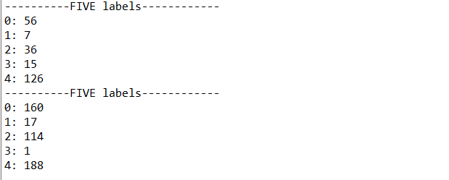

這是切0.5秒我的model

這是切0.25秒你的model