Charlie Huemmler

Environmental Data Science

Prof. Kropp

Activity 2



The NOAA data set has 157,849 rows (observations) and 9 columns (variables).



A character is a string, otherwise just words. Numeric data is numbered data, with or without a decimal point. Integers are whole number data points. Factors are character vectors with an attached integer vector for ordering.



Main

|  |  |
| --- | --- |
| Argument | What it does |
| datW$TAVE[datW$siteN == 1] | specifys the data to visualize. I.e: looking at the average temperature for site 1 |
| Freq = FALSE | tells the graph to display the density (relative frequency) instead of frequency of the data. |
| main = paste(levels(datW$NAME)[1] | Main title for graph |
| xlab = "Average daily temperature (degrees C)" | Sets X axis label |
| ylab="Relative frequency" | Sets Y axis labels |
| col="grey50"  Border = “white” | Sets the color of the bars  Sets color of border |

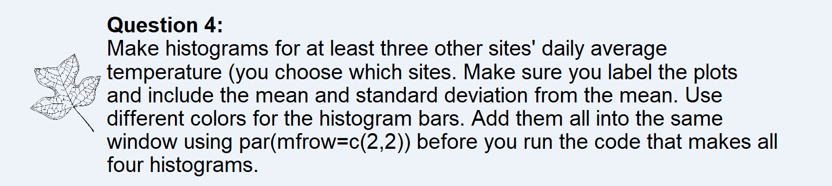

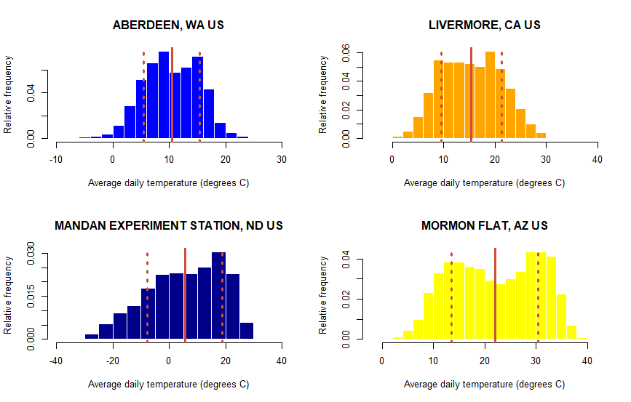



Some of the sites appear more normally distributed in air temperature than others. Livermore and Aberdeen seem fairly normal, while Mandan is left skewed and Mormon Flat is bi-modal.

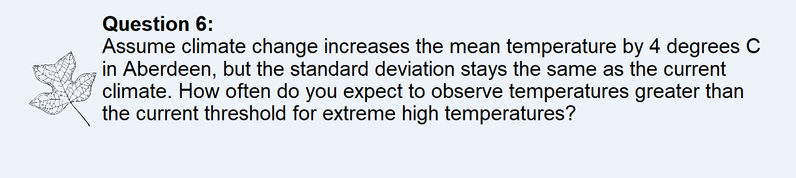

We will expect to see temperatures above the 18.51 degrees C threshold 20.31% of time, given a 4 degrees C increase in mean temperature in Aberdeen.

