Charlie Huemmler

Activity 3

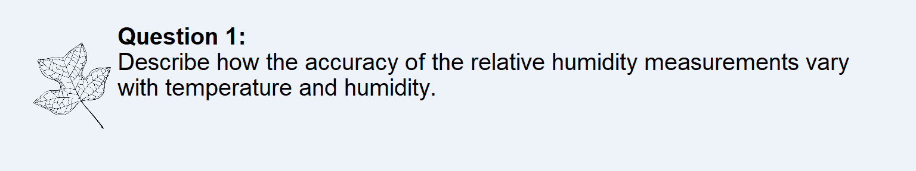

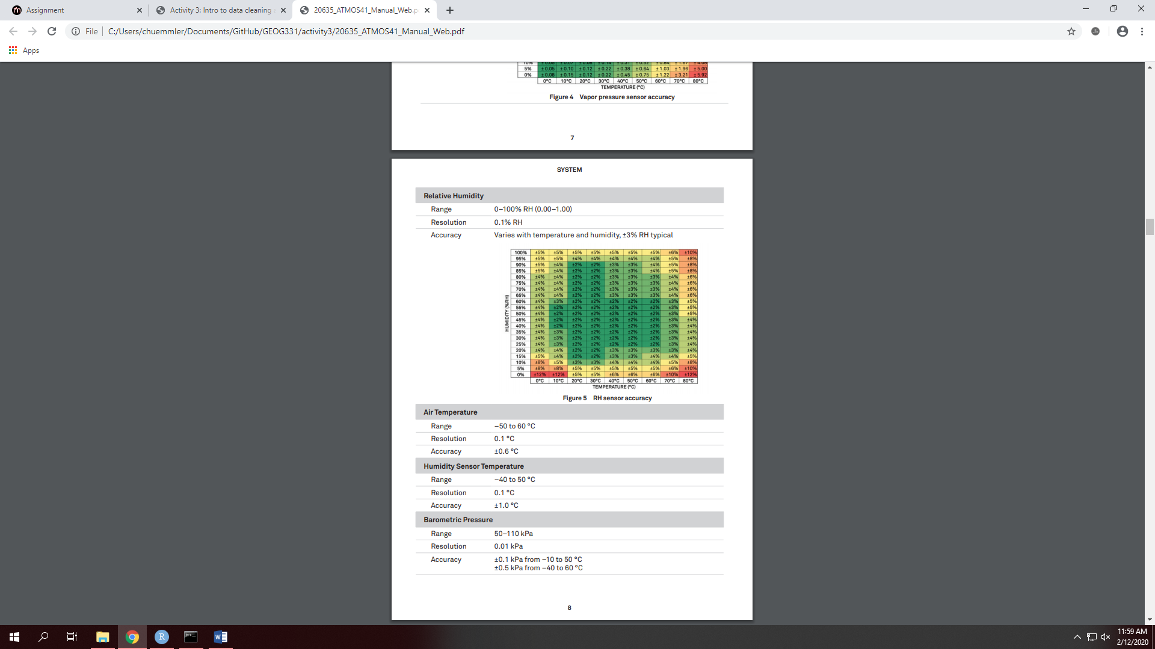

The accuracy of relative humidity measurements is maximized when temperature and humidity are in their middle ranges. When temperature is between 10 degrees Celsius and 60 degrees Celsius, and when Humidity is between 15% and 90%, the accuracy of relative humidity is highest, close to a 2% error level in most cases.

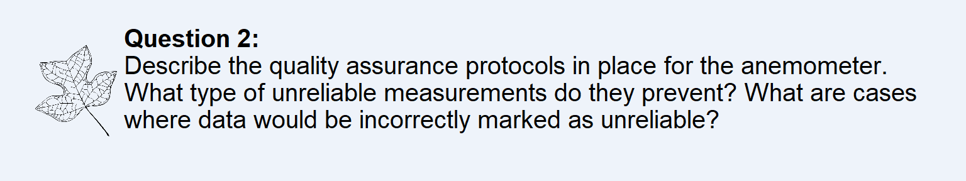

If a measurement is more than 8 times the average of the last 10 measurement’s, it is flagged and not recorded in the data. This typically happens when factors other than the wind trigger the sensor, such as a bumble bee buzzing by. Data will be incorrectly marked as unreliable if the wind actually does increase in speed by 8 times the average of the last 10 measurements.



Skip tells R to skip the first three rows when loading the data in. We do this because these rows are metadata and not the same datatype as the regular data (characters instead of numeric). Nrows tells R to load in only that number of rows. In our case, this only loads in the metadata. When loading in data, if header=TRUE, the first row becomes the column names (headers). Inversely, header=FALSE keeps the first row as the first row, and the columns are given generic names.

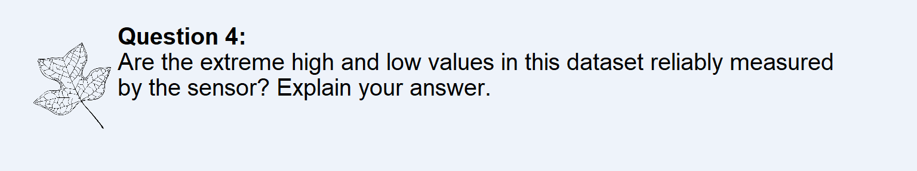

These extreme values are accurately measured by the sensor. I am confident of this for a couple reasons. First, there are no drastic leaps to reach the extremes. Temperature over time is a continuous function and the data’s behavior follows that. Furthermore, the measurements are similar to that found on [https://www.wunderground.com/history/daily/us/ny/rome](https://www.wunderground.com/history/daily/us/ny/rome.), which presumably is accurate.

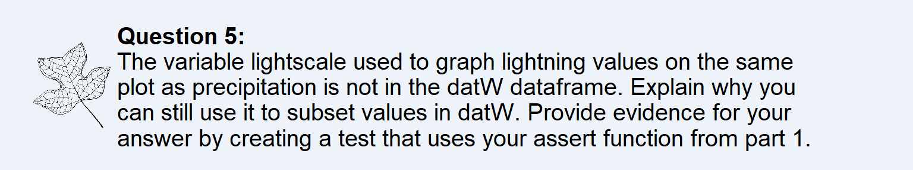

Lightscale can still subset values of datW because they have the same amount of observations. If the subsetted values are smaller than the dataframe, then the subset vector will be looped until the end of the dataframe.

Because assert(length(lightscale) == nrow(datW),err.message = "Bad") is true, we don’t receive the error message.

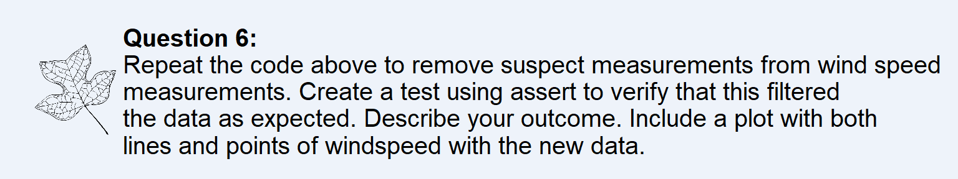

> assert(is.na(datW$wind.speed2), "Not the Same")

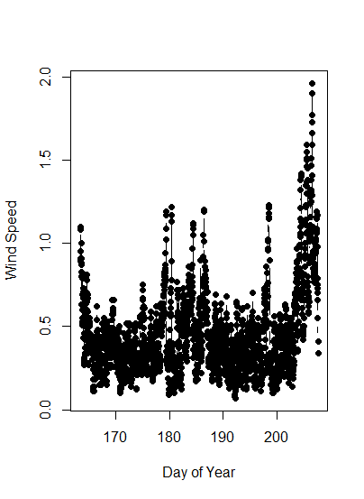

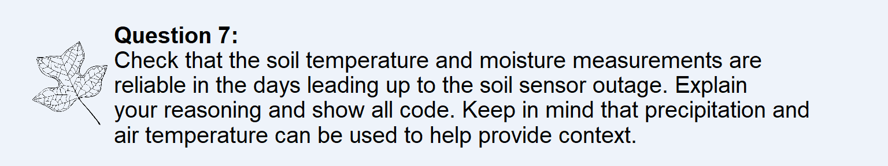

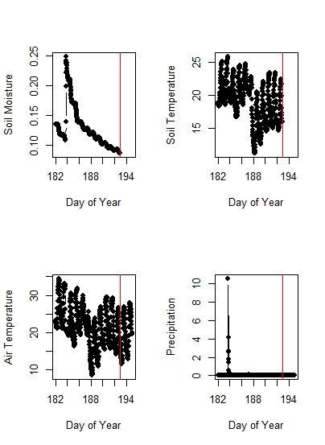

I created 4 graphs, zooming in on the time period right before the soil sensor outage, marked by a red vertical line. It seems soil moisture is at low as it has been more than a week since the last precipitation event, which is the longest it had been all summer. The dry soil may have made it easier to dislodge. Both soil and air temp look normal. Perhaps a bear dislodged the sensor.

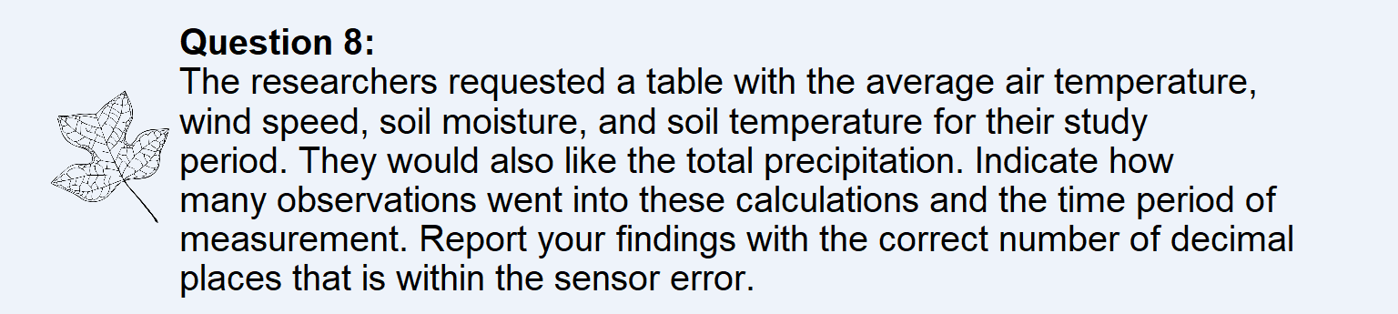

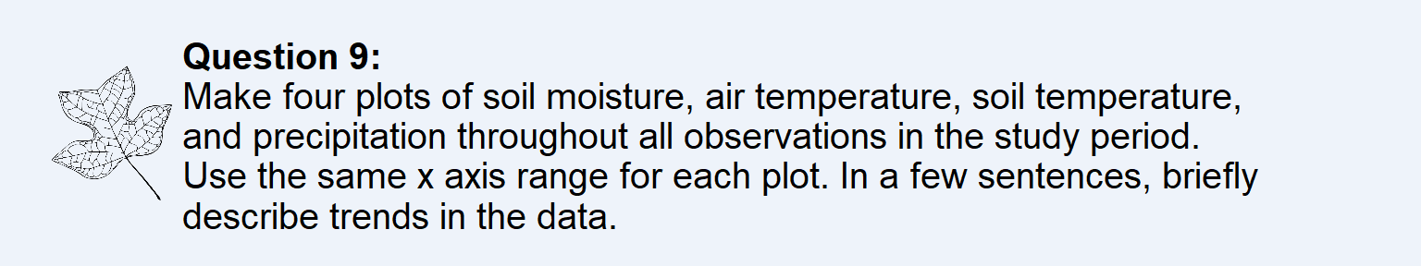

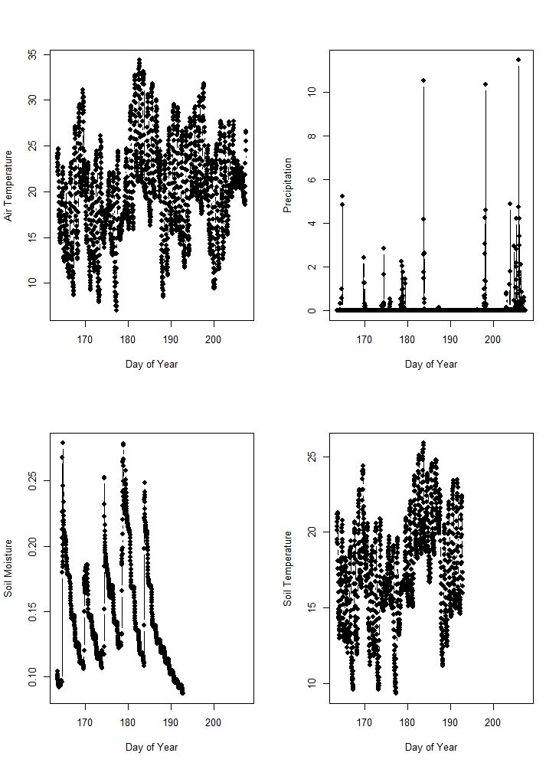

We see soil moisture spike after precipitation events, which drops soil temperature. As air temperature increases, soil temperature follows. Air temperature is typically colder during precipitation events.

