Charlie Huemmler

Prof. Kropp

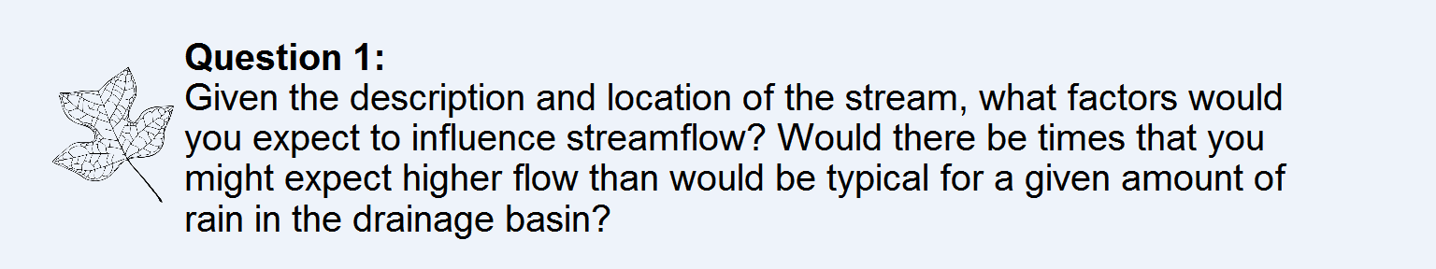

Stream flow will be influenced by precipitation by a lag. This lag will vary depending on temperature. When I it rains normally, flow will increase, but when it rains when snow is already on the ground, or if there is an unusually warm day with snow on the ground, snowmelt will cause flow to spike. This will happen in the spring time.

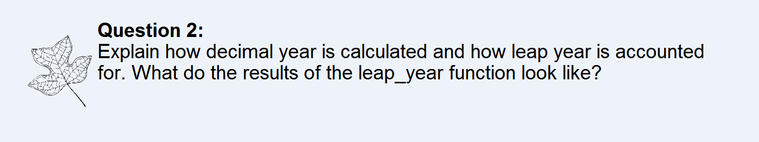

Decimal year is calculated first by calculating the decimal day of year. This is the day of the year, plus the proportion of day that has already passed at the time of observation. The decimal day of year is then divided by the amount of days in a year so it is out of 1, then added to the year itself. The function leap_year returns a Boolean for if the year is a leap year or not.

