Charlie Huemmler

Activity 6



The projection this spatial file is in is Universal Transverse Mercator. NAD83 is the horizontal and geometric control datum for this spatial file, as it is located in the United States. The zone refers to 1 of the 60 slices of the Earth created with the UTM projection. These slices start and end at each pole, with 6 degrees of separation between each. For each slice (zone), it is flattened onto a secant cylinder. This makes measurements become inaccurate the further from the central meridian line the zone is mapped onto.

Scale is constant north/south along the meridians, but is warped east/west. This coordinate system is meant for the scale of within each zone. If you have to analyze an area that spans more than one zone, another projection may work better.

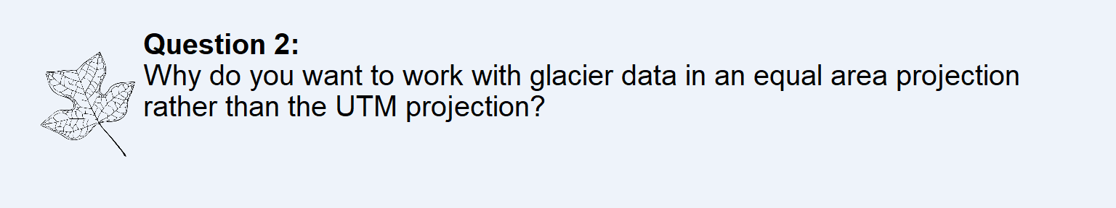

We want to work with the glacier data in the equal area projection for two reasons. First, the NDVI data is in this projection, so we need to align the two data sets for analysis. Furthermore, the equal are projection does not skew the geographical distances, meaning everything we look at properly spaced.

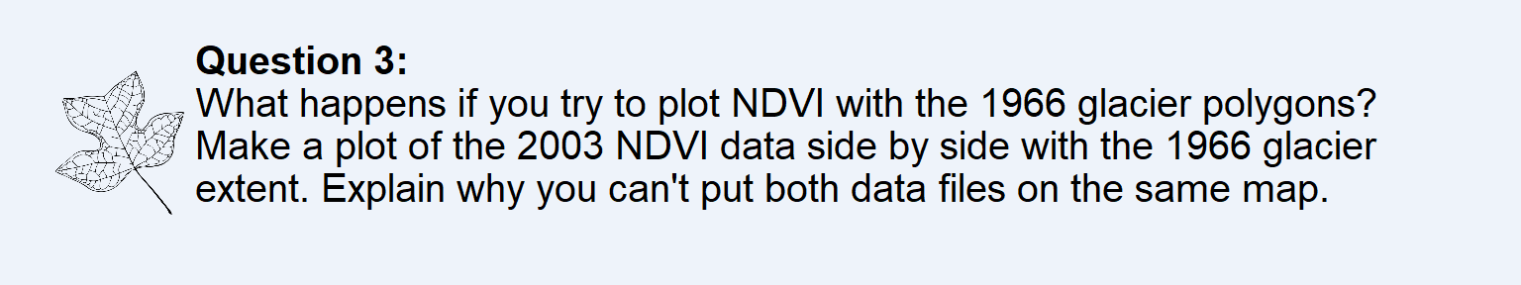

You cannot plot the NDVI data with the 1966 glacier polygons as they don’t have the same projection. The coordinates (as seen on the axes) are different, so the maps will not line up.

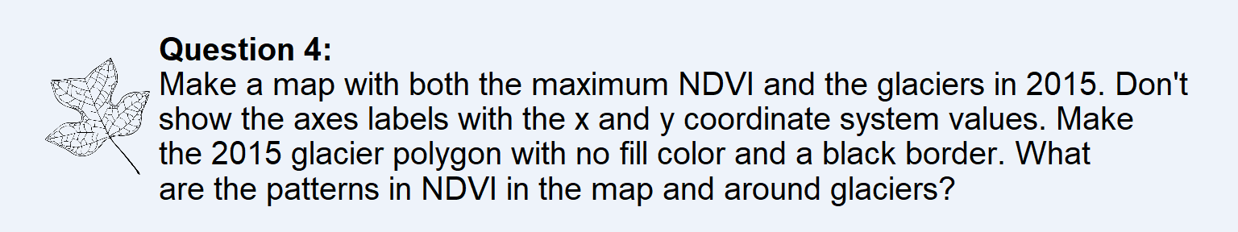



There are clearly lower levels of vegetation around the areas where the glaciers are.

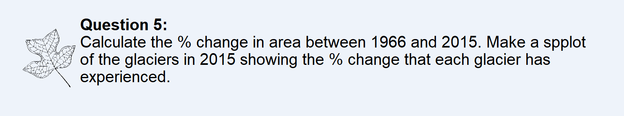



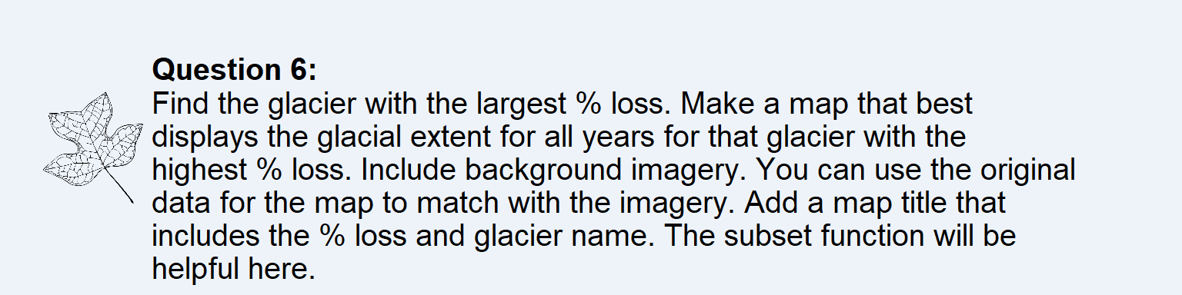



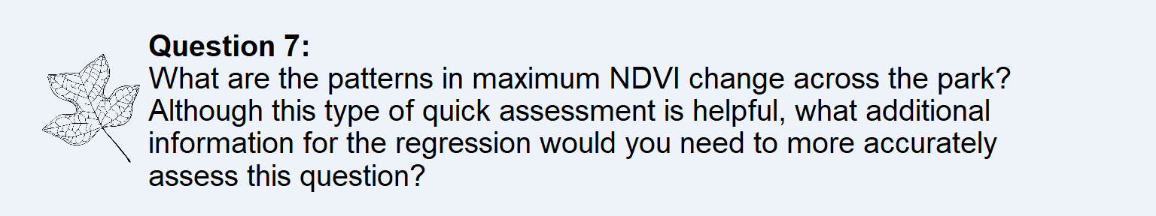

It appears that there is the highest level of change of maximum NDVI around areas with already high NDVI. I believe these are in lower elevations but I cannot tell for sure.

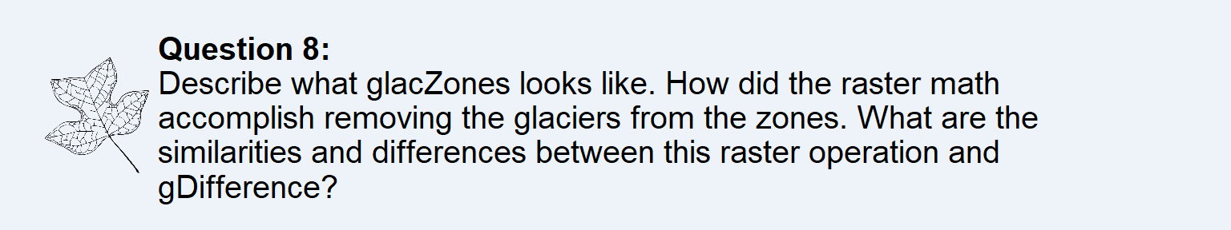

glacZones is the area surrounding each glacier by 500 meters, not including the glaciers themselves.

An object is created the expands the size of the glaciers by 500 meters in each direction, then the shape of the glacier is subtracted from this new shape. The raster is different than the gDifference operation because rasters are a matrix of cells, while the gDifference applies to polygon shapes.





It seems larger glaciers tend to have a smaller amount of NDVI change. Also there is more change the further North the glacier is.

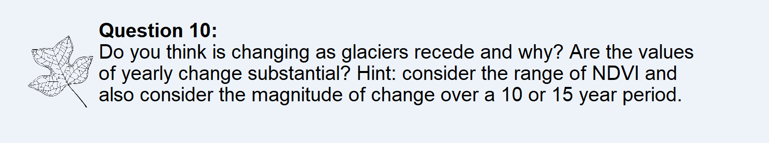

**Do you think vegetation is changing as glaciers recede and why? Is the change in NDVI per year (slope) substantial? Hint consider the range of NDVI and the magnitude of change over a 10-15 year period.**

The effect of vegetation increasing as the glaciers recede is minimal.

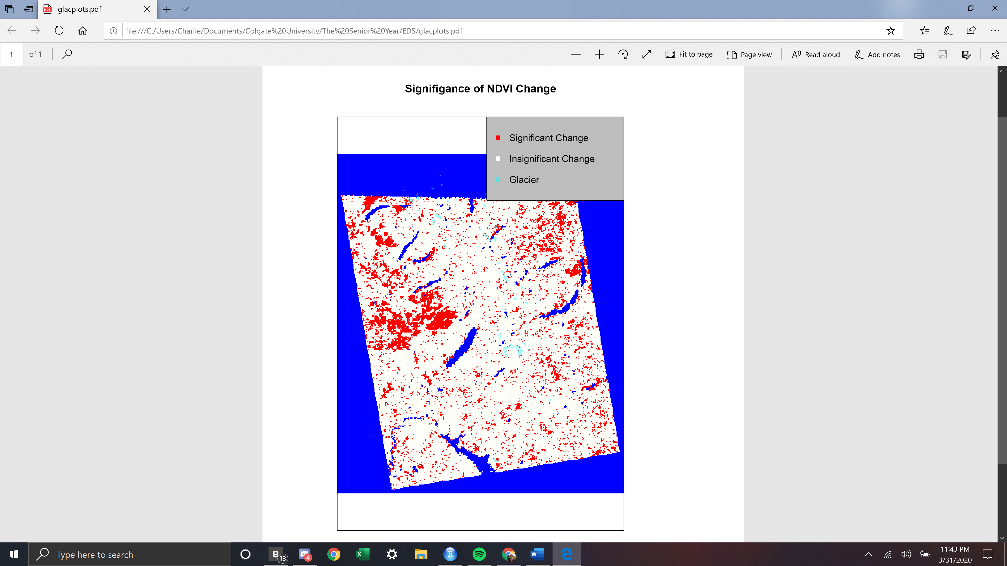

As we see from this graph, only so much of the area of Glacier National Park experienced statistically significant change in vegetation from 2003 to 2016, at a 95% confidence level. This area seldom aligns with where the glaciers lay, so it is hard to infer that their receding affected vegetation growth.

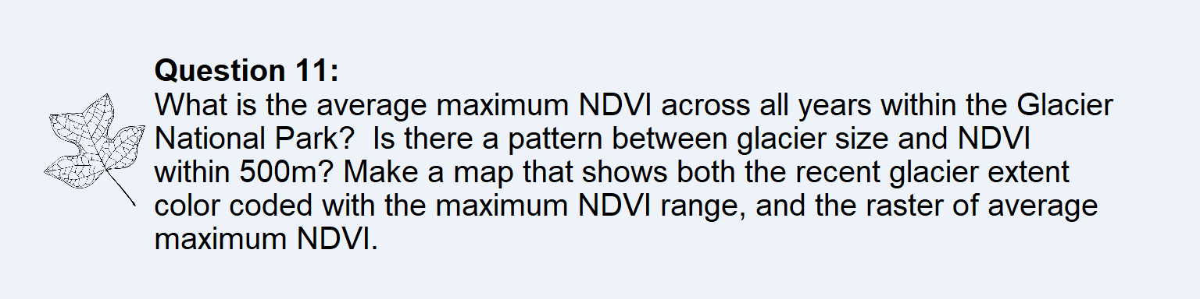

The average maximum NDVI across all years is 0.7439836.



It does appear that there is a correlation between smaller glaciers and more vegetation.



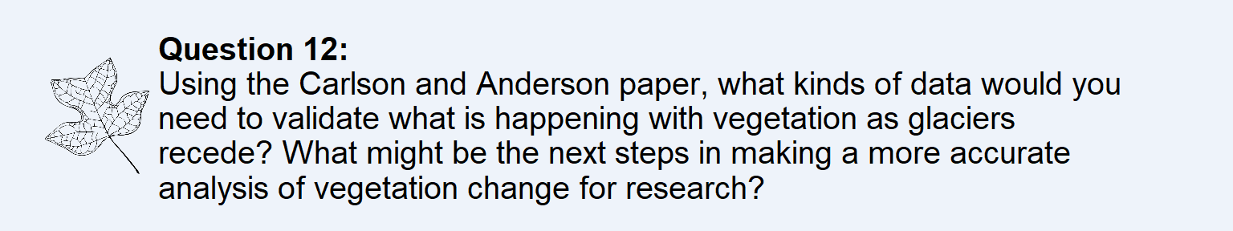

If we had data on elevation, we may be able to uncover the full story of what is happening with the glaciers and vegetation. I assume that glaciers are more likely to form and be larger at higher elevations, as the temperatures are cooler. Furthermore, I know that there is less vegetation at higher elevations. This makes sense as to why there is little change in vegetation as the glacier recedes. Also, it shows why smaller glaciers have higher levels of vegetation surrounding them; they are at lower altitudes. As a next step, I would like to run regressions for maximum NDVI and glacier size by elevation to see how these variables change for each additional meter of elevation.

