Charlie Huemmler

EDS Activity 7

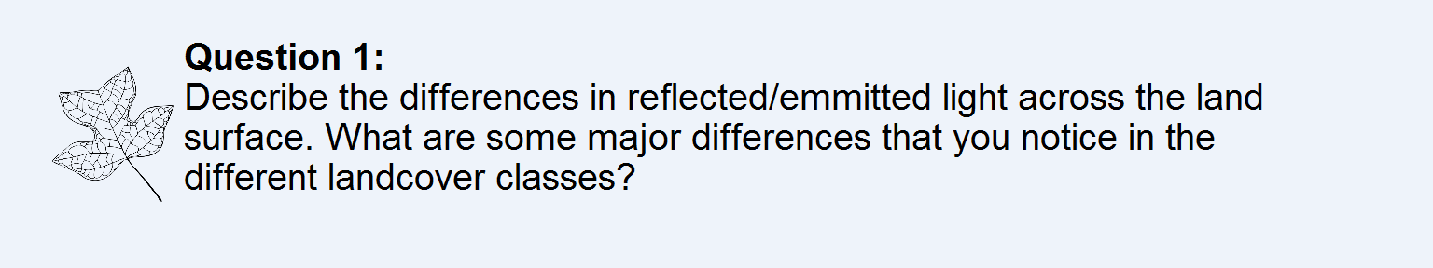

Different areas of land reflect different spectrums of light for our sensors to read. You can tell which areas of land are wooded, farms, or urban based on the bands that are most present in those regions. In the false color image, we can see the urban areas come out as gray, forests as purple, and agriculture as pink.

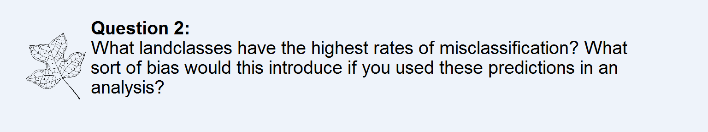

Both ‘Built’ and ‘Agriculture’ have high rates of misclassification, frequently being mistaken for each other. This introduces a bias for more of these land class to appear than is actually true.