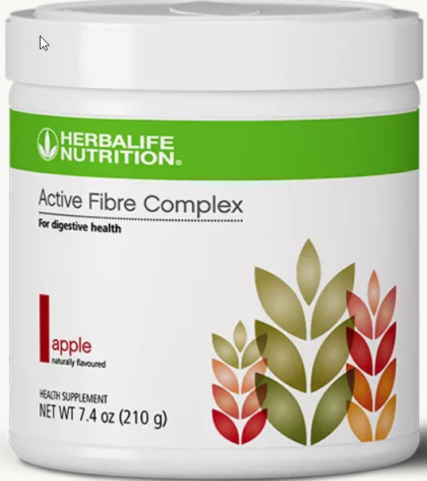
Active Fibre Complex
Helps support bowel regularity and healthy digestion.
Active Ingredients: Sugarcane Fibre, Maize Dextrin, Soy Fibre, Inulin and Citrus Fibre
Other Ingredients: Natural Apple Flavour, Citric Acid, Sodium Carboxymethyl cellulose, Sucralose, Silicon Dioxide, Maltodextrin, Caramel Colour and Beet Juice (Colour)
Allergen info
CONTAINS SOYBEAN INGREDIENT

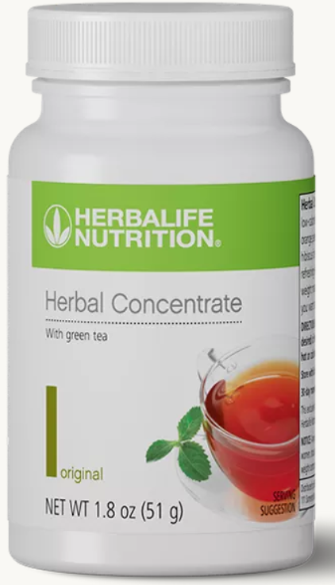
Herbal Concentrate
An energizing, low-calorie instant tea you can enjoy any time of the day for an uplifting treat
Ingredients
Maltodextrin, Green Tea Extract, Orange Pekoe Extract, Lemon Flavour, Cardamom Seed Extract, Hibiscus Flower Powder and Malva sylvestris Extract.

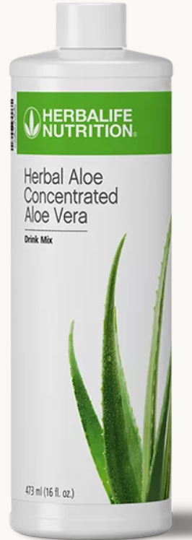
Herbal Aloe Concentrated Aloe Vera
Support your digestive health with the soothing benefits of aloe vera.
Ingredients
Purified Aloe vera (Leaf) (Aloe vera Concentrate, Citric Acid, Sodium Benzoate, Potassium Sorbate and Water), Citric Acid, Water, Sodium Citrate, Potassium Sorbate, Sodium Benzoate, Chamomile Extract (Chamomile Extract, Maltodextrin), Lemon Juice Concentrate (Lemon Juice Concentrate, Sodium Metabisulfite)
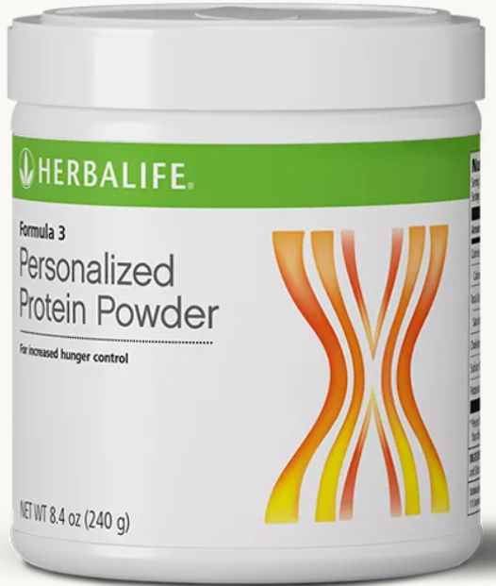
Formula 3 Personalized Protein Powder
Optimize your protein intake with this blend of whey and soy.
Ingredients
Soy Protein Isolate, Whey Protein Concentrate, Natural Flavour and Silicon Dioxide
Allergen info
CONTAINS MILK AND SOYBEAN

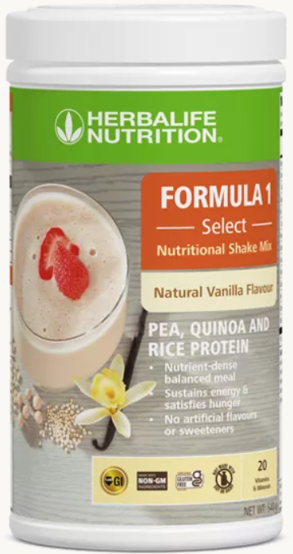
Formula 1 Select: Natural Vanilla
A nutrient-dense, balanced meal shake mix made with carefully selected ingredients. It contains 100% plant-based protein blend of Pea Protein, Rice Protein and Quinoa Powder. It is naturally gluten free and made with non-GM ingredients to activate your healthy lifestyle with plant-based power.
Ingredients
Pea protein, fructose, rice protein concentrate, inulin, cellulose, canola oil, natural vanilla flavours, quinoa powder, guar gum, vitamin mix (beta carotene, ascorbic acid, dl-aplha tocopheryl acetate, biotin, niacinamide, cyanocobalamin, calcium pantothenate, folic acid, ergocalciferol, pyridoxine hydrochloride, thiamine mononitrate and riboflavin), mineral mix (dicalcium phosphate, magnesium oxide, sodium selenite, ferrous fumarate, zinc oxide, copper gluconate and chromium chloride), rice fibre, steviol glycosides, ginger root powder and blueberry powder.

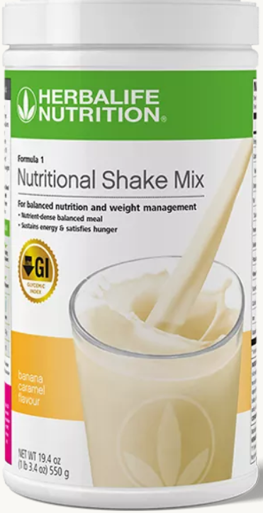
Formula 1: Banana Caramel
Delicious meal replacement shake.
Ingredients
Fructose, Soy Protein Isolate, Milk Protein, Soy Lecithin, Soybean Oil, Cellulose, Oat Fibre, Banana Flavour, Guar Gum, Fructooligosaccharides*, Corn Bran, Silicon Dioxide, Dextrose, Calcium Citrate, Potassium Phosphate, Xanthan Gum, Beta Carotene, Carrageenan, Peach Flavour, Vanilla, Licorice Extract, Potassium Chloride, Apricot Flavour, Magnesium Oxide, Rapeseed Oil, Mango Flavour, Ascorbic Acid, Ferrous Fumarate, Citrus Pectin, Dl-alpha Tocopheryl Acetate, Niacinamide, Parsley Powder, Papaya Powder, Zinc Oxide, Copper Gluconate, Vitamin A Palmitate, Pantothenic Acid, Vitamin D3, Antioxidant Mix (Dl-alpha Tocopherol, Ascorbyl Palmitate, Lecithin), Manganese Carbonate, Pyridoxine Hydrochloride, Cyanocobalamin, Riboflavin, Thiamine Hydrochloride, Folic Acid, Potassium Iodide, Sodium Selenite and Biotin
*Fructooligosaccharides (FOS are known as prebiotics and help promote the growth of positive flora.)
Allergen info
CONTAINS GLUTEN, MILK AND SOYBEAN

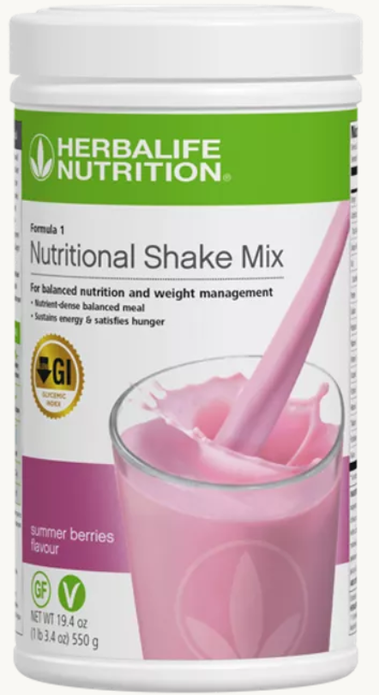
Formula 1: Summer Berries
Delicious meal replacement shake.
Ingredients
Soy protein isolate, fructose, inulin, gluten-free oat fibre, soybean oil, mineral mix (calcium citrate, magnesium oxide, maltodextrin, ferrous fumarate, sodium selenite, zinc oxide, manganese carbonate, chromium chloride, potassium iodide and copper citrate), natural raspberry and blueberry flavours, potassium phosphate, soy lecithin, flaxseed powder, xanthan gum, colour (beetroot red), vitamin mix (ascorbic acid, dl-alpha tocopheryl acetate, maltodextrin, nicotinamide, retinyl acetate, biotin, calcium pantothenate, cholecalciferol, folic acid, phylloquinone, pyridoxine hydrochloride, thiamine hydrochloride, cyanocobalamin, riboflavin), sodium chloride, steviol glycosides, guar gum, papaya powder, parsley powder, blueberry powder, pomegranate powder, silicon dioxide.
Allergen info
CONTAINS OAT AND SOYBEAN.
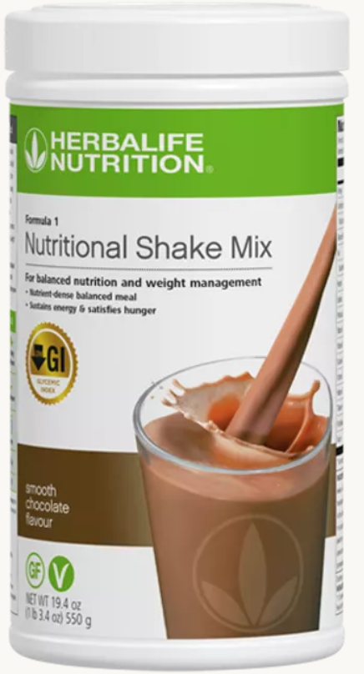
Formula 1: Smooth Chocolate
Delicious meal replacement shake.
Ingredients
Soy protein isolate, fructose, inulin, gluten-free oat fibre, soybean oil, cocoa powder, mineral mix (calcium citrate, magnesium oxide, maltodextrin, ferrous fumarate, sodium selenite, zinc oxide, maganese carbonate, chromium chloride, potassium iodide and copper citrate), potassium phosphate, soy lecithin, flaxseed powder, xanthan gum, natural chocolate flavour, colour (caramel), sodium chloride, vitamin mix (ascorbic acid, dl-alpha tocopheryl acetate, maltodextrin, nicotinamide, retinyl acetate, biotin, calcium pantothenate, cholecalciferol, folic acid, phylloquinone, pyridoxine hydrochloride, thiamine hydrochloride, cyanocobalamin, riboflavin), steviol glycosides, guar gum, papaya poweder, parsley powder, blueberry powder, pomegranate powder, silicon dioxide.
Allergen info
CONTAINS OAT AND SOYBEAN.

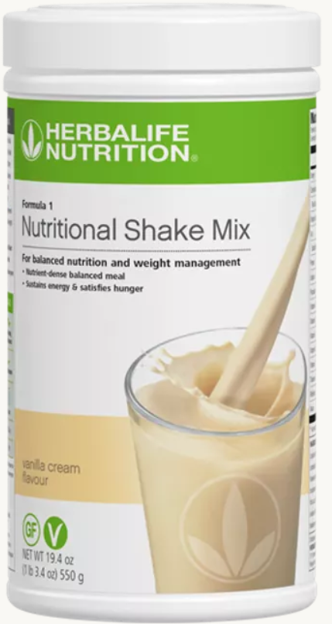
Formula 1: Vanilla Cream
Delicious meal replacement shake.
Ingredients
Soy protein isolate, fructose, inulin, gluten-free oat fibre, soybean oil, mineral mix (calcium citrate, magnesium oxide, maltodextrin, ferrous fumarate, sodium selenite, zinc oxide, manganese carbonate, chromium chloride, potassium iodide and copper citrate), potassium phosphate, soy lecithin, flaxseed powder, xanthan gum, natural vanilla cream flavour, vitamin mix (ascorbic acid, dl-alpha tocopheryl acetate, maltodextrin, nicotinamide, retinyl acetate, biotin, calcium pantothenate, cholecalciferol, folic acid, phylloquinone, pyridoxine hydrochloride, thiamine hydrochloride, cyanocobalamin, riboflavin), sodium chloride, colour (beta-carotene), steviol glycosides, guar gum, papaya powder, parsley powder, blueberry powder, pomegranate powder, silicon dioxide.
Allergen info
CONTAINS OAT AND SOYBEAN.
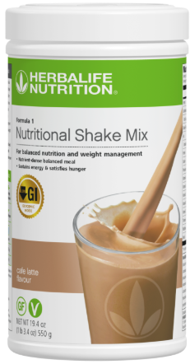
Formula 1: Café Latte
Delicious meal replacement shake.
Ingredients
Soy protein isolate (39%), fructose, inulin (7.5 g/100 g), gluten-free oat fibre, soybean oil, mineral mix (calcium citrate, magnesium oxide, maltodextrin, ferrous fumarate, sodium selenite, zinc oxide, manganese carbonate, chromium chloride, potassium iodide and copper citrate), decaffeinated coffee powder, potassium phosphate, emulsifier (lecithin), natural flavouring substance, flaxseed powder, thickeners (xanthan gum, guar gum), natural colour (caramel), vitamin mix (vitamin C, vitamin E, maltodextrin, vitamin B3, vitamin A, biotin, vitamin B5, vitamin D, folic acid, vitamin K1, vitamin B6, vitamin B1, vitamin B12 and vitamin B2), sodium chloride, steviol glycosides, papaya powder, parsley powder, blueberry powder, pomegranate powder, anticaking agent (silicon dioxide).
Allergen info
CONTAINS OAT AND SOYBEAN.

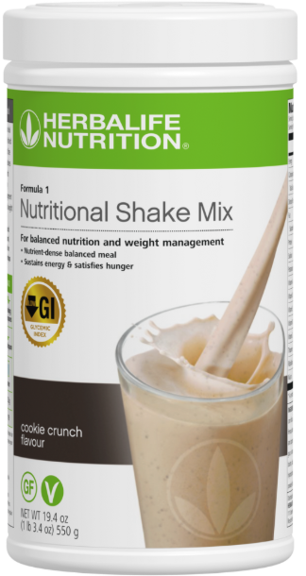
Formula 1: Cookie Crunch
Delicious meal replacement shake.

