Quick Start Guide
Welcome to the Tax-Aide TrueCrypt Utility for Tax Year 2011. This Quick Start Guide contains what you need to know to obtain and use the Utility when your target computer or USB-connected drive either has no prior installation of TrueCrypt for Tax-Aide or has a prior installation that is configured in one of the standard ways described in earlier versions of the TrueCrypt for Tax-Aide Manual.
A summary of the benefits of converting to this Version of the Utility is contained on the next page.
The complete User Guide for The current Tax Year starts on page iii. You may want to scan its Table of Contents to see what it contains before using this Quick Start Guide.
CAUTION: If you have files that you want to retain in existing Tax-Aide TrueCrypt volumes on your computer or external storage device, do not uninstall your existing version of the TrueCrypt program before launching this version of the Utility. Doing so may interfere with the Utility’s automatic copying of the contents of the existing TrueCrypt Volumes to the new volume. If TrueCrypt software at version 6.2 or 6.3 is found it is upgraded to TrueCrypt 7.0. The TrueCrypt data file migration in this instance is not done.

Quick Start Steps:
- Download the Tax-Aide TrueCrypt Utility program and the Tax-Aide TrueCrypt User Guide from the Technology page of the AARP Tax-Aide ExtraNet at aarp.org/tavolunteers.
- Have the User Guide in front of you when doing the installation.
- Close all open programs.
- Close any open TrueCrypt volumes.
- Launch the Utility.
- In steps 7 to 9, references to the Travelers Drive will only be seen if you have a Travelers Drive inserted into your computer.
- Select the “Do Tasks on Hard Drive” or “Do Tasks on Traveler Drive” task selection.
- Select the “Resize TrueCrypt / Traveler Volume” or “Upgrade TrueCrypt (and Tax-Aide) Software”
- If you have selected “Resize TrueCrypt / Traveler Volume” option in step 7, specify your new TrueCrypt volume size (allow about 500 MB for each year of TaxWise) .
- Note: In the following steps, it is possible for one window to be on top of another window. If no activity appears to be occurring, move the window to another area on the screen to detect this possibility.
- Enter the password you want to use for the new volume, if existing volumes are detected you will be asked for those passwords.
- Your old files will automatically be copied to the new TrueCrypt volume on drive P: by the Utility.
- If you have more data to copy than you allowed space for on the new TrueCrypt volume, the automatic copy will abort. Restart the utility and it will offer choices to solve the issue. The User Guide contains instructions.
- Click on OK and test the installation by clicking on the Start Tax-Aide Drive icon.
Troubleshooting - If you run into problems,
- Please first look for solutions in the Tax-Aide TrueCrypt User Guide.
- When you have questions about the information contained in the manual or need assistance, please turn next to your AARP Tax-Aide district or state-level technology leaders.
- If you still have unanswered questions or problems after doing so, send an email asking your question or describing your problem to the National Technology Committee and the National Technology Office at TaxAideTech@aarp.org. Please cc your state Technology Specialist on your email. Alternatively, submit your question to the T-VOG user group where it will be answered.

Summary of Benefits

Why use the 2011 Tax-Aide TrueCrypt Utility?
- It creates new TrueCrypt Volumes using TrueCrypt Version 7.0, which is much higher performance and more secure than volumes created by some pre-2009 versions.
- No existing files are lost; they are all moved to the new TrueCrypt Volumes.
- Icons to open and close these TrueCrypt Volumes are installed on the system.

What are the advantages of the 2011 Utility over pre-2009 versions?
The 2009 and later Tax-Aide TrueCrypt procedures are extremely simple and user-friendly, avoiding all unnecessary dialog boxes and questions.
- Installation is simple, with only three steps:
  - The user chooses what function is to be performed on a chosen drive (either USB or local hard Drive.
  - The user specifies the new TrueCrypt Volume size and password.
  - After that point, TrueCrypt Volume creation and setup are automatic, with no further user involvement except for entering passwords for the old volumes.
  - Vista, Windows 7, and 64-bit versions of the operating systems and hardware are handled in addition to the previously supported Windows XP versions. This includes TaxWise server systems, standalone systems and ERO transmitting systems.
- Vista and Windows 7 may be used with User Account Control (UAC) turned on or off.
The new Start and Stop Tax-Aide Drive procedures do not ask any questions; they simply open and close the TrueCrypt Volume using TrueCrypt software for password entry.
The new procedures can detect the state of TrueCrypt on the system upon which they are running and may automatically upgrade the installation to the new version. USB drives are handled in a similar manner.
New functions added for Tax Year 2010 & 2011
- Resize a TrueCrypt Volume on a Hard Drive or Traveler Drive. For TY2011 this is enhanced to be more reliable and also to recover when something goes wrong.
- Install or upgrade TrueCrypt system files only

For further information…
The complete manual is available for download on the Technology page of the AARP Tax-Aide ExtraNet at aarp.org/tavolunteers.

User Guide

Table of Contents
Quick Start Guide i
Summary of Benefits iii
Why use the 2011 Tax-Aide TrueCrypt Utility? iii
What are the advantages of the 2011 Utility over pre-2009 versions? iii
New functions added for The current Tax Year iii
For further information… iii
User Guide iv
Table of Contents iv
Introduction 1
Overview 1
Operating Systems Supported 2
TrueCrypt Volume Standardization 2
TATCU for TY2011 versus TATCD for TY2009 2
Considering Migration to the TATCU program for The current Tax Year 3
Local and Traveler Modes Defined 4
Using Local Mode 4
Using Traveler Mode 5
Using the Utility Program to Create / Update a TrueCrypt Volume 6
Selecting the Drive Type and Task 7
Selecting the USB Drive 7
Specifying the Volume Size 8
Specifying the Volume Password 9
Formatting the Volume 10
Starting the Tax-Aide Drive 10
Handling Errors during TrueCrypt Upgrade 11
TrueCrypt blue key icon 11
APPENDIX A – Understanding Migration Scenarios 12
Changes for Tax Years 2009 and 2010 12
Migration Scenarios 14
Scenario 1 – No TrueCrypt previously installed 14
Scenario 2 –Internal Mode TrueCrypt previously installed 14
Scenario 3 – External or Traveller Mode TrueCrypt previously installed 14
Scenario 4 – TATCU for The current Tax Year Traveler Mode drive inserted into a computer with a version of TrueCrypt prior to 7.0 installed 15
APPENDIX B – Resolving Migration Errors 17
APPENDIX C – Locating TrueCrypt Volume container files 18
APPENDIX D – Accessing Source Code 18
APPENDIX E – Changing a TrueCrypt Volume Password 19
APPENDIX F – Changing the size of a TrueCrypt Volume 21
APPENDIX G – Starting the Tax-Aide Drive at Windows Log on 21

Introduction
AARP Tax-Aide policy requires that encryption must be used to protect taxpayer data.
TrueCrypt has several attributes that are important for the AARP Tax-Aide program. It allows all of the data associated with tax returns that are prepared in the Tax-Aide program to be stored on a computer or a removable data storage device in an encrypted form. If the computer or removable data storage device is lost or stolen there is no immediate access to the data. Only TrueCrypt allows the encrypted data to be decrypted and accessed. Software such as the TaxWise tax preparation program can be used to prepare tax returns by accessing the encrypted data through TrueCrypt as though it were on a regular hard drive. For additional technical information on the TrueCrypt program and its history the Wiki should be consulted http://en.wikipedia.org/wiki/TrueCrypt; for additional technical depth the TrueCrypt website should be used http://www.truecrypt.org/.
Help is available. When you have questions about the information contained in this manual or need assistance in using these tools, please turn first to your AARP Tax-Aide district or state-level technology leaders for assistance. If you still have unanswered questions or problems after doing so, send an email asking your question or describing your problem to the National Technology Committee and the National Technology Office at TaxAideTech@aarp.org. Please cc your state Technology Specialist on your email. Alternatively, you may ask your questions in the T-VOG forum. If you do not have access to the forum, contact your TC or state TCS for associated information on how to obtain a T-VOG login.

Overview

Files that are encrypted by TrueCrypt are stored within a special container file called a TrueCrypt Volume. This volume looks just like a regular Windows file and has the file extension .TC. TrueCrypt Volume container files will show up in Windows with a red key icon like this one.
The TrueCrypt program is used to create the TrueCrypt Volume, to open it for use, to decrypt and encrypt the data as other programs read and write the data, and finally to close the TrueCrypt Volume after it has been used.
During the Volume Creation process, the user supplies a Volume Password that allows access to the encrypted data in the TrueCrypt Volume. This password has to be supplied to open the TrueCrypt Volume.
TrueCrypt has many more capabilities than are used by the AARP Tax-Aide program. A software tool called the Tax-Aide TrueCrypt Utility (TATCU) program has been written to make it easier for volunteers to install and use just those pieces of TrueCrypt that are needed for the AARP Tax-Aide program. The TATCU program creates a TrueCrypt Volume with as little user input as possible. The Utility suggests a default Volume Size that can be accepted or changed by the user. Once a TrueCrypt Volume is created, the Start and Stop Tax-Aide Drive procedures can be triggered by a mouse click on a Windows desktop shortcut to open and close the TrueCrypt Volume. The TATCU program can also be used to resize a TrueCrypt Volume while preserving its contents.

Operating Systems Supported
The TATCU program has been tested and is approved for use with the following operating systems:
- Windows XP Home and Professional (32 and 64 bit)
- Windows Vista Home, Business and Ultimate (32 and 64 bit)
- Windows 7 (32 and 64 bit)

TrueCrypt Volume Standardization
When using the TATCU program, the TrueCrypt Volume or container file will always be named TPDATA.TC and will always be opened as drive P:; it will always be shared as TaxWiseServer_P. This differs from versions of the TrueCrypt for Tax-Aide procedures released before Tax Year 2009 where some Internal Mode volumes were named TSDATA.TC, opened as S:, and shared as TWSRVR_S; and where External or Traveller Mode volumes were given the names TQDATA.TC or TRDATA.TC, were opened as Q: or R:, and shared as TWSRVR_Q and TWSRVR_R, respectively.

TATCU for the current tax year

TrueCrypt has been updated to version 7 and this is the version that will be used for the 2011 tax season. There is no change in the functions of TrueCrypt that the Tax-Aide program uses. However, the program has been updated to take advantage of the performance capability of 64-bit hardware and software if they exist in a machine. The TATCU has been updated to use TrueCrypt version 7.
TC version 7 is somewhat incompatible with prior TrueCrypt versions. TC V7.0 will open TrueCrypt volumes created by prior versions of TrueCrypt; however, a TrueCrypt volume created by version 7 cannot be opened by any prior version of TrueCrypt. If the volume is on a flash drive and it is inserted into a host system with TrueCrypt installed, then that host system must have version 7 installed in order for the volume on the flash drive to be opened. Consequently the TY2011 version of TATCU incorporates a variety of upgrade scenarios to deal with this situation.

Considering Migration to the TATCU program
“Migration” is the term used to describe the process of changing over from earlier versions of the TrueCrypt for Tax-Aide procedures to the TATCU program for the current Tax Year . The term “legacy” is used to mean any version of TrueCrypt or the Tax-Aide TrueCrypt Installer or the TC_Start and TC_Stop procedures earlier than Version 6.2 for Tax Year 2009.
Here are some reasons for choosing to migrate from a legacy Tax-Aide TrueCrypt configuration to the TATCU program for the current Tax Year :
- You would like to keep the primary Tax-Aide security software up to date
- You have a 64-bit computer
- You want to insert a Traveler Mode drive into a 64-bit system
- You want to run Windows Vista with UAC turned on
- You want to use Windows 7
- You want Tax-Aide TrueCrypt procedures that are easier to use than the legacy procedures
- You want the increased performance of the newer versions of TrueCrypt
- You understand the security vulnerability issues of not staying up to date and moving to latest releases. TrueCrypt container files that were created with releases before 5.0 are not as secure as those created with release 5.0 and later.
If you have computers or removable data storage devices that contain TrueCrypt Volumes that were set up in Tax Year 2009 using that year’s version of TATCU then the TrueCrypt software and the TATCU scripts will be automatically upgraded as the current Tax Year version of TATCU is used. The TrueCrypt Volumes will be unchanged in this scenario.
If you have computers or removable data storage devices that contain TrueCrypt Volumes that were set up using earlier versions of the TrueCrypt for Tax-Aide Installer (before version 6.2 for Tax Year 2009) and want to preserve those contents, you will need to read and use the procedures that are contained in Appendix A for migrating from those legacy installations to the TATCU program for the current Tax Year .
If you are migrating from a legacy TrueCrypt for Tax-Aide Installer (before version 6.2 for Tax Year 2009) AND you are using TWMapTools to facilitate the use of computers in multiple roles, AND the version of TWMapTools that you are using is dated earlier than July 2009, then you will need to upgrade your TWMapTools installation to the version dated July 2009 or later when you migrate to the TATCU program for The current Tax Year . The July 2009 TWMapTools version will work with 2009, 2010, and legacy TrueCrypt for Tax-Aide installations.
The potential use of multiple TrueCrypt Volumes containing multiple copies of a single year of TaxWise on a single Windows installation is not supported. Please refer to the document “Multiple EFIN Setup for 2010” (or its successor) on the Technology software page of the AARP Tax-Aide ExtraNet for supported procedures for setting up computers with multiple EFINs.

Local and Traveler Modes Defined
The TATCU program and its procedures can be used in either of two modes: Local or Traveler.
In Local Mode the TATCU program is used to install TrueCrypt and create a TrueCrypt Volume on the target computer’s local hard drive, the System or hard drive. The TrueCrypt Volume is then opened as drive P: by using the “Start Tax-Aide Drive” desktop icon. Then TaxWise can be installed on the P: drive.
In Traveler Mode the TATCU program is used to install TrueCrypt and create a TrueCrypt Volume on any USB-connected removable data storage device, either a flash key or an external hard disk drive. The TrueCrypt Volume is then mounted as drive P: by opening the drive and running the Start Traveler.exe program if you don’t get the option to start the Traveler when you plug the drive in the computer. Then TaxWise can be installed on this P: drive.
Traveler Mode has several uses:
- Computers are borrowed, and no Tax-Aide data can be left on them when not in use
- Computers are old and potentially unreliable, and it is desired that no taxpayer data be left on them in case they fail
- The same computers are used at multiple sites for tax preparation, but different transmitting computers are used. The Traveler mode allows using a different Traveler for each physical site.
- The ERO or Transmitting computer may change during the tax season, in which case the Traveler mode facilitates easy movement of the transmitting TaxWise installation between computers.

Using Local Mode
When a TrueCrypt Volume is created on the C drive by the TATCU program, two Icons are put on the desktop. They look like this:
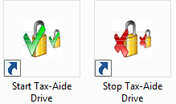
The Start Tax-Aide Drive icon is used to request the Volume Password and use it to open the TrueCrypt Volume and make it appear as drive letter P:. The start procedure sets the appropriate permissions on the volume and shares it for network use. This sharing is only relevant when the volume is on a TaxWise server. If the TrueCrypt Volume is being used on a standalone computer, sharing it does no harm. Once the TrueCrypt Volume is opened, the icon below will appear in Windows explorer.
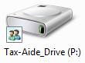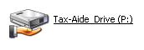
Vista & Windows 7 (Icon)
Windows XP (Tile)

At this point the TaxWise application can be started.
Instructions for setting up TaxWise client/server networking are contained in the Networking TaxWise for Tax-Aide document that is posted on the Technology page of the AARP Tax-Aide ExtraNet. Following those instructions carefully is essential to successful networking.
When its icon is clicked, the Stop Tax-Aide Drive procedure will look to see if it is possible that there may be workstations still signed on to this computer that may be a TaxWise server. If there are any existing network connections, the user will be asked to verify that all TaxWise workstations are signed off. When the go-ahead is received, or if it was not necessary to ask, the Stop Tax-Aide Drive procedure will shut down any network shares on the drive and cause TrueCrypt to close the volume, resulting in the P: drive disappearing from Windows explorer. Entry of the Volume Password will be required to re-open the TrueCrypt Volume.

Using Traveler Mode
When a Traveler Mode removable data storage device is inserted into a USB port on a computer, one of the following will appear:
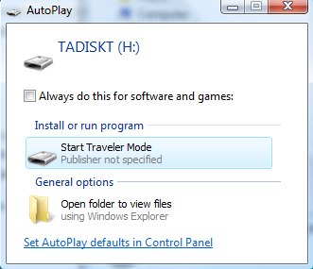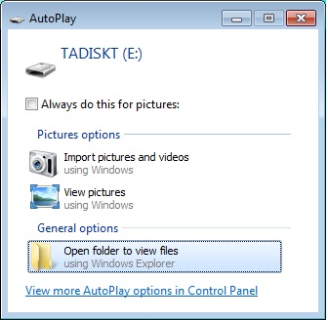
There will be some variation in the look of the boxes depending on the operating system and its settings. If “Start Traveler Mode” is available then this may be clicked to open the TrueCrypt Volume which is on the USB drive. If the operating system options preclude the autoplay options from showing, as is the case in the second picture above, then click on the ”Open folder to view files” option and click on the “Start Traveler” file located in the root of the USB drive.
In some circumstances, Windows may not display any autoplay options when the Traveler drive is plugged into the USB port. Specifically in Windows 7 the operating system disallows the autoplay option for removable media that is read/write (flash drives). In other cases, you may want to re-start the Traveler drive without unplugging it and plugging it into the USB port again to trigger the autoplay options. In either case, you can start the Traveler drive by opening the removable drive from “My Computer” and clicking on the “Start Traveler” file located in the root of the drive.
Once triggered, the “Start Traveler” procedure will cause TrueCrypt to open the TPDATA.TC volume and make it appear as drive letter P: in the file manager, as below.
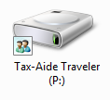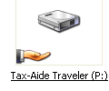
Vista & Windows 7 (Icon)
Windows XP (Tile)

At this point the TaxWise application can be started.
In addition to making the P drive appear in the Windows file manager display, the “Start Traveler” procedure puts a Stop Traveler icon on the computer system desktop, as shown below.
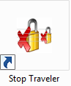
When tax preparation activities are completed (and if this is a server on a network when everyone is logged out of TaxWise) then this icon may be clicked. The resulting activities will stop network sharing, close the P: drive TrueCrypt Volume, and remove the Stop Traveler desktop icon and associated files from the system. Entry of the Volume Password will be required to re-open the TrueCrypt Volume.

Using the Utility Program to Create / Update a TrueCrypt Volume
Download the TATCU program for latest tax year from the Technology page of the AARP Tax-Aide ExtraNet (www.aarp.org/tavolunteers). Close any open TrueCrypt volumes; then run this file.
Important Note: If you have an older version of TrueCrypt on the system, the Utility will likely automatically upgrade it. This process will work much better if the TrueCrypt program has NOT been run since the last reboot. Otherwise it is quite likely that the uninstall of the old TrueCrypt will require a reboot before continuing. This is because TrueCrypt installs a Windows driver when it starts up and there is no mechanism to uninstall this driver without a reboot.
The “Select a Task…” dialog box will appear whose content is based on the system configuration that is detected by the TATCU program.

Selecting the Drive Type and Task
If there is at least one USB-connected disk drive attached to the system, the TATCU program will list the available tasks that can be done on a Traveler Drive or provide an option to “Do Tasks on Hard Drive”. The “Select a Task…” dialog looks like this when a blank flash drive is detected on G: and there is at least one other USB-connected drive:
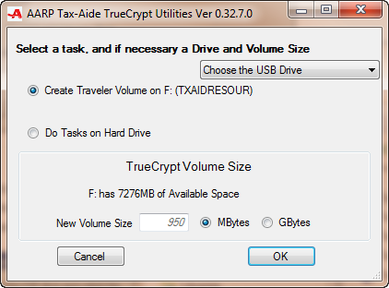

Selecting the USB Drive
When more than one USB-connected disk drive is detected, one of them will be chosen by the program as its target Traveler drive; but there will also be a “Choose the USB Drive” box that can be clicked to change which of the attached USB drives is chosen as the Traveler Mode target of the TATCU program.
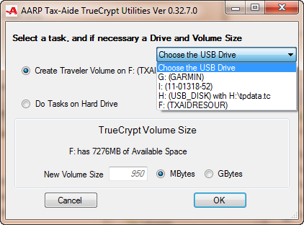

Specifying the Volume Size
When creating a new True Crypt Volume or resizing an existing one, the user must specify the new TrueCrypt Volume size in the “Select a Task…” dialog.
There have been a variety of recommendations for the appropriate TrueCrypt Volume container file size. Generally, for the current tax year and up to 1,000 tax returns, 500 Megabytes should be large enough. Since the number of tax returns done for prior years will be much smaller and the TaxWise application itself is smaller in prior years, the additional size of the TrueCrypt container file for those years can be less than 500 Megabytes. For the current year and 3 prior years of TaxWise installations plus tax returns, the recommended size is 1,800 Megabytes, often rounded to 2 Gigabytes. The size entry box accepts only numbers without commas, so choose “Megabyte” or “Gigabyte” accordingly.
Once the size entry has been made in the “Select a Task…” dialog box and “OK” has been clicked, if the Hard Drive has been selected the TATCU program will create the desktop shortcuts to allow opening and closing the TrueCrypt Volume. The TATCU program then automatically starts the TrueCrypt Volume-formatting software and moves through the first few boxes, entering the AARP Tax-Aide standard parameters. The TATCU program will pause at the Volume Password entry box shown below.

Specifying the Volume Password
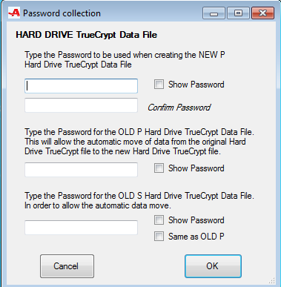
At this point, the user specifies the passwords that will be used later to open the new TrueCrypt Volume, and the passwords necessary to open any old TrueCrypt Volumes. The passwords to the old volumes are used to allow automatic transfer of data from the old volumes to the new volume. This dialog box only displays as many password entry points as are necessary for the task in hand.
Once the password has been entered the TATCU program uses the TrueCrypt program to carry out the selected actions.

Formatting the Volume
While the Volume is being formatted, the following screen will be displayed.
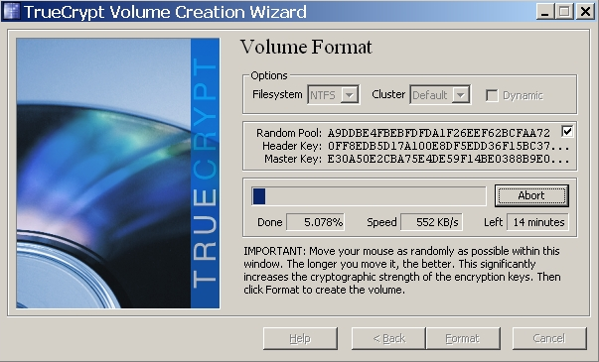
Don’t worry about TrueCrypt’s IMPORTANT instruction to move your mouse within this window. By the time you see this screen, the TATCU program has already clicked “Format.”
This process could take a long time! Once the operation completes, it may take a while for that window to close. Do not attempt to close the window; just wait for the format operation to complete.

Starting the Tax-Aide Drive
After the TATCU program has completed its tasks the “Start Tax-Aide Drive” icon on the desktop may be clicked. The program prepares to open the volume by presenting the dialog box below requesting the password:
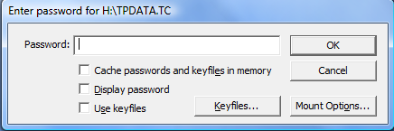
Once the correct password is entered, the TrueCrypt Volume will be opened and shared. The Tax-Aide Drive Open dialog will be presented:
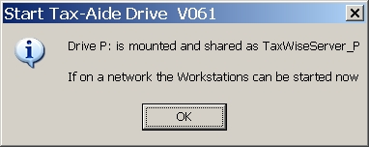

Handling Errors during TrueCrypt Upgrade
If the Local hard Drive is chosen and contains an existing installation of TrueCrypt, the TrueCrypt installer may fail in its attempt to replace the older version. If this happens, the TATCU program will detect this failure, report the error, and exit. A message may suggest restarting Windows to get around this error. If this error condition occurs, use Control Panel > Add or Remove Programs to manually uninstall the previously-installed version of TrueCrypt; then restart Windows and restart the TATCU program.
Do not attempt to prevent this error from occurring by preemptively uninstalling a legacy version of TrueCrypt before launching the TATCU program. Doing so will interfere with the TATCU program’s automatic migration of the contents of legacy TrueCrypt Volumes to newly-created volumes.

TrueCrypt blue key icon
The TATCU program attempts to remove the TrueCrypt blue key icon from the desktop, to avoid volunteer confusion between it and the Start and Stop Tax-Aide Drive icons. In some circumstances this blue key icon is not successfully deleted by the program and cannot be manually deleted from the desktop using the normal Windows delete operations. In some of these cases, a right click on an empty part of the desktop and selection of “Refresh” from the displayed context menu will complete the removal of this icon.

APPENDIX A – Understanding Migration Scenarios
This appendix deals with the issues arising from the use of the TATCU procedures for the current Tax Year and legacy versions of the Tax-Aide TrueCrypt procedures. When the TATCU program is used, the first thing it does is check to see if legacy versions of TrueCrypt software exist on the computer upon which the TATCU program is being run. If the TATCU program is being used to create a Traveler Mode TrueCrypt Volume, the traveler USB drive is also checked to see if any legacy versions of TrueCrypt software exist on the USB drive.
If TrueCrypt software prior to version 6.2 is found, it is upgraded, any existing Tax-Aide TrueCrypt procedures are removed, and the TrueCrypt Volumes with filenames TPDATA.TC, TSDATA.TC, TRDATA.TC, and TQDATA.TC are marked to be upgraded to the latest TrueCrypt Volume technology.
If TrueCrypt software at version 6.2 or 6.3 is found it is upgraded to TrueCrypt 7.0. The data file migration described below is not done in this scenario.
PLEASE NOTE that only the standard legacy TrueCrypt for Tax-Aide setups listed above are migrated automatically. If nonstandard locations or names have been used for the TrueCrypt volumes then simply moving the TrueCrypt volume to the standard location (c:\ for Windows XP and c:\users\public for Vista and windows 7) and renaming the volumes to the standard names (tpdata.tc and tsdata.tc) will allow this automatic migration to proceed.

Changes for Tax Years 2009 and 2010
Legacy TrueCrypt for Tax-Aide Installers (before version 6.2) offered two modes of TrueCrypt usage for internal hard disk drives: Single and Dual Internal Modes. In Dual Internal Mode, a Primary TrueCrypt Volume named TPDATA.TC opened as drive P: was intended to contain only the current year of TaxWise, while a Secondary volume named TSDATA.TC -- opened as drive S: -- was intended to contain any prior years of TaxWise that were installed on that same internal hard disk drive.
The TATCU procedures for The current Tax Year provide only Local Mode for internal hard disk drives, similar to legacy Single Internal Mode. In Local Mode, the TrueCrypt Volume TPDATA.TC -- opened as drive P: -- is intended to contain both the current year of TaxWise as well as any prior years of the program that may be installed on that same internal hard disk drive.
Legacy TrueCrypt for Tax-Aide procedures also offered two modes of operation for removable data storage devices: External and Traveller Modes. In External Mode, the TrueCrypt program was installed on and loaded for execution from the C: drive of the computer to which the removable data storage device was attached. By contrast, in Traveller Mode the TrueCrypt program was installed on and loaded for execution from the removable data storage device that also contained the TrueCrypt Volume. The TATCU procedures for The current Tax Year provide only Traveler Mode operation for removable data storage devices.
Starting with TaxWise 2008 and continuing with TaxWise 2009, a TaxWise design change has made running TaxWise from different drive letters more difficult than it is to always run the program from the same drive letter. In light of this change in TaxWise and also to simplify the use of TrueCrypt for Tax-Aide, the National Technology Committee decided to discontinue support for the Dual Internal and the External Modes of the legacy installers and to use only drive P: when opening all TrueCrypt Volumes for the AARP Tax-Aide program.

Migration Scenarios

Scenario 1 – No TrueCrypt previously installed
If you are installing Tax-Aide TrueCrypt procedures for the current tax year on a computer or removable data storage device that does not already have a legacy TrueCrypt for Tax-Aide installation, there are no migration issues – just use the TATCU program in the appropriate mode.

Scenario 2 –Internal Mode TrueCrypt previously installed
If you are installing Tax-Aide TrueCrypt procedures for the current tax year on a computer that already has a 6.2 or 6.3 TrueCrypt Tax-Aide installation, the existing TrueCrypt software and Tax-Aide script files will be removed and replaced with their Latest TrueCrypt version equivalents. The TrueCrypt volume data file will be left unchanged.
If you are installing Tax-Aide TrueCrypt procedures for The current Tax Year on a computer that already has a legacy Internal Mode TrueCrypt for Tax-Aide installation, the legacy installation can be in either Dual Internal Mode (using both drives P: and S:) or Single Internal Mode (using drive P: only).
The TATCU program will change the names of legacy volumes TPDATA.TC and TSDATA.TC to TPDATAOLD.TC and TSDATAOLD.TC. Then the user will be asked to create a new TrueCrypt Volume. It is vital to make the new volume large enough to hold all of the data in the old volumes and any new data that will be added. Once the new volume has been created, the user will be asked for the password to open the new volume and then, in turn, for the passwords of the old volumes to open them. The entire contents of the old volumes will be copied across to the new P: volume. This is done first for TSDATAOLD.TC and then for TPDATAOLD.TC. This can take a long time! Once the copying has completed successfully, the old volumes are deleted. If any errors occur, the old volumes will be left for the user to open and manually copy data across to the new volume. Appendix B contains instructions for resolving these migration errors.
If a TaxWise installation for tax year yy that will now be running from drive P: previously ran from drive S:, you will need to delete any desktop icons that launched TaxWise from the S: drive and run P:\UTSyy\TWTech\setup.exe to properly set up the TaxWise software and to create new desktop icons that launch from drive P: before launching that year of TaxWise.

Scenario 3 – External or Traveller Mode TrueCrypt previously installed
This scenario is relevant if the user has requested that the volume on the removable data storage be “resized” or that the software be “upgraded”.
If you are installing Tax-Aide TrueCrypt procedures for The current Tax Year on a removable data storage device that already has an existing TrueCrypt for Tax-Aide installation based on either version 6.2 or 6.3 then the existing TrueCrypt software and Tax-Aide script files will be removed and replaced with their Latest TrueCrypt version equivalents. The TrueCrypt volume data file will be left unchanged.
If you are installing Tax-Aide TrueCrypt procedures for The current Tax Year on a removable data storage device that already has an existing TrueCrypt for Tax-Aide installation earlier than version 6.2, the legacy installation can be in either External or Traveller Mode.
In either case, the legacy installation will be detected, and the TrueCrypt files TRDATA.TC or TQDATA.TC will be moved to the root directory of the C: drive of the system upon which the Installer is running. The files will be renamed TRDATAOLD.TC and TQDATAOLD.TC.
Then the user will be asked to create a new TrueCrypt volume on the USB drive. The container file for this Volume needs to be large enough to hold whatever was in the old volume plus any additional data that will be stored in it. Once the new volume has been created, the user will be asked for the password to open the new volume and then the password to open the old volume. The entire contents of the old volume will then be copied across to the new P volume. This can take a long time! Once the copying has completed successfully, the old volume is deleted. If any errors occur, the old volume will be left for the user to open and manually copy data across to the new volume. Appendix B contains instructions for resolving these migration errors.

If a TaxWise installation for tax year yy that will now be running from drive P: previously ran from drive Q: or R:, you will need to delete any desktop icons that launched TaxWise from those drives and run P:\UTSyy\TWTech\setup.exe to properly set up the TaxWise software and to create new desktop icons that launch from drive P: before launching that year of TaxWise.

Scenario 4 – TATCU for The current Tax Year Traveler Mode drive inserted into a computer with a version of TrueCrypt prior to 7.0 installed
If a Traveler Mode drive that was created or updated by the TATC procedures for Tax Years 2010 is inserted into a computer with TrueCrypt installed on the system’s local hard drive, TrueCrypt uses the TrueCrypt driver installed on the system to access the Traveler Mode TrueCrypt Volume. As a result, the TrueCrypt version installed on the system must be compatible with the TrueCrypt Volume on the Traveler Drive. If the procedure detects that this is not true, it will automatically upgrade the TrueCrypt software and any TATCU scripts on the local hard drive.
If a TrueCrypt volume is detected and the existing local hard drive TrueCrypt software is at less than release 6.2 then:
- The user is asked for the size of the new TrueCrypt volume to be created on the local hard drive
- The legacy TrueCrypt software is uninstalled
- Legacy Tax-Aide procedures are removed
- The TrueCrypt Volume files TPDATA.TC and TSDATA.TC are renamed TPDATAOLD.TC and TSDATAOLD.TC
- The version 7 TrueCrypt software is installed
- The TATCU scripts are installed
- The data is migrated from the old files to the new files
Then the Traveler volume is opened as normal using the newly upgraded TrueCrypt software.
If the Local hard drive had TrueCrypt version 6.2 or 6.3 installed, then the following occurs:
- The legacy TrueCrypt software is uninstalled
- Legacy Tax-Aide procedures are removed
- TrueCrypt version 7 is installed together with the associated TATCU scripts
Then the Traveler volume is opened as normal using the newly upgraded TrueCrypt software.

APPENDIX B – Resolving Migration Errors
Background: During the installation of TATC procedures for The current Tax Year over a legacy version prior to 6.2, the TATCU program changes the name of the old volume from TPDATA.TC to tpdataold.tc. To transfer the files and folders from the old volume to the new volume, the TATCU program temporarily opens the old volume as a different drive, drive S:. During a normal installation without errors, after you have entered the password for the new volume and the password for the old volume, you will then see a window that lists each file as it is being transferred. In case of error during the copying process the procedure below must be used.
There may be a flashing icon in the lower right task bar saying that the TATCU program is paused. To get rid of the flashing icon, right click on it and select “Exit.” This will forcibly exit the TATCU program; if anything useful was going on it will be lost.
Go to the Start menu and open the TrueCrypt Application.
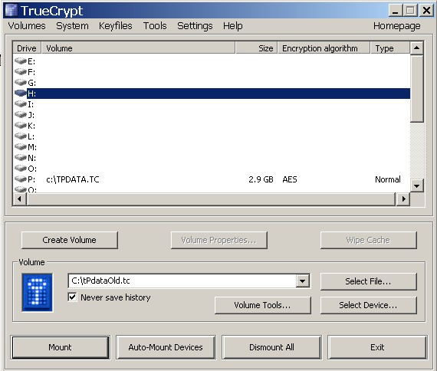

Ensure that the P: drive is open with C:\tpdata.tc (Windows XP) or C:\users\public\tpdata.tc (Windows Vista or Windows 7) and the H: drive is open with tpdatold.tc. For instructions on how to do this see TrueCrypt help.
Minimize the TrueCrypt window.
Go to My Computer and open the H: drive.
Go to Edit, Select All, and then copy or move all of the files and folders from the H: drive to the P: drive.
Finally, restore the TrueCrypt window, highlight the H: volume, and press the “Dismount” button. You can then close the TrueCrypt window.

APPENDIX C – Locating TrueCrypt Volume container files
In Local Mode, where the container file is stored depends on which Windows version is in use.
- For Windows XP – The file is stored in the root of the C drive; the path for the TrueCrypt Volume is
  - C:\TPDATA.TC
- For Windows Vista and Windows 7 – The file is stored at the root of the Public directory; the path for the TrueCrypt Volume is
  - C:\Users\Public\TPDATA.TC
In Traveler Mode the container file is stored at the root of the flash key or removable hard disk drive and is named TPDATA.TC.
This path information is only needed when the time comes to delete the TrueCrypt Volume. Under all normal usage scenarios, the TATCD procedures use the appropriate paths; the user does not have to be concerned with them.

APPENDIX D – Accessing Source Code
The source code for the TATCU program is written in the C# programming language. The source is open to everyone and is published in a common source code repository for the tools endorsed or supported by the National Technology Committee. A link to the published source codes is posted on the Technology page of the AARP Tax-Aide ExtraNet.

APPENDIX E – Changing a TrueCrypt Volume Password
It is a good data security practice to change the Volume Password of Tax-Aide TrueCrypt Volumes annually in preparation for a new tax season. It may be necessary to do so at other times if the password is compromised. This section shows how to change a Volume Password.
Download the Tax-Aide TrueCrypt Volume Password Changer from the Technology page of the AARP Tax-Aide ExtraNet. Close any open TrueCrypt volumes; then run this file. The first dialog box that appears is shown below:
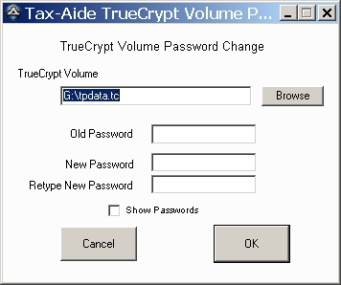
When it is launched, the Password Changer searches the system on which it is running to find the TrueCrypt Volume that is the most likely candidate for having its password changed, starting with removable drives. It puts the path to that volume in the “TrueCrypt Volume” field. If the suggested default is not the volume whose password you want to change, click on the Browse button to bring up a Browse dialog:
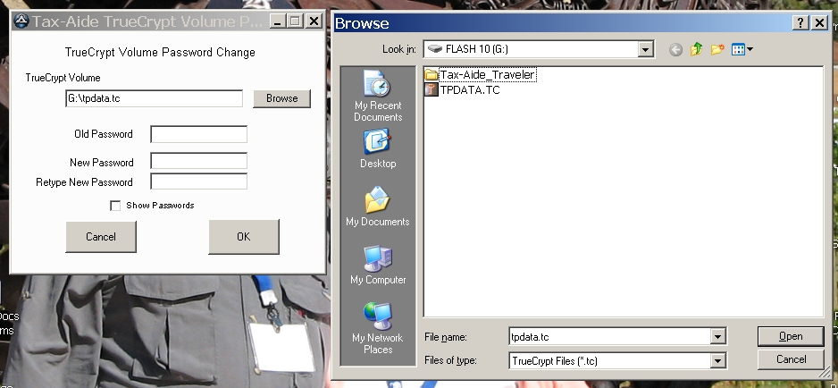
Use the Browse dialog to locate and select the TrueCrypt Volume with the password you want to change. When that file is selected, click on “Open.” This will return you to the TrueCrypt Volume Password Change dialog with the path to the selected volume in the “TrueCrypt Volume” field. Now you can enter the old and new Volume Passwords and click on OK.
If you enter an incorrect old password, the Password Changer procedure will exit to the native TrueCrypt user interface so that you can use that interface to re-enter the old password and complete the task. If the correct old password is entered, the Password Changer procedure will drive TrueCrypt through the Change Password process.
This dialog may appear:
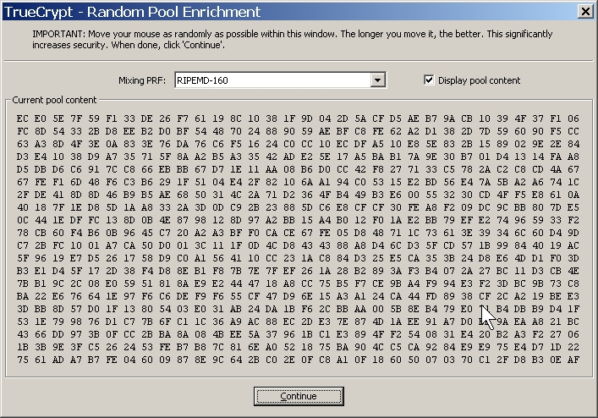
If it does appear, you will need to click on “Continue.”
This dialog will appear:
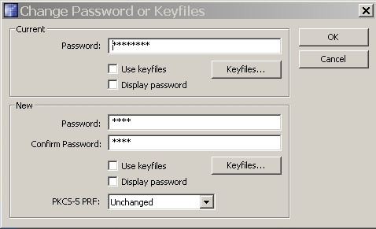
You do not need to enter or click anything at this point; just wait for this process to complete. It can take longer than you might expect it to, so be patient. When it is done, this confirmation will be displayed:
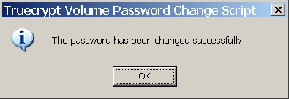

APPENDIX F – Changing the size of a TrueCrypt Volume
As a TrueCrypt volume is effectively a formatted disk drive, there is no way to directly change its size. However, a new volume can be created that is the desired size, and the contents of the “old” volume can be copied to the new one. Assume that you originally created the volume TPDATA.TC at 2 GB and now you want to change if to 2.5 GB. The TATCU program contains a function that automates the resizing of a standard Tax-Aide TrueCrypt volume on either a Hard Drive or a Traveler Drive.
Shown below is the “Select a task…” dialog box configured to resize the TrueCrypt volume on a Hard Drive.

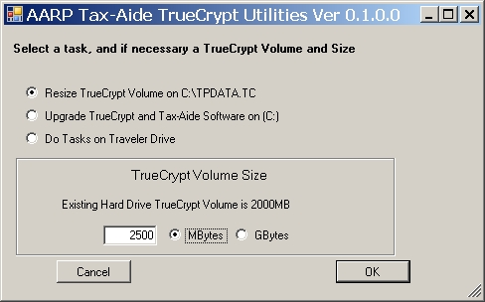

If you are making the size of the volume smaller you should verify that the smaller volume is large enough to hold all of the files. If you proceed with reducing the size and all of the files do not fit in the smaller size, the utility will warn you and give the option to start over again or just discard files that don’t fit as follows:
The example below was for resizing a Traveler Drive. During the utility’s process of copying the files from the old volume to the new volume, you will get a message similar to the:
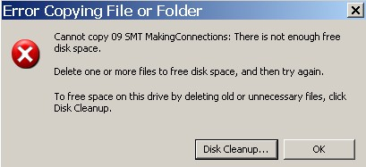

If you click OK, then you get the following dialog:

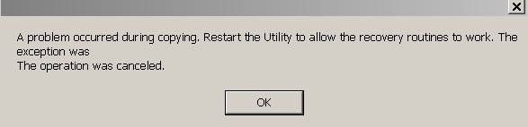

When you click OK all TATCU messages will eventually leave the desktop. The utility takes time to close both the new and old volumes. Then you need to restart the TATCU Program. When you restart you will get the following window:

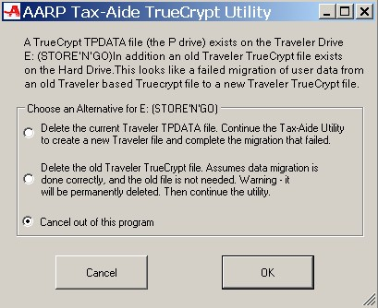

The first choice deletes the new small volume, but, retains the old volume and allows you to start over with a new volume size larger than the one that failed. All files that were in the original old volume are retained in that volume. The second choice discards the old volume and starts the utility over again. This second choice means that files that did not copy to the new volume cannot be retrieved. If you select “Cancel out of this program” the utility quits and the new small volume and the old volume remain until you restart the utility. With either the first or second choice you will get the following window:

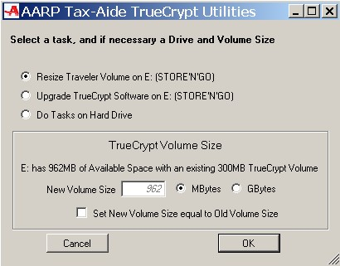

If you do not want to do any more with the Utility, just select Cancel.

APPENDIX G – Starting the Tax-Aide Drive at Windows Log on
If you want the Local C-drive TrueCrypt volume to be opened automatically when a volunteer logs on to Windows:
For Windows XP - Copy the Start Tax-Aide Drive shortcut from the desktop to this folder:
C:\Documents and Settings\All Users\Start Menu\Programs\Startup\
For Windows Vista and Windows 7 -
- Click the Start button, click All Programs, right-click the Startup folder, and then click Open.
- Open the location that contains the item you want to create a shortcut to.
- Right-click the item, and then click Create Shortcut. The new shortcut appears in the same location as the original item.
- Drag the shortcut into the Startup folder.

The TrueCrypt Volume will also be shared as TWSRVR_P for compatibility with workstations that were configured to map this share name, a legacy from earlier versions of TrueCrypt for Tax-Aide.
The legacy TrueCrypt for Tax-Aide documentation spelled this mode “Traveller.” We use that spelling when we refer to legacy installations. In Version 6.3 we are using the more common spelling that only contains one “l.”
The previously-installed version of TrueCrypt may have already been uninstalled when you look at the list of installed programs. If so, continue as though you had just uninstalled it.

