OAD Exercise 2
T-Rec
Group 48

1. The team

Eman Basic | 01531724
Emir Salkic | 01531697
Josip Letica | 01531757
Marin Piric | 01432207
Nedim Vejo | 01637395
Marko Stojanovic | 01532165

2. Exercise 1
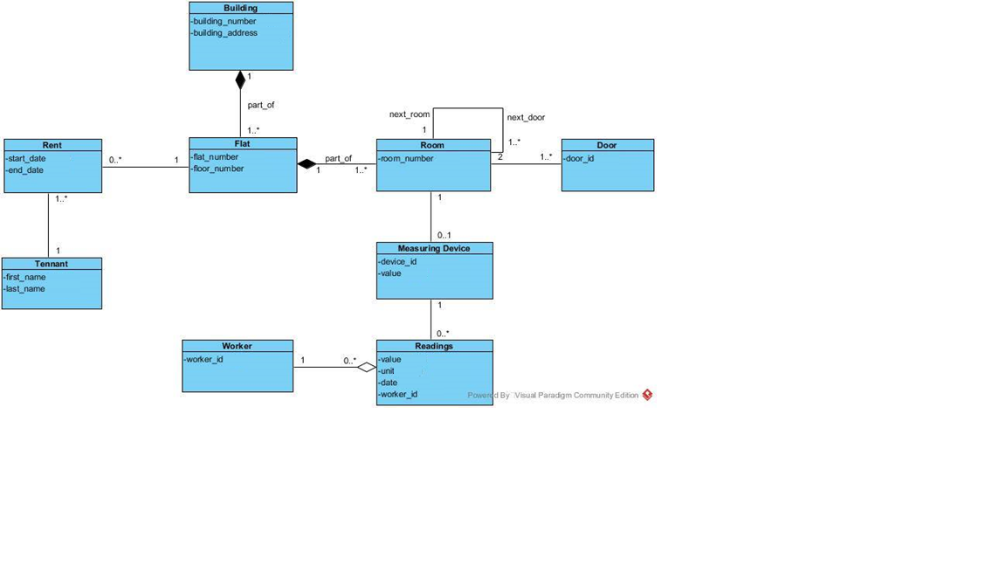

3. Exercise 2

3.1 Class diagram
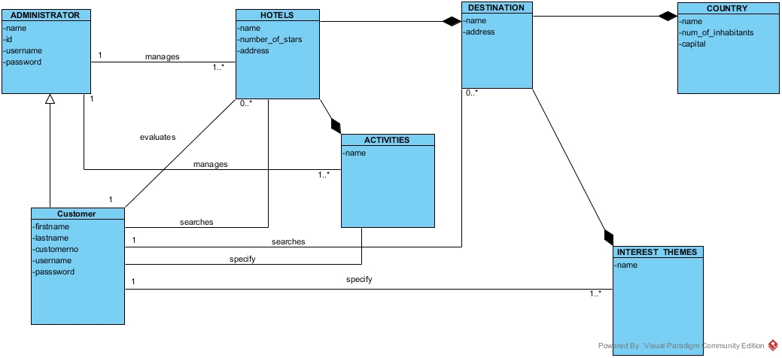

3.2 Use Cases

Priorities

Priority | Use Case Properties
Low | Not so important Use Case, but can be useful sometimes
Average | Should be implemented, but can be implemented later
High | Needs to be implemented in the current iteration

1 Prioritization for Use Cases

3.2.1 Use Cases in textual form

Registration

Use case: Registration | Priority: High
Description:
How a user of T-Rec performs the registration process.
Scenario 1
- User comes to Homepage and options are offered – register, log in.
- User clicks on register.
- The system asks for the first name, last name, email, username, password, password confirmation, gender, age and occupation
- User enters ['Max', 'Musterman', 'muster@.tugraz.at', ‘max1’, 'Pass321','Pass321', ‘male’, ‘23’, ‘Developer’].
- The system accepts and stores new profile.
- The login form is displayed again to the user

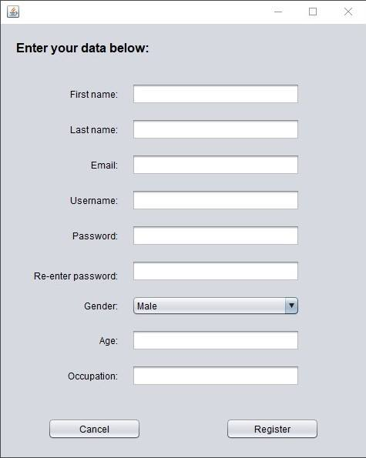
Example UI:

Login

Use case: Login | Priority: High
Description:
How a user of T-Rec performs the log in process.
Scenario 1
- User enters data (username, password) but system alerts “Profile is not
registered.
- If user isn’t registered, the system offers the registration panel.
Scenario 2
- User enters data some wrong data (wrong username or password or both)
- User Clicks login.
- “Wrong password or username, please try again” is displayed
- User enters right data ['Traveller','Pass321'].
- The system accepts and gives Customer options to user.
- User gets Customer options and access to search accommodation / interests.
Scenario 3
- Administrator enters admin data['Admin’,'admin123'].
- Administrator clicks login.
- The system accepts and gives Administrator options to user.
- With administrator options he can manage app and master data.

Example UI:
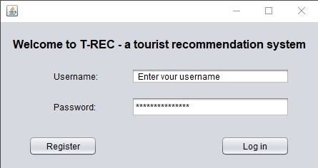

III) Search Destination

Use case: Search Destination | Priority: High
Description:
How a user performs Destination search.
Scenario 1
- User signs in as User.
- User gets Customer privilege and customer options
- User chooses a country and a city from a combo box.
- List of possible cities change with the selection of the country, as well as the list of places to visit
- The Customer can bookmark that destination.

Scenario 2
- User signs in as Administrator.
- He chooses a country, a city and a hotel.
- The administrator can also bookmark this destination.
- The main difference is that the Admin hub is visible to the admin, where he can manage this data

Example UI:

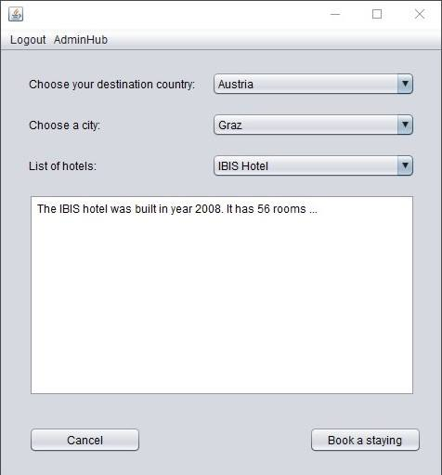
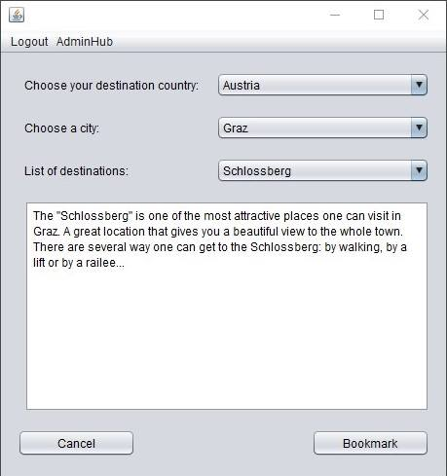

IV) Search accommodation

Use case: Search accommodation | Priority: High
Description:
How a user of T-rec performs the accommodation search.
Scenario 1

- -User enters data (username, password).
- -User Clicks login.
- -User becomes customer privilege with restricted access.
- -User clicks on search for accommodations.
- -User chooses a country, a city and an accommodation.

Scenario 2

- User signs in as Administrator.
- He chooses a country, a city and a hotel.
- The administrator can also book a staying in that hotel.
- The main difference is that the Admin hub is visible to the admin, where he can manage this data

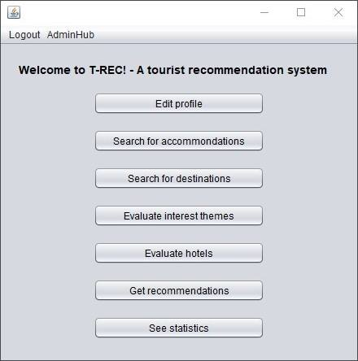
Example UI:

V) AdminHub for administration purposes

Use case: Application managment | Priority: High
Description:
How an admin of T-Rec manages the application
Scenario

- User enters data (username, password).
- User Clicks login.
- User becomes admin privilege.
- At the app homepage and at any other form in the app, the AdminHub button is visible.
- The administrator clicks on the AdminHub button and goes to the hub.
- He can manage users and accommodation data.

Example UI:
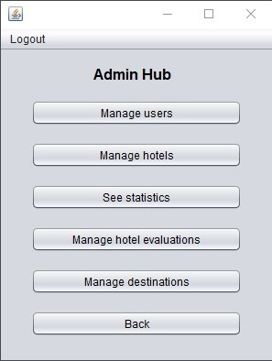

VI) Customer Hub

Use case: How Customer navigates the app | Priority: High
Description:
How a user of T-rec navigates through the app and knows his options.

Scenario

- User enters data (username, password).
- User Clicks login.
- User becomes Administrator / Customer privileges.
- The “Welcome to T-Rec!” form is shown, and this is the Home form of the app
- User can choose between various options like profile editing, accommodation or destination search, evaluate interest themes, evaluate and give ratings to hotels, see statistics and get recommendations.
Example UI:

VI) Logout

Use case: Logout | Priority: Average
Description:
How a user of T-Rec performs Logging out
Scenario

- User enters data (username, password).
- User clicks login.
- User becomes Customer / Administrator profile.
- User clicks on logout.
- User logged out.
- Login form is offered.

3.2 Use Cases Diagram

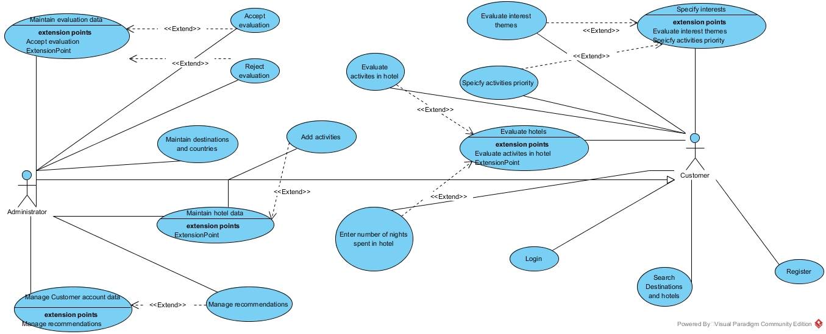

4. Business Case

4.1 Executive Summary

The following business case is created to show the ideas and main objectives of the T-Rec application. The business case will show us the project definition as also the objective, benefits and limitations, outline plan and the costs of the project.

4.2 Project Definition

4.2.1 Project Overview

The Administrator: Can oversee T-REC application, more specifically manages hotel data and everything on the platform, overseeing the Customer requests and new destinations of Hotels including the activities which are arranged by the Hotel. In order to maintain the activities depending on the Hotel, at the same time maintaining evaluations from hotel reviewers, customers while inheriting the class. The administrator has full control of what is going on at any given time or any given process.

The Customer: Can manage, create and cancel their own requests. By creating a request simultaneously giving personal data which is stored into the system, which can only be accessed by the Administrator. By specifying the interest and creating an interest profile regarding the hotels which are dependent on the touristic activities, along with nights spent in the hotel and the textual description of their stay they are creating the evaluatory report of the hotel (Feedback).

The Hotel: Corresponds with according Destination in which it is built. The destination data is maintained by the Administrator as well as the Hotel data. Each hotel has unique data which accords to a certain location, rating and name.

The Country: Each having geographical and economical data regarding inhabitants and capital and name and is dependent on the Destinations class.

The Destinations: Coresponds with a Country, maintained by the Administrator and is dependent on the Hotel class.

4.2.2 Background information

Tourists need infrastructure, activity planning, clear booking overview, time management and planing ahead, which should be in most of the cases already handed-out and explained in detail by the activity creator. When traveling an visiting foreign places, there needs to be a sense of security and certainty. A tourist is often times left alone to search and attend activities. A lack of preparation might mean time and money not well spent.

This application should solve most of the stated problems by giving a clear overview of activities and management of accommodation, while also providing information about the reputation of every hotel in the applications database, rated by other fellow tourists who already visited the same hotel and who took the time to give feedback about the hotel and their overall experience.

4.2.3 Business Objective

The main goal is to make a interface where we would bring all informations on one place what would help the customers in there desicion and make a better overview of there options and possibilities that they have. The interface will give the customer the possibility of searching for sertain destinations of there choice and give them a specific list of accomodations fort the specific destination. With every accomodation comes a list of activities that is provided for the customer. Customer will also have the possibilty of evaluateing the accommodation that will give a good overview for others that are interested in the same options.

4.2.4 Benefits and Limitations

Benefits:

Tourist evaluations can benefit other tourists choice of accommodation.

Updating the database regularly -> the app being up-to-date with new up and coming hotels, would ultimately give more choice to Tourists to pick where they are staying.

Tracking of activities can allow tourists to scroll and pick activities seamlessly without having to seek the information manually and verbally.

Limitations:

On version 1.0 of the application the choice of hotels is small as we accommodate a certain fee for every hostel which wants to be visible on our application. Only with time can trust and interest grow and help in the future establishment of the application. (Cold-Start factor)

Lack of investors and financial support can result in a weak teambase, and lack of Figures that are required as part of the team to carry out functions and support the project. In result some functions may not be fully implemented.

Lack of interest in terms of popularity of the programe. This would result in a financial breakdown, end of trust, and loss of contracts which means loosing investors.

4.2.5 Outline Plan

Based on the Unified Process, our project is divided into tree main phases:

1. Inception: In this phase we will be provided with the GUI Prototype concept and ideas of how should the software look , work and how could new ideas be implemented.

2. Elaboration: in this phase, the project team should be able to make the majority of the system requirements. Primary goal is to make good architecture that will provide a good platform for the rest of the implementations and function that should be implemented in the next phase.

3. Construction: This phase takes most time resources and energy since it is the largest phase in the project, where the rest of the system is constructed upon the base built in the Elaboration phase. All of the features are implemented in intervals featuring irretations, where each irretation produces a deliverable, an version of a executable relaease of the software.

4.2.6 Project Approach

As we explained in section „4.2.5 Outline Plan“ , throught this project the team will take small staps in making the interface to reduce the possibility of making a error or a bad choice. For this project to be successful,most important is the organization and preparation in the team to avoid any possible problems.

4.3 Project Organization

4.3.1 Project Governance

Our team has the following roles:

Role | Name | Description
Project Manager | Eman Basic | Provides executive support for the project.
Developer | Emir Salkic | Handles the development side of the project.
Tester | Marin Piric | Tests the program and gives his opinions.
Usability Tester | Nedim Vejo | Tests the application for any difficulties in navigating the system.
Analyst | Marko Stojanovic | Analyses the specified requirements and gives in depth information about them.
Support | Josip Letica | Supports the rest of the team members in their tasks.

4.4 Costs

The cost for the project that will come up are following:

Developer : Developers are the ones who design and construct the interface so because of that they are the ones that have the highest costs.

Web Hosting: After the manufacture of the interface, there needs to be a possibility present and describe the product. Also there needs to be a provided download link and also a customer support if any problem occurs while using the product.

Marketing: As for any product, such as for this there needs to be a way to introduce the product to the customers. By spreading the word there is more chans of woking up the interest in customers for the product.

The exact cost for the product will be determined additionally.

