

**COMP-9321 Data Services Engineering Assignment 3 Demand & Test Specification**

ASSIGNMENT 3 COMP9321

full stack case based on PYTHON MACHINE LEARNING

Weather superman

2018

1. **Introduction**
   1. **Production Description Statement**

“MovieDigger” is a simple website to analysis users emotional with one movie comment. It allowed user to login or create their own accounts. By inputting one movie commentary sentence, users can receive a feedback about their emotion about this movie. It can be used to count the movie reputation, also it is a good case for the future research about machine learning and data digging.

* 1. **Document Purpose**

This document has two purposes. One is to describe and define the project content requirements in the form of a document, so as to achieve a consistent understanding of the requirements with the user; another purpose is to provide project team members with a better understanding of the demand situation. To make the task and purpose of the project work more clear, and as a basis for project management, review, tracking and other project personnel to check the project work results in the project implementation project.

* 1. **Documented target**

Users, project management, developer, tester

* 1. **Version number**

This website is version 1.0.1. It fixes the bug in the code. If you have error or suggestion support, please email: xxxxxxxxxx@gmail.com.

1. **User guide**

Click “login” or “register” button to login or create a new account

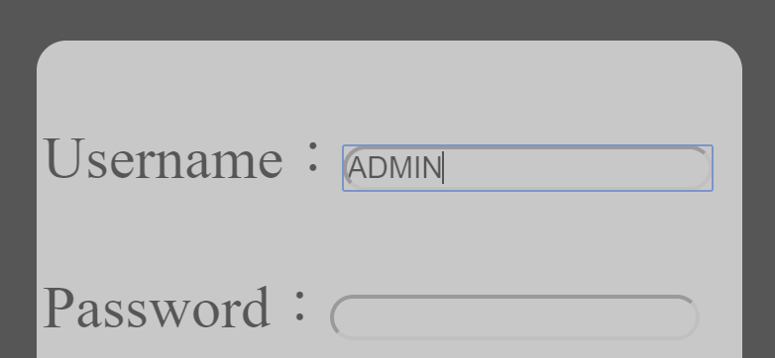Input your id and password

Click “login” or “register” button

Go into “comment search” page, input some words, click “submit” button

Receive the feedback (smile face means “positive emotion” and cry face means “negative emotion”)