**Thesis Current State**

**3 Dropdown lists have been implemented, shape, size, color. The number of elements in it (for example, blue, red, green) depends on the attribute of the dataset.**

**The following 4 methods have been developed, but it still needs to be improved in some special cases or under special conditions.**

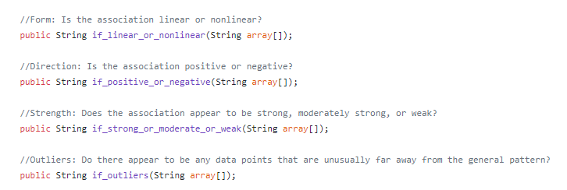

**5 examples of scatterplot to describe:**

1.

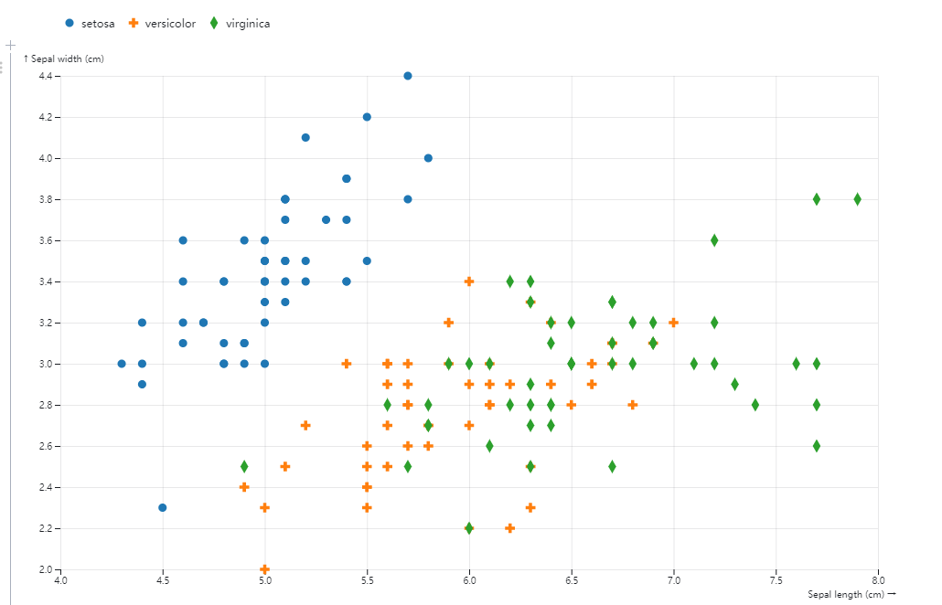

a. **Name of x and y-axis: Sepal length and Sepal width. And a short description: This chart shows the relationship between sepal width (*y*-axis) and sepal length (*x*-axis) for three species.**

b. **color: blue: setosa, orange: versicolor, green: virginica**

**shape: d3.category (d3.library, it’s up to us)**

**size: all the same**

c. **setosa: linear, positive , moderate strong, outliers(2.2-2.4)**

**versicolor: non linear, positive, null, null**

**virginica: non linear, positive, null, null**

d. (template)

**setosa has generally the shortest length than other species, but it has generally the widest width than others.**

**virginica has generally the longest length than other species, but it has generally the shortest length than others.**

**Compare with others, the length and width of versicolor are relatively even.**

2.

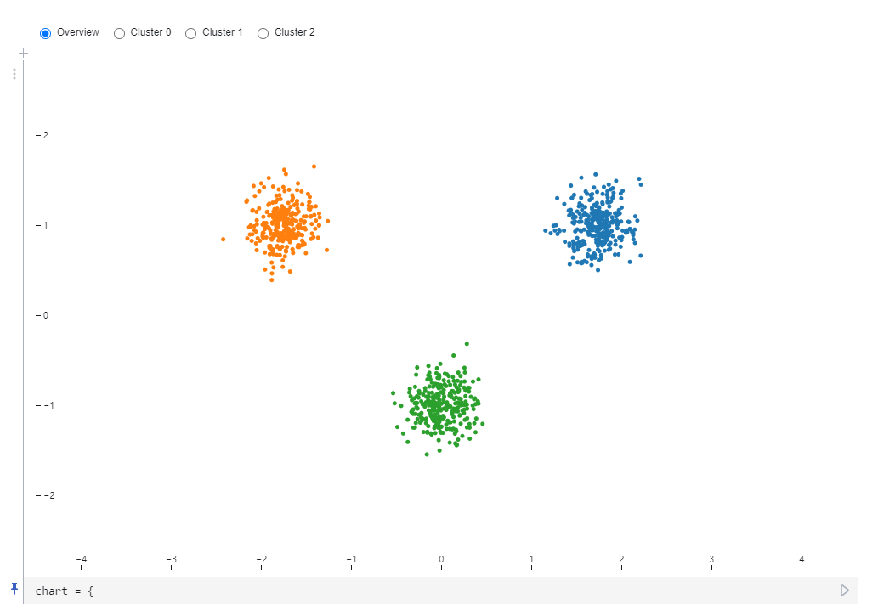

1. **Name of x and y-axis: null (null in the chart) and null. And a short description: This chart shows the relationship between null and null for three variables.**

b. **color: blue: cluster 0, orange: cluster 1, green: cluster 2**

**shape: d3. category (d3.library, it’s up to us)**

**size: all the same**

c. **cluster0: non linear, null ,null, null**

**cluster1: non linear, null , null, null**

**cluster2: non linear, null, null, null (or no relationship)**

d. **There are three data clusters in chart.**

**3.**

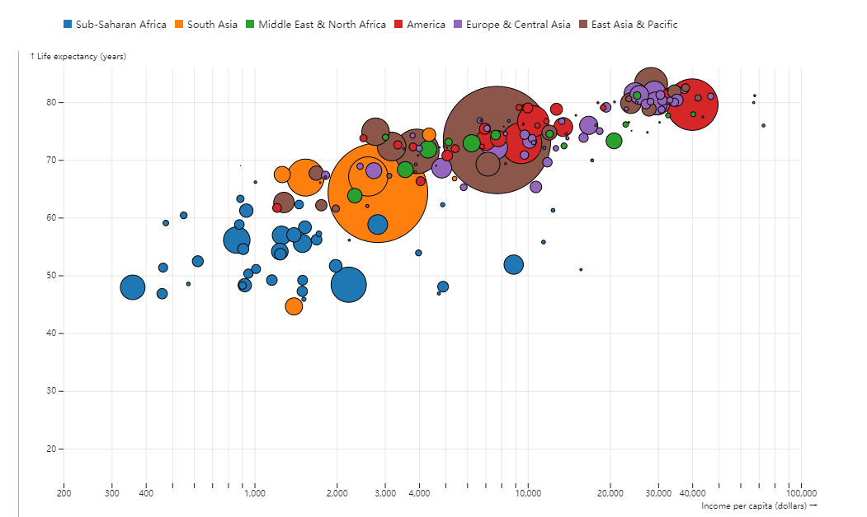

1. **Name of x and y-axis: Income per capita (dollars) and Life expectancy (years). And a short description: This chart shows the relationship between Income per capita (dollars) and Life expectancy (years) for six variables.**

b. **color: Blue: Sub-Saharan Africa Orange: South Asia Green: Middle East & North Red: America Purple: Europe & Central Asia Brown: East Asia & Pacific**

**shape: d3. category (d3.library, it’s up to us)**

**size: population**

c. **Sub-Saharan Africa: non linear, null ,null, null**

**South Asia: non linear, null , null, null**

**Middle East & North: non linear, null, null, null**

**America: non linear, null ,null, null**

**Europe & Central Asia: non linear, null , null, null**

**East Asia & Pacific: non linear, null , null, null (no relationship)**

d. **People in wealthy areas live longer.**

**There is no correlation between population and life expectancy**

4.

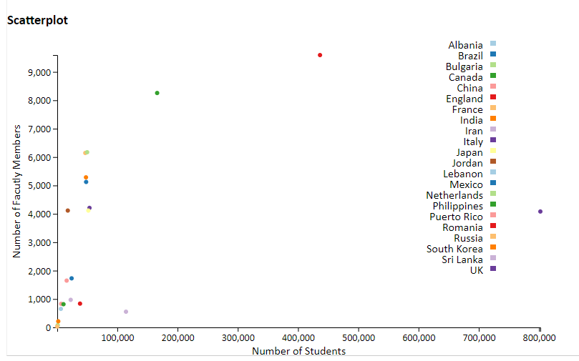

1. **Name of x and y-axis: Number of Students and Number of faculty Members. And a short description: This chart shows the relationship between Number of Students and Number of faculty Members for 22 countries.**

b. **color: Blue: Brazil Orange: Japan Green: Mexico Red: England etc.**

**shape: d3. category (d3.library, it’s up to us)**

**size: all the same**

c. **Brazil: non linear, null ,null, null**

**Japan: non linear, null , null, null**

**Mexico: non linear, null, null, null**

**England: non linear, null ,null, null (no relationship)**

d. **Italy has the largest number of students.**

**England has the largest number of faculty numbers.**

5.

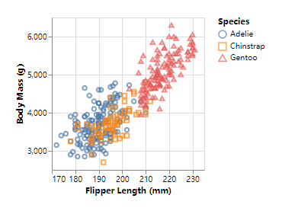

**a. Name of x and y-axis: Flipper Length and Body Mass. And a short description: This chart shows the relationship between Flipper Length and Body Mass for 3 species.**

b. **color: Blue: Adelie Orange: Chinstrap Red: Gentoo.**

**shape: Circle Adelie Rectangle: Chinstrap Delta:Gentoo**

**size: all the same**

c. **Adelie: linear, positive, moderate, null**

**Chinstrap: linear, positive, moderate, null**

**Gentoo: linear, positive, moderate, null**

d. **According to comparison with other species, Gentoo is larger than other species, it has large body mass and long flipper generally.**

**Species Adelie and Chinstrap are similar in flipper length and body mass.**