What is Node.js?

* Non-Blocking IO, asynchronous functioning
* Server side scripting language written in JS
* Runs in a virtual environment
* Single-threaded Event Loop
* Executes on server, not browser

Why use Node.js?

* Writing JavaScript on server
* Access to the HTTP stack
* Direct database access
* Used to overcome blocking I/O problems

What is the purpose of Node.js

* Real-time web apps
* Network apps
* Distributed systems

What asynchronous tasks occur in Event Loop

* Blocking send requests
* High computational requirement
* Real-time I/O operations

Order of execution in control flow statements

* Handling execution and queue
* Data collection and storage
* Concurrency handling and limiting
* Execution of the next piece of code

Node.js advantages

* Asynchronous meaning non-blocking I/O
* Doesn’t wait for API to return data
* No buffering, outputs data in chunks

Node.js disadvantages

* Multi-threaded runs more effectively when executing intensive CPU computation

Security implementations in Node.js

* Error handling protocols
* Authentication pipelines

Pyramid test

* Series of test cases executed
* Unit Testing -> Integration testing -> Combined testing

What is middleware for?

* Execution of code
* Updating request and response objects
* Completion of request-response iterations
* Call next middleware

Assert

* var assert = require('assert');
* assert( result === 8, 'three summed with five is eight');

Why use Express.js

* Framework built using Node.js
* Controls data flow between server and server-side apps
* Lightweight and flexible

Difference between readFile and createReadStrem

* Readfile is a synchronous and loads all content before user accesses
* 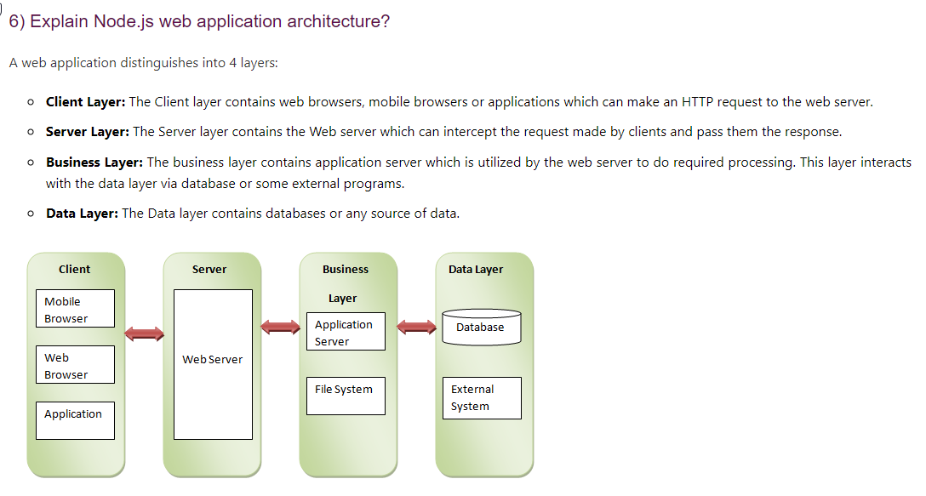createReadStream breaks up field into smaller chunks then reads

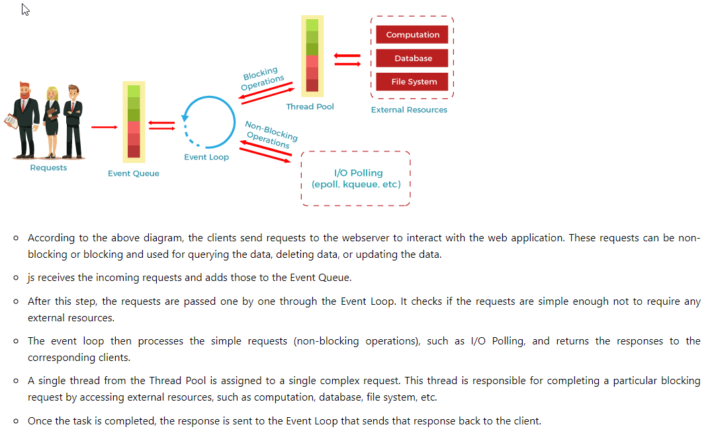

What is I/O?

* Input and output, anything used to access data outside of the application

What is npm?

* Node Package Manager
* For online repositiories and CL utility to install packages, do version management and dependency management of Node.js packages