|  |  |  |  |  |
| --- | --- | --- | --- | --- |
|  |  |  |  | **fuzzytable** |
|  |  |  |  |  |
|  |  |  |  |  |
|  |  |  |  |  |
|  |  |  |  |  |



# Maxeta

# Options:

1: 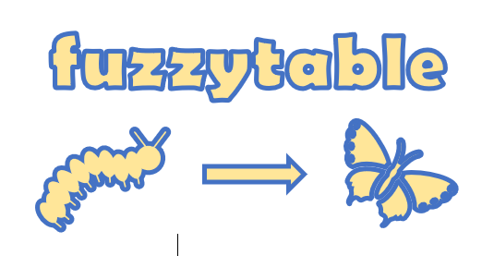

2: 

3: 

4: 